## The vulnerability of threatened species and ecological communities to climate change in NSW

## Final report on the vulnerability of threatened species and ecological communities to climate change in NSW

## Michelle R. Leishman, Claire A. Laws, Linda Beaumont and Nola M. Hancock





## Report prepared for the NSW Office of Environment and Heritage

## Project funded by the NSW Adaptation Research Hub – Biodiversity Node

**Table of Contents**

Acknowledgements

List of Tables

List of Figures

**Introduction**…………………………………………………………………………………………………...1

**Section 1**

**1.1 Status of threatened species and ecological communities in NSW**……………………………...4

*1.1.1 Species and ecological communities listed as threatened under the NSW* *Threatened Species Conservation Act 1995* …………………………………………………………………………………………….4

*1.1.2 Review of NSW Scientific Committee Final Determinations*  ………………………………………...4

**1.2 Vulnerability of threatened species and communities to climate change** …………………….8

*1.2.1 How many threatened species and ecological communities have climate change identified as a threat in their Final Determination?* ………………………………………………………………8

*1.2.2 Which types of species and ecological communities have climate change identified as a threat in their Final Determination?* …………………………………………………………………………………..20

*1.2.3 What types of climate change threats are identified in Final Determinations and how are these distributed across the different types of species and ecological communities?* …..21

**Section 2**

**2.1 Assessment of Conservation Projects for site-managed species** …………………………….….24

**2.2 Species Distribution Modelling** …………………………………………………………………………………...27

**2.3 Assessment of 18 Saving our Species Conservation Projects ………………………………….**…30

Vulnerable plants …………………………………………………………………………………….30

Endangered plants……………………………………………………………………………………36

Critically Endangered plants………………………………………………………………….……63

Vulnerable animals………………………………………………………………………….……….99

Critically Endangered animals……………………………………………………………………104

**2.4 How well do the 18 conservation projects address the threat from climate change?** 110

*2.4.1 Species with multiple management sites in Saving our Species conservation projects* …………………………………………………………………………………………………………………………………………110

*2.4.2 Saving our Species conservation projects which directly address the climate change threat identified in the Final Determination* …………………………………………………………………….111

*2.4.3 Control of existing threats and adaptive management* .…………………………………………..111

*2.4.4 Species with translocation site(s) suggested in SoS conservation project* …………….…..111

*2.4.5 Species with population supplementation suggested in SoS conservation project* ……112

**Section 3**

**3.1 A decision framework for selecting management sites for threatened species** ……….114

*3.1.1 Introduction* …………………………………………………………………………………………………………….114

*3.1.2. How to use the Decision Framework* ………………………………………………………………………116

*3.1.3 Application of the Decision Framework to 18 site-managed species* ………………………..119

*Example 1: Eucalyptus aggregata (Black Gum)* ……………………………………………………….120

*Example 2: Syzygium paniculatum* (Magenta Lilly Pilly) …………………………………………..124

*Example 3: Anthochaera phrygia* (Regent Honeyeater)…………………………………………...128

**References** …………………………………………………………………………………………………..131

**Appendix**

**Acknowledgments**

This project was funded through the NSW Adaptation Research Hub – Biodiversity Node (Round 2, 2014).

The authors would like to thank and acknowledge the contributions of the following: James Brazill-Boast (NSW Office of Environment and Heritage) for providing guidance and helpful discussion throughout the project and for providing access to the Saving our Species conservation projects; Tony Auld (NSW Office of Environment and Heritage) and Rachael Gallagher (Macquarie University) for their input and collaboration on this project; and Stuart Allen (Macquarie University) for developing the maps and graphs presented in this report.

This report is complementary to a searchable web-based tool [www.nswthreatenedspecies.net](http://www.nswthreatenedspecies.net) developed by Stuart Allen. This website provides public access to a range of information on threatened species and ecological communities in NSW.

**List of tables**

**Table 1.** Number of threatened species and ecological communities in NSW. Value in brackets is the number of species with a Final Determination by the NSW Scientific Committee. All threatened ecological communities have a Final Determination.

**Table 2.** Categories of climate change threat identified in NSW Scientific Committee Final Determinations for species and ecological communities.

**Table 3.** Species for which climate change is identified as a threat by the NSW Scientific Committee in the species’ Final Determination, the identified threat, threat status of the species and allocated management stream in the Saving our Species program.

**Table 4**. Ecological communities for which climate change is identified as a threat by the NSW Scientific Committee in its Final Determination, the identified threat and threat status of the community.

**Table 5.** Number of NSW Scientific Committee Final Determinations for species that identify climate change as a threat, grouped by taxa. Value in brackets is the percentage of Final Determinations that identify climate change as a threat for that taxa type.

**Table 6.** Categories of climate change threat identified in NSW Scientific Committee Final Determinations for ecological communities. Note some Final Determinations identified multiple threats and there is some overlap among threat types.

**Table 7.** List of 18 site-managed species with SoS Conservation Projects, where climate change was identified as a threat in the Determination, assessed in order of threated status.

**Table 8.** Species for which habitat suitability modelling was undertaken using MaxEnt, and the number of unique occurrence records used for model calibration and testing.

**Table 9.** Criteria included in our decision framework for selecting management sites for threatened species.

**Table 10.** Compilation of information required to apply decision framework to *Eucalyptus aggregata* (Black Gum).

**Table 11.** Compilation of information required to apply decision framework to *Syzygium paniculatum* (Magenta Lilly Pilly).

**Table 12.** Compilation of information required to apply decision framework to *Anthochaera phrygia* (Regent Honeyeater).

**List of figures**

**Figure 1.** Number of NSW Scientific Committee Final Determinations for threatened species, grouped by year of gazettal.

**Figure 2.** Number of NSW Scientific Committee Final Determinations for threatened ecological communities, grouped by year of gazettal.

**Figure 3.** Percentage of Final Determinations for species that identify climate change as a threat, grouped by year of gazettal. Numbers above bars are number of Final Determinations that identify climate change as a threat out of the total number of Determinations made.

**Figure 4.** Percentage of NSW Scientific Committee Final Determinations for ecological communities that identify climate change as a threat, grouped by year of gazettal. Numbers above bars are number of Final Determinations that identify climate change as a threat out of the total number of Final Determinations made.

**Figure 5.** Categories of climate change threat identified in NSW Scientific Committee Final Determinations for species, grouped by taxa. Note some Final Determinations identified multiple threats and there is some overlap among threat types.

**Figure 6.** Map of species occurrence records and management sites for *Eucalyptus aggregata*

**Figure 7**. Maps of projected current and future (2030, 2070) suitable habitat for *Eucalyptus aggregata*

**Figure 8.** Environmental variables for the NSW distribution of *Eucalyptus aggregata*, outside and within management sites

**Figure 9.** Map of species occurrence records and management sites for *Calochilus pulchellus*

**Figure 10**. Environmental variables for the NSW distribution of *Calochilus pulchellus* outside and within management sites

**Figure 11.** Map of species occurrence records and management sites for *Dampiera fusca*

**Figure 12**. Maps of projected current and future (2030, 2070) suitable habitat for *Dampiera fusca*

**Figure 13.** Environmental variables for the NSW distribution of *Dampiera fusca*, outside and within management sites

**Figure 14.** Map of species occurrence records and management sites for *Eucalyptus parvula*

**Figure 15**. Maps of projected current and future (2030, 2070) suitable habitat for *Eucalyptus parvula*

**Figure 16.** Environmental variables for the NSW distribution of *Eucalyptus parvula* outside and within management sites

**Figure 17.** Map of species occurrence records and management sites for *Pelargonium* sp.(G. W. Carr 10345) (Omeo Storksbill)

**Figure 18.** Environmental variables for the NSW distribution of *Pelargonium* sp.(G. W. Carr 10345) outside and within management sites

**Figure 19.** Map of species occurrence records and management sites for *Rytidosperma vickeryae* (Perisher Wallaby-grass)

**Figure 20.** Environmental variables for the NSW distribution of *Rytidosperma vickeryae* outside and within management sites

**Figure 21.** Map of species occurrence records and management sites for *Syzygium paniculatum*(Magenta Lilly Pilly)

**Figure 22.** Maps of projected current and future (2030, 2070) suitable habitat for *Syzygium paniculatum*

**Figure 23.** Environmental variables for the NSW distribution of *Syzygium paniculatum* outside and within management sites

**Figure 24.** Map of species occurrence records and management sites for *Gentiana bredboensis* (Bredbo Gentian)

**Figure 25.** Environmental variables for the NSW distribution of *Gentiana bredboensis* outside and within management sites

**Figure 26.** Map of species occurrence records and management sites for *Gentiana wingecarribiensis*(Wingecarribee Gentian)

**Figure 27**. Environmental variables for the NSW distribution of *Gentiana wingecarribiensis* outside and within management sites

**Figure 28.** Map of species occurrence records and management sites for *Eucalyptus imlayensis*(Imlay Mallee)

**Figure 29.** Environmental variables for the NSW distribution of *Eucalyptus imlayensis* outside and within management sites

**Figure 30.** Map of species occurrence records and management sites for *Lepidorrhachis mooreana* (Little Mountain Palm)

**Figure 31.** Environmental variables for the NSW distribution of *Lepidorrhachis mooreana* outside and within management sites

**Figure 32.** Map of species occurrence records and management sites for *Pomaderris walshii*(Carrington Falls Pomaderris)

**Figure 33.** Maps of projected current and future (2030, 2070) suitable habitat for *Pomaderris walshii*

**Figure 34.** Environmental variables for the NSW distribution of *Pomaderris walshii* outside and within management sites

**Figure 35.** Map of species occurrence records and management sites for *Prasophyllum keltonii* (Kelton's Leek Orchid)

**Figure 36.** Environmental variables for the NSW distribution of *Prasophyllum keltonii* outside and within management sites

**Figure 37.**Map of species occurrence records and management sites for *Thelymitra kangaloonica* (Kangaloon Sun Orchid)

**Figure 38**. Environmental variables for the NSW distribution of *Thelymitra kangaloonica* outside and within management sites

**Figure 39.** Map of species occurrence records and management sites for *Zieria buxijugum* (Box Range Zieria)

**Figure 40**. Environmental variables for the NSW distribution of *Zieria buxijugum* outside and within management sites

**Figure 41.** Map of species occurrence records and management sites for *Zieria formosa* (Shapely Zieria)

**Figure 42**. Environmental variables for the NSW distribution of *Zieria Formosa* outside and within management sites

**Figure 43.** Map of species occurrence records and management sites for *Pterodroma leucoptera leucoptera* (Gould’s Petrel)

**Figure 44**. Maps of projected current and future (2030, 2070) suitable habitat for *Pterodroma leucoptera leucoptera*

**Figure 45.** Environmental variables for the NSW distribution of *Pterodroma leucoptera leucoptera* outside and within management sites

**Figure 46.** Map of species occurrence records and management sites for *Anthochaera phrygia* (Regent Honeyeater)

**Figure 47**. Maps of projected current and future (2030, 2070) suitable habitat for *Anthochaera Phrygia*

**Figure 48.** Environmental variables for the NSW distribution of *Anthochaera Phrygia* outside and within management sites

**Figure 49.** Consideration of species range-level criteria. Step 1 of the decision framework for selecting management sites for threatened species

**Figure 50.** Consideration of site-level criteria. Step 2 of the decision framework for selecting management sites for threatened species.

**Appendix**

**Table A1**. The 389 Final Determinations spread across taxa

**Table A2**. Climate change threats listed in the Final Determinations, distributed across taxa

**Table A3.** IBRA (Interim Biogeographic Regionalisation for Australia) where the 44 species with Final Determinations that listed climate change as a threat are found

**Table A4.** Description of habitat for the 44 species with Final Determinations that listed climate change as a threat

**Table A5.** Saving our Species management streams for the 44 species with Final Determinations that listed climate change as a threat, and the number of conservation projects that are currently funded

**Table A6. O**ther threats (which may be exacerbated by climate change) listed in species’ Final Determinations (all 389 species)

**Table A7. O**ther threats (which may be exacerbated by climate change) listed in species’ Final Determinations (44 Species listing climate change as a threat in Final Determination)

**Table A8. O**ther threats (non-climate change) distributed across taxa (all 389 species with Final Determinations)

**Table A9.** Other threats distributed across taxa (44 species listing climate change as a threat in the Final Determination)

**Table A10.** IBRA (Interim Biogeographic Regionalisation for Australia) where the 23 threatened ecological communities that listed climate change as a threat are found

**Table A11.** Descriptions of habitat for the 23 Ecological Communities that listed climate change as a threat

**Table A12.** Other threats (which may be exacerbated by climate change) that are listed in Final Determinations (all104 Ecological Communities)

**Table A13.** Other threats (which may be exacerbated by climate change) that are listed in Final Determinations for 23Ecological Communities listing climate change as a threat in the Final Determination

**Table A14**. Other threats (non-climate change) distributed across taxa (all 104 Ecological Communities)

**Introduction**

Anthropogenic climate change poses a significant threat to global biodiversity. Impacts will occur over a range of organisational levels in biological systems, from individual species to communities and whole ecosystems (Walther *et al.* (2002). Local extinctions and population declines have already been attributed to climate change (Walther *et al.* 2002; Cahill *et al.* 2013) and many species face increased extinction risk into the future (Walther *et al.* 2002; Thomas *et al.* 2004). Potential impacts on species include increased physiological stress, reduced reproduction, reduction in suitable habitat, changes to species distributions and uncoupling of inter-specific interactions (Hughes 2000; Walther *et al.* 2002; Foden *et al.* 2009). As climate change is likely to alter species’ competitive ability and geographic distributions, it will also have impacts at the community level and will result in changes to community composition and ecosystem function, including disturbance regimes and biogeochemical cycles (Walther *et al.* 2002; Caplat *et al.* 2013).

Species will vary in their ability to respond and adapt and so will have different extinction risk or vulnerability to climate change. A species’ vulnerability to climate change is a function of exposure, sensitivity and adaptive capacity (Williams *et al.* 2008; Dawson *et al.* 2011; Bellard *et al.* 2012; Foden *et al.* 2013). Those species most likely to be vulnerable are confined to habitats likely to be highly exposed to climate change (e.g. mountain tops and coastal areas), have a narrow range of physiological tolerances (e.g. plant species that rely on a narrow temperature window for germination), are dependent on highly specific interactions (e.g. for pollination or seed dispersal) or on environmental triggers (e.g. for migration, breeding), have a restricted or localised habitat and small population sizes, are unable to disperse across landscapes, and are unable to adapt *in-situ* (Department of Environment, Climate Change and Water NSW (DECCW) 2010; Foden *et al.* 2013; Gallagher *et al.* 2014). By incorporating climate change adaptation into biodiversity management, there is an opportunity to increase species’ adaptive capacity and reduce their vulnerability to climate change.

Recognition that climate change is likely to pose a significant threat to global biodiversity has resulted in the development of government policies and strategies incorporating climate change adaptation into conservation actions (Natural Resource Management Ministerial Council (NRMMC) 2004; DECCW 2010; NRMMC 2010). Many of the suggested strategies are not targeted towards specific species and operate at broad spatial scales (i.e. landscape, continental). They aim to maximise multiple species’ adaptive capacity and resilience and include a wide range of management actions. These include increasing the area of land within reserve systems (Lawler 2009; NRMMC 2010), using predictions of future climates and species distributions to guide selection of new protected areas (Department of Environment and Climate Change NSW (DECC) 2007; Bellard *et al.* 2012; Gillson *et al.* 2013), protecting likely climate refugia (Mawdsley *et al.* 2009; Department of Environment Climate Change and Water NSW (DECCW) 2010; Groves *et al.* 2012; Gillson *et al.* 2013), conserving the full range of environmental heterogeneity/habitat diversity within reserve systems (DECCW 2010; Bellard *et al.* 2012; Dunlop *et al.* 2012; National Fish, Wildlife and Plants Climate Adaptation Partnership (NFWP) 2012; Gillson *et al.* 2013), improving connectivity between protected areas (DECC 2007; Mackey *et al.* 2008; Mawdsley *et al.* 2009; NRMMC 2010; NFWP 2012; Gillson *et al.* 2013), improving the condition of land outside protected areas to improve conservation value (Mackey *et al.* 2008; Mawdsley *et al.* 2009; Dunlop *et al.* 2012), managing existing broad scale threats such as land clearing and weed invasion (DECC 2007; Lawler 2009), and managing for maintenance of ecosystem services and function rather than species composition (Lawler 2009; Mawdsley *et al.* 2009; Caplat *et al.* 2013).

While the adaptation strategies mentioned above are relatively low risk (Heller and Zavaleta 2009) and are likely to benefit multiple species, highly vulnerable species, such as those which are currently listed as threatened under state and federal legislation, will likely require more intensive and targeted conservation actions (NRMMC 2010). Threatened species possess many of the traits which contribute to increased sensitivity to climate change and reduced adaptive capacity, such as small population size, restricted distribution, and low genetic diversity (DECCW 2010; Foden *et al.* 2013). Therefore they will require species-specific actions to increase resilience and reduce extinction threat under climate change (Mawdsley *et al.* 2009; NRMMC 2010). Suggested strategies for increasing resilience of highly vulnerable species include assisted migration/translocation (Mawdsley *et al.* 2009; DECCW 2010; Bellard *et al.* 2012; Gillson *et al.* 2013), *ex-situ* conservation including seed banking and captive breeding (Mawdsley *et al.* 2009; DECCW 2010; Gillson *et al.* 2013), managing non-climate threats (Mawdsley *et al.* 2009; DECCW 2010), protecting climate refugia (DECCW 2010), using genetically diverse material for revegetation and restoration actions (Heller and Zavaleta 2009; Lawler 2009), and direct management of climate change threats (Heller and Zavaleta 2009).

Due to the significant threat posed from climate change and the limited resources available for conservation actions (Lawler 2009), it is crucial to determine which species and communities are likely to be most vulnerable to enable targeted management strategies (Mawdsley *et al.* 2009; Gillson *et al.* 2013). In 2000, ‘Anthropogenic Climate Change’ was listed as a key threatening process under the *NSW* *Threatened Species Conservation Act* 1995, highlighting the significant threat it poses to species and communities in New South Wales. In New South Wales, a total of 897 species and 104 threatened ecological communities are listed on the Schedules of the *NSW* *Threatened Species Conservation Act* 1995, excluding 72 species listed as ‘Presumed extinct’ (as of 28 November 2014). This report reviews the status of threatened species and ecological communities and assesses the vulnerability of threatened species to climate change in New South Wales (NSW).

This report comprises three sections:

* **Section 1**. An assessment of threatened species and ecological communities in NSW in relation to the threat of climate change as identified in the NSW Scientific Committee’s Final Determinations, listed on the Schedules of the *NSW Threatened Species Conservation Act* 1995.
* **Section 2**. An assessment of the efficacy of *Saving our Species* (SoS) Conservation Projects for site-managed species to address the climate change threat identified in the NSW Scientific Committee’s Final Determinations. Species distribution modelling output for those species with sufficient occurrence data is included and suggestions are provided for the maximization of climate change adaptation for the 18 identified site-managed species.
* **Section 3**. Development of a decision framework for selecting management sites for threatened species that explicitly incorporates threat from climate change.

In addition, a compilation of tables comprising data that was generated to underpin this report is included as an appendix. These tables are not referred to in the text of this report but provide valuable summaries of threats across the broader range of threatened species than those that are the focus of this report.

**Section 1**

**1.1 Status of threatened species and ecological communities in NSW**

***1.1.1*** *Species and ecological communities listed as threatened under the* NSW Threatened Species Conservation Act *1995*

As of 28 November 2014, there are 897 species listed on the Schedules of the *NSW* *Threatened Species Conservation Act* 1995; this does not include the 72 species which are listed as ‘Presumed extinct’. Table 1 shows the number of species and ecological communities listed at each threat level and how these are distributed across the different taxa. The majority of threatened species are listed as either Endangered (429) or Vulnerable (398), with 70 species listed as Critically Endangered. Plant species make up more than half (68%) of all listed threatened species.

There are 104 ecological communities listed as threatened on the Schedules of the *NSW* *Threatened Species Conservation Act* 1995. The majority of these (88) are listed as Endangered. Most threatened ecological communities are described as plant communities (100), however these communities also support a diverse range of fauna and micro-organisms (Table 1).

*1.1.2 Summary of NSW Scientific Committee Final Determinations*

We reviewed all NSW Scientific Committee Final Determinations for threatened species and ecological communities, current to 28 November 2014. These were accessed via the NSW Office of Environment and Heritage website: (<http://www.environment.nsw.gov.au/committee/finaldeterminations.htm>). We did not review Determinations for species listed as ‘presumed extinct’, or endangered populations. Final Determinations from the NSW Scientific Committee list threats for each species and ecological community and the evidence for those threats. It is important to note that not all listed species have a Final Determination, as many species were put directly onto the Schedules of the *NSW* *Threatened Species Conservation Act* 1995 at the inception of the Act, for example from the list of Rare or Threatened Australian Plants (ROTAP).In total, 389 of the 897 (43%) listed threatened species have a Final Determination from the NSW Scientific Committee. We did not review any information on climate change threat for the remaining 508 listed species.

**Table 1.** Number of threatened species and ecological communities in NSW. Value in brackets is the number of species with a Final Determination by the NSW Scientific Committee (see 1.1.2). All threatened ecological communities have a Final Determination.

|  |  |  |  |  |
| --- | --- | --- | --- | --- |
| Species | Critically Endangered | Endangered | Vulnerable | Total |
| Plant | 50 (50) | 337 (147) | 226 (61) | 613 (258) |
| Bird | 11 (11) | 23 (12) | 91 (26) | 125 (49) |
| Mammal | 2 (2) | 16 (7) | 39 (2) | 57 (11) |
| Reptile | 0 | 18 (15) | 23 (6) | 41 (21) |
| Amphibian | 5 (5) | 12 (10) | 11 (4) | 28 (19) |
| Invertebrate | 2 (2) | 14 (14) | 0 | 16 (16) |
| Fungi | 0 | 5 (5) | 4 (4) | 9 (9) |
| Marine Mammal | 0 | 3 (3) | 4 (2) | 7 (5) |
| Alga | 0 | 1 (1) | 0 | 1 (1) |
| Total | **70 (70)** | **429 (214)** | **398 (105)** | **897 (389)** |
|  | | | | |
| Ecological community | **Critically Endangered** | **Endangered** | **Vulnerable** | **Total** |
| Plant | 11 | 85 | 4 | 100 |
| Bird | 0 | 1 | 0 | 1 |
| Fungi | 1 | 0 | 0 | 1 |
| Invertebrate | 0 | 1 | 0 | 1 |
| Lichen | 0 | 1 | 0 | 1 |
| Total | **12** | **88** | **4** | **104** |

While reading through each Final Determination, we collected information on:

* Date of gazettal
* Type of species or ecological community (i.e. plant, bird, amphibian etc.)
* Level of threat (Vulnerable, Endangered, Critically Endangered)
* Habitat type
* Whether climate change was identified as a threat. If climate change was listed as a threat in the Final Determination, we recorded the nature of the threat. See Table 2 for a description of the 17 categories used to describe climate change threats. In cases where a Final Determination listed more than one type of climate change threat, multiple categories were recorded.
* Other relevant threats listed which may be exacerbated by climate change or increase a species’ vulnerability to climate change (e.g. exotic species, pathogens and disease, land clearing, low genetic diversity).

This information was compiled into a searchable database that is publicly available at: [www.nswthreatenedspecies.net](http://www.nswthreatenedspecies.net).

**Table 2.** Categories of climate change threat identified in NSW Scientific Committee Final Determinations for species and ecological communities.

|  |  |
| --- | --- |
| Climate change threat | Description of threat |
| Mountain ecosystem | Species occurs in a montane (high elevation) habitat. Especially vulnerable due to proximity to climate thresholds |
| Restricted geographic distribution/narrow ecological range | Includes species with specialised and restricted habitat. These species are likely to be more vulnerable to environmental change |
| Limited ability to shift range | Includes species with limited capacity to disperse elsewhere |
| Changes to precipitation | Includes changes to amount and seasonality of rainfall, increased drought |
| Increase in extreme weather events | Increase in frequency or intensity of extreme weather events such as tropical cyclones and floods |
| Altered fire regimes | Changes to fire frequency, intensity, seasonality or severity |
| Increased temperatures | Increased temperatures may exceed the physiological tolerance of a species or may affect food availability or reproduction |
| Increase in abundance or distribution of native co-occurring species | Changes in the abundance or distribution of native species that have a negative impact on the species e.g. competitors, predators, herbivores |
| Exotic plant species | Changes in habitat structure due to climate change-facilitated invasion by exotic plant species |
| Altered hydrology | Changes to hydrological regimes and water quality including drying of swamps |
| Sea-level rise | Rise in sea-level resulting in loss of coastal habitat |
| Changes to cloud formations | Applies to Lord Howe Island Cloud Forest. Includes changes to the onset, magnitude and duration of cloud cover |
| Food availability | Changes in the distribution and abundance of prey |
| Impacts on reproduction | Includes changes to timing of reproduction and sex-ratio of offspring, loss of pollinator species |
| Unfavourable vegetation changes | Changes to vegetation structure and composition affecting the quality of habitat and resources |
| Reduction in extent of preferred habitat | Climate change induced reductions in the distribution of habitat required by the species |
| Climate change | No further detail provided in Final Determination |

Figures 1 and 2 show the number of Final Determinations made by the NSW Scientific Committee since its formation in 1996, for threatened species and ecological communities respectively. Figure 1 shows that the largest proportion of Determinations (159/41%) for threatened species were made between 2001 and 2005, with only 28 (7%) made since 2011. However, Determinations to list species as Critically Endangered have only been made since 2006, when that threat level of assessment was introduced under the legislation, and have made up a significant proportion of Determinations made during this time (55% for 2006-2010 and 46% for 2011-present) (Figure 1).

Figure 2 shows a similar trend for threatened ecological communities. Most Determinations (43/41%) were made between 2001 and 2005, with Determinations to list communities as Critically Endangered only being made since 2006 (Figure 2).

**Figure 1.** Number of NSW Scientific Committee Final Determinations for threatened species, grouped by year of gazettal.

**Figure 2.** Number of NSW Scientific Committee Final Determinations for threatened ecological communities, grouped by year of gazettal.

**1.2 Vulnerability of threatened species and communities to climate change**

*1.2.1* *How many threatened species and ecological communities have climate change identified as a threat in the Final Determination?*

The proportion of Determinations that identify climate change as a threat has increased over time (Figure 3). Of the 389 Final Determinations for threatened species, 44 (11%) identify climate change as a threat to the survival of the species (Table 3). No Determinations made between 1996-2000 identify climate change as a threat compared with 26% and 25% of Determinations made between 2006-2010 and 2011-present respectively.

Figure 4 shows that the proportion of Determinations for ecological communities that identify climate change as a threat has also increased over time, from no Determinations between 1996-2000 to 73% of Determinations between 2011-present. Of the 104 Determinations for threatened ecological communities, 23 (22%) identify climate change as a threat to the community (Table 4).

0/99

**Figure 3.** Percentage of NSW Scientific Committee Final Determinations for species that identify climate change as a threat, grouped by year of gazettal. Numbers above bars are number of Final Determinations that identify climate change as a threat out of the total number of Determinations made.

**Table 3.** Species for which climate change is identified as a threat by the NSW Scientific Committee in the species’ Final Determination, the identified threat, threat status of the species and allocated management stream in the Saving our Species program.

|  |  |  |  |
| --- | --- | --- | --- |
| Name | Climate change threat identified in Determination | Threat status of species | Saving our Species management stream |
| Algae | | | |
| *Nitella partita* | Climate change (no specific threat identified) | Endangered | Data-deficient species |
| Amphibians | | | |
| *Crinia sloanei*  (Sloane's Froglet) | Climate change (no specific threat identified) | Vulnerable | Data-deficient species |
| *Philoria kundagungan*  (Mountain Frog) | Reduction in extent of preferred habitat (habitat loss) | Endangered | Landscape species |
| *Philoria loveridgei*  (Loveridge's Frog) | Reduction in extent of preferred habitat (habitat loss) | Endangered | Landscape species |
| *Philoria pughi*  (Pugh's Frog) | Reduction in extent of preferred habitat (habitat loss) | Endangered | Landscape species |
| *Philoria richmondensis*  (Richmond Frog) | Reduction in extent of preferred habitat (habitat loss) | Endangered | Landscape species |
| *Pseudophryne corroboree*  (Southern Corroboree Frog) | Restricted geographic distribution/narrow ecological range  Mountain ecosystem | Critically Endangered | Iconic species |
| *Pseudophryne pengilleyi*  (Northern Corroboree Frog) | Mountain ecosystem  Restricted geographic distribution/narrow ecological range  Impacts on reproduction (timing), Altered hydrology (breeding pools)  Unfavourable vegetation changes (growth and dynamics in breeding habitat) | Critically Endangered | Site-managed species |
| Birds | | | |
| *Anthochaera phrygia*  (Regent Honeyeater) | Changes to precipitation (drought)  Food availability (reduced due to drought) | Critically Endangered | Site-managed species |
| *Botaurus poiciloptilus*  (Australasian Bittern) | Changes to precipitation (reduced)  Altered hydrology (reduced flows) | Endangered | Landscape species |
| *Calidris ferruginea*  (Curlew Sandpiper) | Increased temperatures  Reduction in extent of preferred habitat (reduction in suitable breeding habitat in N. Hemisphere) | Endangered | Landscape species |
| *Callocephalon fimbriatum*  (Gang-gang Cockatoo) | Unfavourable vegetation changes  Reduction in extent of preferred habitat (habitat loss) | Vulnerable | Landscape species |
| *Epthianura albifrons*  (White-fronted Chat) | Unfavourable vegetation changes (mangrove encroachment)  Sea-level rise (habitat loss) | Vulnerable | Landscape species |
| *Macronectes giganteus*  (Southern Giant Petrel) | Food availability (reduced marine prey - due to sea temperature/upwelling changes) | Endangered | Landscape species |
| *Neophema chrysogaster*  (Orange-bellied Parrot) | Sea-level rise (habitat loss - winter feeding habitat) | Critically Endangered | Partnership species |
| *Pterodroma leucoptera leucoptera*  (Gould’s Petrel) | Limited ability to shift range (lack of suitable colonisation sites to the south) | Vulnerable | Site-managed species |
| Mammals | | | |
| *Burramys parvus*  (Mountain Pygmy-possum) | Increased temperatures (reduced duration and extent of snow cover)  Altered fire regimes (increased frequency)  Reduction in extent of preferred habitat (reduced snow cover and more frequent fire leading to habitat loss)  Increase in abundance or distribution of native co-occurring species (competitors, predators)  Food availability (reduced) | Endangered | Site-managed species |
| Marine Mammals | | | |
| *Balaenoptera musculus*  (Blue Whale) | Climate change (no specific threat identified) | Endangered | Partnership species |
| *Eubalaena australis*  (Southern Right Whale) | Food availability (distribution and abundance - due to changes in sea ice and extent)  Sea-level rise (habitat loss - nursery grounds and sheltering areas) | Endangered | Partnership species |
| Plants | | | |
| *Calochilus pulchellus*  (Pretty Beard Orchid) | Climate change (no specific threat identified) | Endangered | Site-managed species |
| *Calomnion complanatum*  (Tree-fern Calomnion) | Changes to precipitation (reduced)  Altered fire regimes (increased frequency) | Endangered | Site-managed species |
| *Dampiera fusca*  (Kydra Dampiera) | Increased temperatures  Changes to precipitation (reduced reliability/increased drought) | Endangered | Site-managed species |
| *Eucalyptus aggregata*  (Black Gum) | Changes to precipitation (reduced)  Increased temperatures  Increase in abundance or distribution of native co-occurring species | Vulnerable | Site-managed species |
| *Eucalyptus approximans*  (Barren Mountain Mallee) | Climate change (no specific threat identified) | Vulnerable | Keep-watch species |
| *Eucalyptus imlayensis*  (Imlay Mallee) | Changes to precipitation (increased drought) | Critically Endangered | Site-managed species |
| *Eucalyptus parvula*  (Small-leaved Gum) | Increased temperatures  Changes to precipitation (reduced)  Increase in abundance or distribution of native co-occurring species | Endangered | Site-managed species |
| *Gentiana bredboensis*  (Bredbo Gentian) | Changes to precipitation (reduced)  Altered hydrology (reduced flow, drying of habitat) | Critically Endangered | Site-managed species |
| *Gentiana wingecarribiensis*  (Wingecarribee Gentian) | Changes to precipitation (reduced) | Critically Endangered | Site-managed species |
| *Goodenia nocoleche*  (Nocoleche Goodenia) | Climate change (no specific threat identified) | Endangered | Data-deficient species |
| *Haloragis exalata* subsp. *exalata*  (Square Raspwort) | Sea-level rise (habitat loss) | Vulnerable | Keep-watch species |
| *Lepidorrhachis mooreana*  (Little Mountain Palm) | Changes to cloud formations (onset, magnitude and duration of cloud cover in summer) | Critically Endangered | Site-managed species |
| *Pelargonium* sp. (G. W. Carr 10345)  (Omeo Storksbill) | Increased temperatures  Changes to precipitation (reduced winter-spring) | Endangered | Site-managed species |
| *Pomaderris walshii*  (Carrington Falls Pomaderris) | Changes to precipitation (orographic rainfall)  Reduction in extent of preferred habitat | Critically Endangered | Site-managed species |
| *Prasophyllum innubum*  (Brandy Marys Leek-orchid) | Altered hydrology | Critically Endangered | Data-deficient species |
| *Prasophyllum keltonii*  (Kelton's Leek Orchid) | Altered hydrology | Critically Endangered | Site-managed species |
| *Pterostylis oreophila*  (Blue-tongued Greenhood) | Altered hydrology | Critically Endangered | Data-deficient species |
| *Rotala tripartita* | Changes to precipitation (reduced) | Endangered | Partnership species |
| *Rytidosperma vickeryae*  (Perisher Wallaby-grass) | Restricted geographic distribution/narrow ecological range  Mountain ecosystem  Altered hydrology (reduced snow meltwater) | Endangered | Site-managed species |
| *Syzygium paniculatum*  (Magenta Lilly Pilly) | Sea-level rise (habitat loss) | Endangered | Site-managed species |
| *Thelymitra kangaloonica*  (Kangaloon Sun Orchid) | Altered hydrology (drying of swamp habitat) | Critically Endangered | Site-managed species |
| *Zieria buxijugum*  (Box Range Zieria) | Changes to precipitation (increased frequency and intensity of drought) | Critically Endangered | Site-managed species |
| *Zieria formosa*  (Shapely Zieria) | Changes to precipitation (increased frequency and intensity of drought) | Critically Endangered | Site-managed species |
| Reptiles | | | |
| *Cyclodomorphus praealtus*  (Alpine She-oak Skink) | Exotic plant species (weed invasion)  Increase in abundance or distribution of native co-occurring species (changes to habitat floristics)  Restricted geographic distribution/narrow ecological range  Mountain ecosystem | Endangered | Landscape species |
| *Dermochelys coriacea*  (Leatherback Turtle) | Increased temperatures (affecting sex-ratio of hatchlings)  Impacts on reproduction (more females with rising temperatures)  Increase in extreme weather events (increased storm events) | Endangered | Landscape species |

**Figure 4.** Percentage of NSW Scientific Committee Final Determinations for ecological communities that identify climate change as a threat, grouped by year of gazettal. Numbers above bars are number of Final Determinations that identify climate change as a threat out of the total number of Final Determinations made.

**Table 4.** Ecological communities for which climate change is identified as a threat by the NSW Scientific Committee in its Final Determination, the identified threat and threat status of the community.

|  |  |  |
| --- | --- | --- |
| Ecological community | Climate change threat identified in Determination | Threat status of the community |
| Araluen Scarp Grassy Forest in the South East Corner Bioregion | Changes to precipitation (increased magnitude and duration of drought) | Endangered |
| Blue Mountains Swamps in the Sydney Basin Bioregion | Changes to precipitation (reduced - contraction of swamps)  Extreme weather events (causing erosion and peat fires) | Vulnerable |
| Carex Sedgeland of the New England Tableland, Nandewar, Brigalow Belt South and NSW North Coast Bioregions | Altered hydrology (groundwater flow)  Altered fire regimes | Endangered |
| Castlereagh Scribbly Gum Woodland in the Sydney Basin Bioregion | Changes to precipitation (drought) | Vulnerable |
| Coastal Saltmarsh in the New South Wales North Coast, Sydney Basin and South East Corner Bioregions | Sea-level rise (habitat loss) | Endangered |
| Coastal Upland Swamp in the Sydney Basin Bioregion | Increased temperatures  Changes to precipitation (reduced)  Altered fire regimes (increased frequency and intensity)  Changes to extent of preferred habitat | Endangered |
| Freshwater Wetlands on Coastal Floodplains of the New South Wales North Coast, Sydney Basin and South East Corner Bioregions | Sea-level rise  Altered hydrology (flooding regimes) | Endangered |
| Gnarled Mossy Cloud Forest on Lord Howe Island | Mountain ecosystem  Changes to cloud formations (upward altitudinal shift)  Extreme weather events (frequency of severe storms) | Critically Endangered |
| Hunter Floodplain Red Gum Woodland in the NSW North Coast and Sydney Basin Bioregions | Altered hydrology | Endangered |
| *Lagunaria* Swamp Forest on Lord Howe Island | Sea-level rise (habitat loss)  Range shift/increased densities of competitive native species (mangrove encroachment) | Critically Endangered |
| Lower Hunter Valley Dry Rainforest in the Sydney Basin and NSW North Coast Bioregions | Climate change (no specific threat identified) | Vulnerable |
| Lowland Rainforest in the NSW North Coast and Sydney Basin Bioregions | Climate change (no specific threat identified) | Endangered |
| Montane Peatlands and Swamps of the New England Tableland, NSW North Coast, Sydney Basin, South East Corner, South Eastern Highlands and Australian Alps Bioregions | Changes to precipitation (reduced)  Altered hydrology (drying up and contraction of peatlands)  Altered fire regimes (increased frequency) | Endangered |
| Mount Kaputar high elevation and dry rainforest land snail and slug community in the Nandewar and Brigalow Belt South Bioregions | Mountain ecosystem  Restricted geographic distribution/narrow ecological range  Changes to precipitation  Altered fire regimes  Increased temperatures | Endangered |
| New England Peppermint (*Eucalyptus nova-anglica*) Woodland on Basalts and Sediments in the New England Tableland Bioregion | Changes to precipitation (increased summer rainfall - favourable for scarab beetles which preferentially feed on *Eucalyptus nova-anglica*)  Range shift/increased densities of competitive native species (scarab beetles - increased herbivory)  Increased temperatures (warmer winter minimums, fewer frosts)  Altered fire regimes (changes to composition and structure of vegetation) | Critically Endangered |
| Porcupine Grass - Red Mallee - Gum Coolabah hummock grassland/low sparse woodland in the Broken Hill Complex Bioregion | Increased temperatures (evaporative demand)  Changes to precipitation (reduced) | Critically Endangered |
| River-Flat Eucalypt Forest on Coastal Floodplains of the New South Wales North Coast, Sydney Basin and South East Corner Bioregions | Altered hydrology (flooding regimes) | Endangered |
| Shale/Sandstone Transition Forest in the Sydney Basin Bioregion | Climate change (no specific threat identified) | Critically Endangered |
| Subtropical Coastal Floodplain Forest of the New South Wales North Coast Bioregion | Altered hydrology (flooding regimes) | Endangered |
| Sun Valley Cabbage Gum Forest in the Sydney Basin Bioregion | Changes to precipitation (increased frequency, duration and intensity of drought)  Extreme weather events (increased frequency and intensity of storms)  Altered fire regimes | Critically Endangered |
| Swamp Oak Floodplain Forest of the New South Wales North Coast, Sydney Basin and South East Corner Bioregions | Sea-level rise  Altered hydrology (flooding regimes) | Endangered |
| Swamp Sclerophyll Forest on Coastal Floodplains of the New South Wales North Coast, Sydney Basin and South East Corner Bioregions | Altered hydrology (flooding regimes) | Endangered |
| Tablelands Snow Gum, Black Sallee, Candlebark and Ribbon Gum Grassy Woodland in the South Eastern Highlands, Sydney Basin, South East Corner and NSW South Western Slopes Bioregions | Unfavourable vegetation changes (composition) | Endangered |

*1.2.2 Which types of species and ecological communities have climate change identified as a threat in their Determination?*

Table 5 shows how the 44 Final Determinations for species that identify climate change as a threat are distributed across the different taxa. More than half (52%) of the Final Determinations which identify climate change as a threat are for plant species. However, this corresponds to only 9% of all Final Determinations for threatened plant species (Table 5). The three taxa with the highest percentage of Final Determinations which identify climate change as a threat are algae (100%, although only one algal species is listed as threatened), marine mammals (40%) and amphibians (37%) (Table 5). No Final Determinations for fungal or invertebrate species identify climate change as a threat.

Of the 23 Final Determinations for ecological communities which identify climate change as a threat, 22 of these are plant communities. This represents 22% of all threatened plant ecological communities. The Final Determination for the only threatened invertebrate community (Mount Kaputar high elevation and dry rainforest land snail and slug community in the Nandewar and Brigalow Belt South Bioregions) also identifies climate change as a threat.

|  |  |
| --- | --- |
| Taxa | Number of species for which climate change is identified as a threat |
| Alga | 1 (100) |
| Marine Mammal | 2 (40) |
| Amphibian | 7 (37) |
| Bird | 8 (16) |
| Reptile | 2 (10) |
| Plant | 23 (9) |
| Mammal | 1 (9) |
| Fungi | 0 |
| Invertebrate | 0 |

**Table 5.** Number of NSW Scientific Committee Final Determinations for species that identify climate change as a threat, grouped by taxa. Value in brackets is the percentage of Final Determinations that identify climate change as a threat for that taxa type.

*1.2.3 What types of climate change threats are identified in Final Determinations and how are these distributed across the different types of species and ecological communities?*

Figure 5 shows the categories of climate change threat identified in the 44 threatened species Final Determinations and how these are distributed among the different taxa. The most commonly identified categories of climate change threat differed between taxa. However even within taxa, there were a number of threats identified and no single threat was identified for all species within the same taxa. Changes to precipitation, especially reduced rainfall and increased drought, were the most commonly identified threat (14 out of the 44 Determinations). However, this threat was only identified in Determinations for 2 of the 7 taxa (12 plant species and 2 bird species). There was no category of threat that was identified in Determinations for all 7 taxa. The categories of climate threat common to the most taxa, excluding the ‘climate change (no specific threat given)’ category, were reduction in extent of preferred habitat (Determinations for Amphibians, Birds, Mammals and Plants) and increased temperatures (Determinations for Birds, Mammals, Plants and Reptiles), which were both identified in Determinations for 4 taxa (Figure 5).

Table 6 shows the categories of climate change threat identified in the 22 threatened plant ecological community Final Determinations. The climate change threats identified for the only invertebrate community are represented with an asterisk. Changes to precipitation and altered hydrology were the most commonly identified threat for plant communities and were both identified in 8 of the 22 Determinations for threatened plant communities (Table 6).

**Table 6.** Categories of climate change threat identified in NSW Scientific Committee Final Determinations for ecological communities. Note some Final Determinations identified multiple threats and there is some overlap among threat types.

|  |  |
| --- | --- |
| Climate change threat | Number of Endangered Ecological Communities (of 23) |
| Changes to precipitation | 9* |
| Altered hydrology | 8 |
| Altered fire regimes | 6* |
| Increased temperatures | 4* |
| Sea-level rise | 4 |
| Increase in extreme weather events | 3 |
| Climate Change (no specific threat given) | 3 |
| Mountain Ecosystem | 2* |
| Increase in abundance or distribution of native co-occurring species | 2 |
| Changes to cloud formations | 1 |
| Reduction in extent of preferred habitat | 1 |
| Restricted geographic distribution/narrow ecological range | 1* |
| Unfavourable vegetation changes | 1 |

*This threat also listed in the Final Determination for the single threatened invertebrate community.

**Figure 5.** Categories of climate change threat identified in NSW Scientific Committee Final Determinations for species, grouped by taxa. Note some Final Determinations identified multiple threats and there is some overlap among threat types.

**Section 2**

**Assessment of Saving our Species Conservation Projects for site-managed species**

**2.1 Assessment of 18 Saving our Species Conservation Projects**

Forty-four of the 389 Final Determinations for threatened species identified climate change as a likely threat (Table 3). Of these 44 species, a total of 21 are site-managed species within the Saving our Species (SoS) program. We reviewed the SoS conservation projects for 18 of these species (3 species did not have a SoS conservation project available for viewing at the time of assessment, July 2014) to assess how well they addressed the climate change threat identified by the Scientific Committee in the Final Determination for the species (Table 7). We then provide suggestions on how climate change adaptation may be better incorporated into these SoS conservation projects. In assessing SoS conservation projects, we considered both management site selection (and number) and the proposed management actions at the different management sites.

There are several principles that should guide the selection of sites as priorities for management. These criteria include those based on (1) principles of maintaining high genetic diversity, encompassing genetic variability and ensuring that gene transfer, adaptation and species movement can persist in the wild, and (2) pragmatic criteria based on feasibility of management. Sites selected to maximise objectives listed under the first group should have large population size, encompass a range of environmental conditions currently inhabited by the species, include sites where environmental conditions will be suitable under future climate, and be well connected in the landscape. Sites selected under the second group should take into consideration land tenure and ease of access. Under the uncertainties of future climate, the principle of maintaining adaptive capacity by maximising the number of populations should be of the highest priority. Otherwise we risk losing species by ‘choosing the wrong basket into which to put our eggs’. This report focuses on maximising adaptive capacity of individual species, however , in reality, the practicalities of budget constraints can necessitate a trade off between maximizing the genetic diversity among all threatened species compared to maximizing genetic diversity within species.

We assessed the 18 site-managed species SoS conservation projects based on the principles outlined above using data on population locations, sizes and environmental factors from occurrence records and the Final Determination, and from species distribution modelling for site selection (see section 2.2) for each species. All occurrence maps and environmental data graphs were generated from <http://nswthreatenedspecies.net/index.php>. The data for the species’ occurrence graphs were sourced from Australia’s Virtual Herbarium (AVH) (http://avh.chah.org.au/) and the NSW Wildlife Atlas (<http://www.bionet.nsw.gov.au/>) for plants and from the Atlas of Living Australia (ALA) (<http://www.ala.org.au/>) and the NSW Wildlife Atlas for animals. Environmental variation data has been cross referenced with Auld *et al.* (2016), where applicable. The occurrence records used by Auld *et.al*. (2016) are from the OEH BioNet system (<http://www.bionet.nsw.gov.au/>) and have been ‘cleaned’, thereby differing from the records used in this report. For the records used here, the AVH data has been cleaned, but the ALA and the NSW Wildlife Atlas databases have not been cleaned, thereby creating a difference between the confidence levels of the observations of the different databases.

The website <http://nswthreatenedspecies.net/index.php> includes national occurrence data, not just NSW data. This data is displayed on the website because the process may highlight the need for managed sites to be co-managed with other State or Territory government agencies. Locations of sensitive sites were included in this report but thereafter removed from the website.

**Table 7.** List of 18 site-managed species with SoS Conservation Projects, where climate change was identified as a threat in the Determination, assessed in order of threat status.

|  |  |
| --- | --- |
| Plants |  |
| *Eucalyptus aggregata* (Black Gum) | VULNERABLE |
| *Calochilus pulchellus* (Pretty Beard Orchid) | ENDANGERED |
| *Dampiera fusca* (Kydra Dampiera) | ENDANGERED |
| *Eucalyptus parvula* (Small-leaved Gum) | ENDANGERED |
| *Pelargonium* sp. (G. W. Carr 10345) (Omeo Storksbill) | ENDANGERED |
| *Rytidosperma vickeryae* (Perisher Wallaby-grass) | ENDANGERED |
| *Syzygium paniculatum* (Magenta Lilly Pilly) | ENDANGERED |
| *Gentiana bredboensis* (Bredbo Gentian) | CRITICALLY ENDANGERED |
| *Gentiana wingecarribiensis* (Wingecarribee Gentian) | CRITICALLY ENDANGERED |
| *Eucalyptus imlayensis* (Imlay Mallee) | CRITICALLY ENDANGERED |
| *Lepidorrhachis mooreana* (Little Mountain Palm) | CRITICALLY ENDANGERED |
| *Pomaderris walshii* (Carrington Falls Pomaderris) | CRITICALLY ENDANGERED |
| *Prasophyllum keltonii* (Kelton's Leek Orchid) | CRITICALLY ENDANGERED |
| *Thelymitra kangaloonica* (Kangaloon Sun Orchid) | CRITICALLY ENDANGERED |
| *Zieria buxijugum* (Box Range Zieria) | CRITICALLY ENDANGERED |
| *Zieria Formosa* (Shapely Zieria) | CRITICALLY ENDANGERED |
| Animals | |
| *Pterodroma leucoptera leucoptera* (Gould’s Petrel) | VULNERABLE |
| *Anthochaera phrygia* (Regent Honeyeater) | CRITICALLY ENDANGERED |

**2.2 Species Distribution Modelling**

Predictive modelling can be used to identify species’ likely resilience to climate change, based on availability of suitable habitat. Species Distribution Models (SDMs) are used to define the environmental conditions that may limit a species’ range. This enables the spatial extent of “suitable” habitat to be identified and mapped. As such, SDMs can reveal potential exposure to climate change: species projected to lose substantial suitable habitat, or to have severe spatial mismatches between current and future suitable habitat, can be identified as vulnerable to climate change (Midgley *et al.* 2003).

The spatial extent of climatically suitable habitat was assessed for seven species (Table 8), under current and future (2030 and 2070) climate scenarios, by modelling species’ distributions using MaxEnt v 3.3.3k (Phillips *et al.* 2006), a commonly-used Species Distribution Model. A brief summary of the requirements of MaxEnt and the methods used are listed below:

**a) Occurrence records of the species distribution**. Data was sourced from Australia’s Virtual Herbarium (AVH, http://avh.chah.org.au/) and OEH Wildlife Atlas for plant species and from the Atlas of Living Australia (ALA, http://www.ala.org.au/) and OEH Wildlife Atlas for animal species. In general, a minimum number of occurrence records (~ 10) is required for model calibration and testing. Once duplicate records (i.e. more than one record within a grid cell) were removed, sufficient data existed to model suitable habitat for seven of the 18 target species (Table 8).

**b) Selection of ‘background’ records representing the surrounding region from which the target species is absent.** Background records were restricted to a random set of up to 10,000 records from the AVH (for plants) or ALA (for animals), which were within IBRA regions where the species is located or IBRA regions adjacent to these. This approach, referred to as ‘targeted background approach’ helps to balance collection biases in the occurrence records of the target species.

**c) Selection of predictor variables at appropriate spatial resolution**. Scenarios of current and future climate developed for the NARCliM project (Evans and Ji 2012) were used for this study (described in www.climatechange.environment.nsw.gov.au). These data cover three time periods: “current” spans the 20-year time period centred on the year 2000; “future” spans two 20-year time periods centred on 2030 and 2070. For both of the future time periods, NARCliM data describes four alternative scenarios, i.e. futures that are a) warmer/wetter, b) warmer/drier, c) hotter/wetter and d) hotter/slightly drier. The global climate models (GCMs) utilised for each of these scenarios were MIROC3.2 medres, CSIROmk3.0, CCCMA3.1 and ECHAM5, respectively. We utilised seven predictor variables to describe suitable climate space for each species: Isothermality (mean diurnal range divided by temperature annual range), Temperature seasonality, Maximum Temperature of the Warmest Month, Minimum Temperature of the Coldest Month, Precipitation of the Wettest Month, Precipitation of the Driest Month, Precipitation Seasonality.

**d) Calibration and testing of the model**. To avoid generating complex models that might not project accurately onto future climate scenarios, we modified MaxEnt models to exclude the use of hinge or threshold features. Other defaults were accepted. Predictive performance of models was assessed using the Area Under the Receiver Operating Curve (AUC), whereby an AUC value > 0.7 represents an acceptable model. All models had acceptable levels of predictive power (i.e. AUC > 0.7). We mapped the current and future distribution of climatically suitable habitat (scaled such that 0 = most unsuitable and 1 = most suitable) for geographic regions containing the sites managed for each species, according to each of the four alternative climate futures. These maps are coloured such that warmer colours (orange-red) represent areas of highest suitability while cooler colours (green to blue) represent lower suitability.

**e) Projection onto climate surfaces**. We visually assessed changes in habitat suitability at each of the sites managed for these species.

When interpreting SDM output, several factors need to be kept in mind. Firstly, suitability refers to climate only, and does not consider other factors that may limit a species’ distribution or determine occupancy. Secondly, SDMs provide a coarse scale estimate of suitability over a geographic region: interpreting results for sites that cover a very small area (e.g. <1 to several 1km x 1km grid cells) is difficult due to limitations in modelling distributions and interpolating climates, and the extent to which micro-habitat buffering may decrease a populations’ exposure to climate change. However, comparisons across alternative climate scenarios (warmer/wetter, warmer/drier, hotter/wetter and hotter/slightly drier) can still provide a useful indication of potential trends.

**Table 8.** Species for which habitat suitability modelling was undertaken using MaxEnt, and the number of unique occurrence records used for model calibration and testing.

|  |  |
| --- | --- |
| Species | Unique Occurrence Records |
| *Anthochaera phrygia* | 1,885 |
| *Dampiera fusca* | 45 |
| *Eucalyptus aggregata* | 232 |
| *Eucalyptus parvula* | 92 |
| *Pomaderris walshii* | 8 |
| *Pterodroma leucoptera leucoptera* | 47 |
| *Syzygium paniculatum* | 245 |

**2.3 Assessment of 18 Saving our Species (SoS) Conservation Projects**

**Vulnerable plants**

***Name:*** *Eucalyptus aggregata* (Black Gum)

***Growth form:*** Tree

***Habitat:*** Grassy woodlands on alluvial soils in moist sites along creeks on broad, cold and poorly-drained flats and hollows

***Distribution:*** South Eastern Highlands, Sydney Basin Bioregion

***Threat status:*** Vulnerable

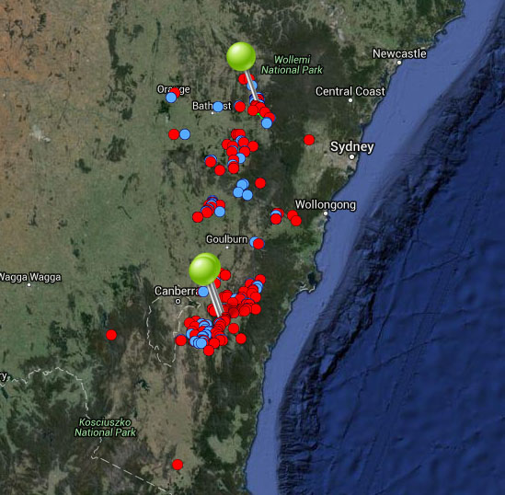

**Figure 6.** Map of species occurrence records in NSW for *Eucalyptus aggregata* (Black Gum). Records from Australia’s Virtual Herbarium are shown in red and records from the NSW Wildlife Atlas are shown in blue, with management sites marked in green.

***Climate change threat(s) identified in Final Determination***

* Changes to precipitation (reduced)
* Increased temperatures
* Increase in abundance or distribution of native co-occurring species

***Number and name(s) of management sites, with estimated population size at each site:*** Three

* [Coxs River area](javascript:__doPostBack('ctl00$ContentPlaceHolder1$gridSites$ctl00$ctl04$linkSite','')): 2000
* [Back Creek Travelling Stock Reserve](javascript:__doPostBack('ctl00$ContentPlaceHolder1$gridSites$ctl00$ctl06$linkSite','')): n/a
* [Bendoura area](javascript:__doPostBack('ctl00$ContentPlaceHolder1$gridSites$ctl00$ctl08$linkSite','')): n/a

***Are all extant sites managed?***

* No. There are130-150 known locations, but most populations consist only of a few remnant trees within a largely cleared landscape.

***Is a translocation site suggested?***

* Yes. Potentially sub-alpine habitat within Kosciuszko National Park or Brindabella National Park. Needs to be cold and wet and free of *E. viminalis and E. rubida*.

***How is climate change threat addressed in the SoS conservation project?***

* SoS conservation project notes acknowledge *E. aggregata* is a climate sensitive species and that southern sites are possibly more secure.
* SoS conservation project notes also recognise the need to secure the coldest and wettest sites at higher altitude.
* Threat of increased competition from *E. viminalis* and *E. rubida* under climate change directly addressed at two of the three management sites (Bendoura area and Back Creek Travelling Stock Reserve). There are management actions to monitor and reduce densities of competing native woody vegetation at these sites.
* Acknowledges translocation site(s) needed to address threat of unfavourable microclimate modification (increased temperatures and reduced rainfall) due to climate change. SoS conservation project states translocation site(s) need to be free of *E. viminalis and E. rubida*, cold and wet, and likely to maintain conditions under climate change.
* There is a management action to supplement one site (Coxs River area) with *ex-situ* material if/when required to increase the population’s resilience to climate change.

***Suggestions to improve species adaptive capacity and resilience to climate change***

* **Species distribution modelling results for site selection**. Contiguous patches of high quality habitat are projected to become more fragmented as the climate changes. By 2030, it is likely that each of the three sites managed for this species will retain suitable (but lower quality) habitat. By 2070, the managed site at Coxs River is projected to be mostly unsuitable, regardless of climate scenario. The two smaller managed sites (Bendoura area and Back Creek Travelling Stock Reserve) may retain suitable habitat, depending on the scenario (Figure 7). These results suggest that the location and number of current management sites may not be suitable by 2070 and alternative (southern and higher elevation) sites should be considered (Figure 8 and see Auld *et al.* (2016), <http://www.nswthreatenedspecies.net/>), and decision framework for site selection page 120). For example, investigate the potential for additional sites within the current distribution where locations are drier and hotter (Figure 8d). Land tenure and site security, as well as habitat quality (including existing threats) also need to be considered when selecting management sites.
* Increase the number of management sites- up to 10 sites should be selected for management (IUCN Standards and Petitions Subcommittee 2014).
* Field (2007) indicates that the two sites in the Bendoura area are likely to contain decent sized populations and the conservation project states population size at the Coxs River site 3 is 2,000 individuals. If Coxs River cannot maintain climatically suitable habitat into the future, and is no longer supported as a management site, the management of one of the largest populations will cease, and alternative strategies for managing genetic diversity will be required.
* Use species distribution modelling to identify the proposed translocation site suitability under future climate and to help determine the best options. As well as future climate, need to consider habitat/soil type (grassy woodlands on alluvial soils in moist sites along creeks on broad, cold and poorly-drained flats and hollows), land tenure and other threats.
* To increase adaptive capacity, supplement populations at management/translocation sites with genotypes collected from the broad range of environmental conditions but particularly from large populations at the northern end and at rainfall extremes (Figure 16 and see Auld et al. (2016)).
* In preparation for supplementation/translocation, determine population genetic parameters: between-population genetic differences, within-population genetic diversity and inbreeding.
* Protect and restore corridors that may facilitate dispersal (Lee *et al.* 2015).

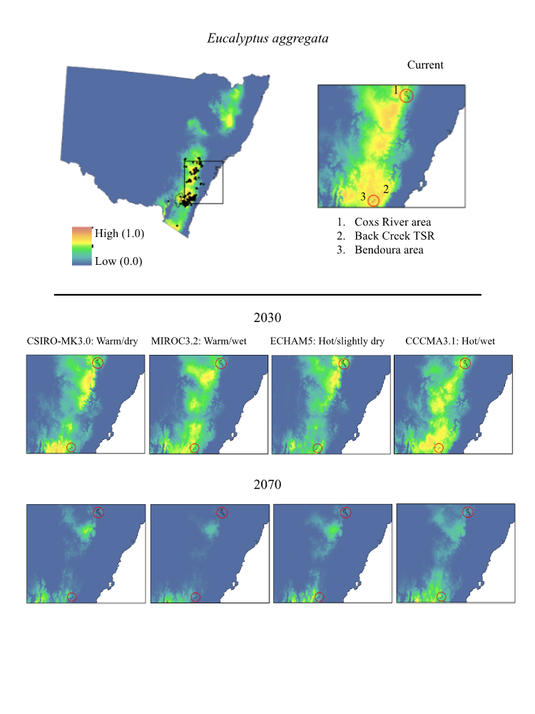**Figure 7.** Maps of projected current and future (2030, 2070) suitable habitat for *Eucalyptus aggregata* (Black Gum)across three site-managed locations, highlighted in red in the top right panel

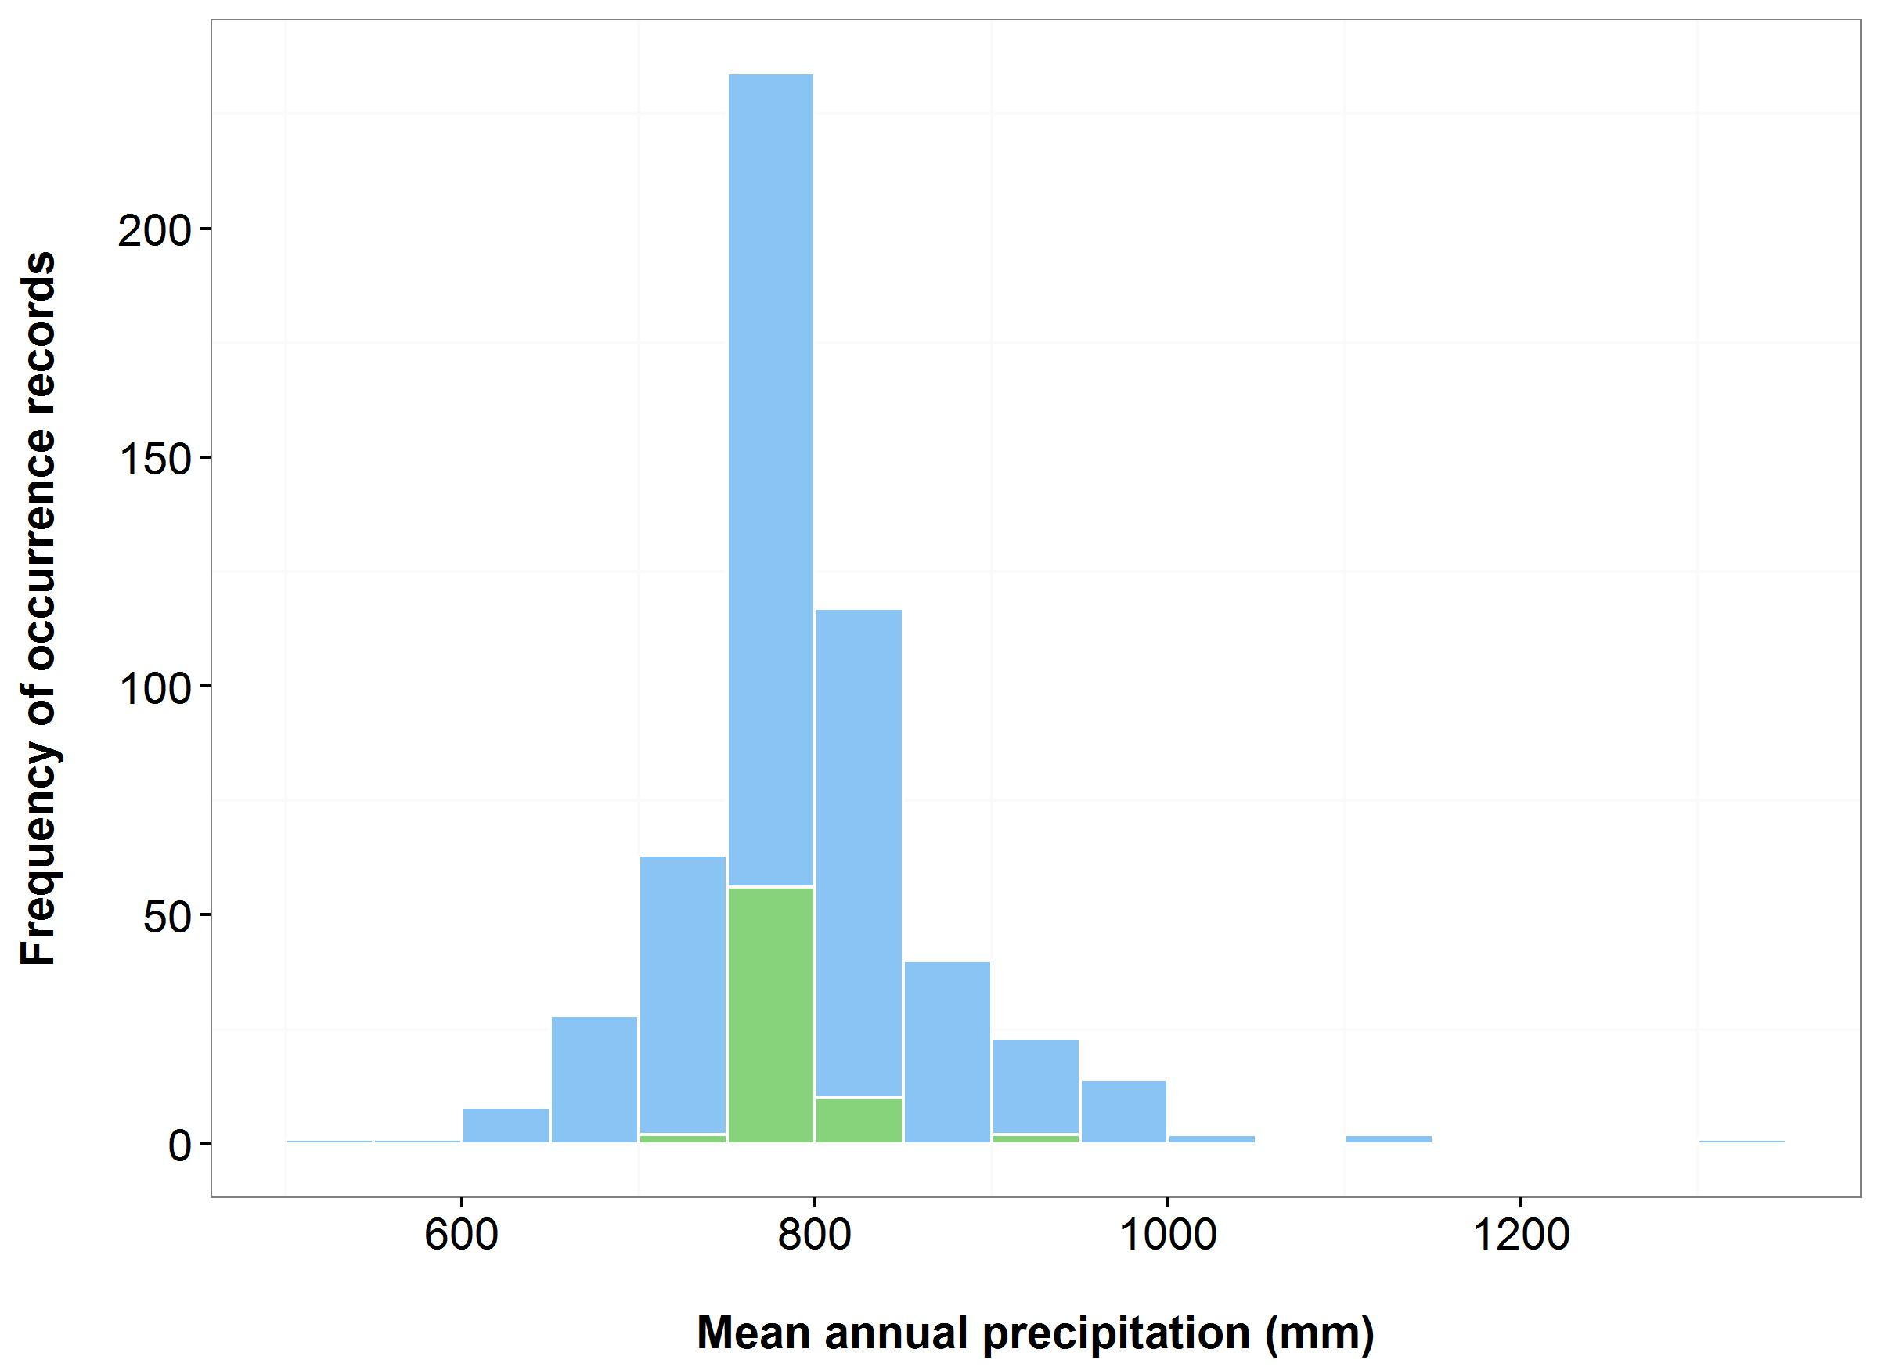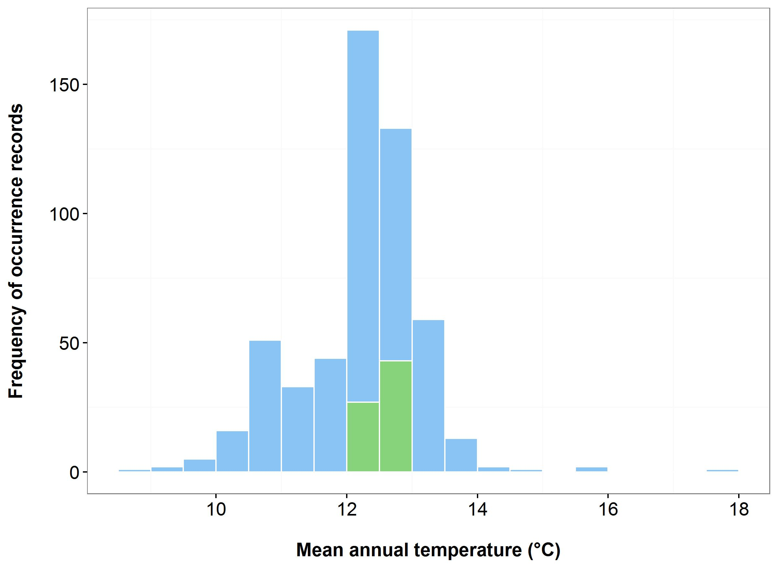

(b)

(a)

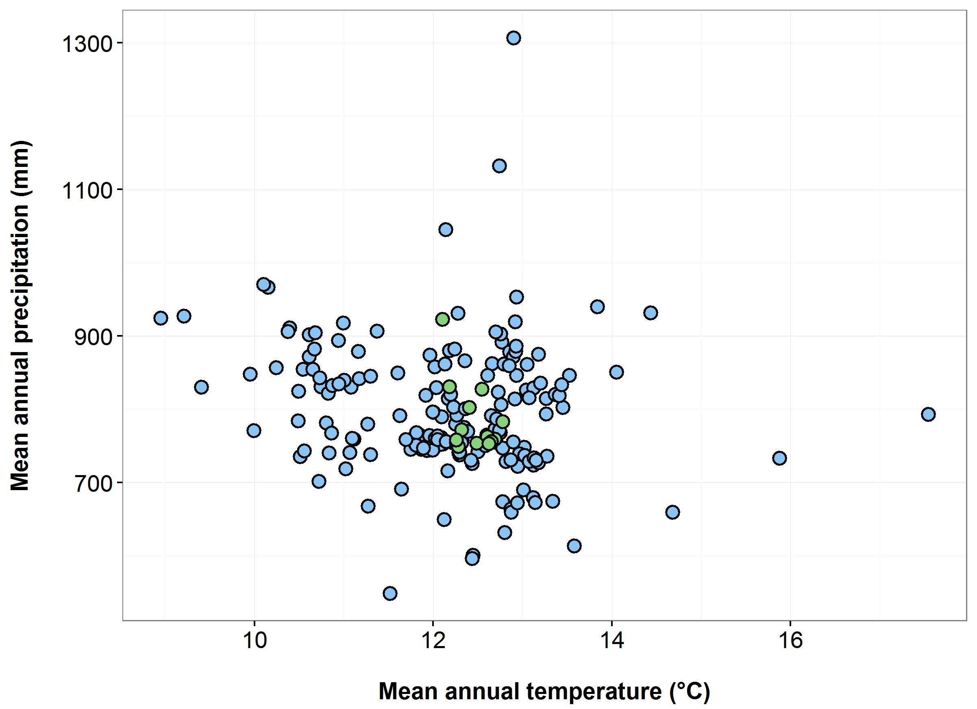

(d)

(c)

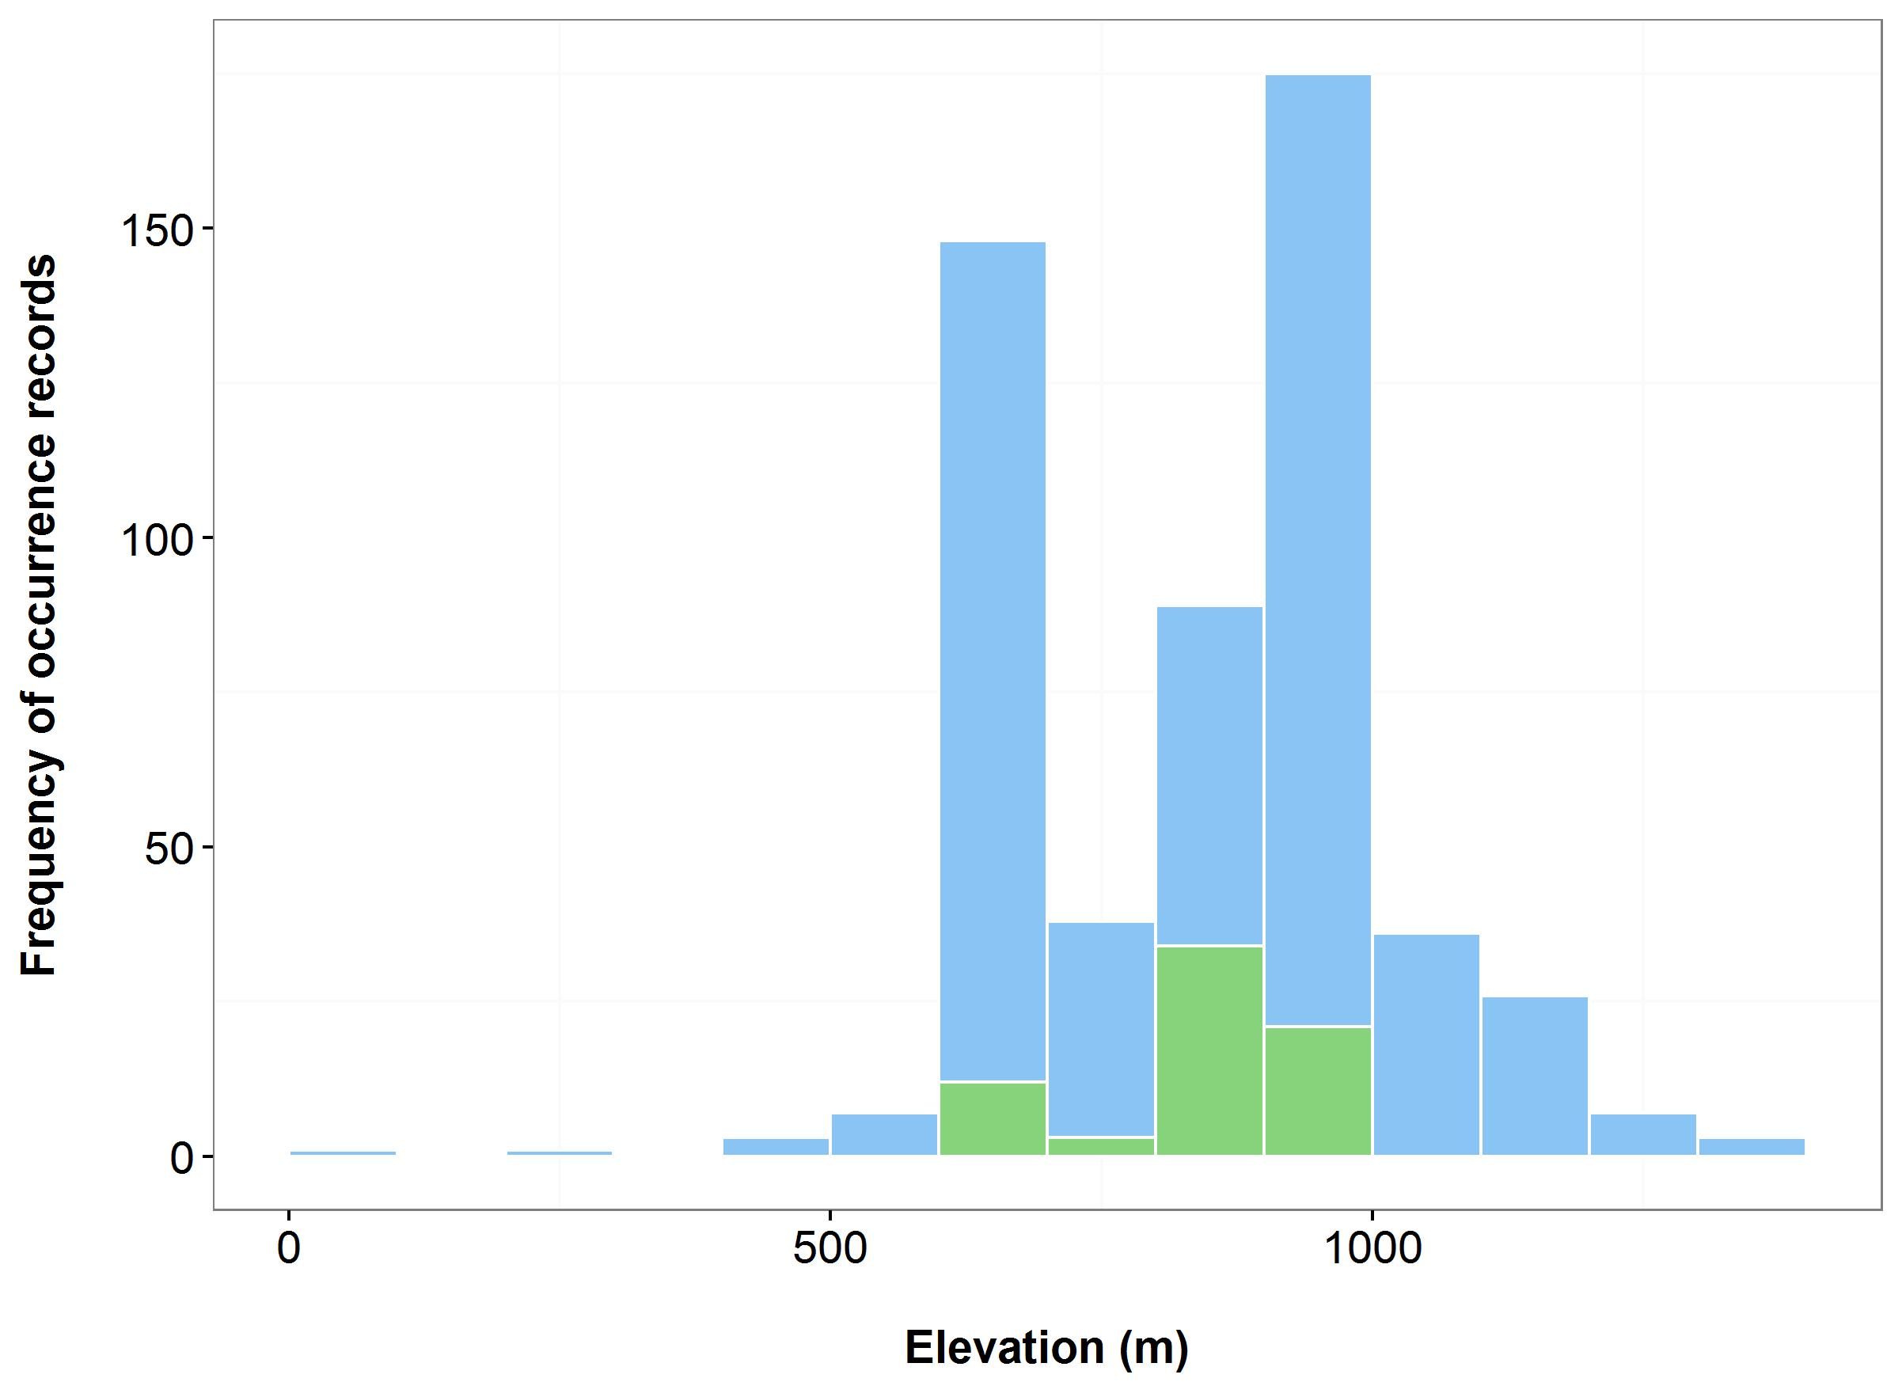

**Figure 8**. Environmental variables for the NSW distribution of *Eucalyptus aggregata* that are outside of Saving our Species (SoS) management sites (blue bars/dots) and within management sites (green bars/dots): mean annual temperature (MAT) (a); mean annual precipitation (MAP) (b); elevation (c); and scatterplot of MAT and MAP (d).

**Endangered plants**

***Name:*** *Calochilus pulchellus* (Pretty Beard Orchid)

***Growth form:*** Herb

***Habitat:*** Low heath among scattered clumps of emergent eucalypts and *Banksia* in shallow coarse white sand over sandstone, in a near-escarpment area subject to strong orographic precipitation

***Distribution:*** Sydney Basin Bioregion

***Threat status:*** Endangered

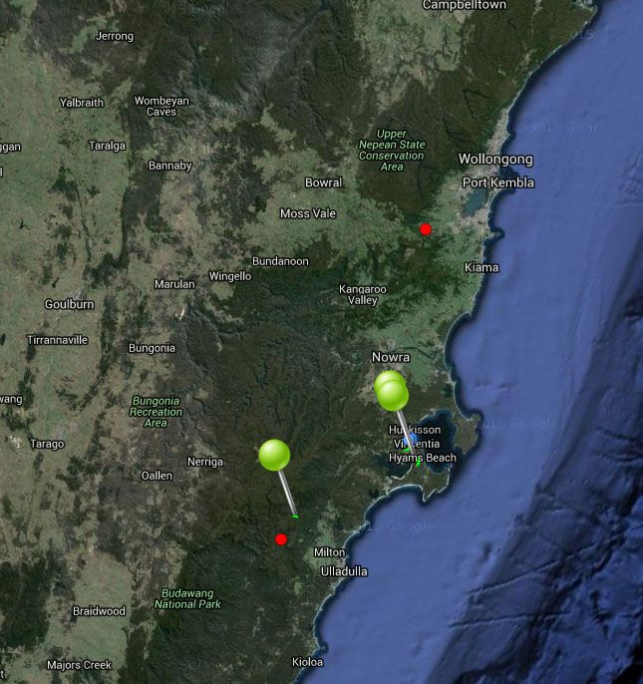

**Figure 9.** Map of species occurrence records in NSW for *Calochilus pulchellus* (Pretty Beard Orchid). Records from Australia’s Virtual Herbarium are shown in red and records from the NSW Wildlife Atlas are shown in blue, with management sites marked in green. N.B. A translocation site (one of the two northern locations) is included in the GIS data used for this map.

***Climate change threat(s) identified in Final Determination***

* Climate change (no specific threat identified). Determination states Little Forest Plateau site possibly threatened by climate change.

***Number and name(s) of management sites, with estimated population size at each site:*** Two

* [Vincentia](javascript:__doPostBack('ctl00$ContentPlaceHolder1$gridSites$ctl00$ctl04$linkSite','')): 9
* [Little Forest Plateau](javascript:__doPostBack('ctl00$ContentPlaceHolder1$gridSites$ctl00$ctl06$linkSite','')): 18

***Are all extant sites managed?***

* No. Final Determination also lists a population in Booderee National Park (but says only one plant was recorded in 2004).

***Is a translocation site suggested?***

* No

***How is climate change threat addressed in SoS conservation project?***

* Notes to justify managing Little Forest Plateau site state climate change is a possible threat.
* There is a management action to collect and store seed to supplement extant populations with *ex-situ* material when needed. This will increase resilience to climate change.

***Suggestions to improve species adaptive capacity and resilience to climate change***

* Conduct a survey in Booderee National Park (a Commonwealth National Park and therefore outside of OEH jurisdiction) to determine whether this population still exists (SoS conservation project states it is worth checking this location after fire). If individuals are recorded here, this site should also be managed.
* Determine the species’ germination/propagation requirements in preparation for supplementation/translocation (Australian PlantBank). Note the SoS conservation project states it may be difficult to germinate seeds and establish new plants in the field.
* Identify translocation sites. Not enough occurrence records for species distribution modelling but use knowledge of predicted future climate and species’ requirements, environmental variation data (Figure 10) and <http://www.nswthreatenedspecies.net/>) to select appropriate sites.
* As well as climate, need to consider habitat/soil type (dense low wet heath in wet sand over sandstone, tall heath and low heath among scattered clumps of emergent eucalypts and *Banksia* in shallow coarse white sand over sandstone, in a near-escarpment area subject to strong orographic precipitation), land tenure and other threats.
* Enter all outstanding occurrence records into databases to enable environmental data to be analysed to assist with site selection (Figure 10).
* In preparation for supplementation/translocation, determine population genetic parameters: between-population genetic differences, within-population genetic diversity and inbreeding.

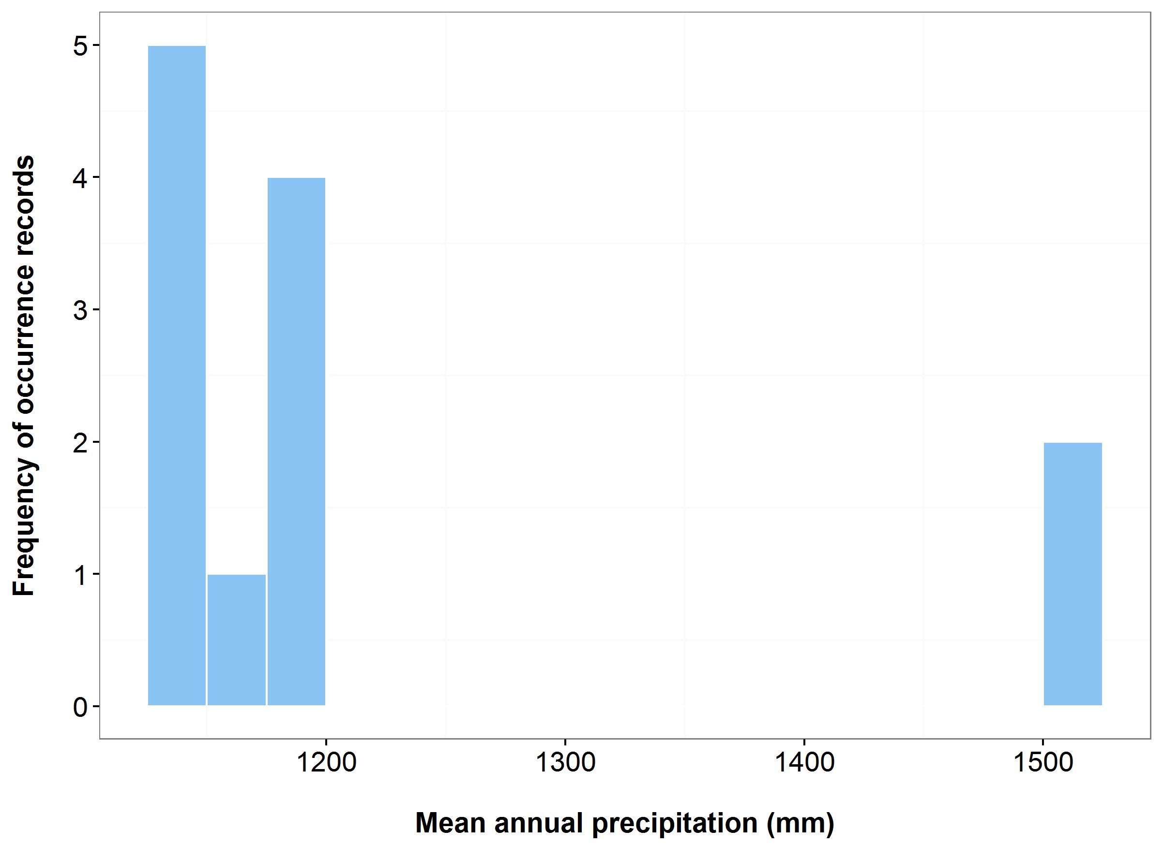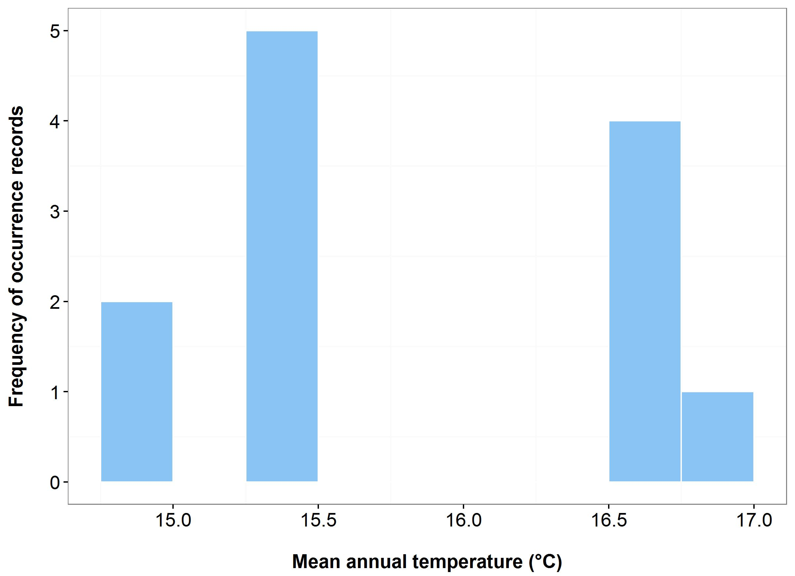

(b)

(a)



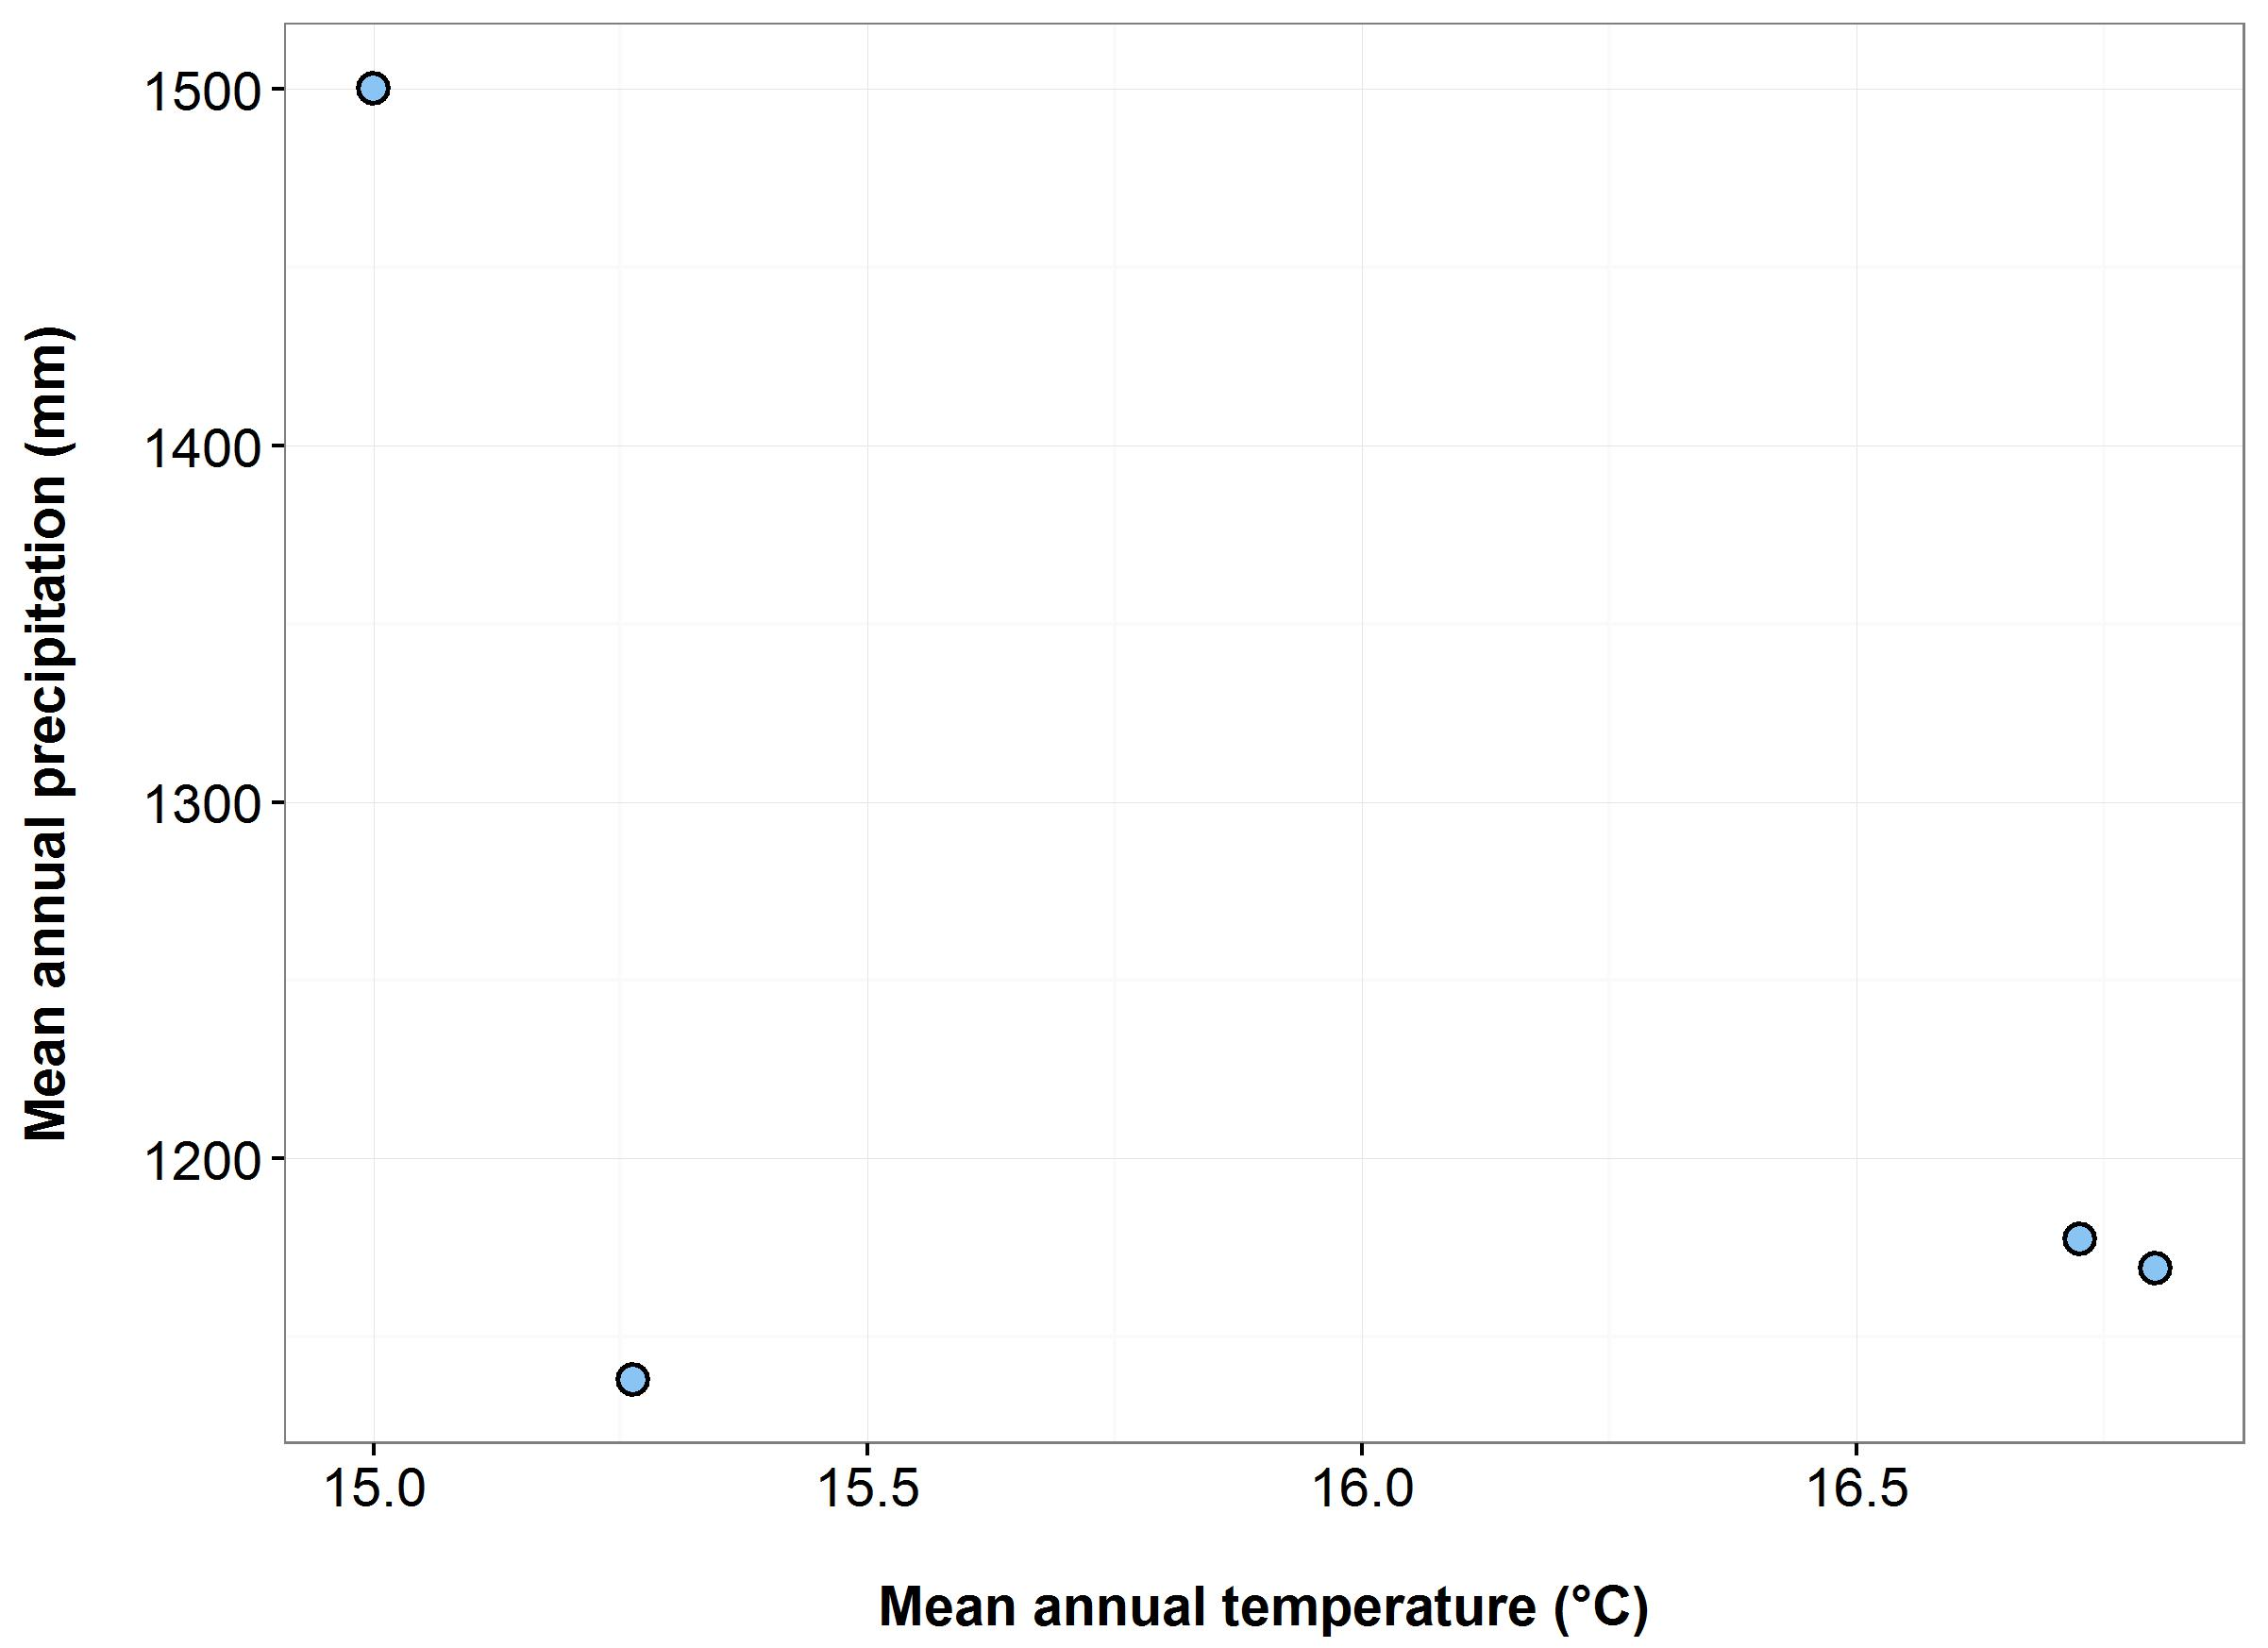

(d)

(c)

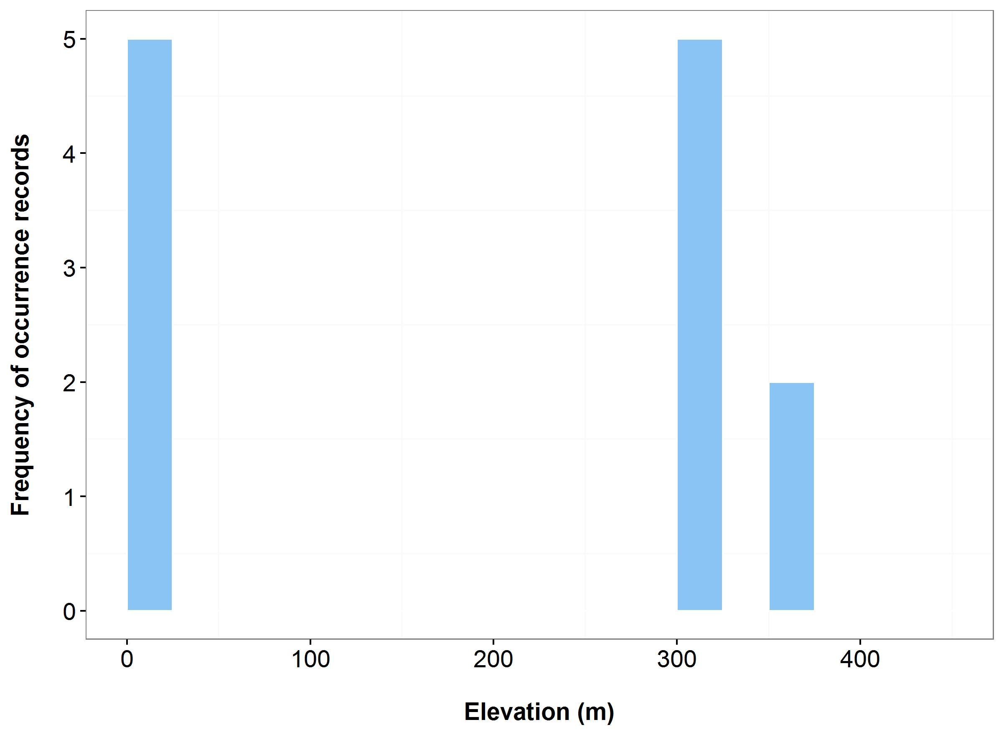

**Figure 10**. Environmental variables for the NSW distribution of *Calochilus pulchellus* that are outside of Saving our Species (SoS) management sites (blue bars/dots) and within management sites (green bars/dots): mean annual temperature (MAT) (a); mean annual precipitation (MAP) (b); elevation (c); and scatterplot of MAT and MAP (d). N.B. Within SoS data has not been entered into the NSW Wildlife Atlas for this species and therefore cannot be shown on these graphs

***Name:*** *Dampiera fusca* (Kydra Dampiera)

***Growth form:*** Shrub

***Habitat:*** Montane heath, also amongst rock platform and tors interspersed with closed heath

***Distribution:*** South Eastern Highlands Bioregion

***Threat status:*** Endangered

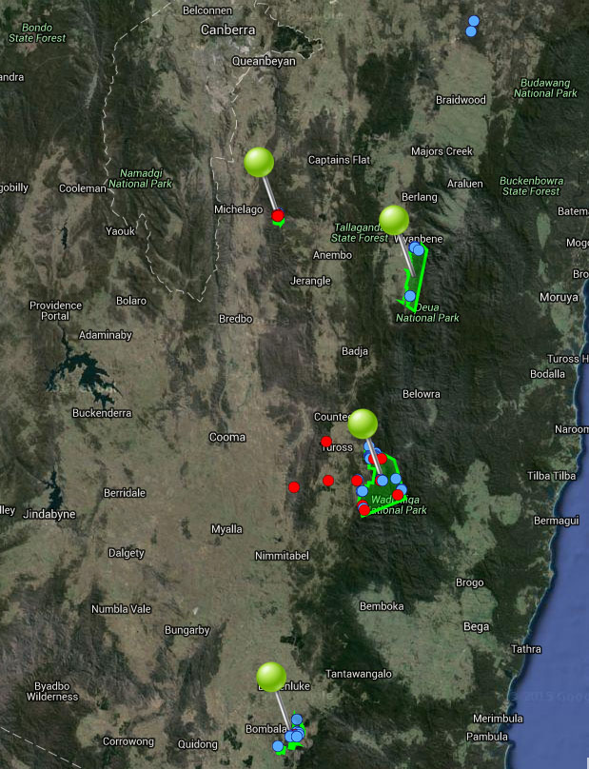

**Figure 11.** Map of species occurrence records in NSW for *Dampiera fusca* (Kydra Dampiera). Records from Australia’s Virtual Herbarium are shown in red and records from the NSW Wildlife Atlas are shown in blue, with management sites marked in green.

***Climate change threat(s) identified in Final Determination***

* Increased temperatures
* Changes to precipitation (reduced reliability/increased drought)

***Number and name(s) of management sites, with estimated population size at each site:*** Four

* [Tinderry Nature Reserve](javascript:__doPostBack('ctl00$ContentPlaceHolder1$gridSites$ctl00$ctl04$linkSite','')): n/a
* [Deua National Park](javascript:__doPostBack('ctl00$ContentPlaceHolder1$gridSites$ctl00$ctl06$linkSite','')): n/a
* [Wadbilliga National Park](javascript:__doPostBack('ctl00$ContentPlaceHolder1$gridSites$ctl00$ctl08$linkSite','')): n/a
* [Coolumbooka Nature Reserve](javascript:__doPostBack('ctl00$ContentPlaceHolder1$gridSites$ctl00$ctl10$linkSite','')): n/a

***Are all extant sites managed?***

* Yes

***Is a translocation site suggested?***

* No

***How is climate change threat addressed in the SoS conservation project?***

* Notes to justify probability of viability without management recognise climate change is a threat.

* Justification for selecting multiple management sites – need to conserve all known sites because the species is highly threatened by climate change.
* Justification for managing the Tinderry Nature Reserve site - the Coolumbooka Nature Reserve site could become a lot drier and there is a risk of too frequent fire due to climate change. Also, the Tinderry Nature Reserve site represents a different habitat type (granite).
* There is a management action at the Tinderry Nature Reserve site to collect and store seed/tissue/living plants, and any relevant symbionts, to supplement the population with *ex-situ* material if/when needed. This action will increase resilience to climate change.

***Suggestions to improve species adaptive capacity and resilience to climate change***

* **Species distribution modelling results for site selection.** The margin between suitable and unsuitable habitat is projected to shift westward. By 2030, at least two of the four sites are likely to retain moderately suitable habitat, depending upon the climate scenario. For instance, Wadbilliga National Park is likely to remain suitable under the warm/wet and hot/slightly dry scenarios, moderately suitable under the hot/wet scenario but unsuitable under the warm/dry scenario. Coolumbooka Nature Reserve is unlikely to be suitable under the warm/dry scenario while Deua National Park may have low-moderate suitable across all scenarios. However, by 2070 this site and Coolumbooka Nature Reserve are projected to be unsuitable across all scenarios. Wadbilliga National Park is also projected to be unsuitable under the hot/wet scenario, although some low quality habitat may still exist under the other scenarios (Figure 12). These results suggest that the location and number of current management sites may not be suitable by 2070 and sites currently outside of the species distribution may have to be considered (see Figure 13 and <http://www.nswthreatenedspecies.net/>). As well as climate, need to consider habitat (montane heath, also amongst rock platform and tors interspersed with closed heath), soil type (skeletal drought- prone soils), land tenure and other threats.
* Figure 13 indicates that management sites do not encompass the entire environmental variability across the species’ range and should include the hotter and drier locations (Figure 13d) and at higher elevations (Figure 13c).
* Collect and store seed/cuttings from all extant populations. Supplement all extant populations if required. In particular, seed should be collected from hotter, drier and lower elevation locations.
* Determine germination/propagation requirements (including mycorrhizal associations) in preparation for supplementation/translocation (Australian PlantBank).
* In preparation for supplementation/translocation, determine population genetic parameters: between-population genetic differences, within-population genetic diversity and inbreeding.

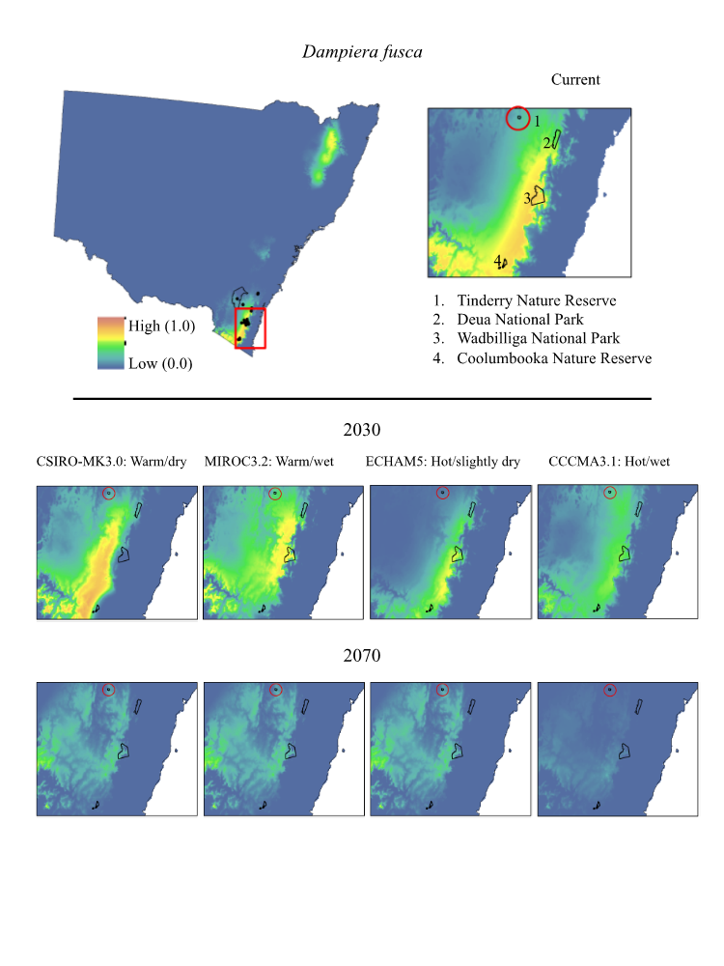

**Figure 12.** Maps of projected current and future (2030, 2070) suitable habitat for *Dampiera fusca* (Kydra Dampiera) across four site-managed locations, highlighted in red in the top right panel.

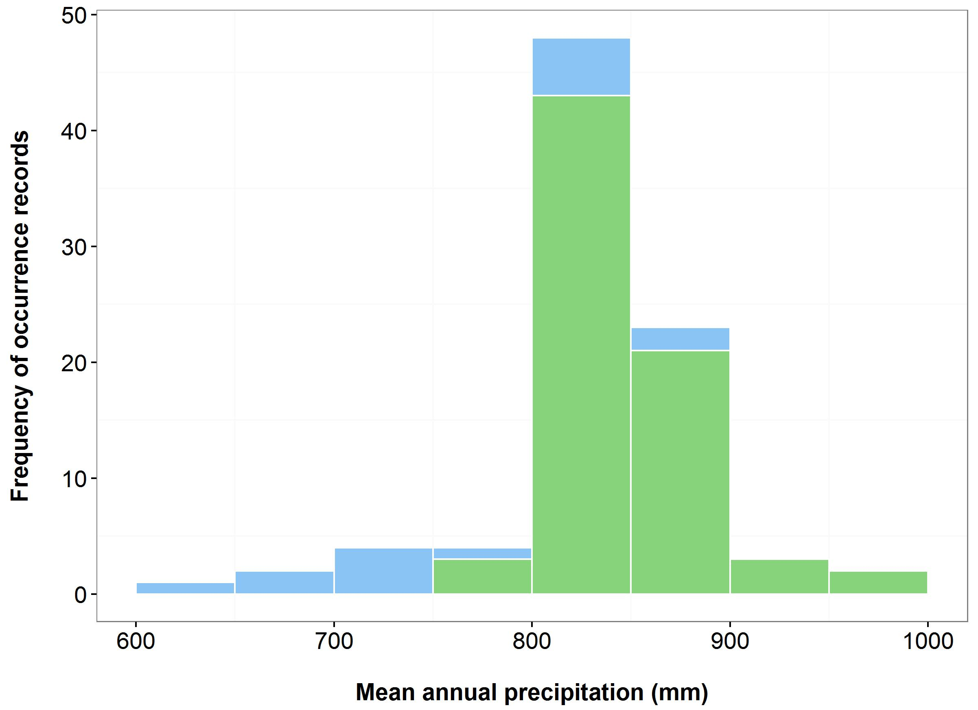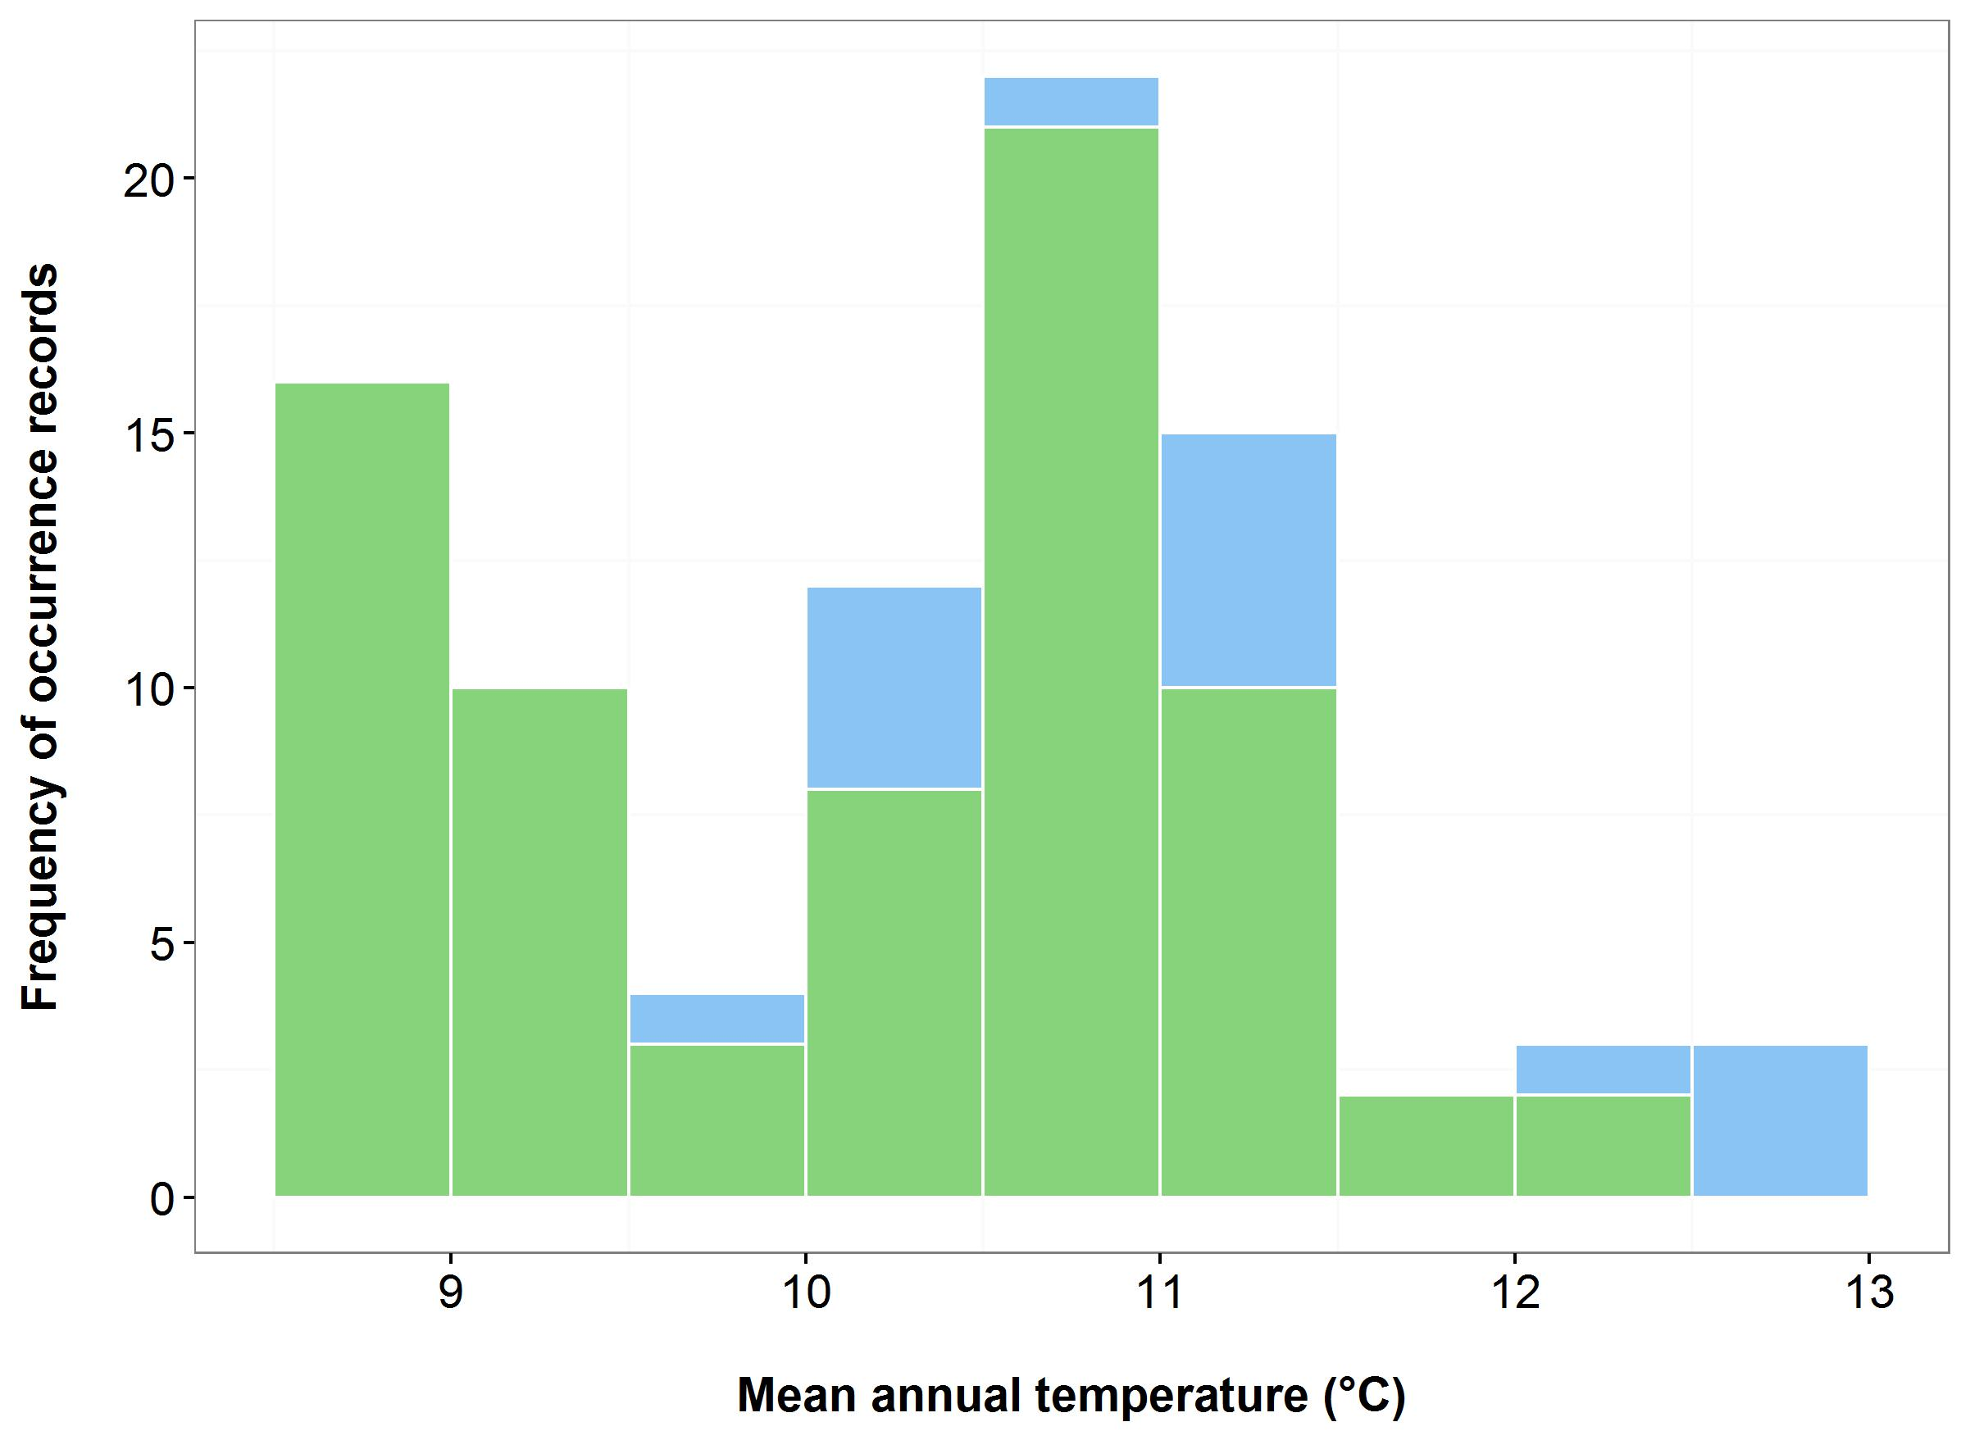

(b)

(a)



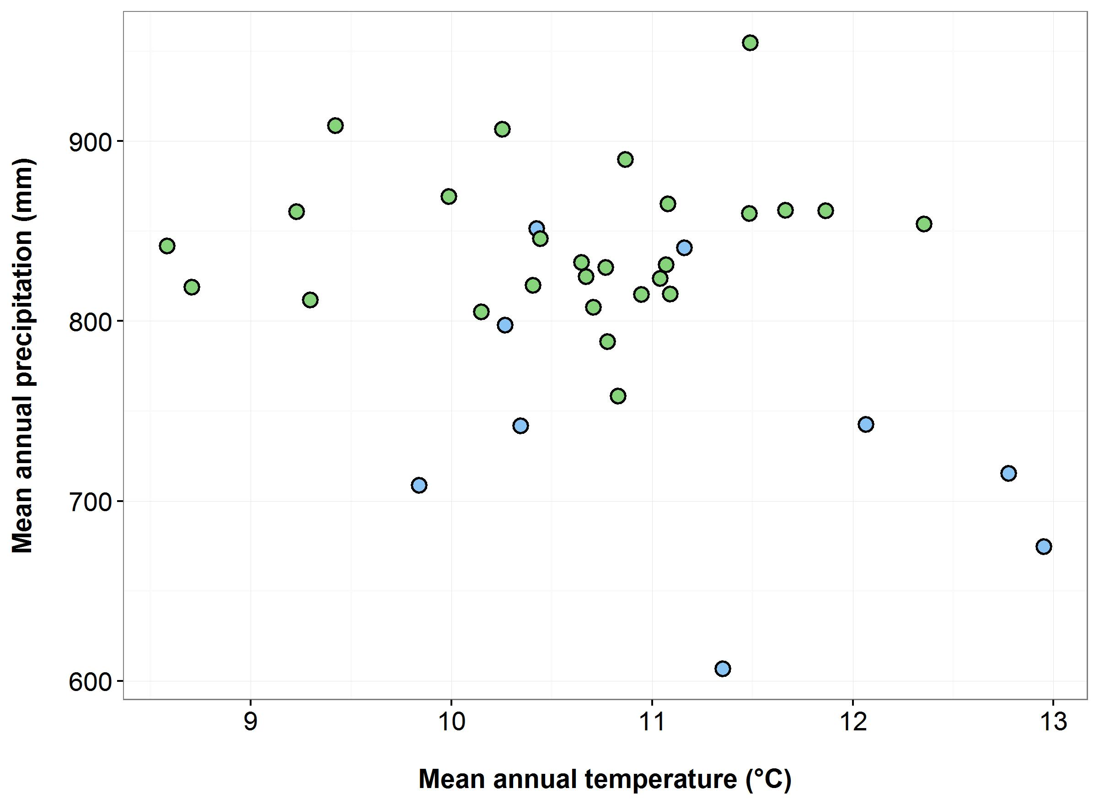

(d)

(c)

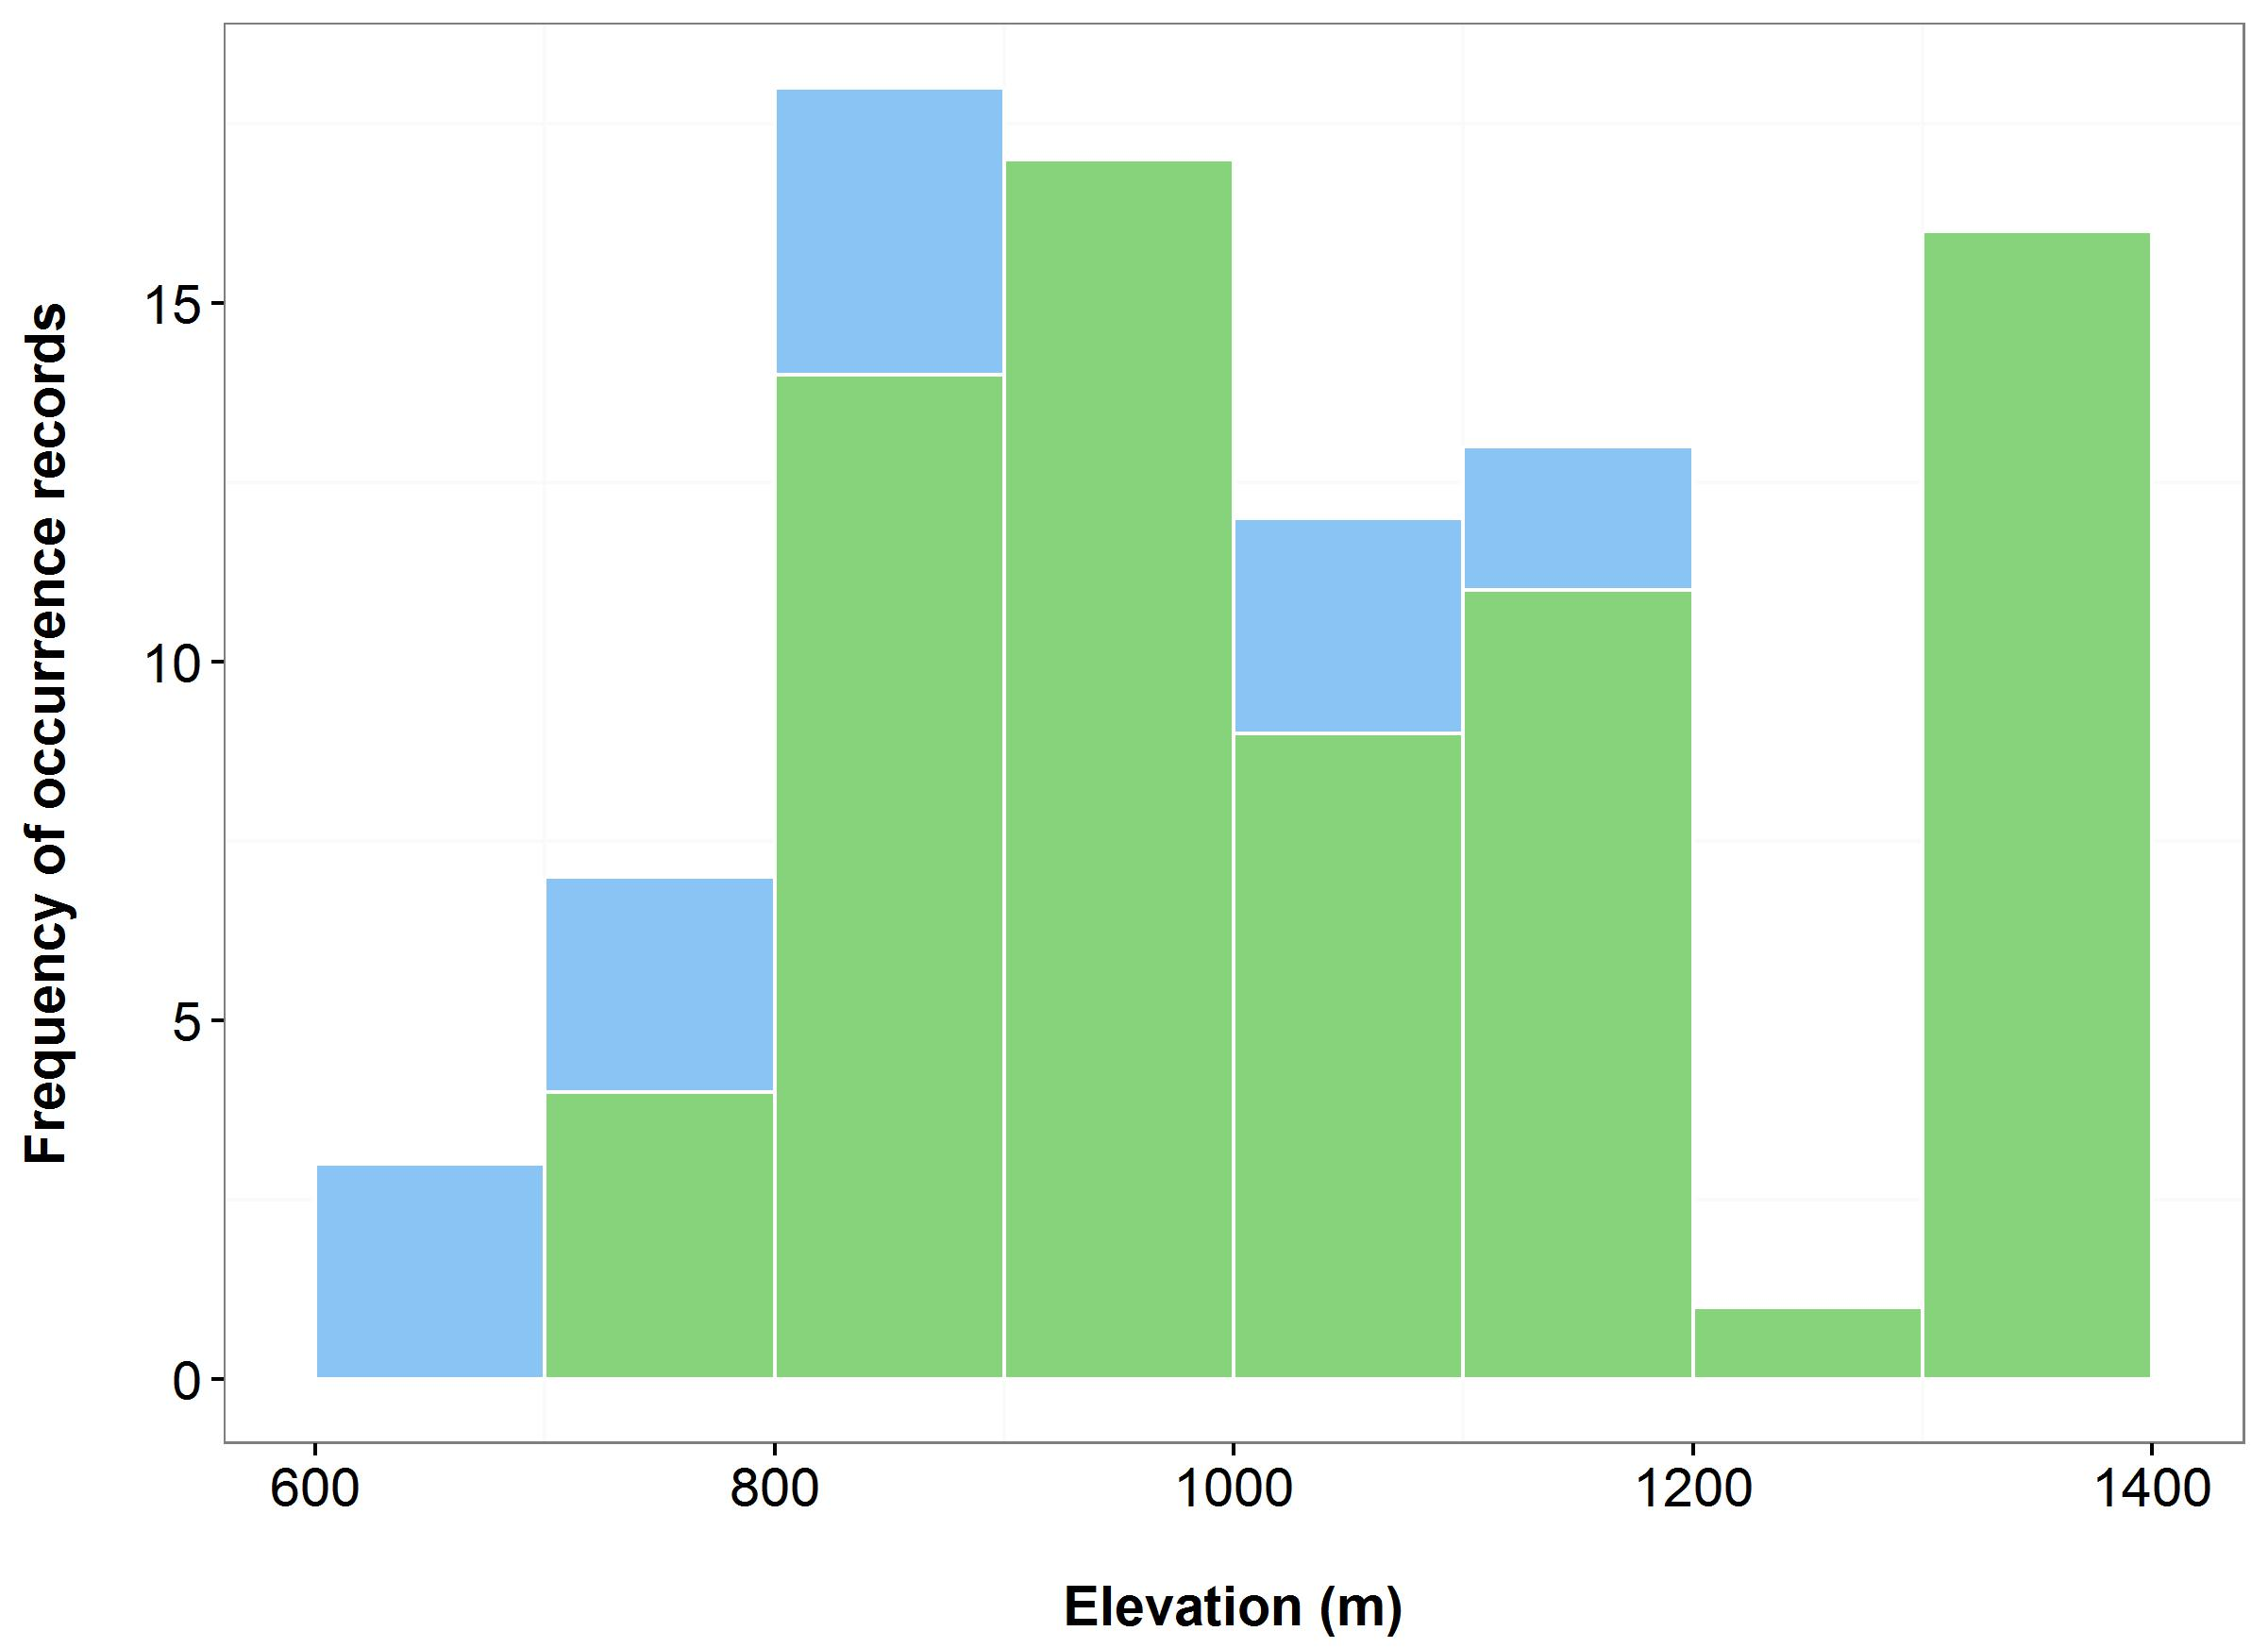

**Figure 13**. Environmental variables for the NSW distribution of *Dampiera fusca*, that are outside of Saving our Species (SoS) management sites (blue bars/dots) and within management sites (green bars/dots): mean annual temperature (MAT) (a); mean annual precipitation (MAP) (b); elevation (c); and scatterplot of MAT and MAP (d).

***Name:*** *Eucalyptus parvula* (Small-leaved Gum)

***Growth form:*** Tree

***Habitat:*** Grassy woodlands around the edges of broad, flat headwater valleys in frost-prone areas at altitudes of 800–1200 m above sea level. Poorly drained humic soils derived from granite or granodiorite

***Distribution:*** South Eastern Highlands Bioregion

***Threat status:*** Endangered

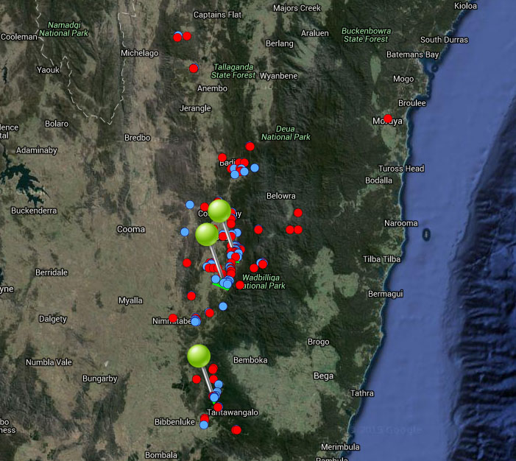

**Figure 14.** Map of species occurrence records in NSW for *Eucalyptus parvula* (Small-leaved Gum). Records from Australia’s Virtual Herbarium are shown in red and records from the NSW Wildlife Atlas are shown in blue, with management sites marked in green.

***Climate change threat(s) identified in Final Determination***

* Increased temperatures
* Changes to precipitation (reduced)
* Increase in abundance or distribution of native co-occurring species

***Number and name(s) of management sites, with estimated population size at each site:*** Three

* [Two Rivers Plain](javascript:__doPostBack('ctl00$ContentPlaceHolder1$gridSites$ctl00$ctl04$linkSite','')): 2400
* [Mowitts Swamp Creek](javascript:__doPostBack('ctl00$ContentPlaceHolder1$gridSites$ctl00$ctl06$linkSite','')): 600
* [Dragon swamp](javascript:__doPostBack('ctl00$ContentPlaceHolder1$gridSites$ctl00$ctl08$linkSite','')): 800

***Are all extant sites managed?***

* No. SoS conservation project identifies five locations where species occurs.

***Is a translocation site suggested?***

* No

***How is climate change threat addressed in SoS conservation project?***

* Justification for managing the Two Rivers Plain site is that the Dragon Swamp site is threatened by stochastic events, including climate change.

***Suggestions to improve species adaptive capacity and resilience to climate change***

* **Species distribution modelling results for site selection**. By 2030, suitable habitat is likely to remain at all management sites under all scenarios except hot/wet. By 2070, high quality habitat is projected for Two Rivers Plain and Mowitts Swamp Creek under the warm/wet scenario only, although lower quality habitat may also exist at these sites under the warm/dry scenario. The higher temperature scenarios are likely to result in low to unsuitable habitat at all sites (Figure 15). These results indicate that under some scenarios, little of the current distribution will be suitable in the future.
* Use species distribution models to identify suitable habitat under future climate and help determine best options for translocation sites. As well as future climate, need to consider habitat (grassy woodlands around the edges of broad, flat headwater valleys in frost-prone areas at 800-1,200 m altitude), soil type (poorly drained humic soils derived from granite or granodiorite), land tenure and other threats.

* As there are a number of outlying records for the species (NSW Scientific Committee Review of Current Information, 2008, [www.environment.nsw.gov.au/resources/nature/.../Euc**parvula**.pdf](http://www.environment.nsw.gov.au/resources/nature/schedules/Eucparvula.pdf) ), these areas should be surveyed for potential additional habitat. If new populations are found and if they are likely to be more resilient or less exposed to climate change (use species distribution modelling to assist with this), they should be managed. Population supplementation may be necessary at these sites if numbers are low.
* Invasion/increased densities of competitive native woody species (other eucalypts) was identified as a climate change threat in the species’ Final Determination. Therefore, there should be management actions to monitor/manage densities of such species at all management sites.
* To increase adaptive capacity, supplement populations at management/translocation sites with genotypes collected from the broad range of environmental conditions within the species’ distribution (Figure 16 and see Auld *et al.* (2016)). The majority of records for this species come from the Badja Mill area (as identified in the NSW Scientific Committee’s 2008 Review of Current Information) so seed collection from this location is particularly important because it most likely contains the highest amount of genetic diversity (see below).
* In preparation for supplementation/translocation, determine population genetic parameters: between-population genetic differences, within-population genetic diversity and inbreeding.
* Protect and restore corridors that may facilitate dispersal (Lee *et al.* 2015).

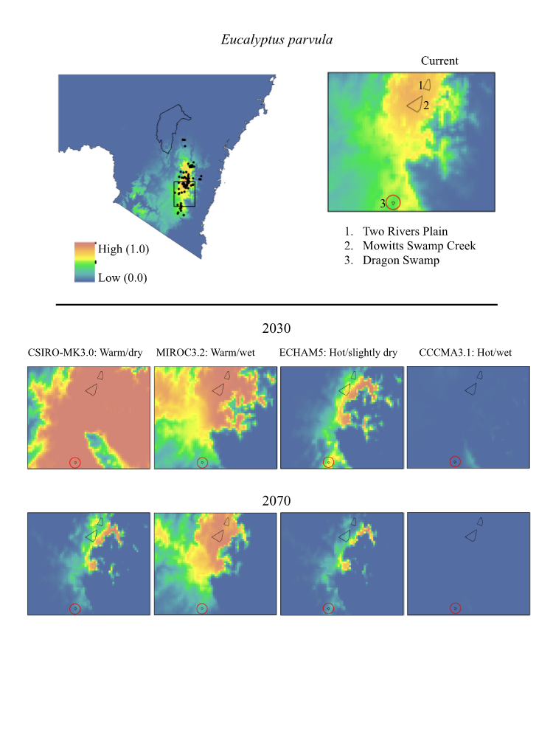

**Figure 15.** Maps of projected current and future (2030, 2070) suitable habitat for *Eucalyptus parvula* (Small-leaved Gum) across three site-managed locations, highlighted in red in the top right panel.

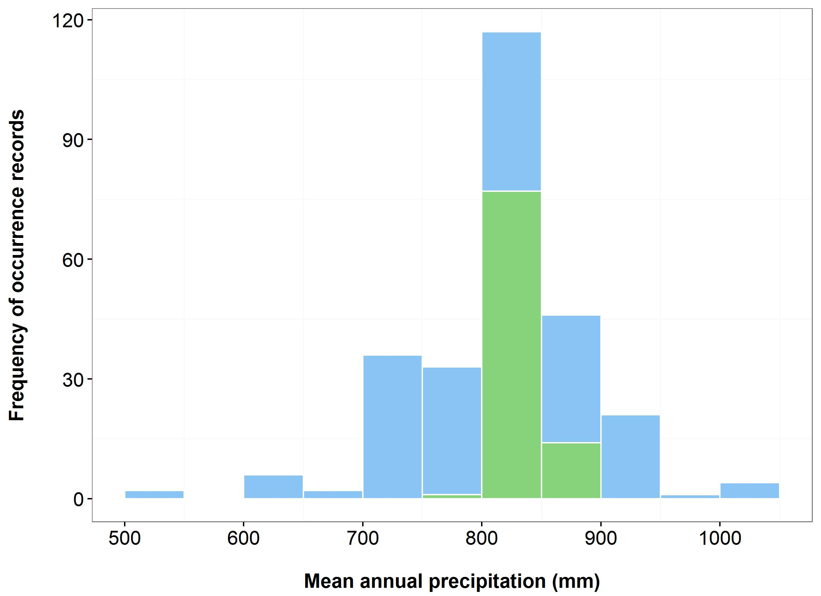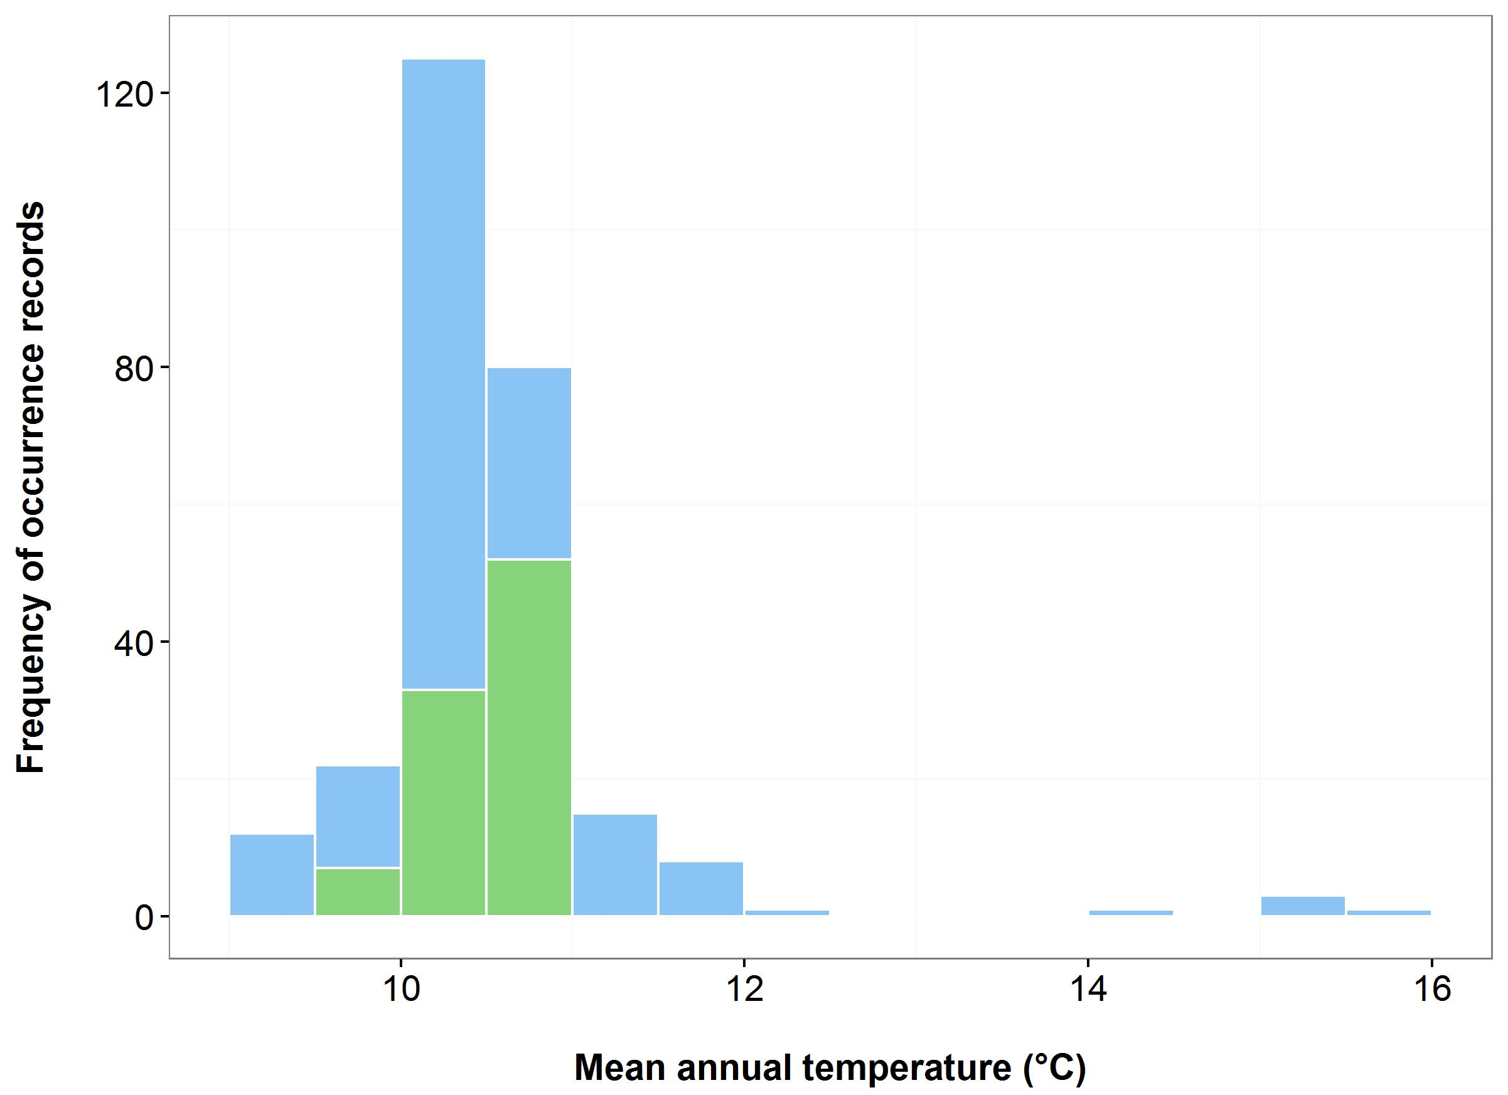

(a)

(b)



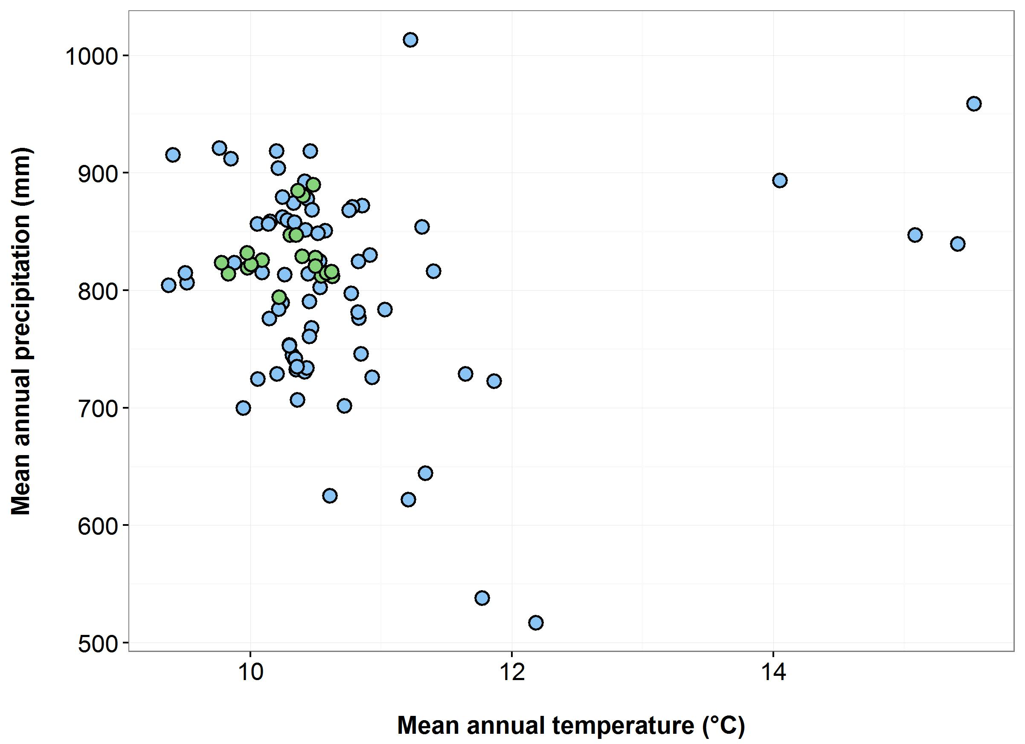

(d)

(c)

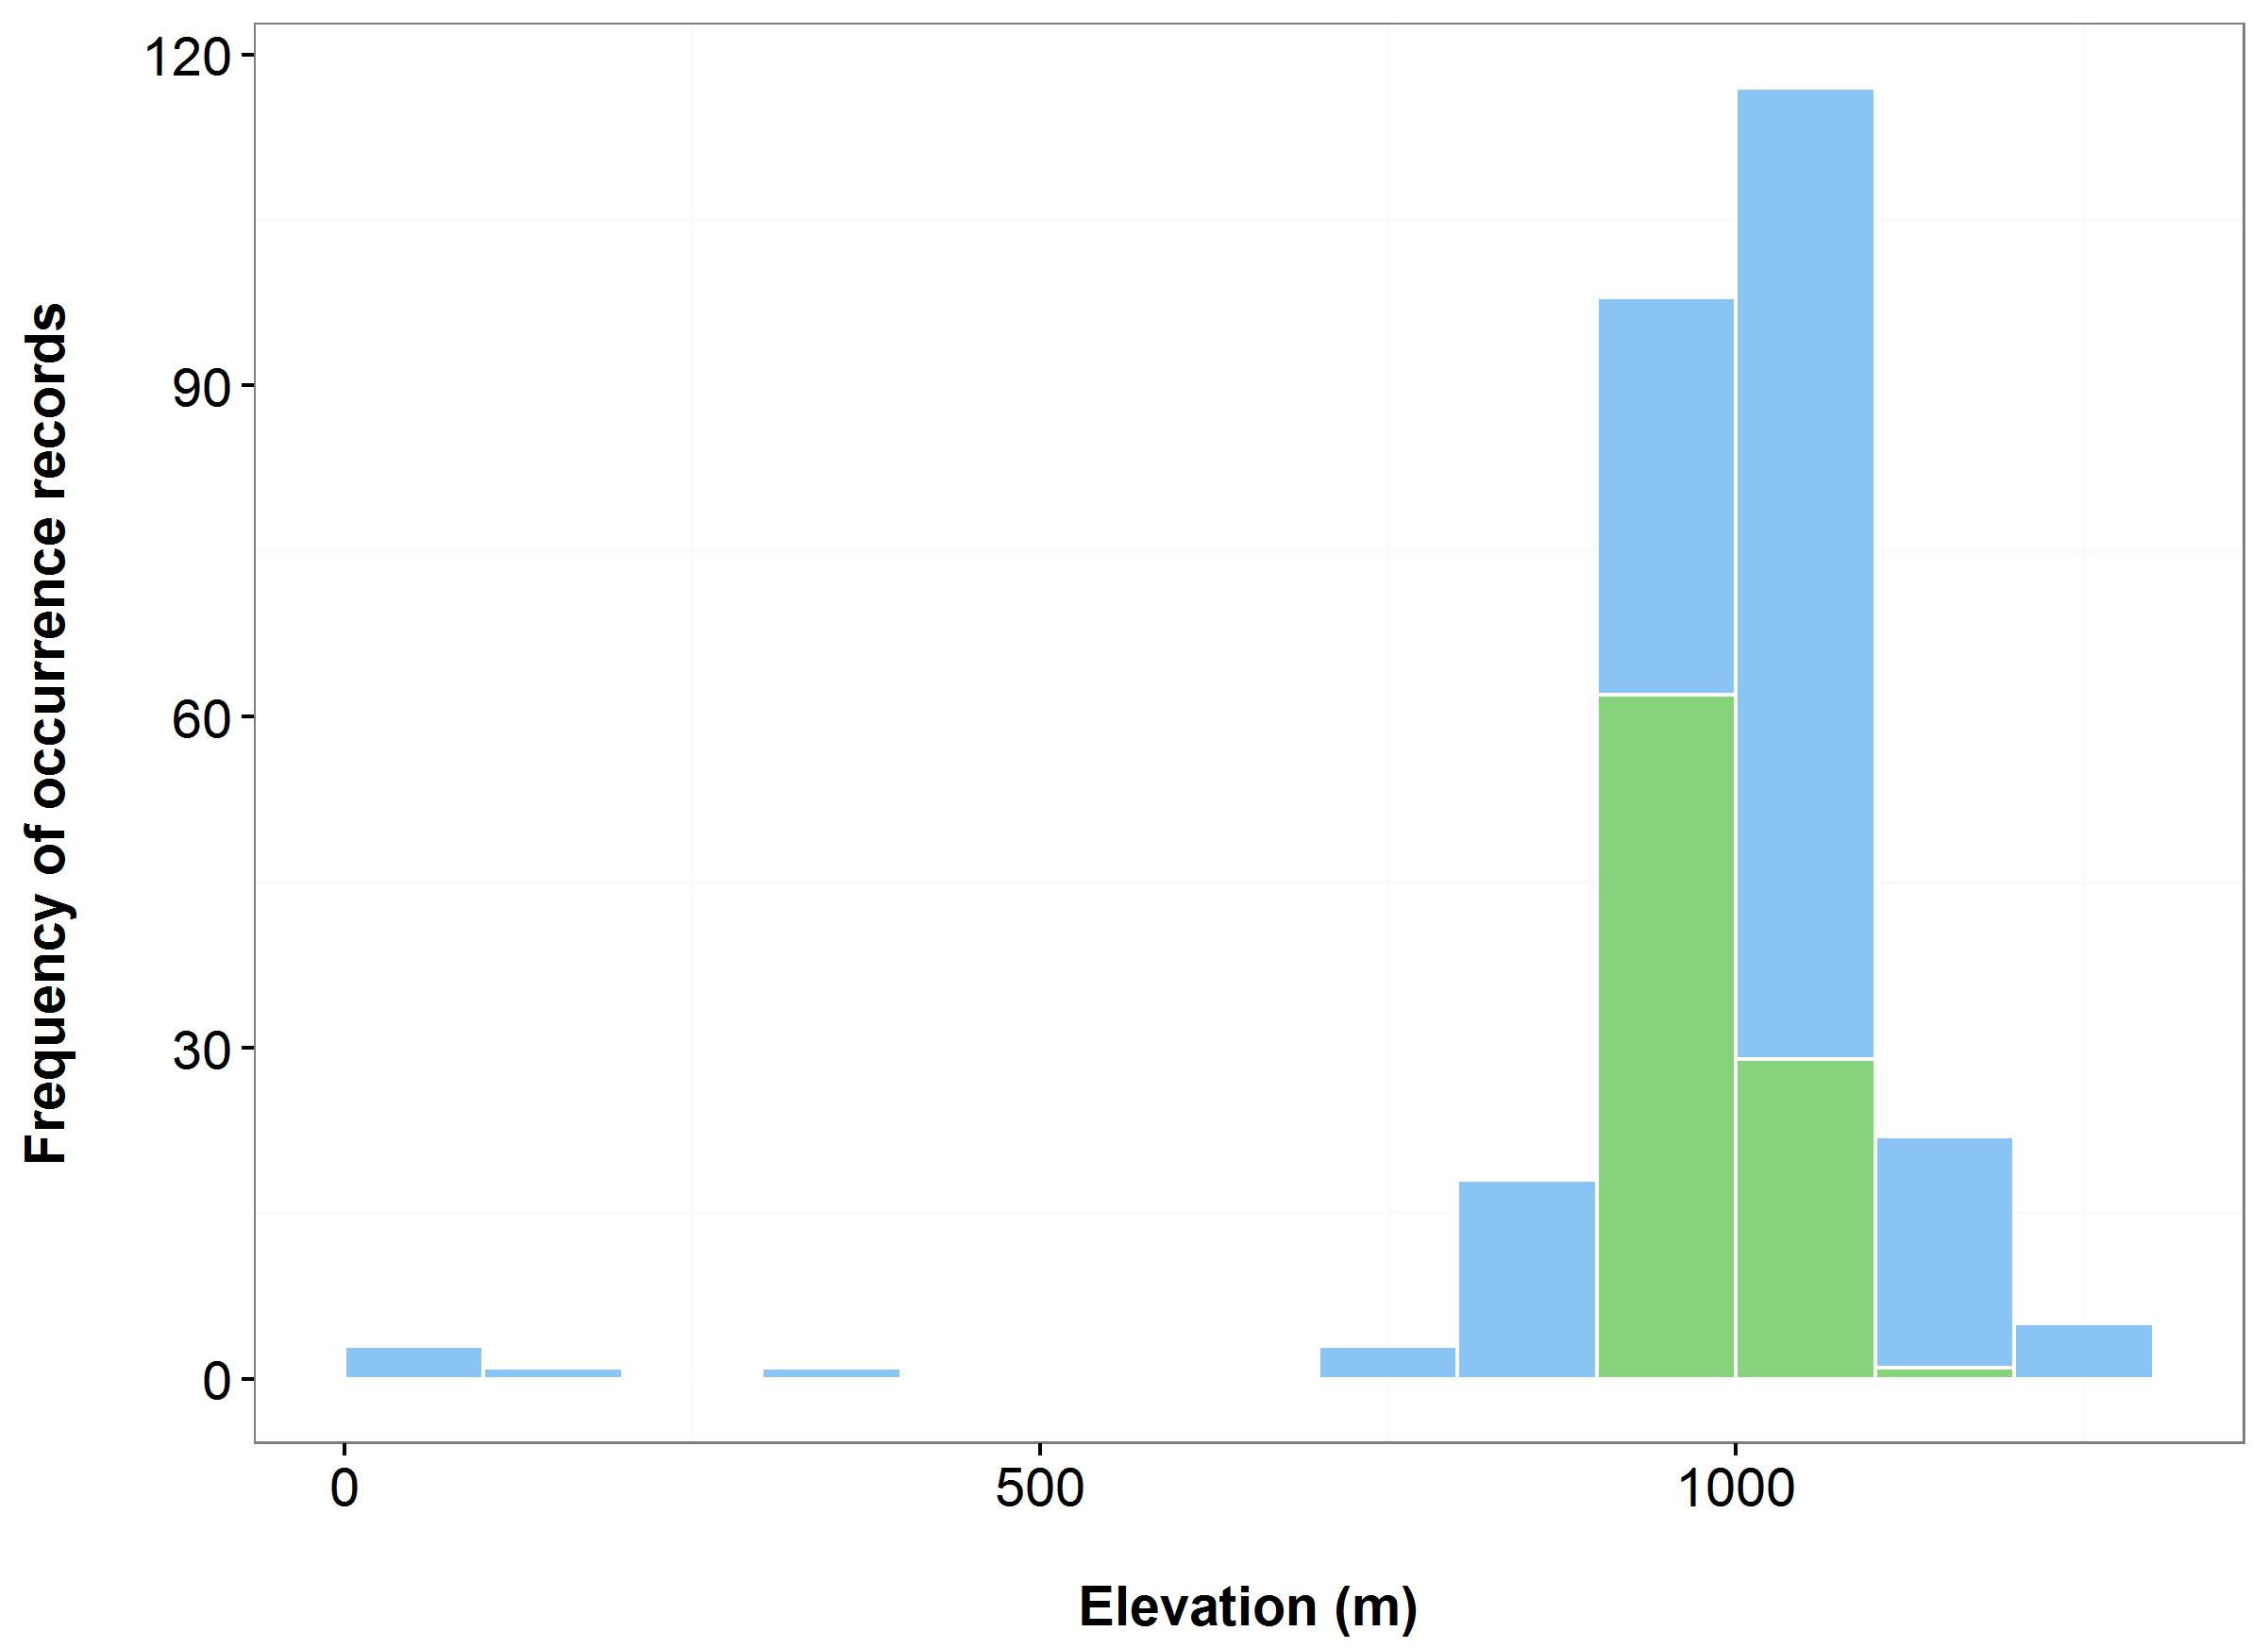

**Figure 16**. Environmental variables for the NSW distribution of *Eucalyptus parvula*, that are outside of Saving our Species (SoS) management sites (blue bars/dots) and within management sites (green bars/dots): mean annual temperature (MAT) (a); mean annual precipitation (MAP) (b); elevation (c); and scatterplot of MAT and MAP (d).

***Name:*** *Pelargonium* sp.(G. W. Carr 10345) (Omeo Storksbill)

***Growth form:*** Herb

***Habitat:*** Narrow habitat that is usually just above the high-water level of irregularly inundated or ephemeral lakes, in the transition zone between surrounding grasslands or pasture and the wetland or aquatic communities

***Distribution:*** South Eastern Highlands Bioregion

***Threat status:*** Endangered

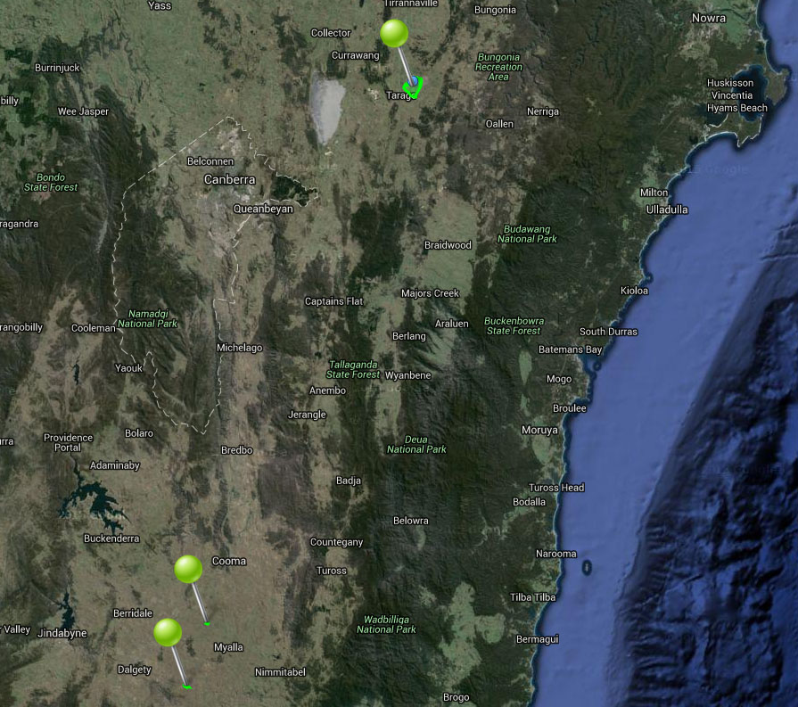

**Figure 17.** Map of species occurrence records in NSW for *Pelargonium* sp.(G. W. Carr 10345) (Omeo Storksbill). Records from Australia’s Virtual Herbarium are shown in red (no records) and records from the NSW Wildlife Atlas are shown in blue, with management sites marked in green.

***Climate change threat(s) identified in Final Determination***

* Increased temperatures
* Changes to precipitation (reduced winter-spring rainfall)

***Number and name(s) of management sites, with estimated population size at each site:*** Three

* [Lake Bathurst area](javascript:__doPostBack('ctl00$ContentPlaceHolder1$gridSites$ctl00$ctl04$linkSite','')): Undetermined
* [Arable area](javascript:__doPostBack('ctl00$ContentPlaceHolder1$gridSites$ctl00$ctl06$linkSite','')): 20
* [Maffra Lake TSR No. 55](javascript:__doPostBack('ctl00$ContentPlaceHolder1$gridSites$ctl00$ctl08$linkSite','')): Unknown

***Are all extant sites managed?***

* Yes. Previously recorded at a fourth site but is now presumed extinct at this location.

***Is a translocation site suggested?***

* Yes

***How is climate change threat addressed in the SoS conservation project?***

* There are management sites at all known locations of the species which will optimize resilience to climate change.
* Translocation site needed to buffer against extinction from stochastic events (such as associated with climate change).

***Suggestions to improve species adaptive capacity and resilience to climate change***

* Supplement all extant populations (estimated population sizes are all very low).
* Identify additional translocation sites (one is not enough). Not enough occurrence records for species distribution modelling but use knowledge of predicted future climate and species’ requirements, environmental variation data (Figure 18) and <http://www.nswthreatenedspecies.net/>) to select appropriate sites.
* .As well as climate, need to consider habitat (just above the high-water level of irregularly inundated or ephemeral lakes, in the transition zone between surrounding grasslands or pasture and the paludal and aquatic communities at 680-1,030 m altitude), land tenure and other threats.
* Enter all outstanding occurrence records into databases to enable environmental data to be analysed to assist with site selection (Figure 18).
* In preparation for supplementation/translocation, determine population genetic parameters: between-population genetic differences, within-population genetic diversity and inbreeding. Information on reproduction method(s) and population sizes is also required.

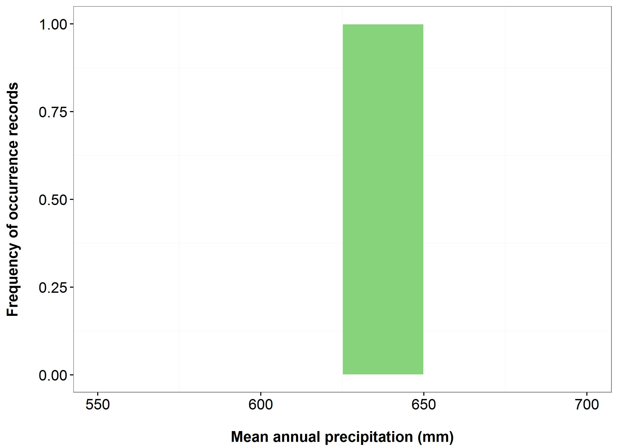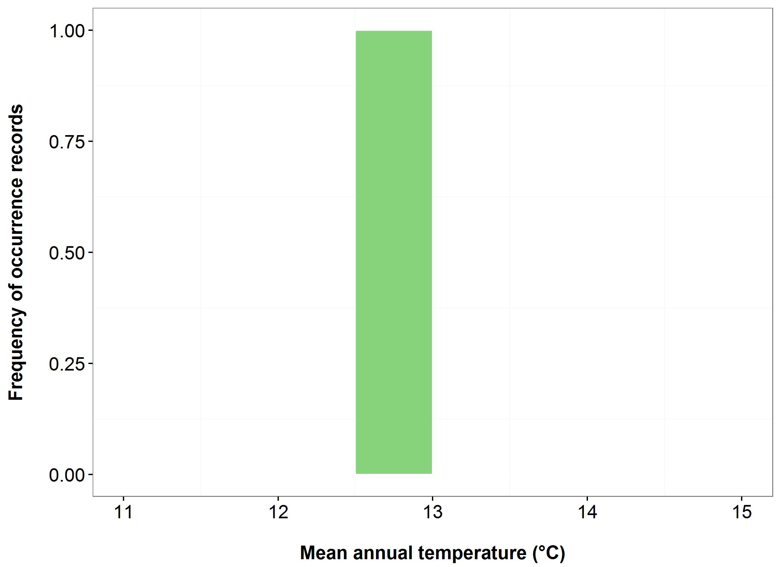

(a)

(a)



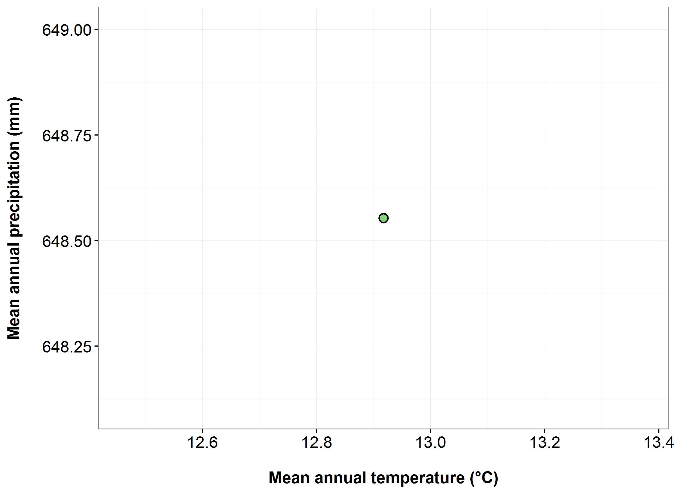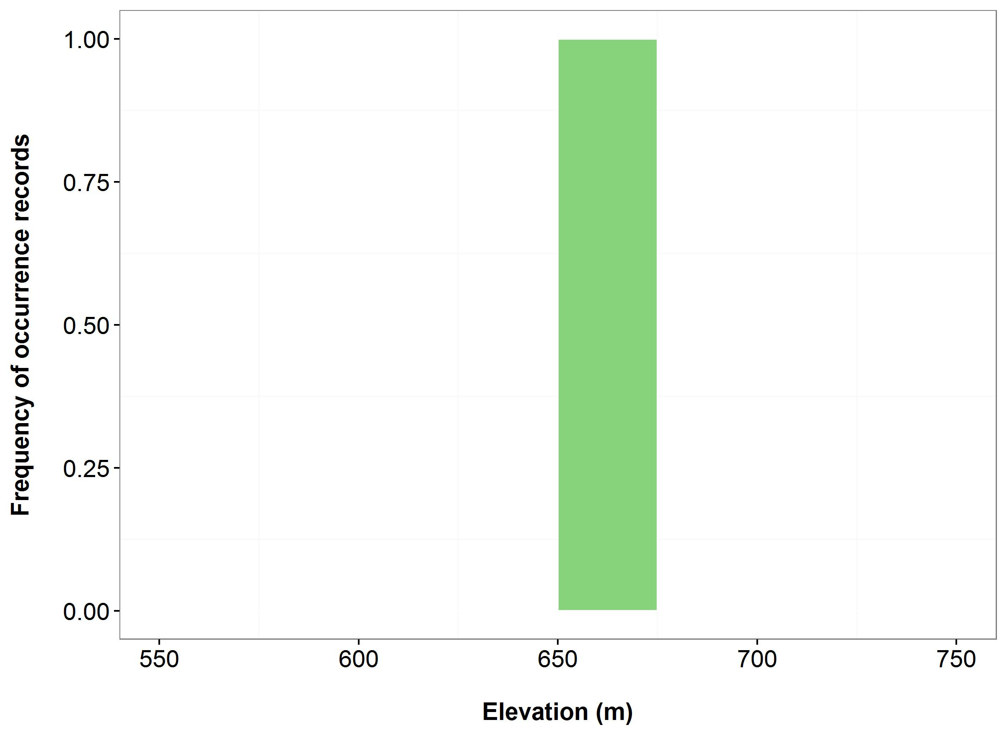

(d)

(c)

**Figure 18.** Environmental variables for the NSW distribution of *Pelargonium* sp.(G. W. Carr 10345) that are outside of Saving our Species (SoS) management sites (blue bars/dots) and within management sites (green bars/dots): mean annual temperature (MAT) (a); mean annual precipitation (MAP) (b); elevation (c); and scatterplot of MAT and MAP (d). N.B. there is only a single data point, which is inside a management site.

***Name:*** *Rytidosperma vickeryae* (Perisher Wallaby-grass)

***Growth form:*** Grass

***Habitat:*** Sphagnum moss in montane peatland communities or along stream edges

***Distribution:*** Australian Alps Bioregion

***Threat status:*** Endangered

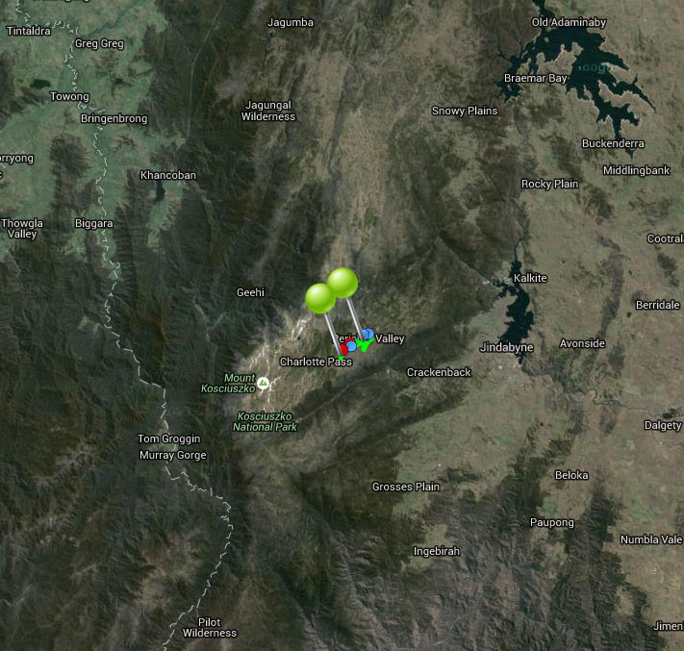

**Figure 19.** Map of species occurrence records in NSW for *Rytidosperma vickeryae* (Perisher Wallaby-grass). Records from Australia’s Virtual Herbarium are shown in red and records from the NSW Wildlife Atlas are shown in blue, with management sites marked in green.

***Climate change threat(s) identified in Final Determination***

* Restricted geographic distribution/narrow ecological range
* Mountain ecosystem
* Altered hydrology (reduced snow meltwater)

***Number and name(s) of management sites, with estimated population size at each site:*** Two

* [Perisher Valley](javascript:__doPostBack('ctl00$ContentPlaceHolder1$gridSites$ctl00$ctl04$linkSite','')): 200
* [Betts Creek](javascript:__doPostBack('ctl00$ContentPlaceHolder1$gridSites$ctl00$ctl06$linkSite','')): 200

***Are all extant sites managed?***

* Yes

***Is a translocation site suggested?***

* No. Translocation site status in now closed – “no longer needed”. Original suggestion for translocation site location was in the upper Snowy River area but may have to be in a wetter site, more likely to be at Betts Creek than Perisher Valley.

***How is climate change threat addressed in the SoS conservation project?***

* The threat of reduced snowfall/snow meltwater leading to drying of wetland habitat under climate change is directly addressed at one of the management sites (Betts Creek). There is a management action to monitor and manage/manipulate drainage patterns to maintain appropriate moisture levels. However, this action is in the maybe/possibility category only to be considered when the threat is affecting the population. The Region will not plan for it until then and is therefore unlikely to be approved.
* The threat from climate change is also directly addressed at the other extant site (Perisher Valley). Small population size means known populations are at high risk due to unpredictable effects of climate change. There is a management action to survey and identify any additional populations in/near this site. A thorough survey will allow identification of any additional populations to manage which will increase the species’ resilience to climate change.

***Suggestions to improve species adaptive capacity and resilience to climate change***

* Identify translocation sites. Not enough occurrence records for species distribution modelling but use knowledge of predicted future climate and species’ requirements, environmental variation data (Figure 20), <http://www.nswthreatenedspecies.net/>) and Auld *et al.* (2016) to select appropriate sites. Figure 20 indicates that the current sites already occupy the driest, hottest and highest sites, so sites outside of the species present distribution may have to be considered. As well as climate, need to consider habitat (subalpine treeless vegetation, mainly recorded from stream-sides, the edges of tarns, and in and around bogs; within bogs, it is often found growing in mounds of Sphagnum cristatum, at 1,500-1,900 m altitude), land tenure and other threats.
* In preparation for translocation, determine population genetic parameters: between-population genetic differences, within-population genetic diversity and inbreeding.
* Implement the proposed action to monitor physical conditions (and include the species’ responses) at Betts Creek. ). This monitoring will allow additional analysis to be undertaken, thereby increasing the adaptive capacity of the species under changing conditions (Allen et al. 2011; Green and Garmestani 2012).
* Protect and restore corridors that may facilitate dispersal (Lee *et al.* 2015).

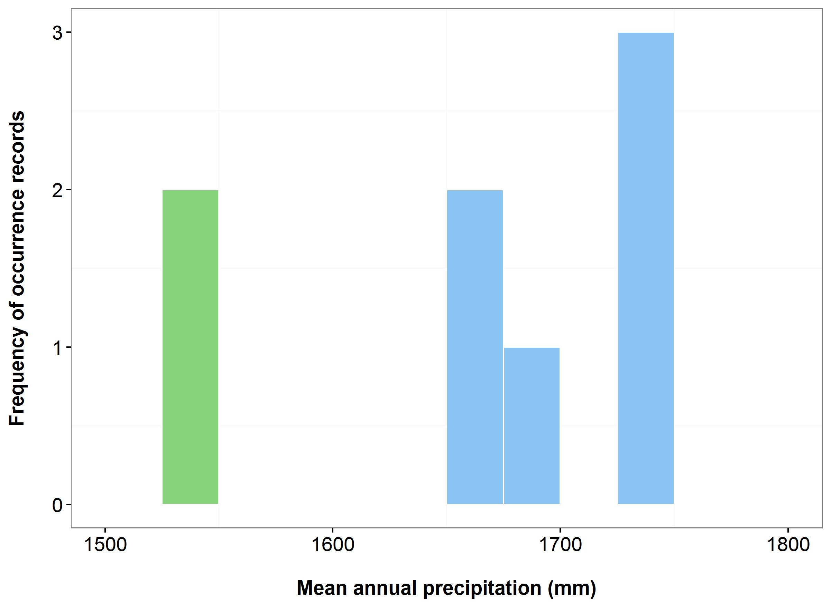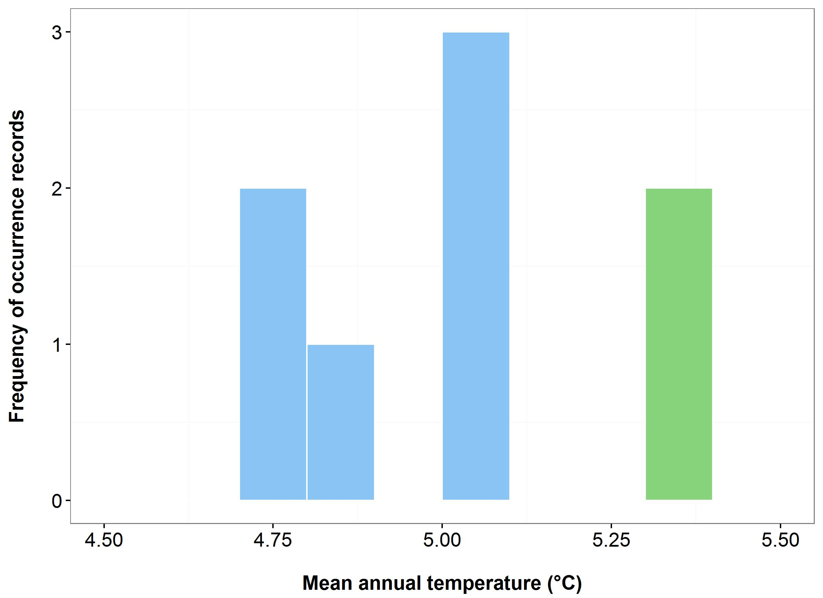

(a)

(b)



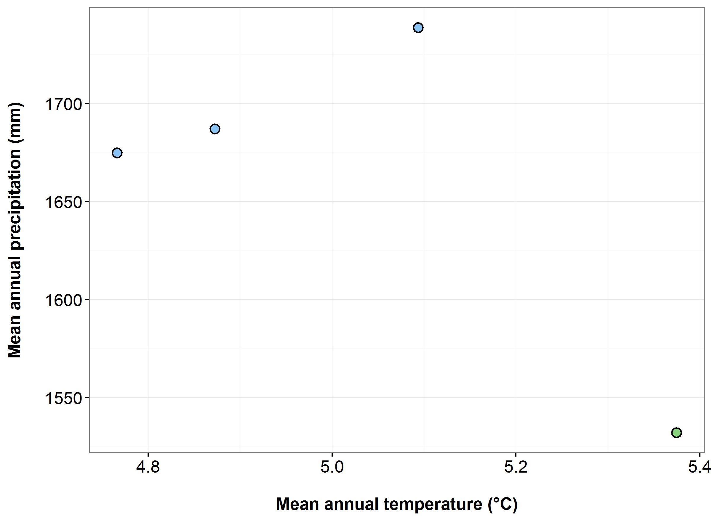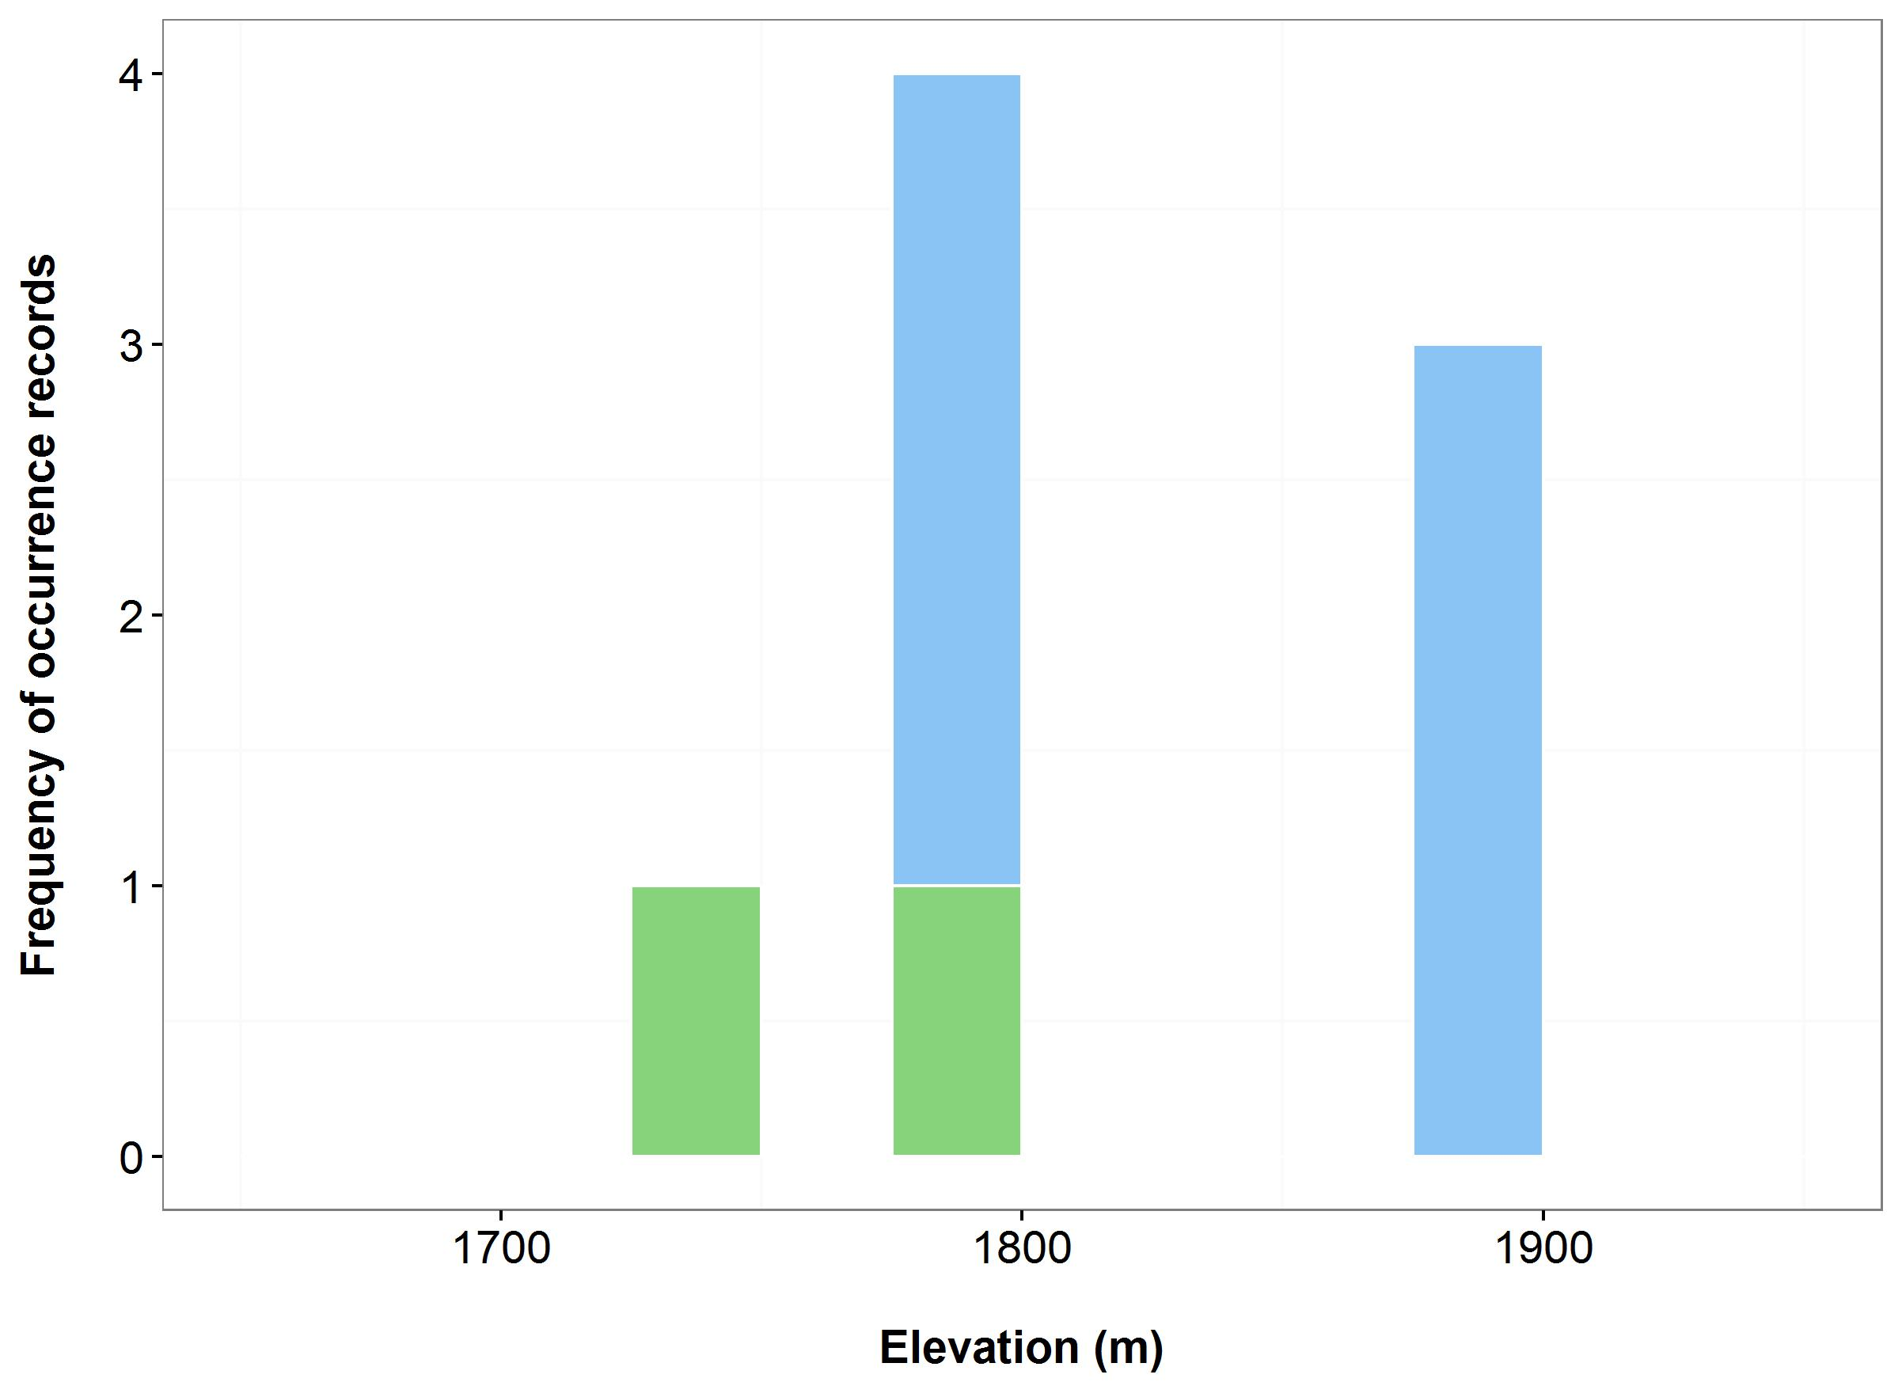

(c)

(d)

**Figure 20.** Environmental variables for the NSW distribution of *Rytidosperma vickeryae* that are outside of Saving our Species (SoS) management sites (blue bars/dots) and within management sites (green bars/dots): mean annual temperature (MAT) (a); mean annual precipitation (MAP) (b); elevation (c); and scatterplot of MAT and MAP (d).

***Name:*** *Syzygium paniculatum*(Magenta Lilly Pilly)

***Growth form:*** Tree

***Habitat:*** Restricted habitats that have been extensively cleared or modified including lowland and littoral rainforest

***Distribution:*** North Coast, Sydney Basin Bioregions

***Threat status:*** Endangered

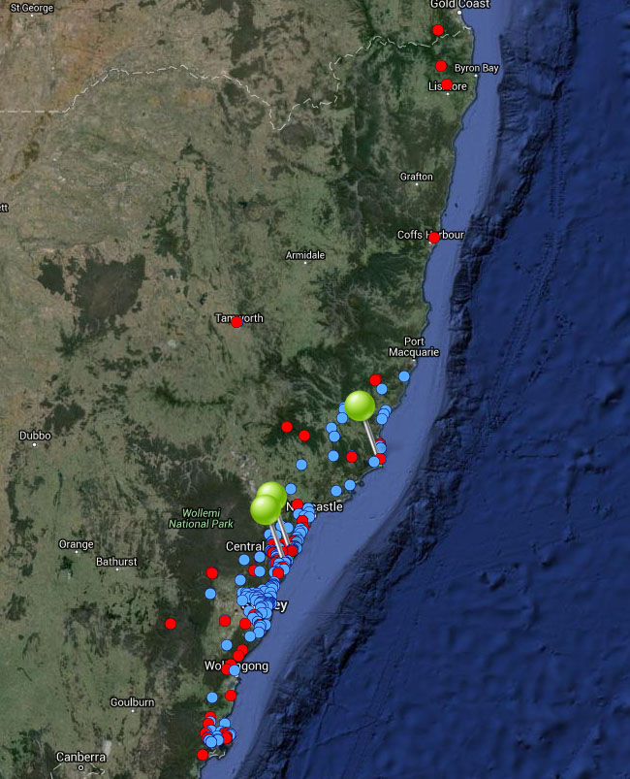

**Figure 21.** Map of species occurrence records in NSW for *Syzygium paniculatum*(Magenta Lilly Pilly). Records from Australia’s Virtual Herbarium are shown in red and records from the NSW Wildlife Atlas are shown in blue, with management sites marked in green.

***Climate change threat(s) identified in Final Determination***

* Sea-level rise (habitat loss)

***Number and name(s) of management sites, with estimated population size at each site:*** Three

* [Seal Rocks](javascript:__doPostBack('ctl00$ContentPlaceHolder1$gridSites$ctl00$ctl04$linkSite','')): 5
* [Wyrrabalong](javascript:__doPostBack('ctl00$ContentPlaceHolder1$gridSites$ctl00$ctl06$linkSite','')): 50
* [Wamberal Lagoon](javascript:__doPostBack('ctl00$ContentPlaceHolder1$gridSites$ctl00$ctl08$linkSite','')): 20

***Are all extant sites managed?***

* No. There are approximately 44 sub-populations in 5 broad meta-populations (Jervis Bay, Coalcliff, Botany Bay, Central Coast and Seal Rocks).

***Is a translocation site suggested?***

* No

***How is climate change threat addressed in the SoS conservation project?***

* Suggests multiple management sites needed as climate change a significant threat.
* Wamberal Lagoon site chosen as is slightly more buffered against sea-level rise because the population is on the back of the dune.
* Recognises Towra Point population likely to be lost to sea-level rise – not chosen as a management site.

***Suggestions to improve species adaptive capacity and resilience to climate change***

* **Species distribution modelling results for site selection.** By 2030, low to high quality habitat is likely to remain in at least one of the three sites managed for this species. For instance, under the warm/wet scenario Wyrrabalong and Wamberal Lagoon are likely to have high suitability, while Seal Rocks is projected to be most suitable under the hot/wet scenario. However, by 2070, Wyrrabalong and Wamberal Lagoon are likely to be unsuitable under the hot/slightly dry and warm/dry scenarios, or have very low suitability under the warm/wet and hot/wet scenarios. The Seal Rocks site may continue to be suitable under the hot/wet scenario for 2070 (Figure 22). These results suggest that the location and number of current management sites may not be suitable by 2070 and new sites should be considered (see page 124 for a decision framework for site selection). Currently, managed sites are at lower elevations and at the higher end of the rainfall range (Figure 23). The suitability of additional sites in drier (Figure 23b) and hotter locations (although this may be limited, see Figure 23a) should be investigated (Auld *et al.* 2016) Sites at higher elevation also appear to be available but these should be tested experimentally. Ideally, sea-level modelling should be incorporated in the decision making process. Up to 10 sites should be selected for management (IUCN Standards and Petitions Subcommittee 2014).
* Do the current management sites contain the largest populations? For example, the Jervis Bay and Central Coast metapopulations support the largest number of individuals and subpopulations. There are 12 and 24 recorded subpopulations in these metapopulations respectively. Up to two-thirds of all individuals of the species occur in three major subpopulations of the Central Coast metapopulation. One of these subpopulations is protected in Wyrrabalong National Park while the other two, at Ourimbah Creek and Martinsville, occur on private property (Office of Environment and Heritage NSW 2012). Use species distribution modelling to assess the future suitability of these locations as managed sites. Modelling at a finer scale than that provided here is advisable for this species because of its restricted habitats and its vulnerability to sea-level rise.
* To increase adaptive capacity, supplement populations at all management/translocation sites with genotypes collected from the broad range of environmental conditions (Figure 23), <http://www.nswthreatenedspecies.net/> and see Auld et al. (2016)). For example, estimated population sizes are all very low with the largest (Wyrrabalong) only 50 individuals.
* Protect and restore corridors for retreat upslope (Lee *et al.* 2015).
* Monitor the survival and health of populations at as many sites as possible and incorporate the information into the management process (adaptive management). This monitoring will allow analysis such as population viability to be undertaken, thereby increasing the adaptive capacity of the species under changing conditions .

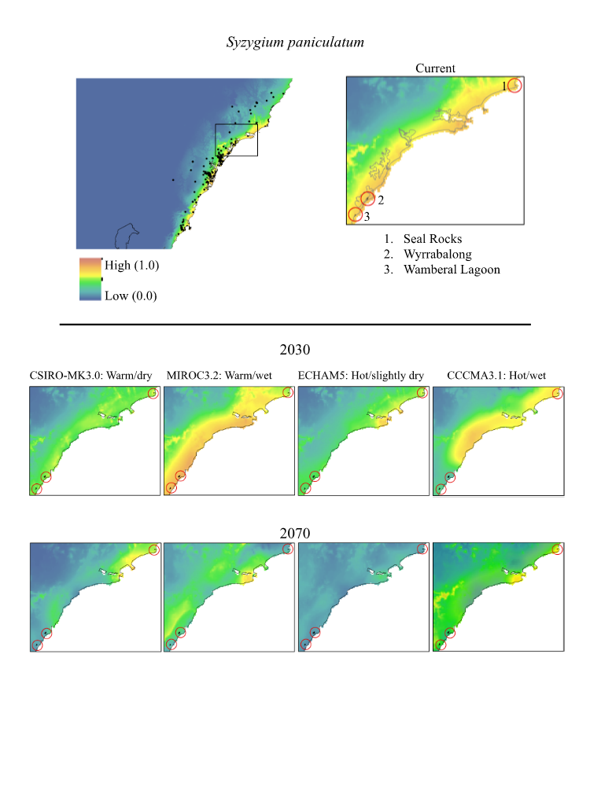

**Figure 22.** Maps of projected current and future (2030, 2070) suitable habitat for *Syzygium paniculatum* (Magenta Lilly Pilly) across three site-managed location, highlighted in red in the top right panel

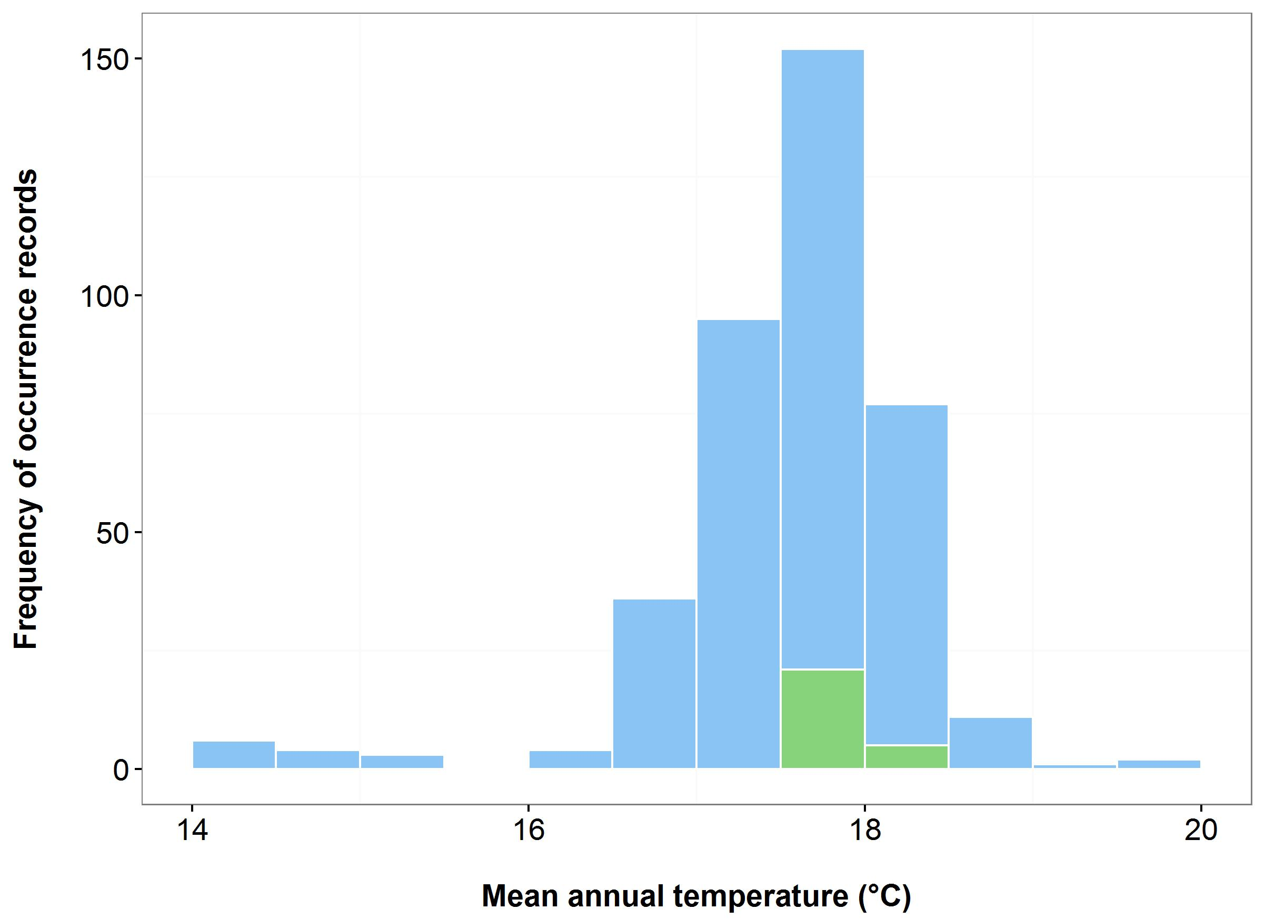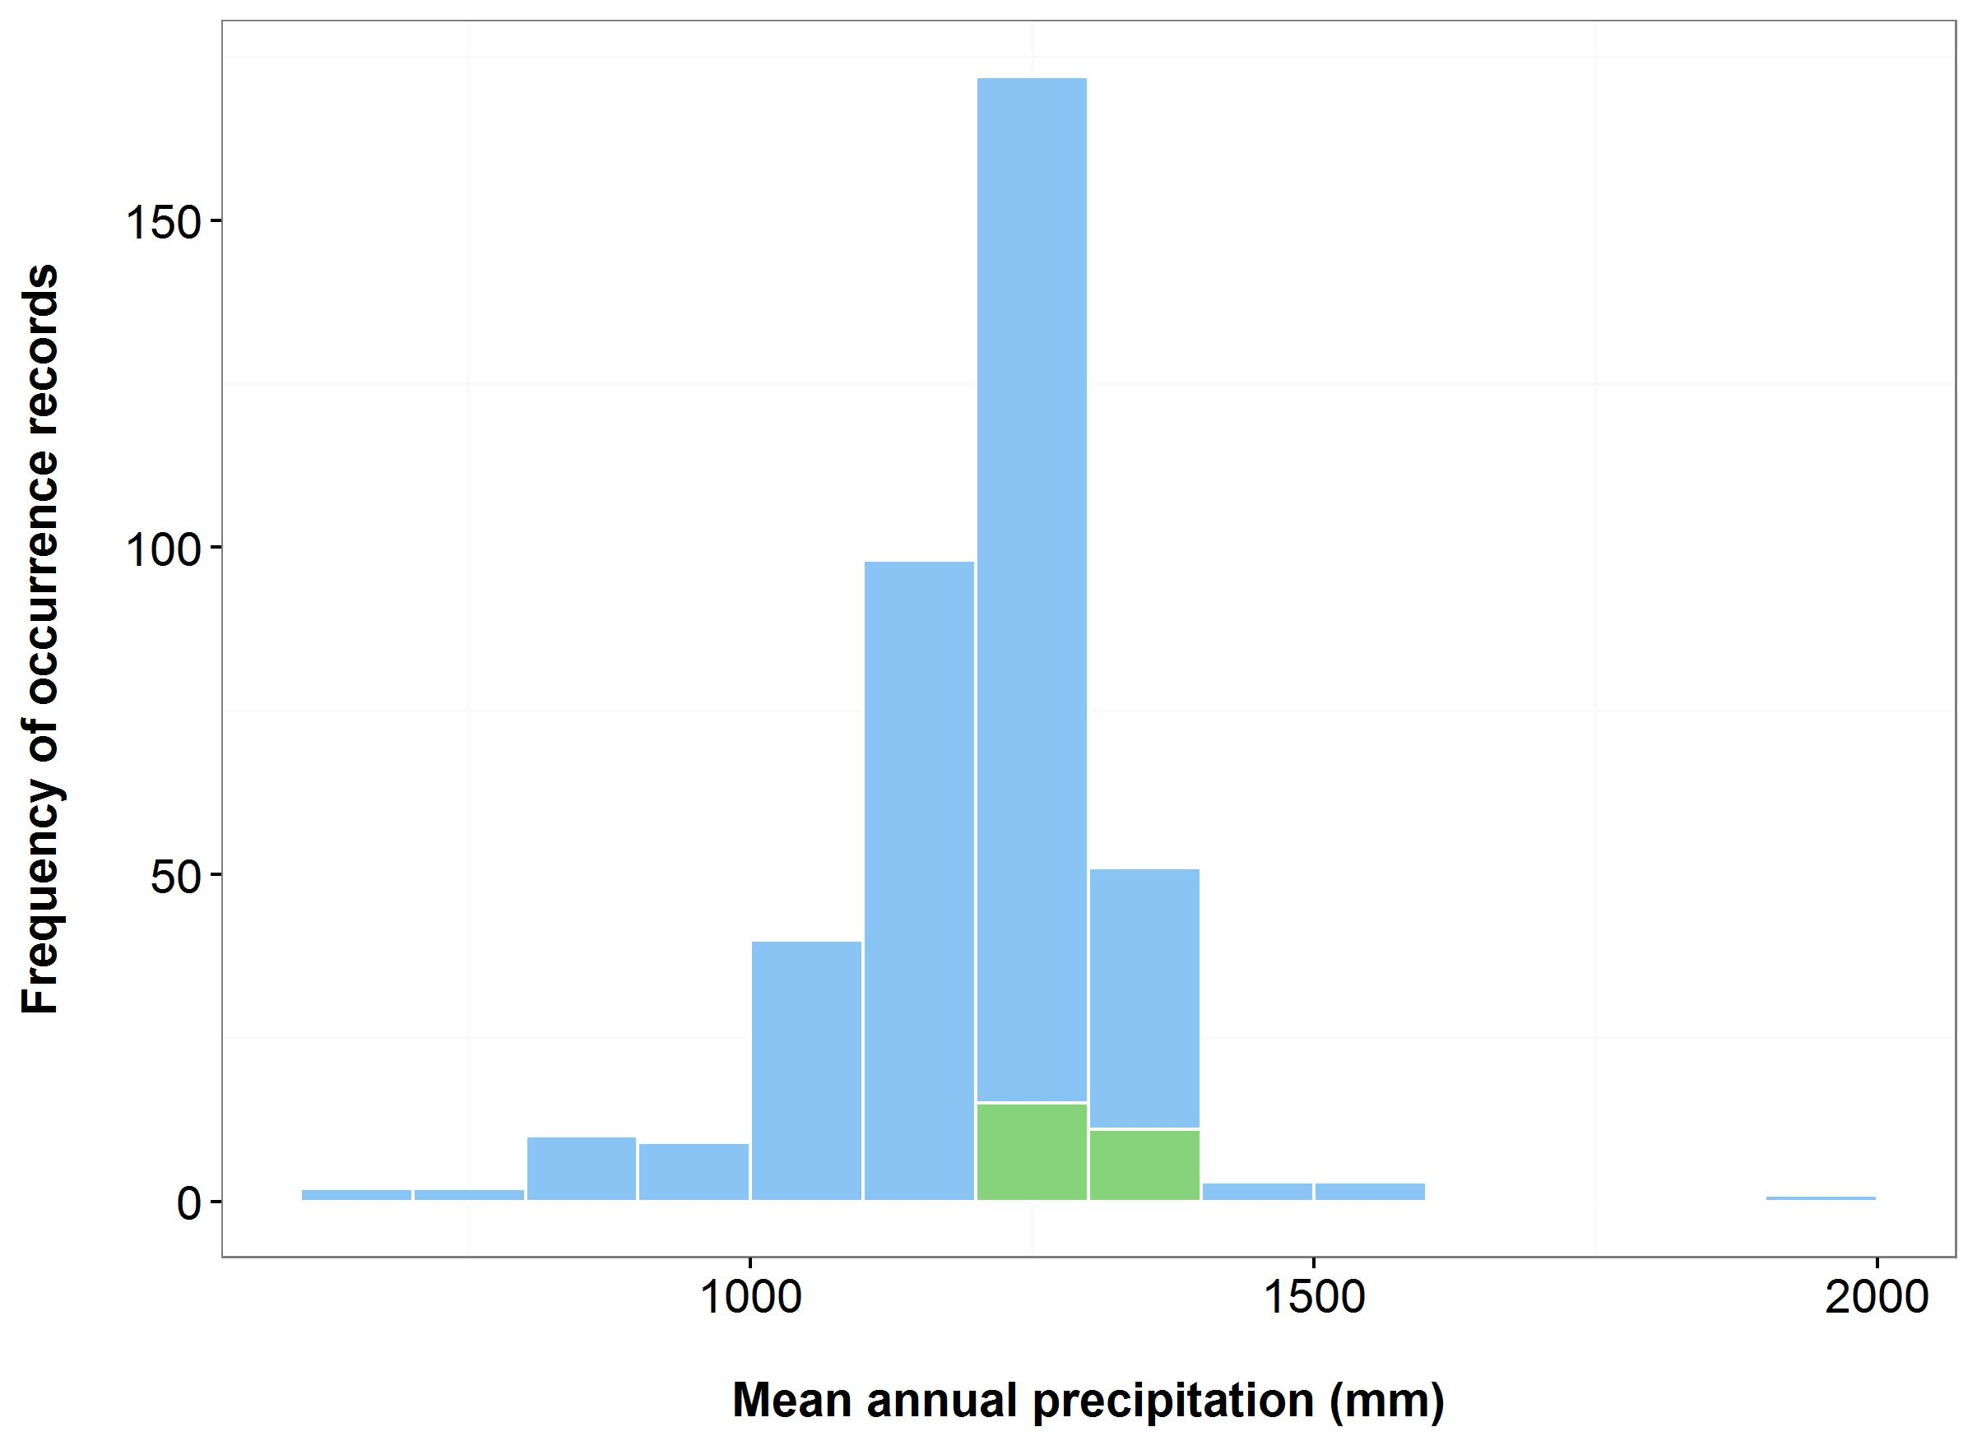

(a)

(b)



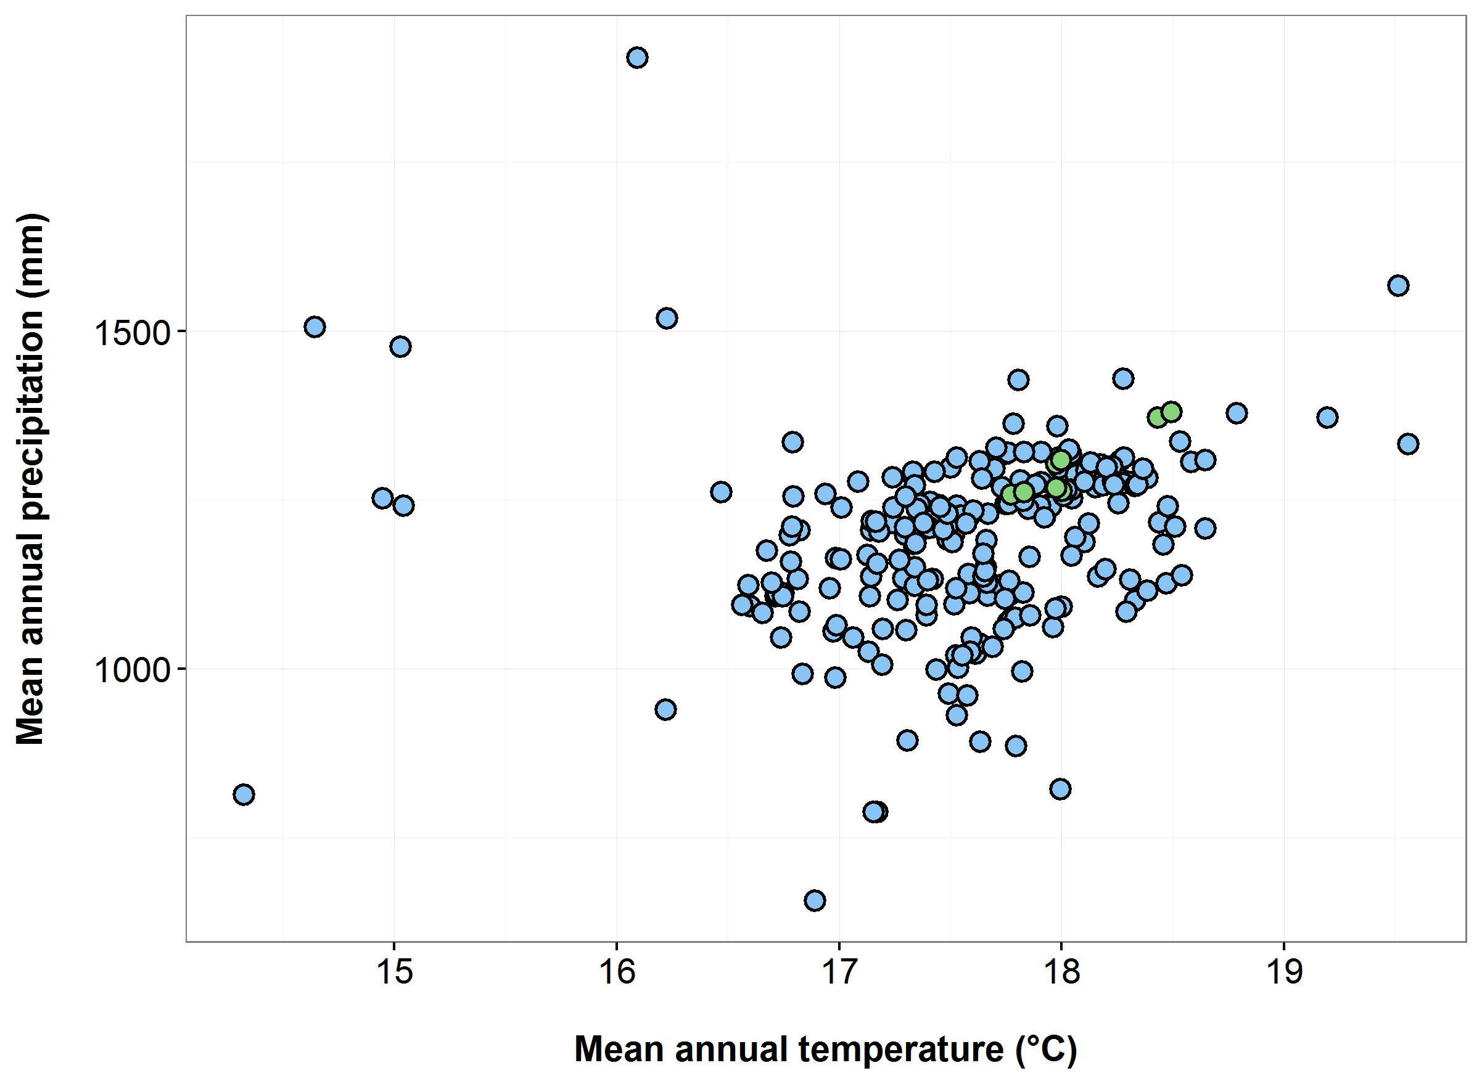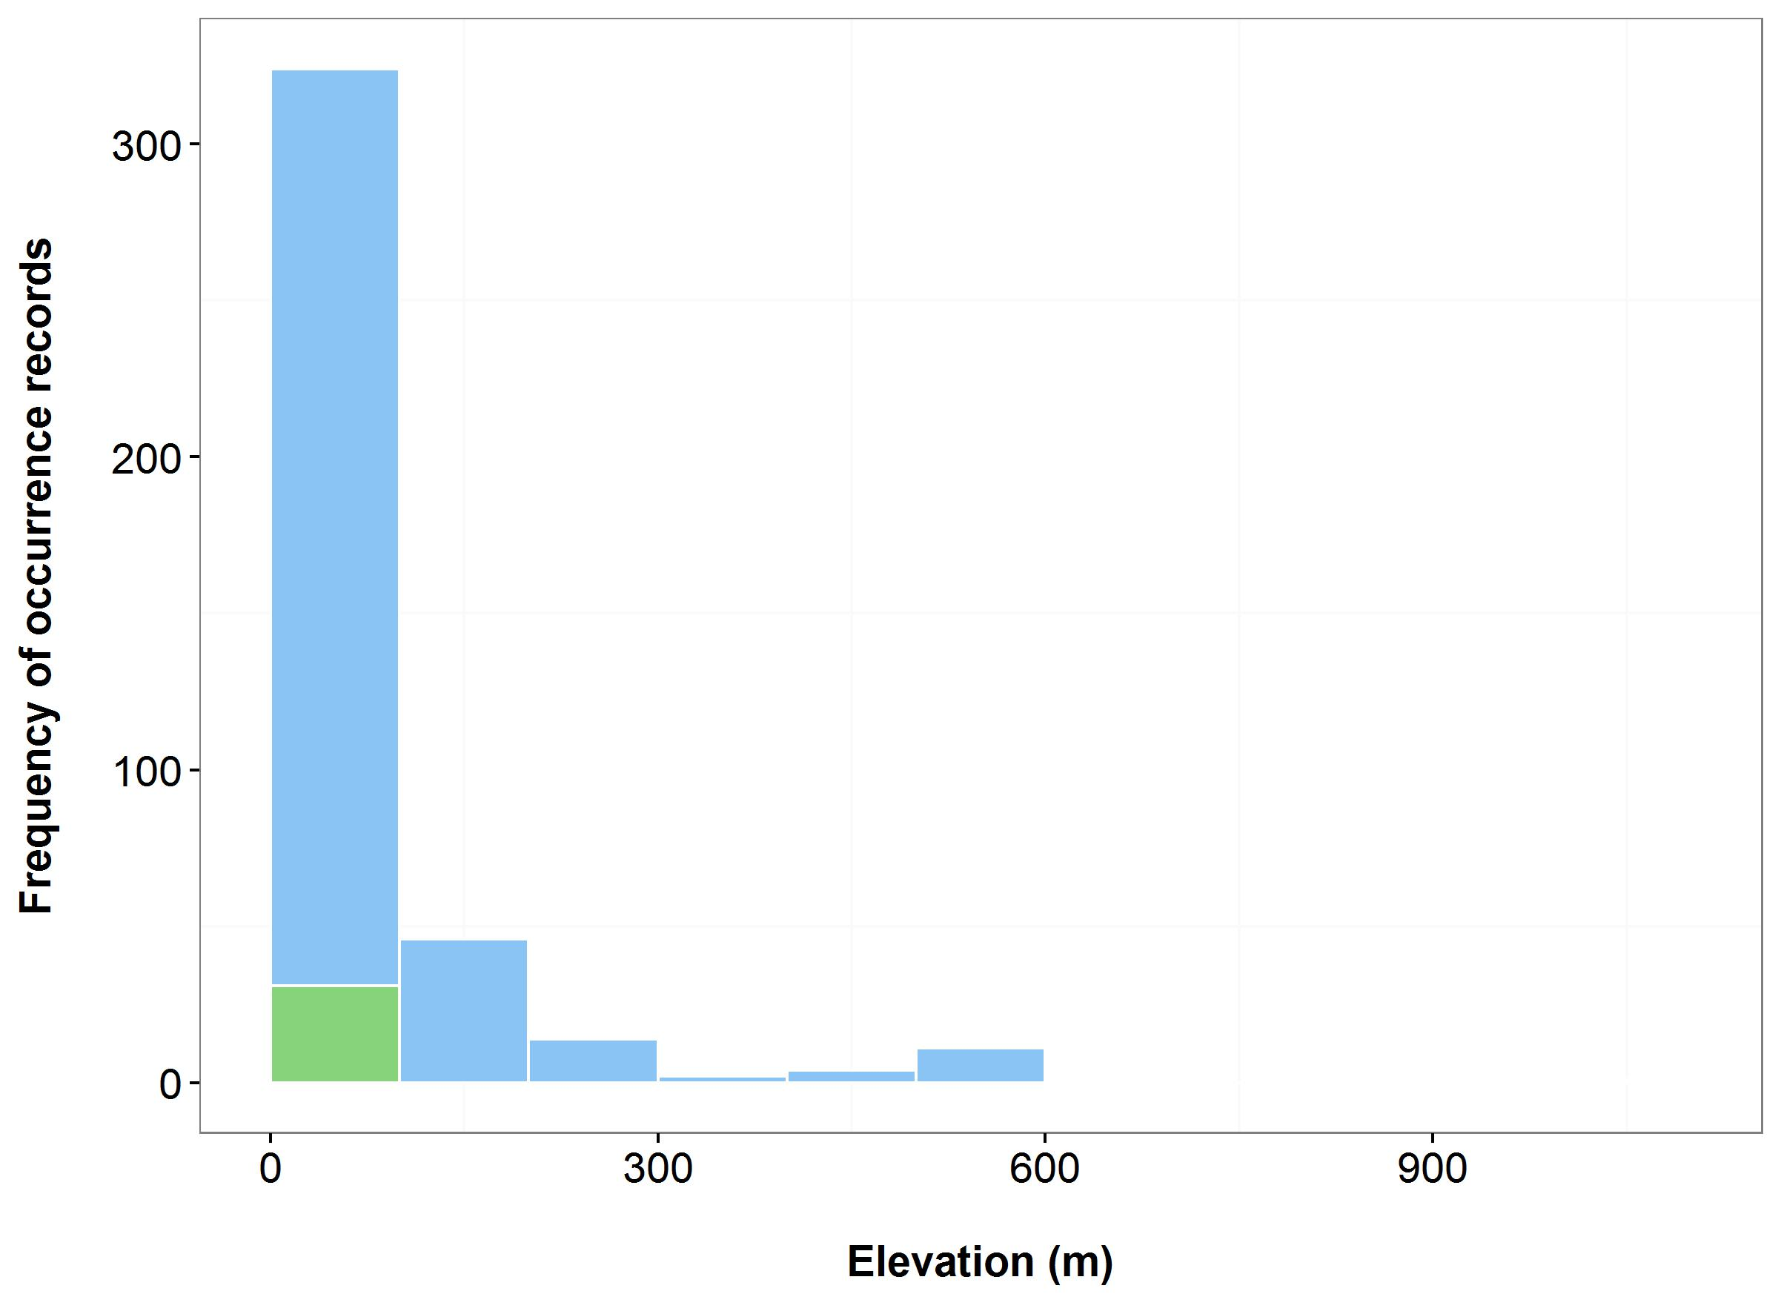

(d)

(c)

**Figure 23.** Environmental variables for the NSW distribution of *Syzygium paniculatum* that are outside of Saving our Species (SoS) management sites (blue bars/dots) and within management sites (green bars/dots): mean annual temperature (MAT) (a); mean annual precipitation (MAP) (b); elevation (c); and scatterplot of MAT and MAP (d).

**CriticallyEndangered plants**

***Name:*** *Gentiana bredboensis* (Bredbo Gentian)

***Growth form:*** Herb

***Habitat:*** Seepage areas in short herbfield communities in open areas amongst tea-tree. Often growing on Sphagnum moss

***Distribution:*** South Eastern Highlands Bioregion

***Threat status:*** CriticallyEndangered

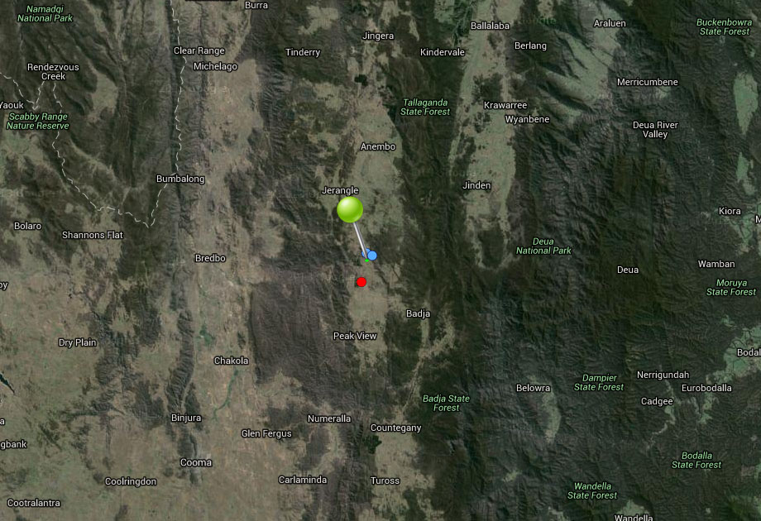

**Figure 24.** Map of species occurrence records in NSW for *Gentiana bredboensis* (Bredbo Gentian). Records from Australia’s Virtual Herbarium are shown in red and records from the NSW Wildlife Atlas are shown in blue, with management sites marked in green.

***Climate change threat(s) identified in Final Determination***

* Changes to precipitation (reduced)
* Altered hydrology (reduced flow, drying of habitat)

***Number and name(s) of management sites, with estimated population size at each site:*** One

[Peak View](javascript:__doPostBack('ctl00$ContentPlaceHolder1$gridSites$ctl00$ctl04$linkSite','')): 50

***Are all extant sites managed?***

* Yes

***Is a translocation site suggested?***

* Yes. Potential reintroduction sites - Tinderry Nature Reserve, Scotsdale Bush Heritage Reserve, and National Parks to the east, on escarpment.

***How is climate change threat addressed in SoS conservation project?***

* There is a management action to collect/store seed to supplement extant population with *ex-situ* material when needed which will increase the species’ resilience to climate change.
* Recognises the need for a translocation site to buffer the small population against extinction. This will increase resilience to climate change (provided future climate considered in site selection).

***Suggestions to improve species adaptive capacity and resilience to climate change***

* Identify additional translocation sites (one is not enough). Not enough occurrence records for species distribution modelling but use knowledge of predicted future climate and species’ requirements, environmental variation data (Figure 25) and <http://www.nswthreatenedspecies.net/>) to select appropriate sites. As well as climate, need to consider habitat/soil type (margin of very wet seepage slopes in pasture on granitic sandy soil in short herbfield communities amongst *Baeckea*-*Leptospermum* thickets), land tenure and other threats.
* Enter all outstanding occurrence records into databases to enable environmental data to be analysed to assist with site selection (Figure 25).
* Determine germination/propagation requirements to prepare for supplementation/translocation (Australian PlantBank). However the conservation project indicates this is likely to be difficult. The Botanic Gardens report no success at germinating Gentian seed. Consider tissue culture as an alternative.
* In preparation for supplementation/translocation, determine within-population genetic diversity and inbreeding.
* Consider appropriate strategies to allow for dependence on moisture including: protect and restore moist environments; change land use and vegetation retention and restoration in catchments to reduce runoff and to increase rainfall retention in soils and vegetation; manufactured strategies (Lee *et al.* 2015).

(b)

(a)

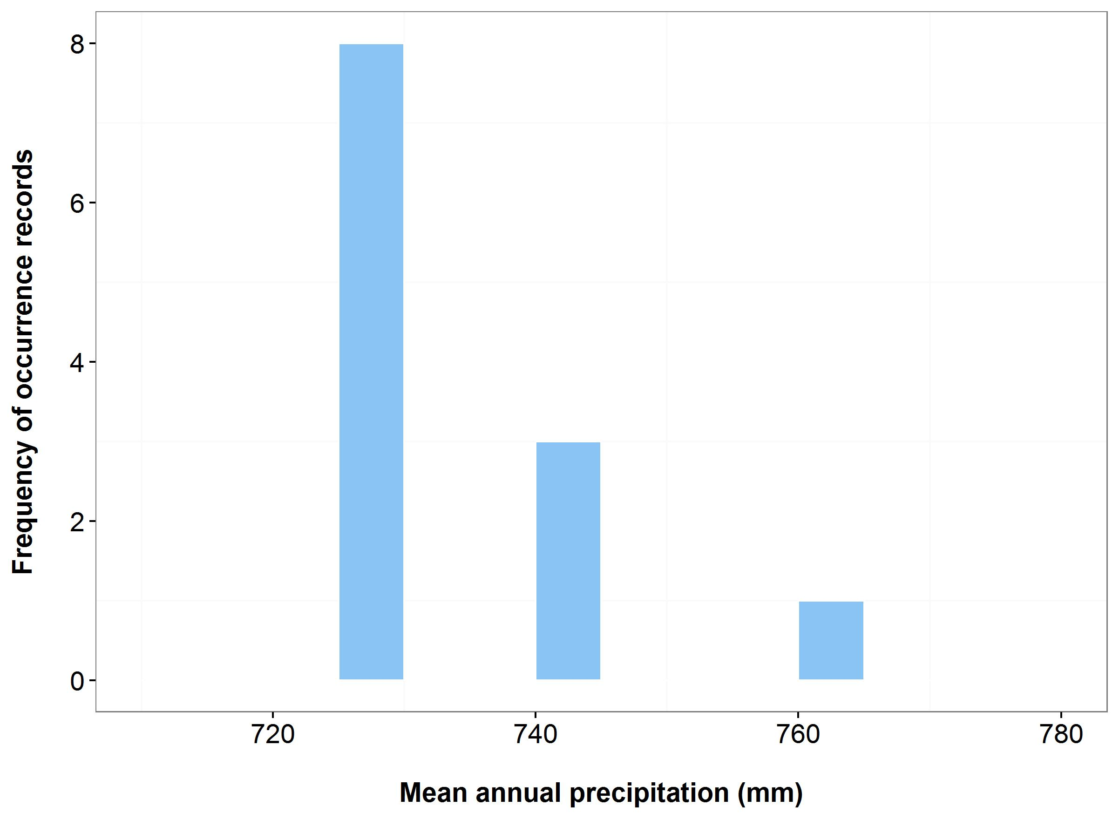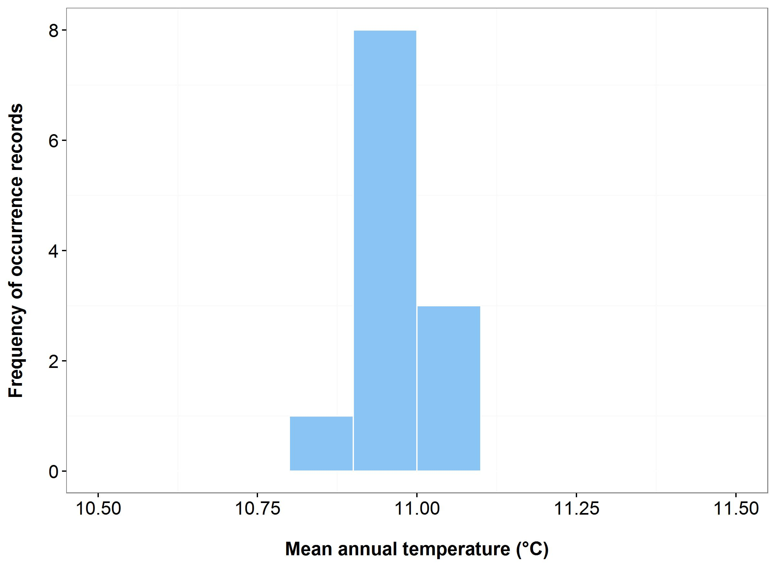



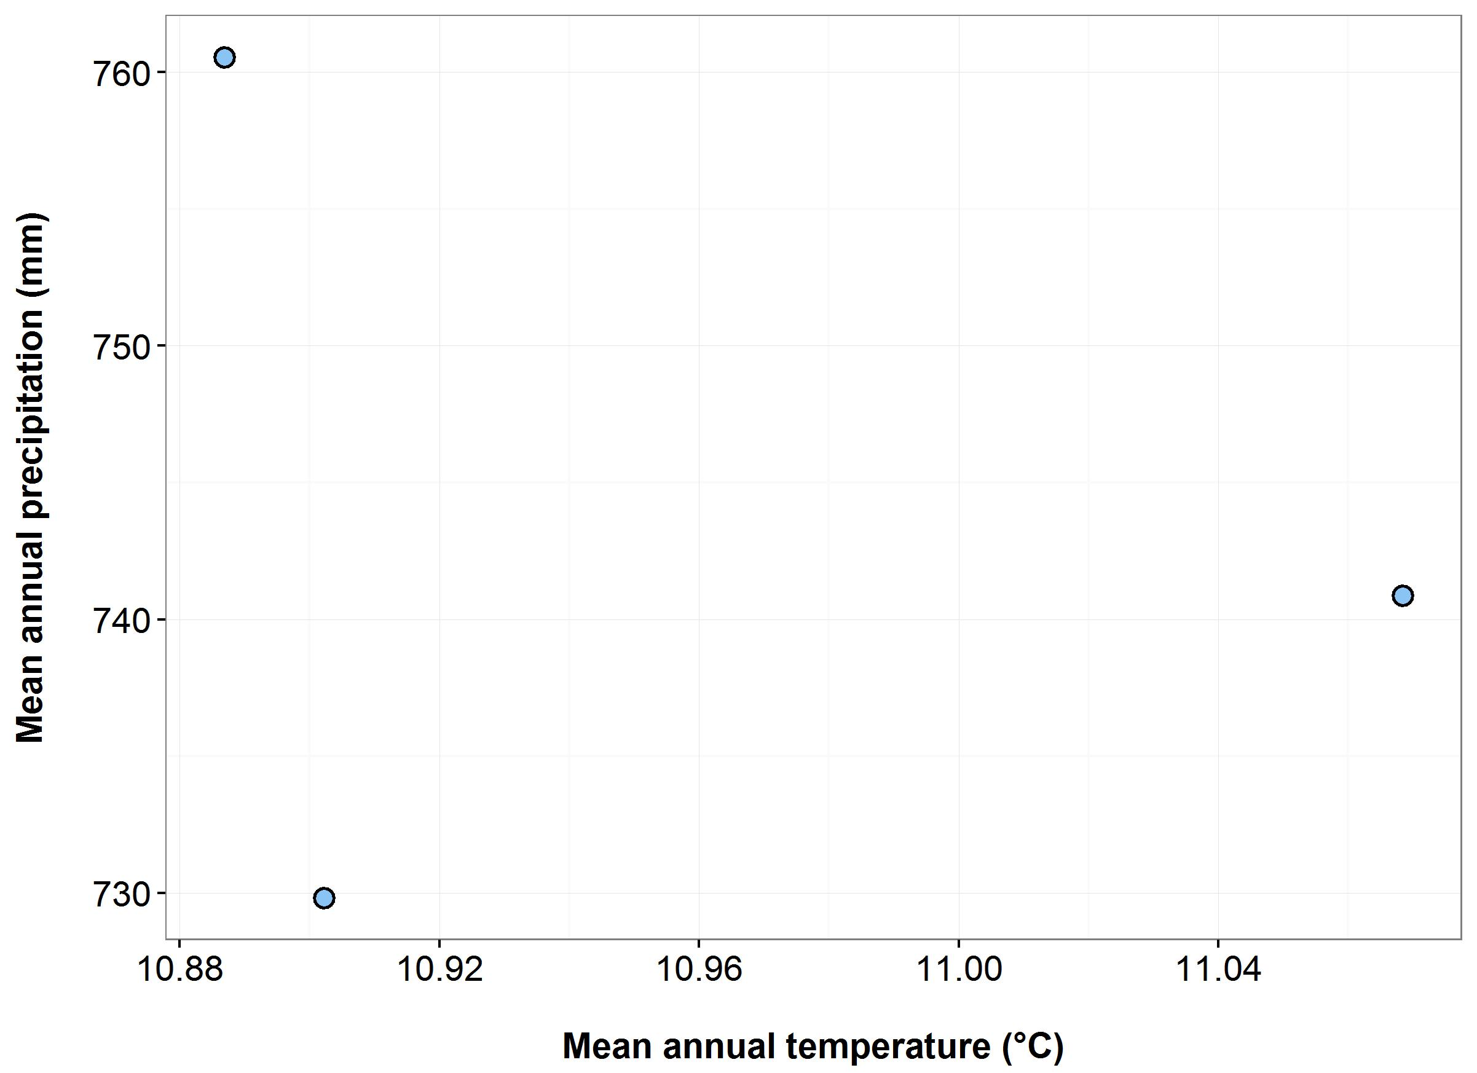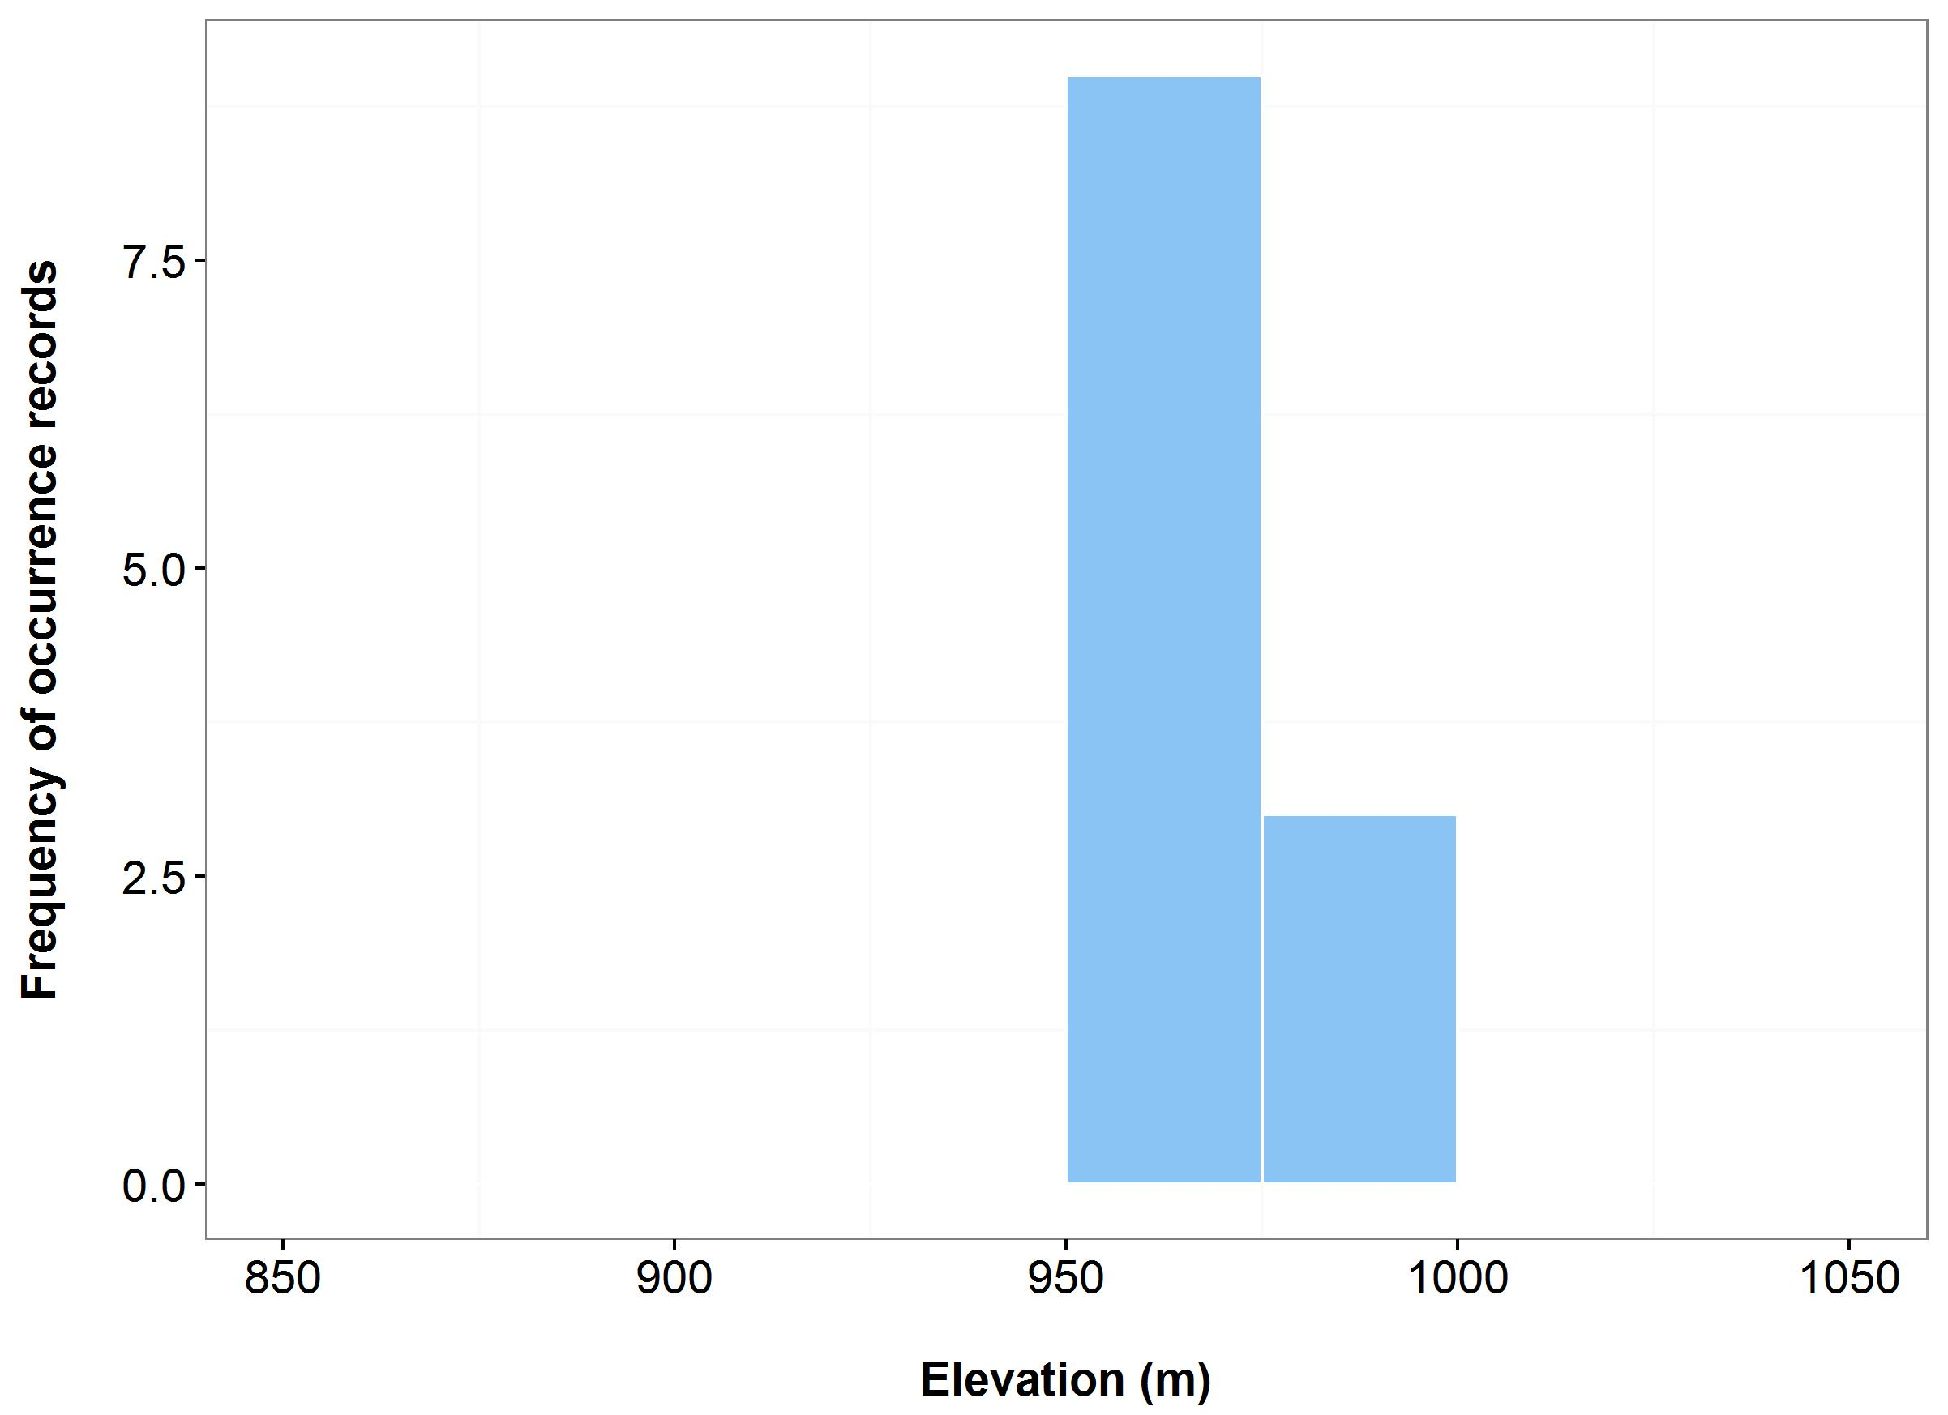

(d)

(c)

**Figure 25.** Environmental variables for the NSW distribution of *Gentiana bredboensis* that are outside of Saving our Species (SoS) management sites (blue bars/dots) and within management sites (green bars/dots): mean annual temperature (MAT) (a); mean annual precipitation (MAP) (b); elevation (c); and scatterplot of MAT and MAP (d). N.B. Within SoS data has not been entered into the NSW Wildlife Atlas for this species and therefore cannot be shown on these graphs.

***Name:*** *Gentiana wingecarribiensis*(Wingecarribee Gentian)

***Growth form:*** Herb

***Habitat:*** Narrow ecotonal areas of open low sward between the swamps and the higher grassland and pasture

***Distribution:*** Sydney Basin Bioregion

***Threat status:*** CriticallyEndangered

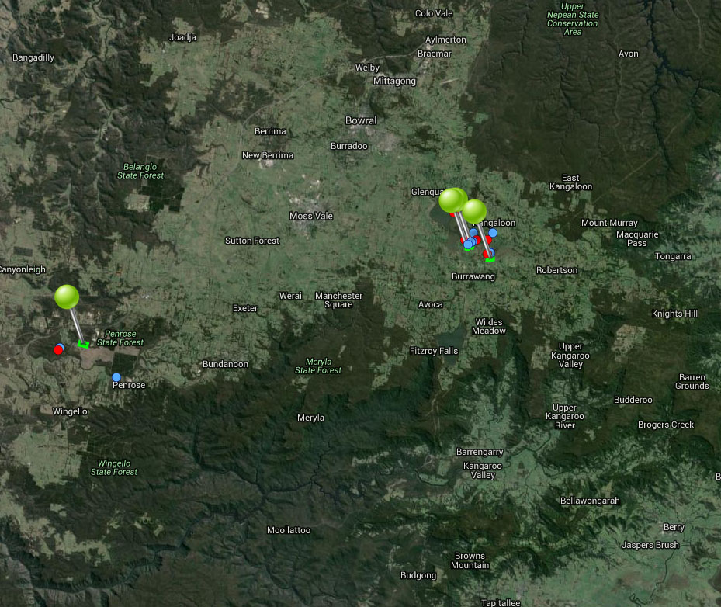

**Figure 26.** Map of species occurrence records in NSW for *Gentiana wingecarribiensis*(Wingecarribee Gentian). Records from Australia’s Virtual Herbarium are shown in red and records from the NSW Wildlife Atlas are shown in blue, with management sites marked in green.

***Climate change threat(s) identified in Final Determination***

* Changes to precipitation (reduced)

***Number and name(s) of management sites, with estimated population size at each site:*** Four

* [Wingecarribee Gentian Site A](javascript:__doPostBack('ctl00$ContentPlaceHolder1$gridSites$ctl00$ctl04$linkSite','')): n/a
* [Wingecarribee Gentian Site B](javascript:__doPostBack('ctl00$ContentPlaceHolder1$gridSites$ctl00$ctl06$linkSite','')): n/a
* [Burrowang (Site C and D)](javascript:__doPostBack('ctl00$ContentPlaceHolder1$gridSites$ctl00$ctl08$linkSite','')): n/a
* [Hanging Rock Swamp (Site E)](javascript:__doPostBack('ctl00$ContentPlaceHolder1$gridSites$ctl00$ctl10$linkSite','')): n/a

***Are all extant sites managed?***

* Yes. There are two populations (Wingecarribee Swamp and Hanging Rock Swamp). It is assumed that all six highly localised sub-populations (four at Wingecarribee Swamp and the two at Hanging rock Swamp) are managed. No standing plants have been recorded at either swamp in recent years, however assume there is a seedbank.

***Is a translocation site suggested?***

* No

***How is climate change threat addressed in the SoS conservation project?***

* There are management sites at all known locations of the species which will optimize resilience to climate change.
* There is a management action at one site, Hanging Rock Swamp (Site E), to ensure it is receiving adequate water from mining activities (Boral sand mine not currently in operation), through monitoring and managing environmental water.
* There is also a management action at the Hanging Rock Swamp (Site E) site to supplement the population with *ex-situ* material to buffer against extinction from stochastic processes (including climate change). However, this action has a low likelihood of success because it is not known whether the species still exists at any of the known sites.

***Suggestions to improve species adaptive capacity and resilience to climate change***

* Monitoring/management of water availability (quantity, timing, duration, frequency and extent) at all sites is essential. Conservation/maintenance of viable habitat at extant sites is primary concern for this species as ex-situ conservation is likely to be difficult (NSW Scientific Committee Review of Current Information, 2008, [www.environment.nsw.gov.au/resources/nature/.../Genbredboensis.pdf](http://www.environment.nsw.gov.au/resources/nature/schedules/Genbredboensis.pdf)).
* Supplement all extant populations. Determine germination/dormancy mechanisms/propagation (including environmental disturbance) requirements and possible symbiotic relationships in preparation for supplementation/translocation (Australian PlantBank). Seed collection/propagation and supplementation could be an issue because no standing plants have been recorded at either location in recent years (but it is not uncommon for the species to have dramatic population fluctuations (NSW Scientific Committee Review of Current Information, 2008). Conservation project also notes *ex-situ* germination is likely to be difficult.

Identify translocation sites. Not enough occurrence records for species distribution modelling but use knowledge of predicted future climate and species’ requirements, environmental variation data (Figure 27), <http://www.nswthreatenedspecies.net/>) and Auld *et al.* (2016) to select appropriate sites. As well as climate, need to consider habitat (narrow ecotonal areas of open low sward between the swamps, which are dominated either by sedges and *Sphagnum*, or sedges and *Leptospermum*, and the higher grassland and pasture), land tenure and other threats. May be difficult to find appropriate habitat – Final Determination states species likely to have highly specific habitat requirements and possibly specific requirements for seed survival, germination and growth.

* N.B. Population supplementation and translocation is not the primary concern – *ex-situ* conservation/translocation likely to be very difficult but action should be taken if propagules become available. Population genetic parameters: between-population genetic differences, within-population genetic diversity and inbreeding should also be determined if possible.

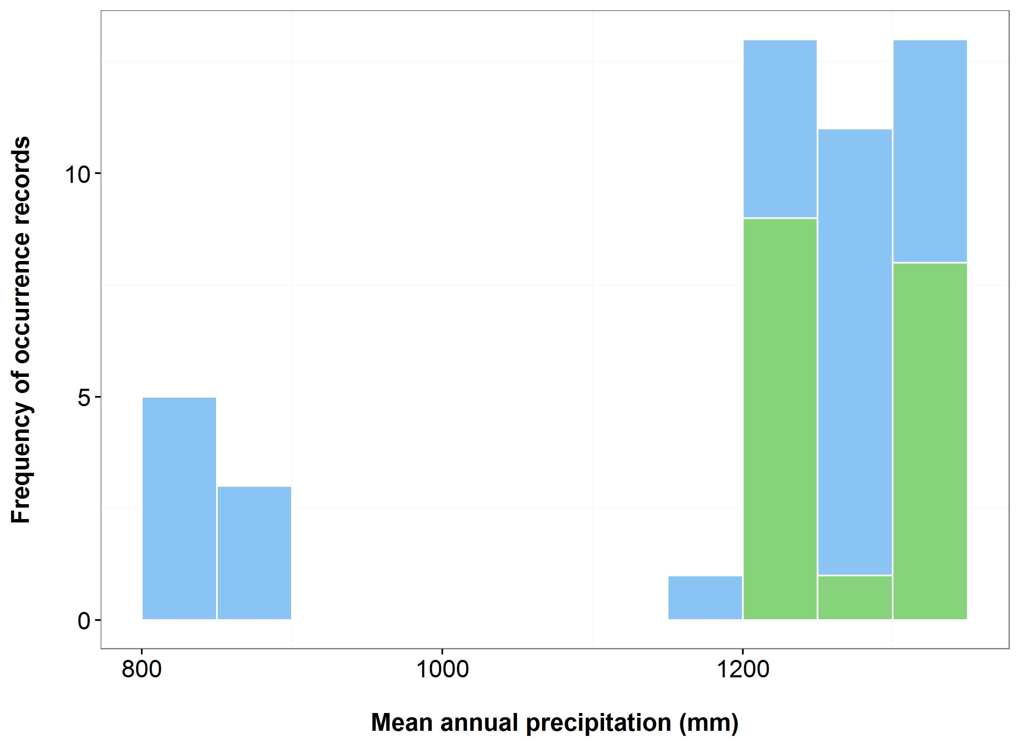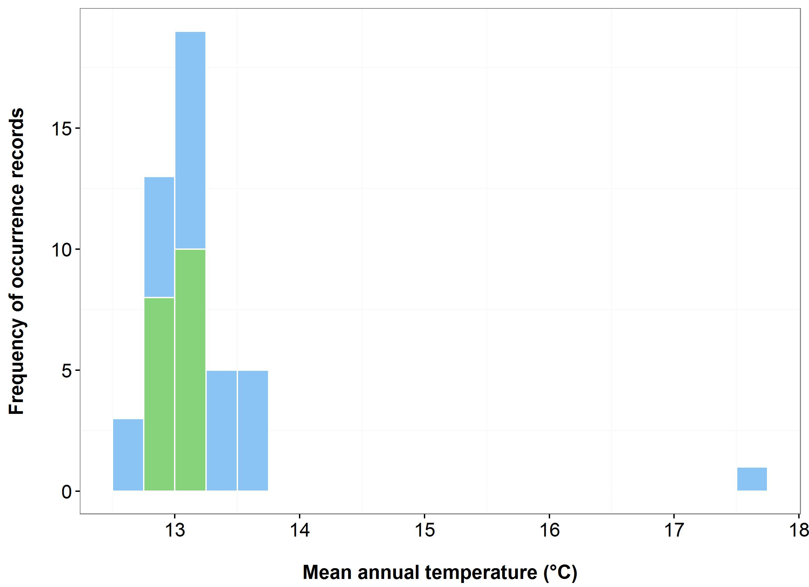

(b)

(a)



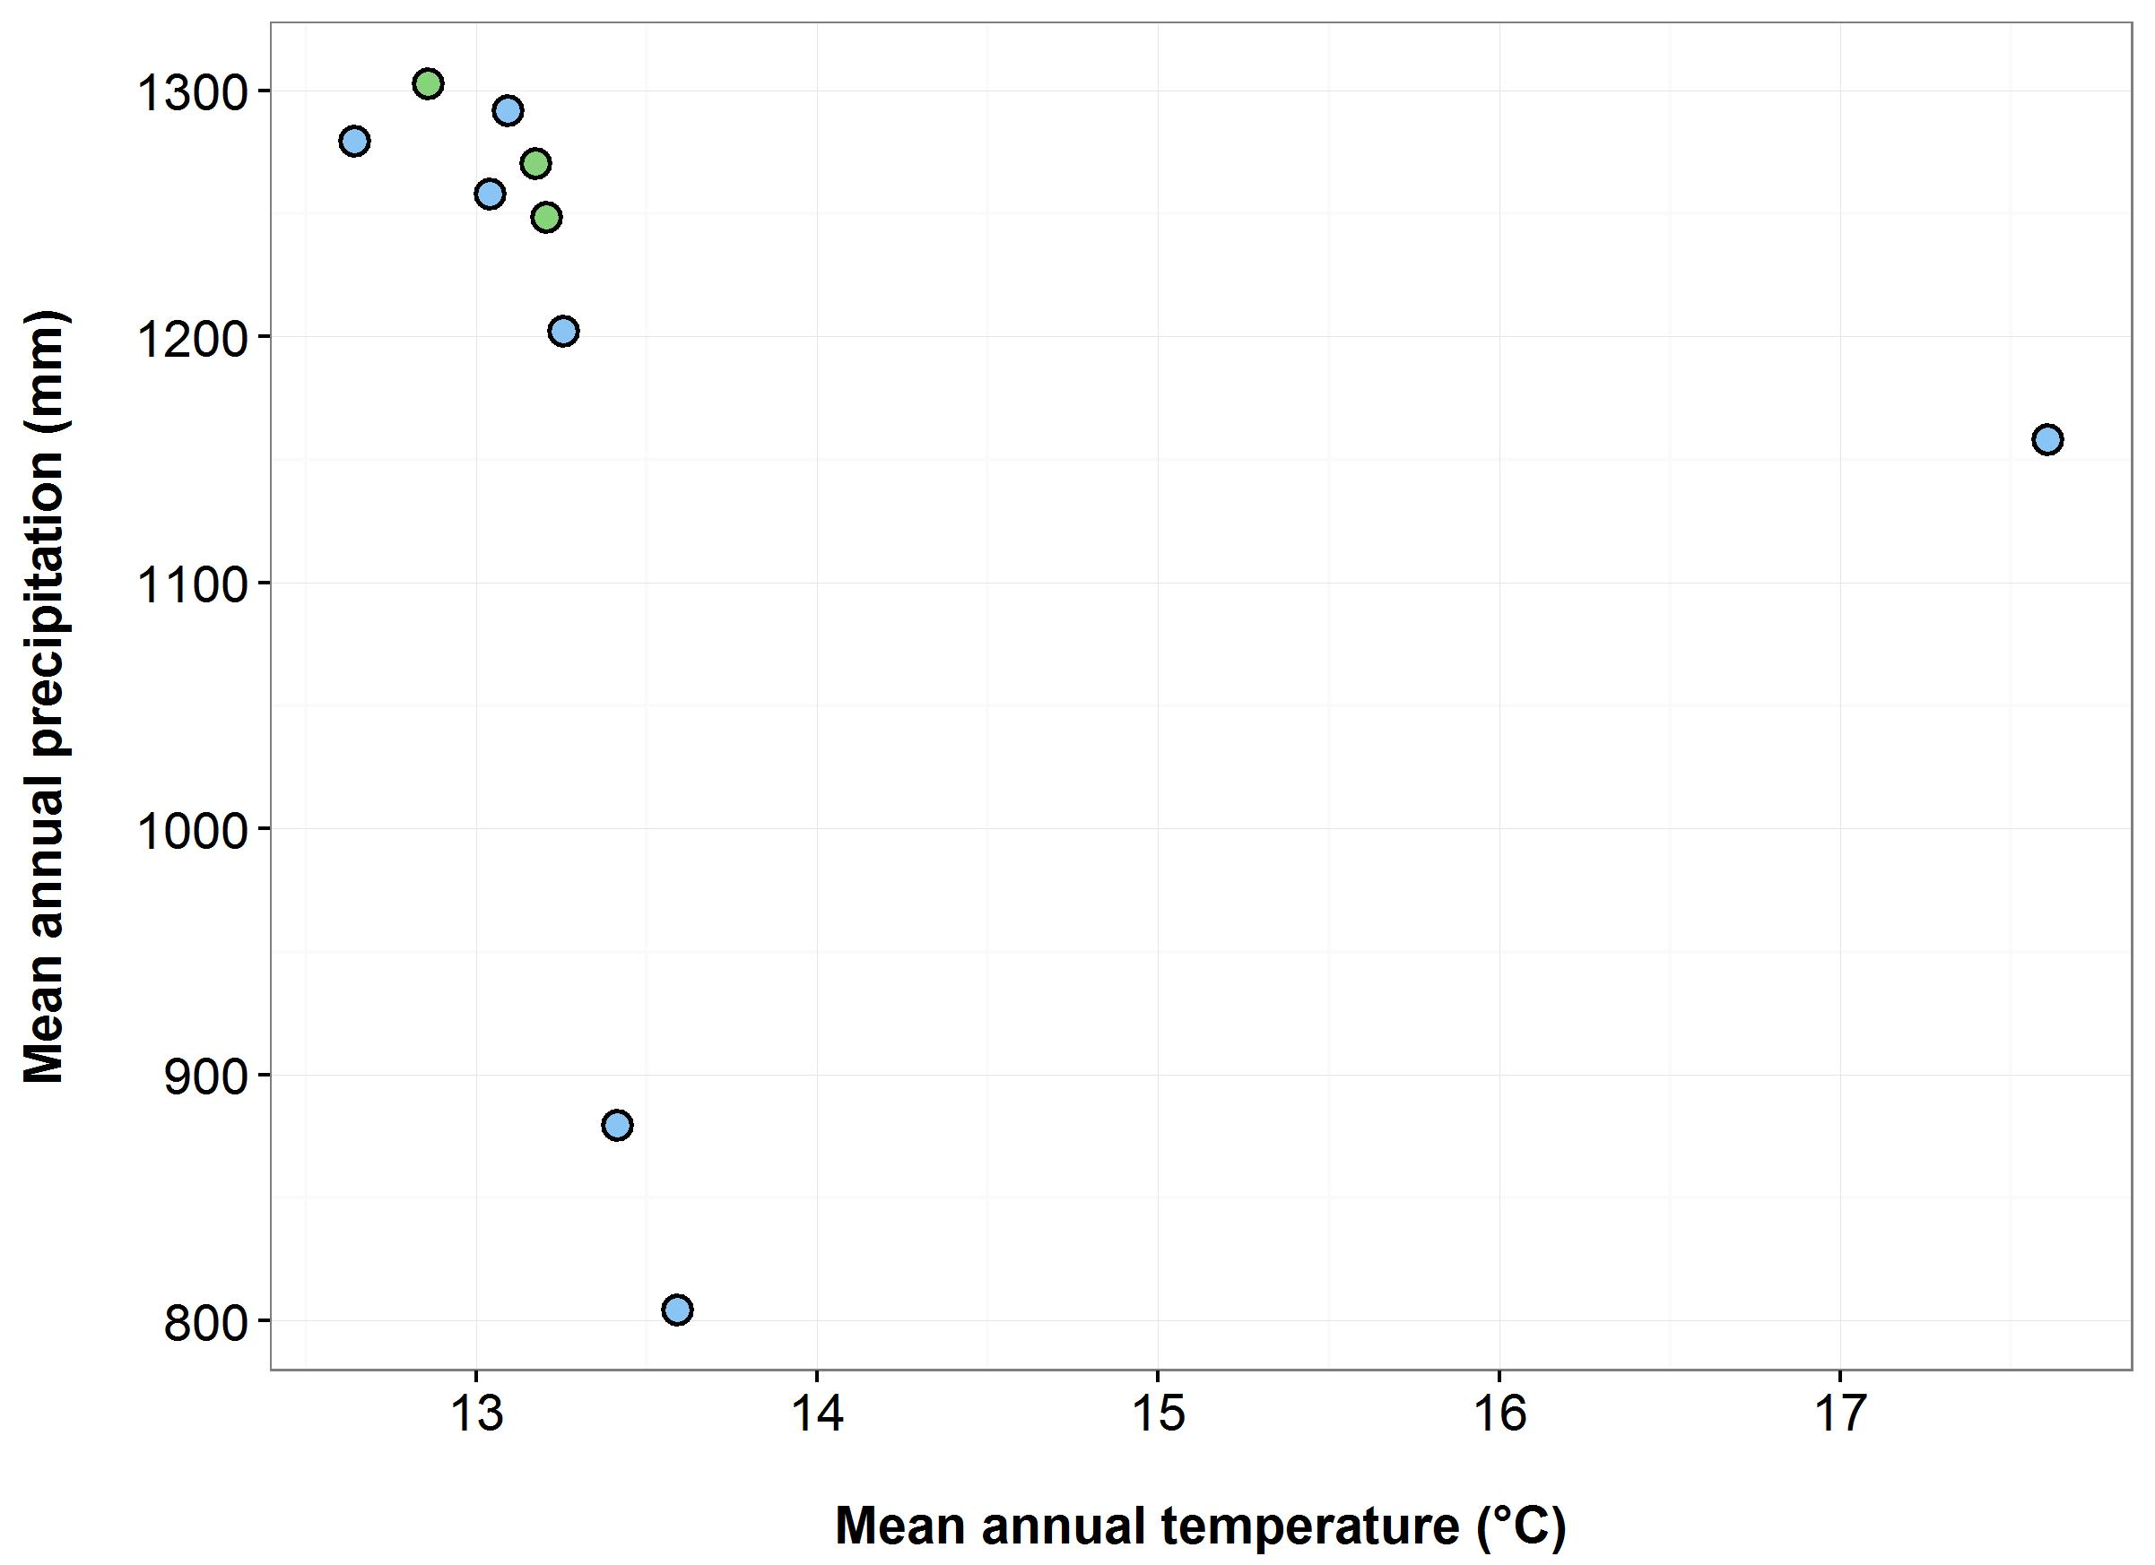

(d)

(c)

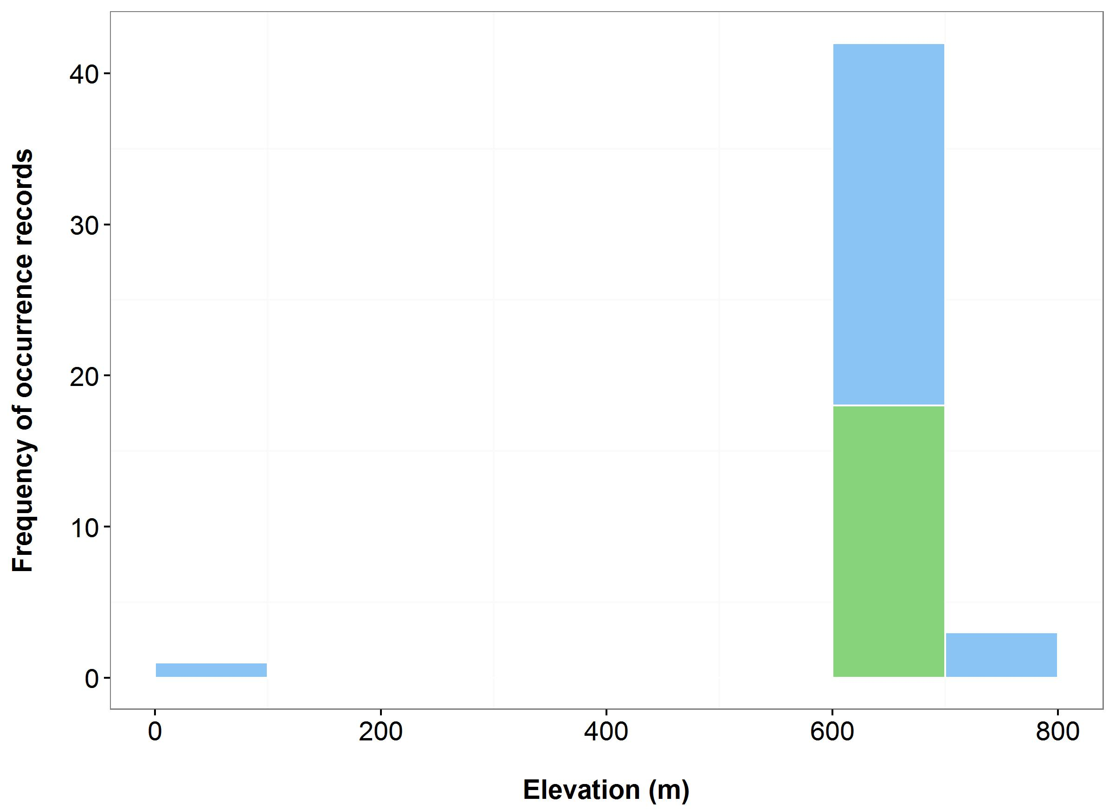

**Figure 27**. Environmental variables for the NSW distribution of *Gentiana wingecarribiensis*that are outside of Saving our Species (SoS) management sites (blue bars/dots) and within management sites (green bars/dots): mean annual temperature (MAT) (a); mean annual precipitation (MAP) (b); elevation (c); and scatterplot of MAT and MAP (d).

***Name:*** *Eucalyptus imlayensis*(Imlay Mallee)

***Growth form:*** Mallee

***Habitat:*** Sclerophyll woodland on skeletal soil on a steep slope

***Distribution:*** South East Corner Bioregion

***Threat status:*** CriticallyEndangered

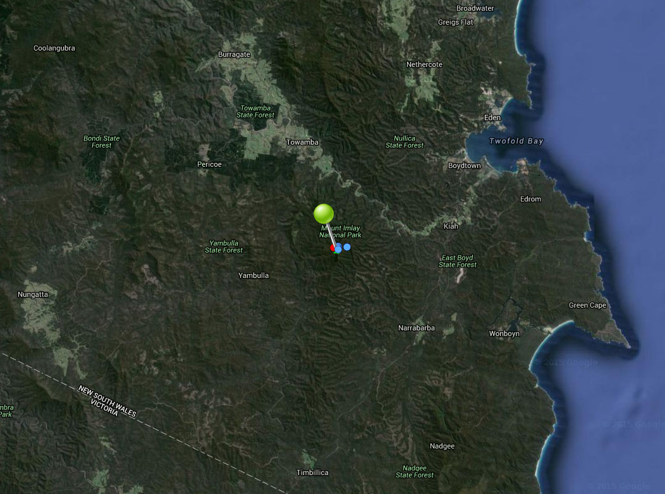

**Figure 28.** Map of species occurrence records in NSW for *Eucalyptus imlayensis*(Imlay Mallee). Records from Australia’s Virtual Herbarium are shown in red and records from the NSW Wildlife Atlas are shown in blue, with management sites marked in green.

***Climate change threat(s) identified in Final Determination***

* Changes to precipitation (increased drought)

***Number and name(s) of management sites, with estimated population size at each site:*** One

Mount Imlay: 65

***Are all extant sites managed?***

* Yes

***Is a translocation site suggested?***

* Yes. Mt Sugarloaf, South East Forests NP (pers comm: Keith McDougall, Project Co-ordinator)

***How is climate change threat addressed in the SoS conservation project?***

There is a management action to supplement the extant population with *ex-situ* material which will increase species’ resilience to climate change (no juvenile plants / no known natural recruitment in Mount Imlay population). N.B. An enhancement planting was undertaken in Sept 2011, results still being assessed (pers comm: Keith McDougall, Project Co-ordinator).

***Suggestions to improve species adaptive capacity and resilience to climate change***

* Identify additional translocation sites (one is not enough). Not enough occurrence records for species distribution modelling but use knowledge of predicted future climate and species’ requirements, environmental variation data (Figure 29), <http://www.nswthreatenedspecies.net/>) and Auld *et al.* (2016) to select appropriate sites. As well as climate, need to consider habitat/vegetation/geology (sclerophyll woodland on a rocky, steep granite, east facing slope at 850 m altitude), soil type (skeletal soil), land tenure and other threats.
* Determine population genetic diversity and level of inbreeding in preparation for translocation.

Translocation to Mt Sugarloaf hasn’t occurred yet for a number of reasons (still assessing how the enhancement planting went, not enough material for more propagation – produces very little seed, very rarely (pers comm: Keith McDougall, Project Co-ordinator). Support for ex-situ germination/propagation required to prepare for supplementation / translocation.

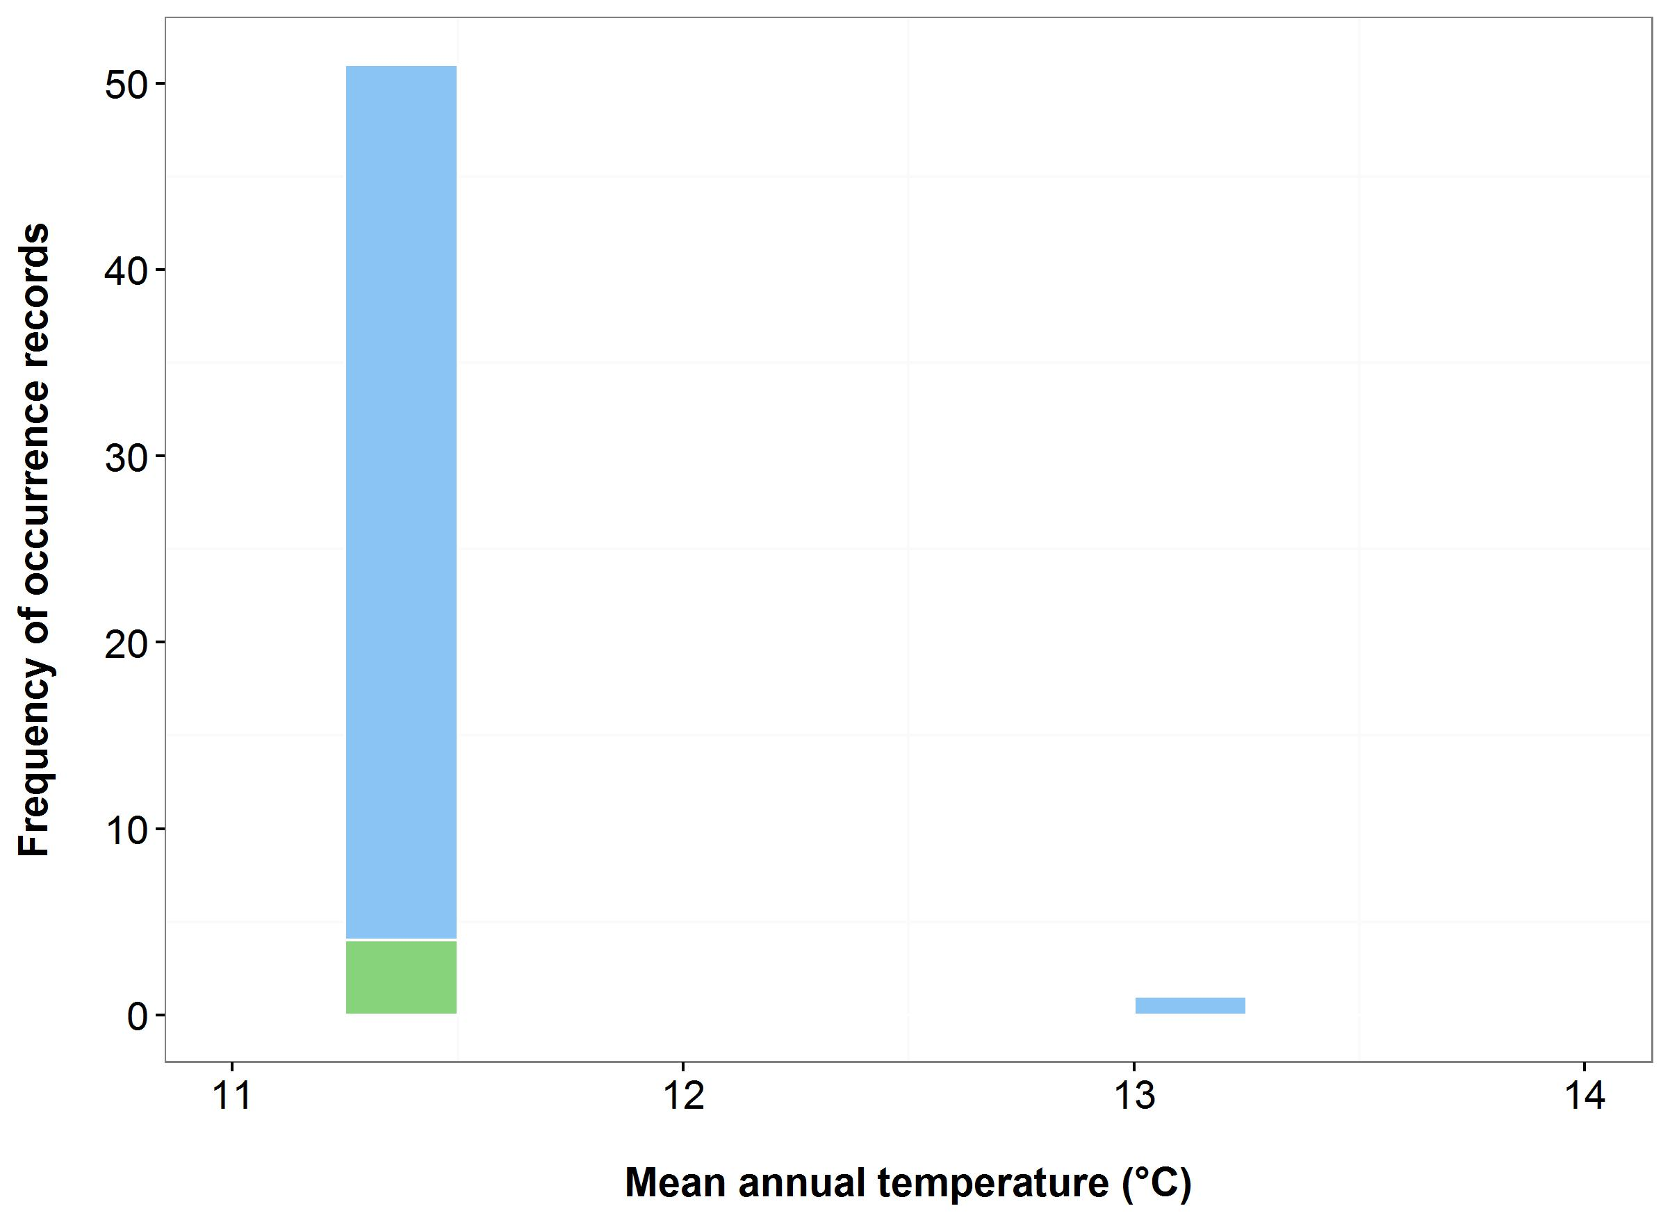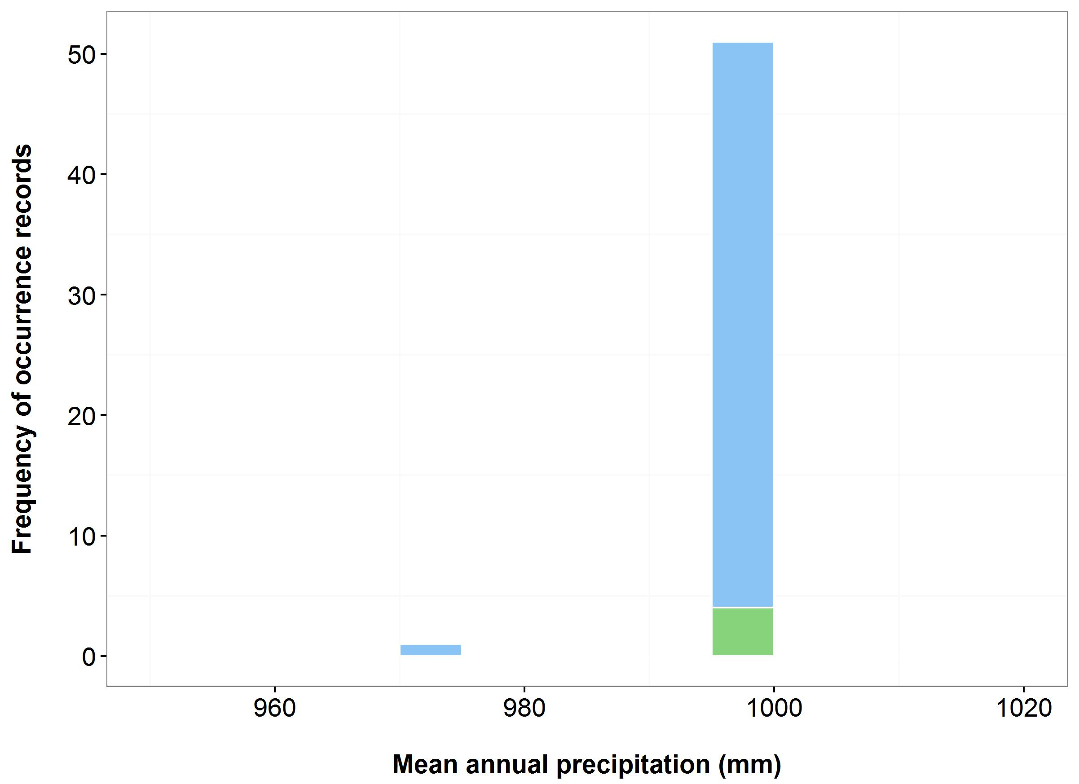

(b)

(a)



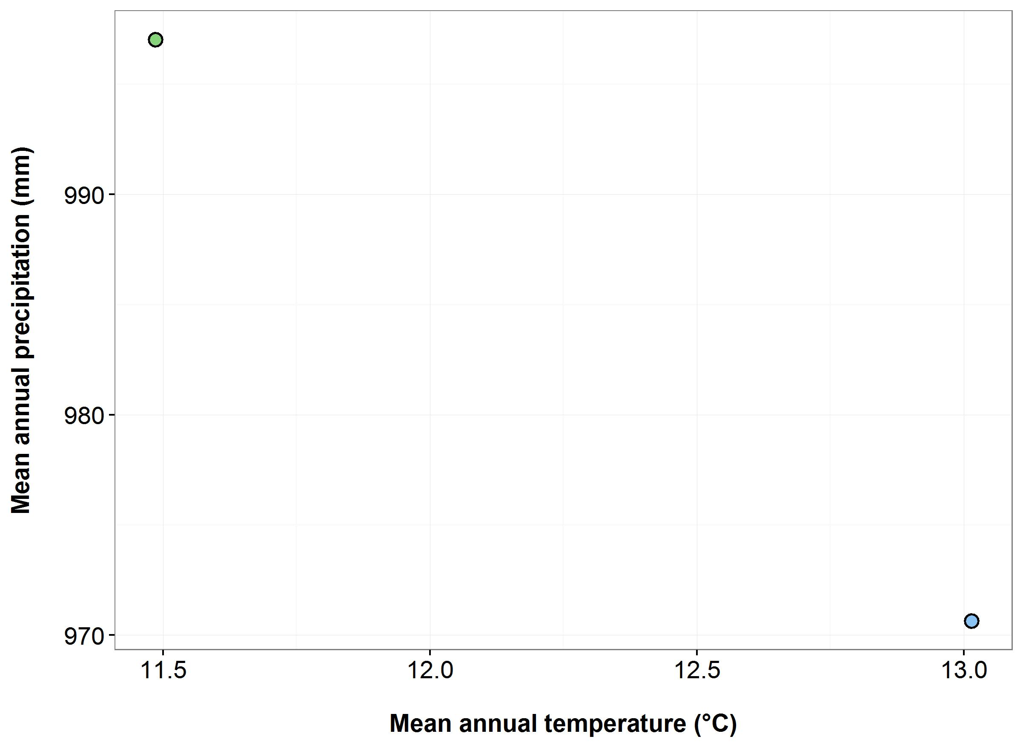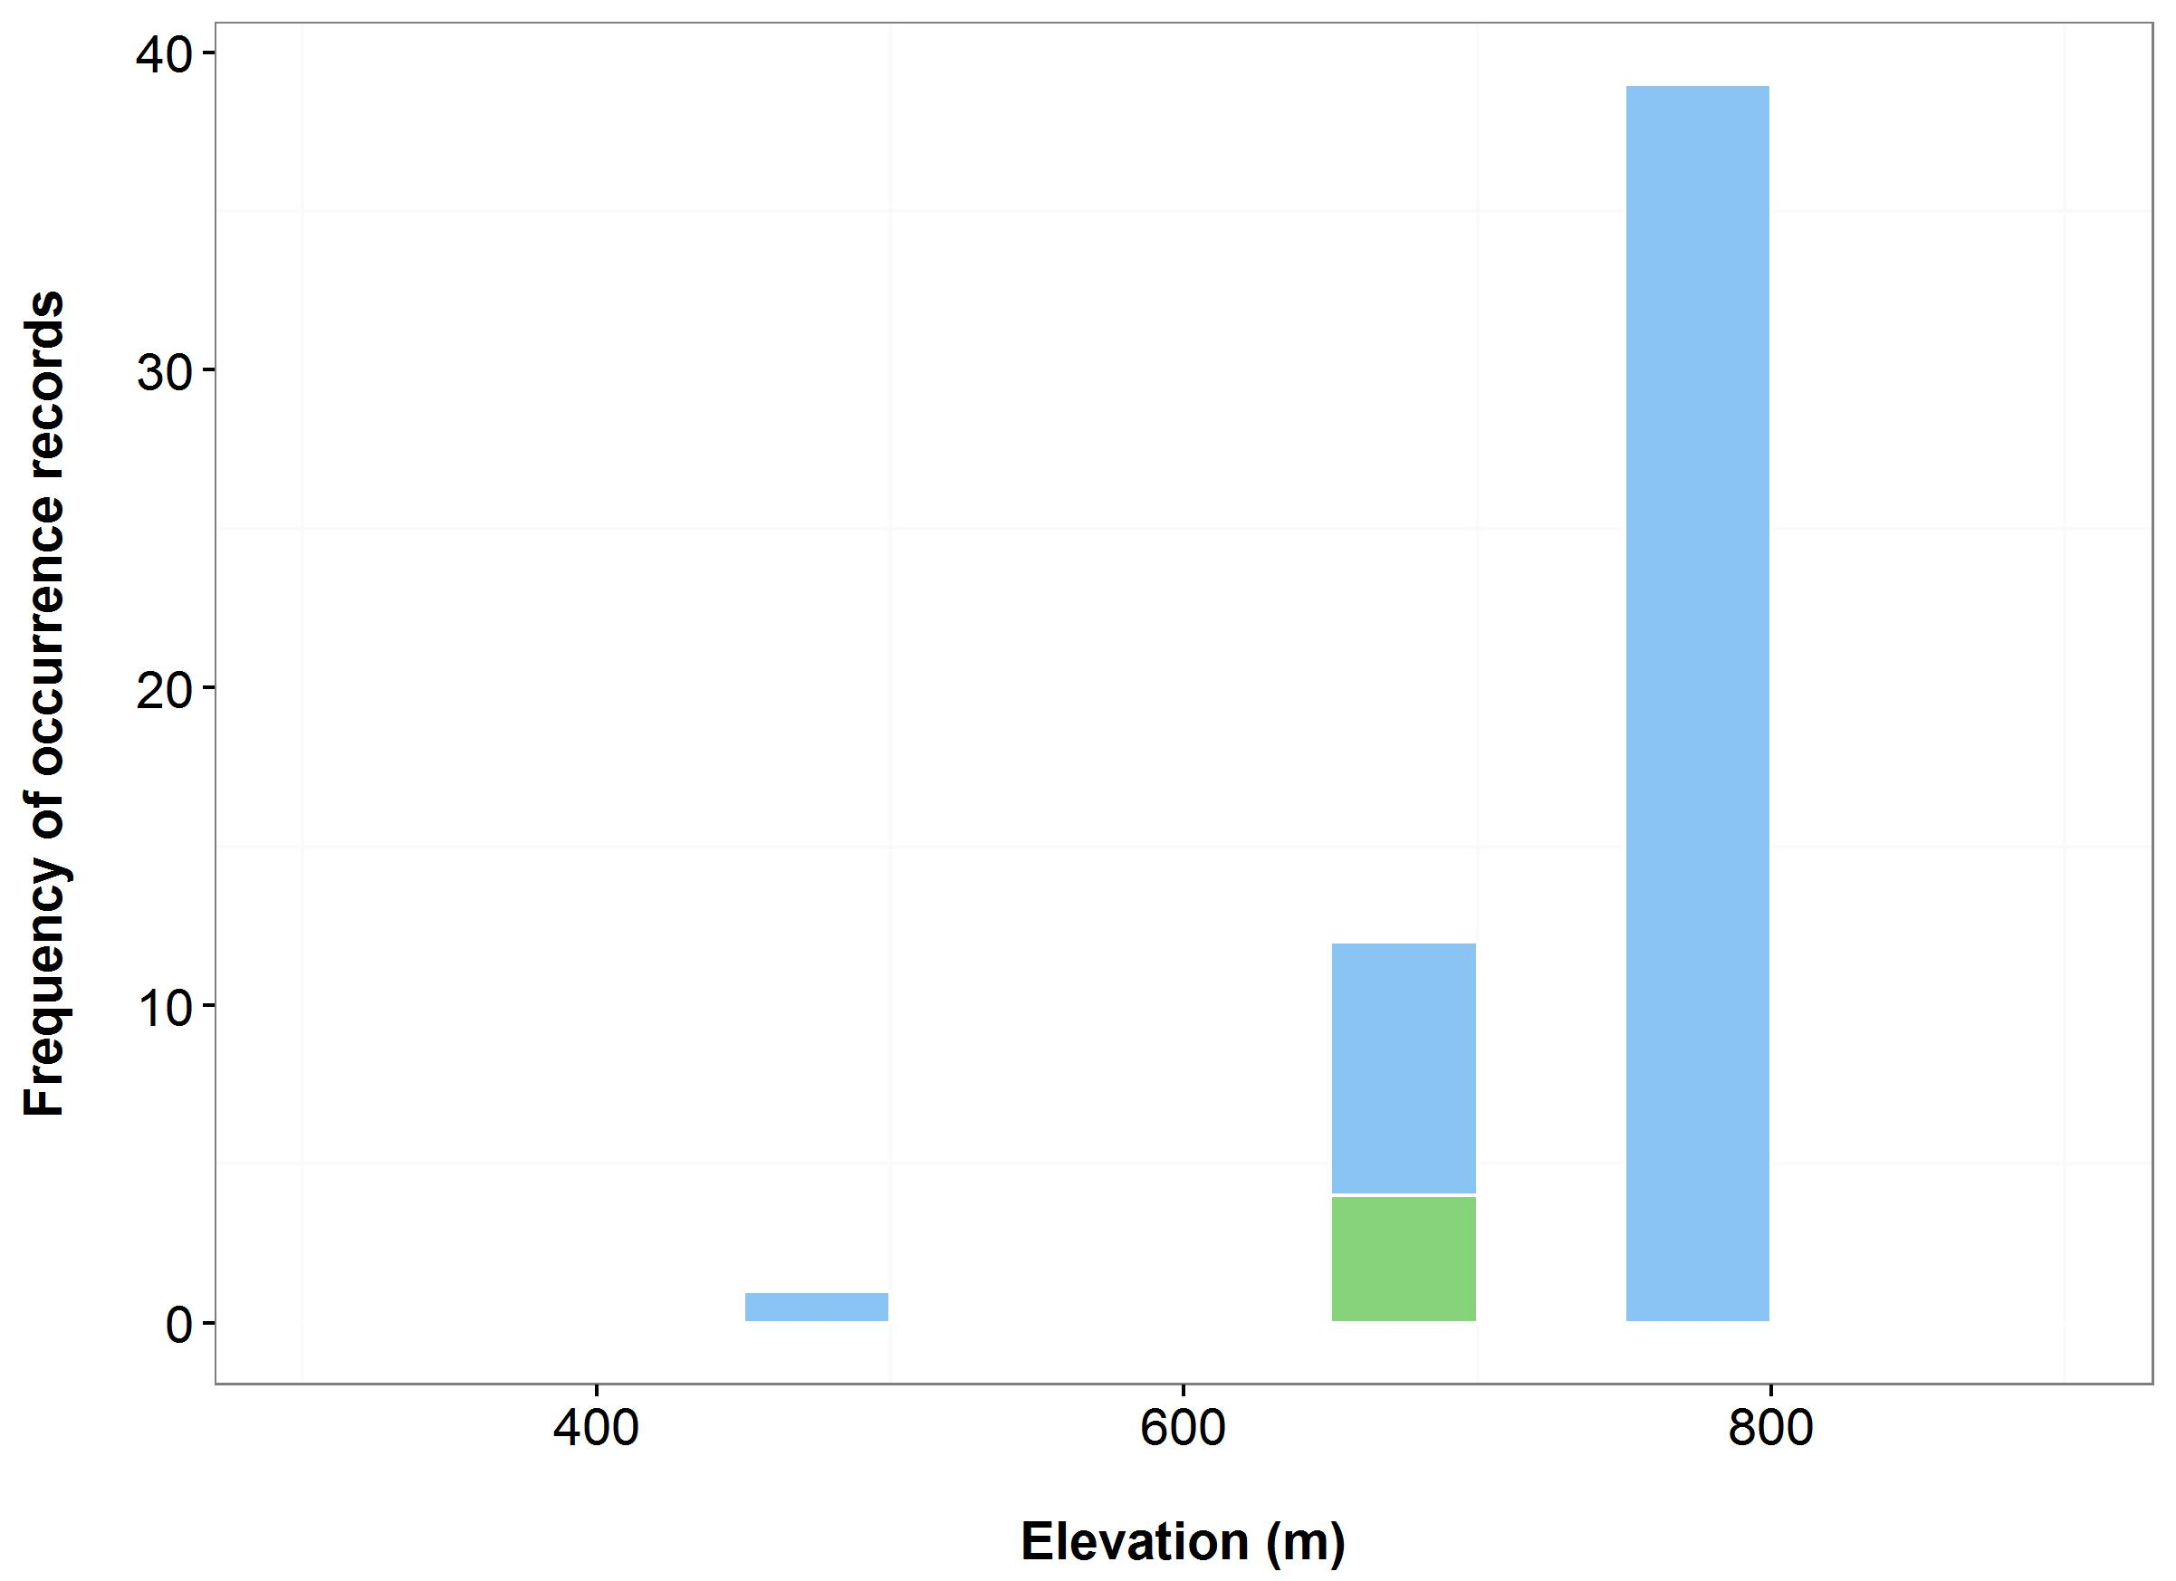

(d)

(c)

**Figure 29.** Environmental variables for the NSW distribution of *Eucalyptus imlayensis*that are outside of Saving our Species (SoS) management sites (blue bars/dots) and within management sites (green bars/dots): mean annual temperature (MAT) (a); mean annual precipitation (MAP) (b); elevation (c); and scatterplot of MAT and MAP (d).

***Name:*** *Lepidorrhachis mooreana* (Little Mountain Palm)

***Growth form:*** Palm

***Habitat:*** Restricted to the cloud forest vegetation at the summits of Mt Gower and Mt Lidgbird. Occurs above an elevation of approximately 740 m

***Distribution:*** Pacific Subtropical Islands Bioregion

***Threat status:*** CriticallyEndangered

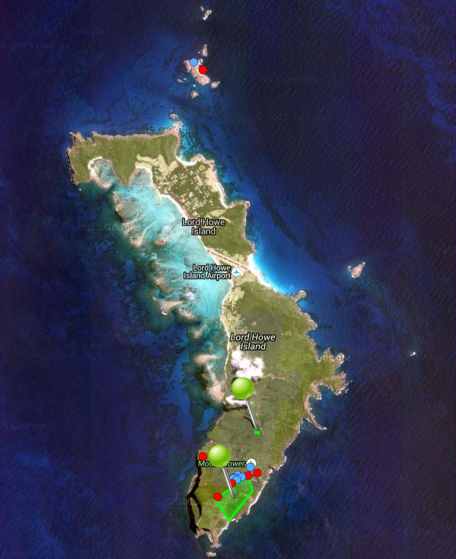

**Figure 30.** Map of species occurrence records in NSW for *Lepidorrhachis mooreana* (Little Mountain Palm). Records from Australia’s Virtual Herbarium are shown in red and records from the NSW Wildlife Atlas are shown in blue, with management sites marked in green.

***Climate change threat(s) identified in Final Determination***

* Changes to cloud formations (onset, magnitude and duration of cloud cover in summer)

***Number and name(s) of management sites, with estimated population size at each site:*** Two

* [Mt Lidgbird](javascript:__doPostBack('ctl00$ContentPlaceHolder1$gridSites$ctl00$ctl04$linkSite','')): n/a
* [Mt Gower](javascript:__doPostBack('ctl00$ContentPlaceHolder1$gridSites$ctl00$ctl06$linkSite','')): n/a

***Are all extant sites managed?***

* Yes

***Is a translocation site suggested?***

* Yes

***How is climate change threat addressed in the SoS conservation project?***

* SoS conservation project acknowledges climate change is a major threat (both with and without management) as species restricted to mountain summits. Also states Mt Lidgbird site more vulnerable to climate change (100 m lower in elevation than Mt Gower).
* There is a management action at the Mt Lidgbird site to conduct a survey to increase understanding of the species’ ecological requirements which may help to better understand/predict the impacts of climate change on the species.

***Suggestions to improve species adaptive capacity and resilience to climate change***

* Identify potential translocation sites likely to be buffered against climate change – However, this may not be achievable because the species is restricted to mountain summits (cloud forest) and endemic to Lord Howe Island.
* In preparation for supplementation/translocation, determine population genetic parameters: between-population genetic differences, within-population genetic diversity and inbreeding.
* Since both extant populations are on reserved land and occur on mountain summits, it is unlikely that the species can be translocated to more resilient locations. Therefore management needs to focus on increasing the resilience of extant populations to climate change by managing/reducing all other known threats.
* *Ex-situ* conservation (seed collection/storage, cultivation) may be necessary to ensure survival, since species restricted to mountain summits.

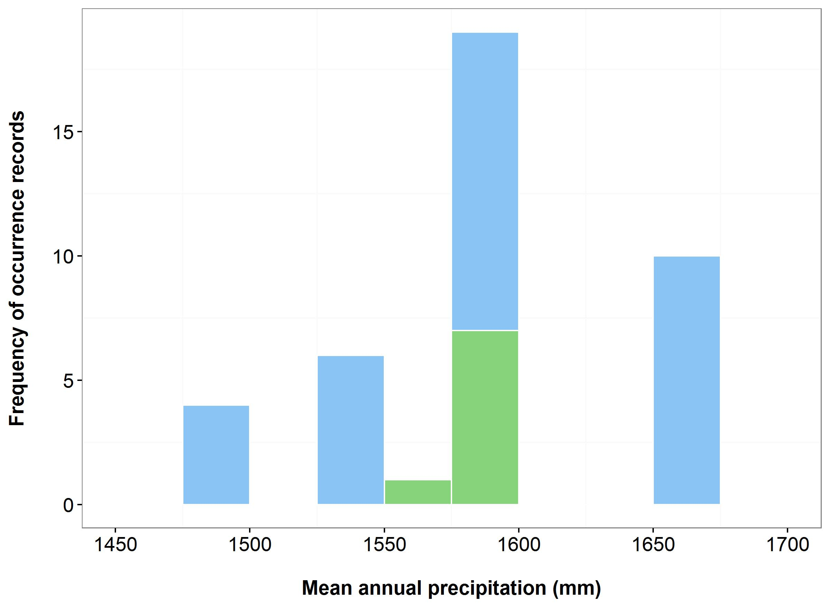

(a)

(b)

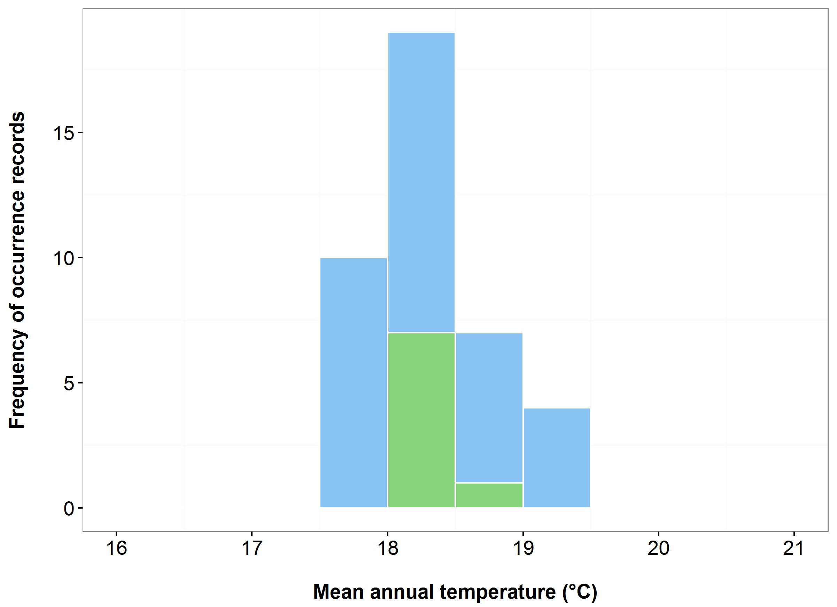



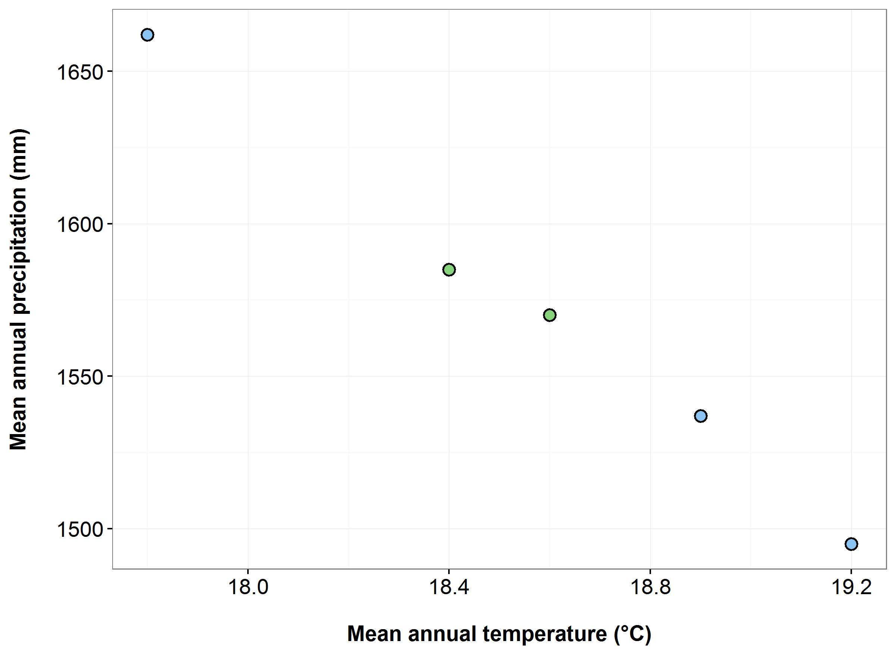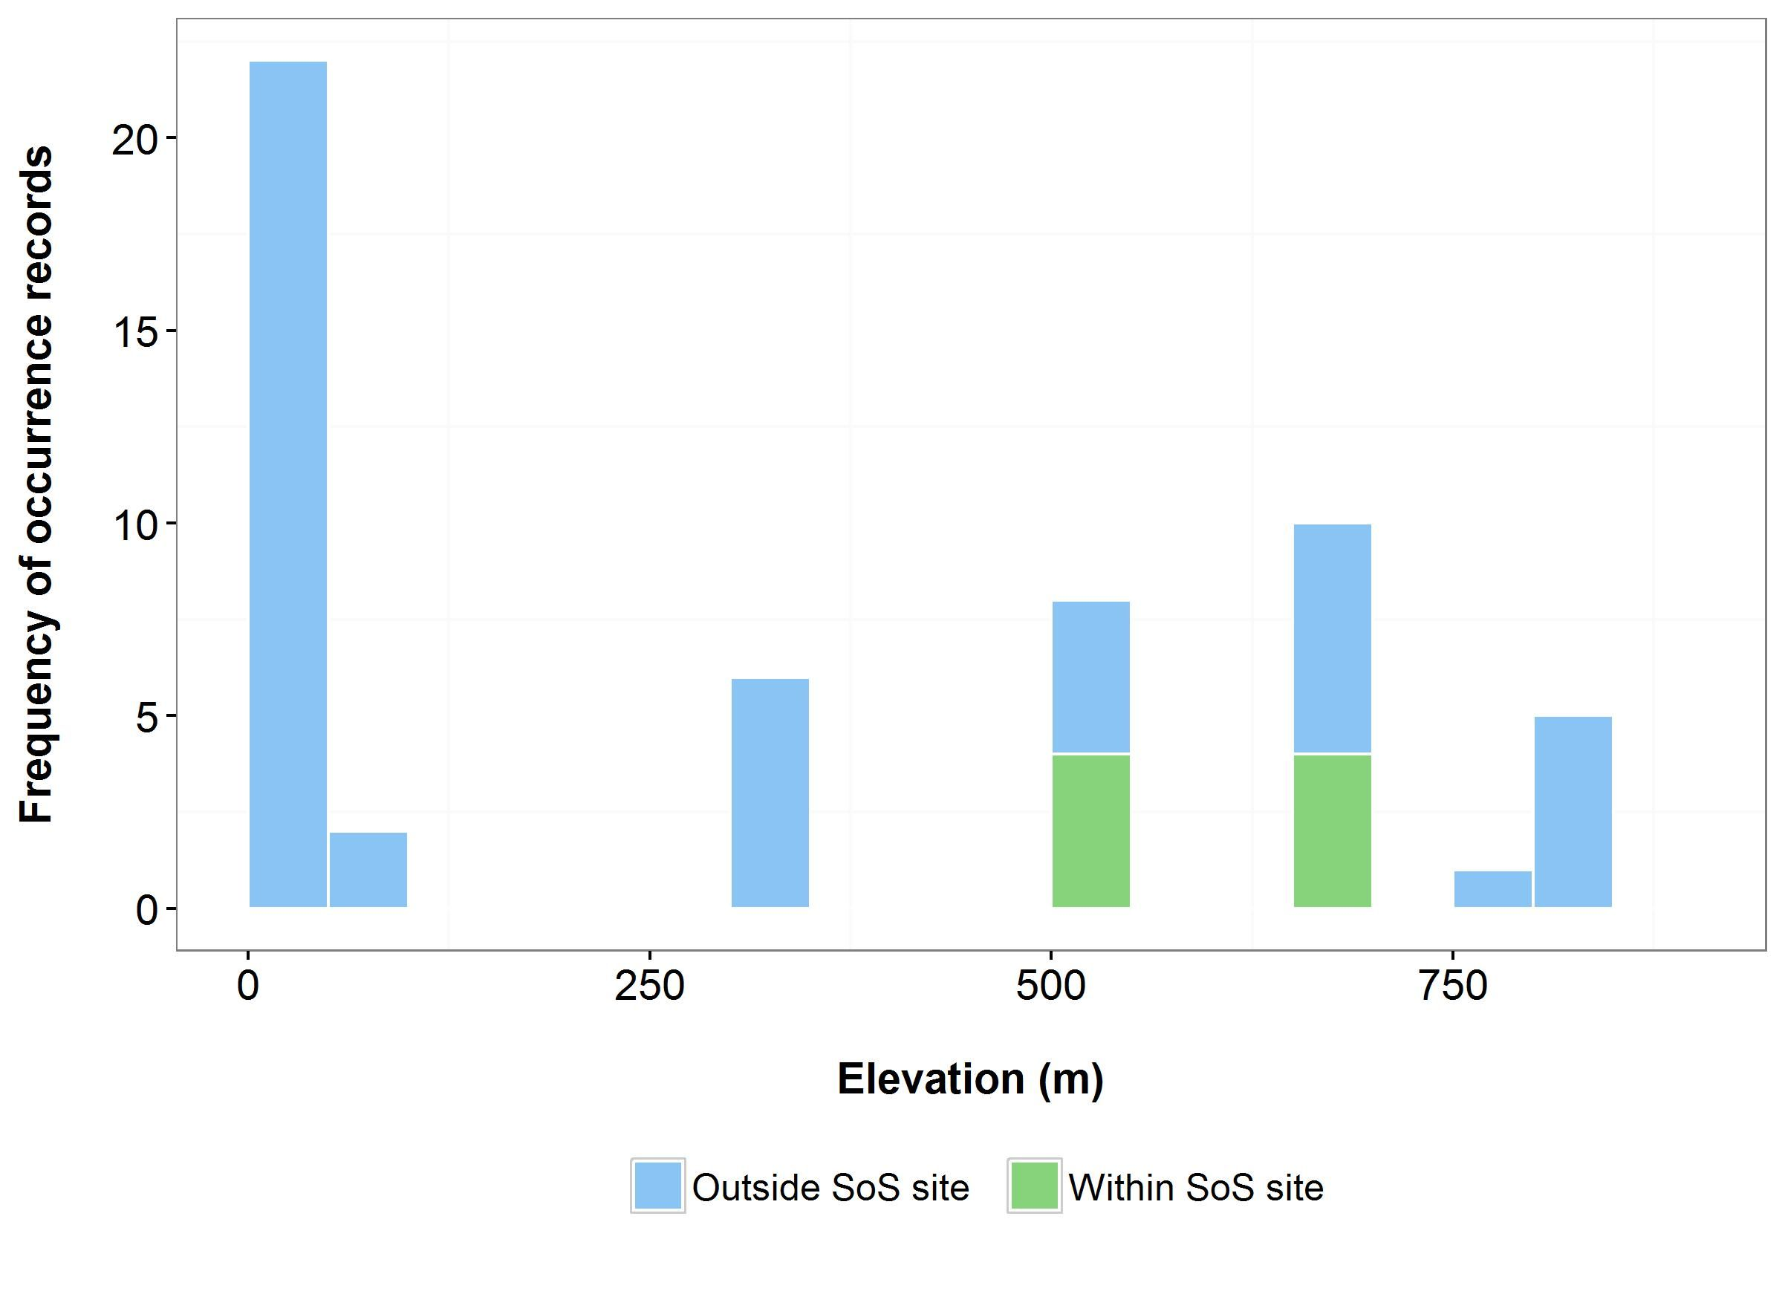

(d)

**(c)**

**Figure 31.** Environmental variables for the NSW distribution of *Lepidorrhachis mooreana* that are outside of Saving our Species (SoS) management sites (blue bars/dots) and within management sites (green bars/dots): mean annual temperature (MAT) (a); mean annual precipitation (MAP) (b); elevation (c); and scatterplot of MAT and MAP (d). N.B. Climate data sourced from Bioclim <http://www.worldclim.org/bioclim>. The resolution for mapping elevation on Lord Howe Island is coarse and the action of rounding of lat/longs has caused distortions (occurrences at 0m).

***Name:*** *Pomaderris walshii*(Carrington Falls Pomaderris)

***Growth form:*** Shrub/Tree

***Habitat:*** Riparian habitat varying from shrubland to open grassy forest

***Distribution:*** Sydney Basin Bioregion

***Threat status:*** CriticallyEndangered

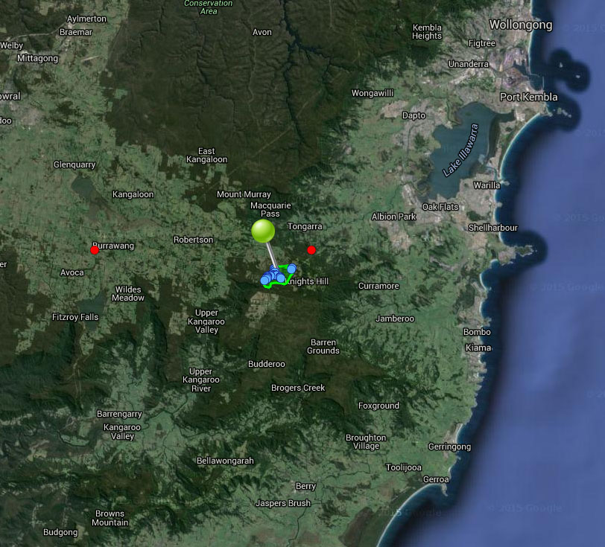

**Figure 32.** Map of species occurrence records in NSW for *Pomaderris walshii*(Carrington Falls Pomaderris). Records from Australia’s Virtual Herbarium are shown in red and records from the NSW Wildlife Atlas are shown in blue, with management sites marked in green.

***Climate change threat(s) identified in Final Determination***

* Changes to precipitation (orographic rainfall)
* Reduction in extent of preferred habitat

***Number and name(s) of management sites, with estimated population size at each site:*** One

* [Carrington Falls](javascript:__doPostBack('ctl00$ContentPlaceHolder1$gridSites$ctl00$ctl04$linkSite','')): 74

***Are all extant sites managed?***

* Yes

***Is a translocation site suggested?***

* Yes – suggest two new populations (translocation sites) needed. Potential sites include Belmore Falls and Fitzroy Falls.

***How is climate change threat addressed in SoS conservation project?***

* Notes to justify probability of viability with management recognition that climate change is a threat.
* There is a management action to supplement the extant population with ex-situ material which will increase the resilience to climate change.
* Current work includes survey and seed banking (ANU) so that species can be reintroduced into new locations based on survey work/habitat modelling to identify preferred habitat.

***Suggestions to improve species adaptive capacity and resilience to climate change***

* **Species distribution modelling results for site selection**. By 2030, low to high quality habitat is likely to remain across Carrington Falls under all scenarios except warm/dry. Highest quality habitat is projected under the warm/wet scenario, and this is likely to be retained until at least 2070 (Figure 33). Under the other scenarios, climate suitability is projected to be poor. Few occurrence records were available for species distribution modelling, meaning that model results should be treated with caution. However, these results suggest that the location and number of current management sites may not be suitable in the future and sites currently outside of the species distribution may have to be considered. Use species distribution modelling, knowledge of species’ requirements, environmental variation data (Figure 34) and <http://www.nswthreatenedspecies.net/>) to select appropriate sites. As well as climate, need to consider habitat (riparian shrubland dominated by *Callicoma serratifolia*, *Ceratopetalum apetalum*, and *Grevillea rivularis and* disturbed open grassy forest dominated by *Eucalyptus fastigata*, partly cleared for grazing), soil type (sandy alluvium), land tenure and other threats.
* In preparation for supplementation/translocation, determine population genetic parameters: within-population genetic diversity and inbreeding.

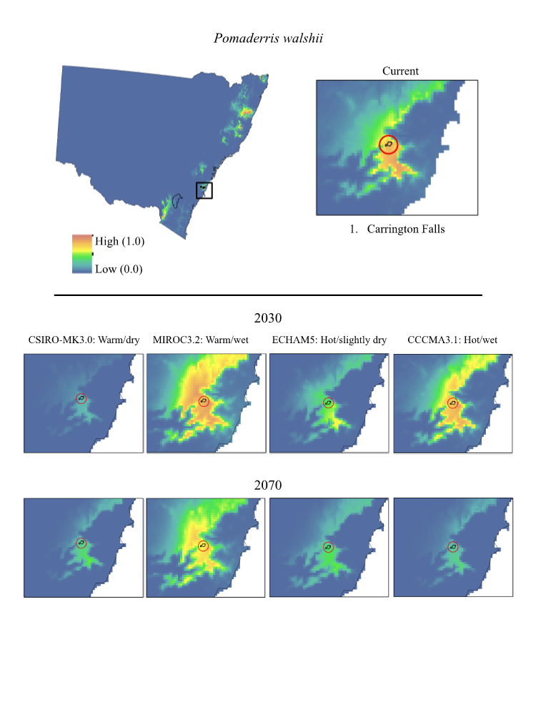

**Figure 33.** Maps of projected current and future (2030, 2070) suitable habitat for *Pomaderris walshii* (Carrington Falls Pomaderris) across its site-managed location, highlighted in red in the top right panel.

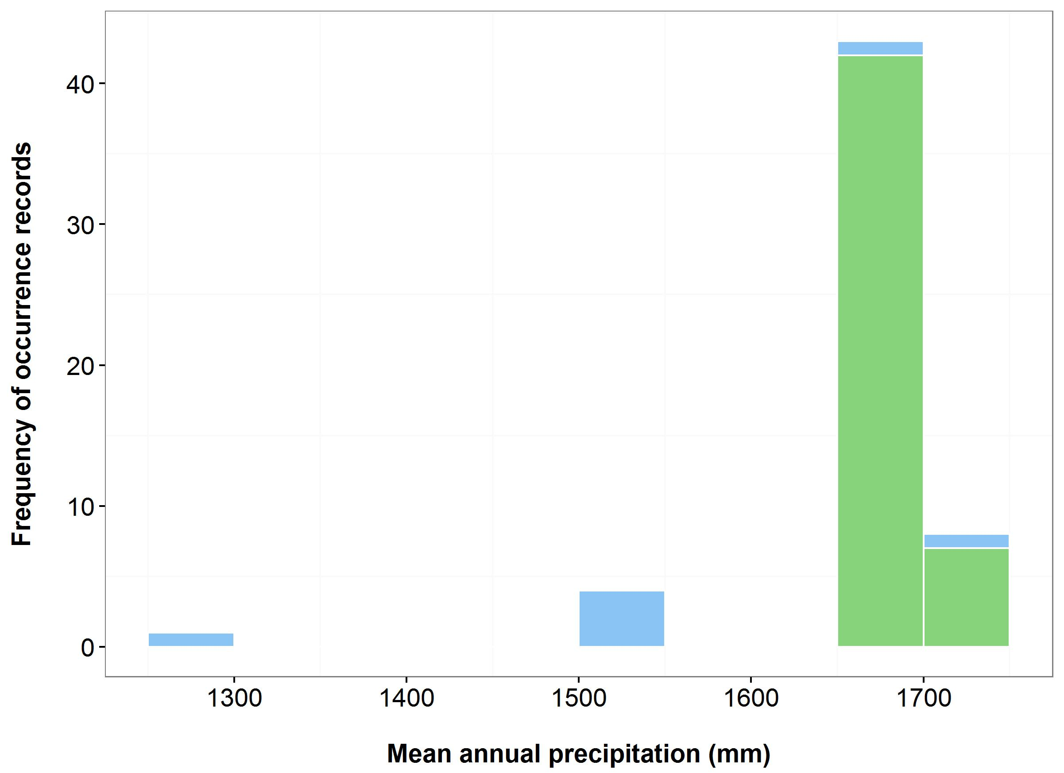

(a)

(b)

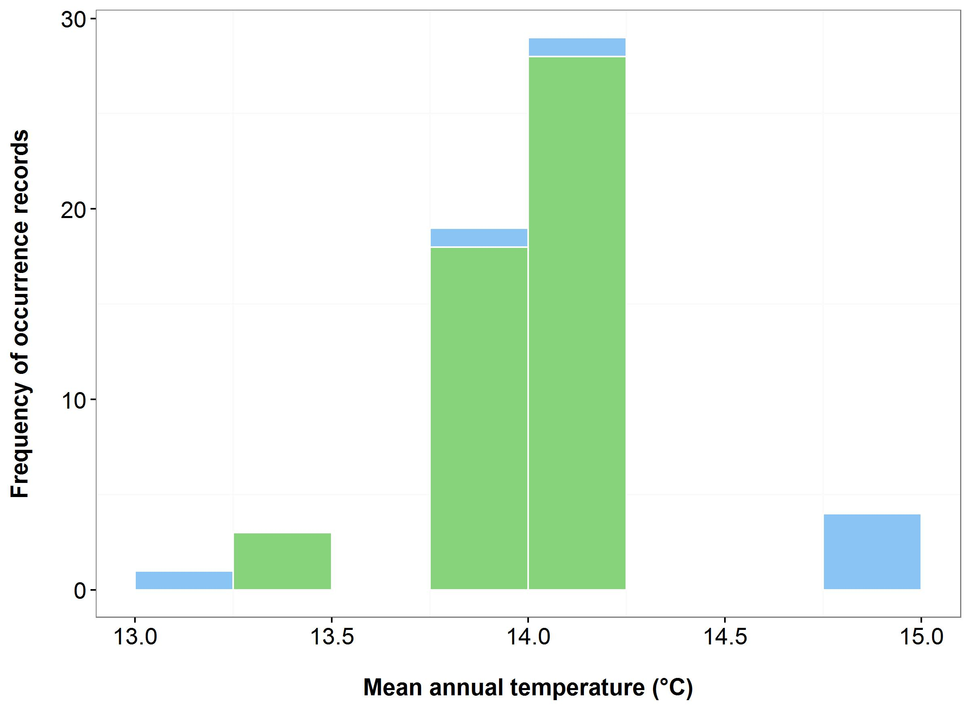



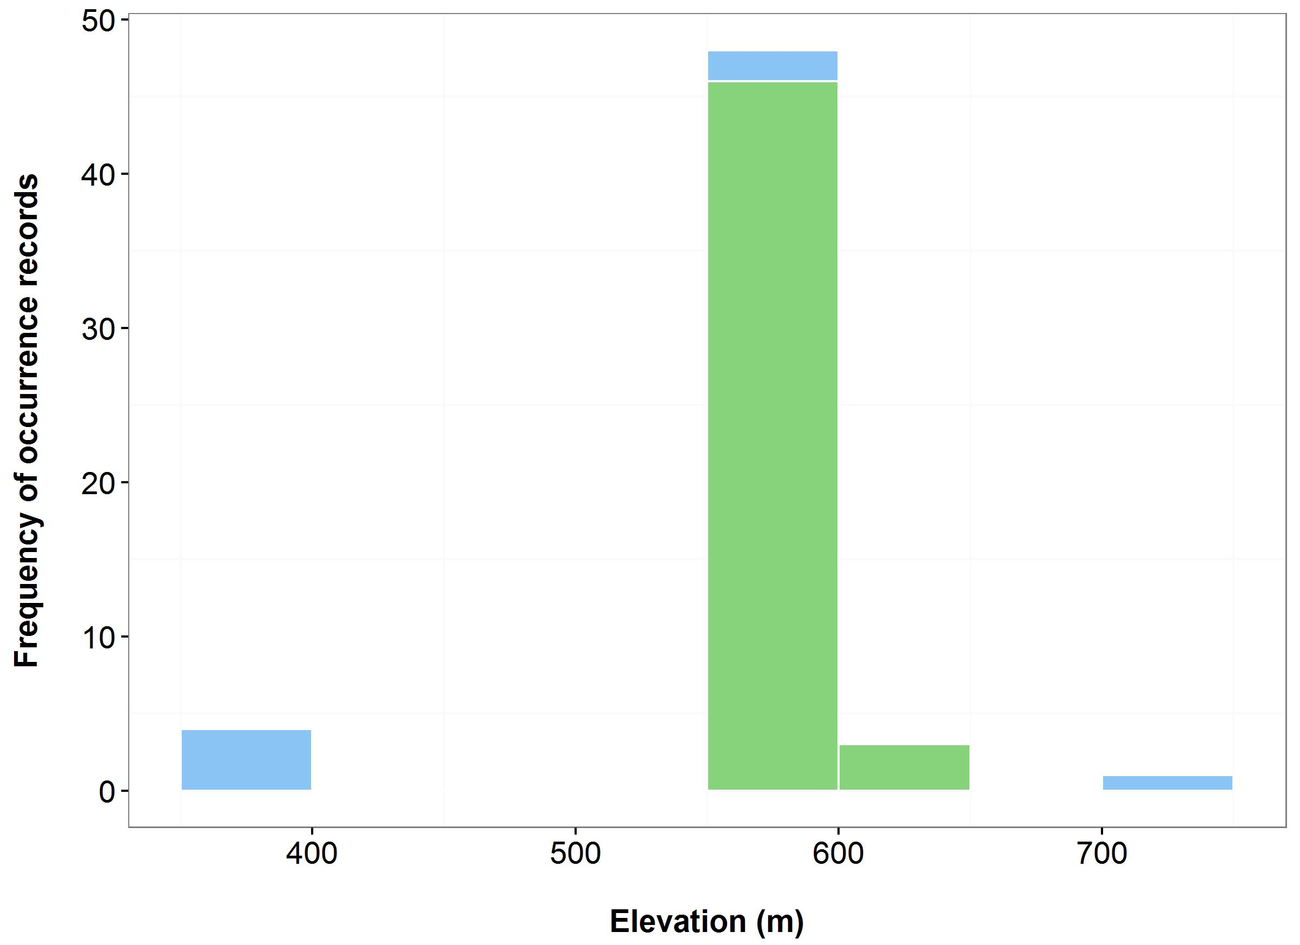

(c)

(d)

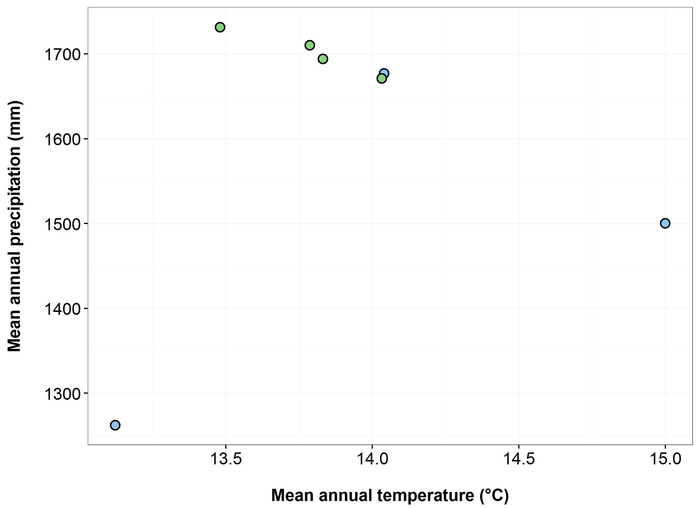

**Figure 34.** Environmental variables for the NSW distribution of *Pomaderris walshii*that are outside of Saving our Species (SoS) management sites (blue bars/dots) and within management sites (green bars/dots): mean annual temperature (MAT) (a); mean annual precipitation (MAP) (b); elevation (c); and scatterplot of MAT and MAP (d).

***Name:*** *Prasophyllum keltonii* (Kelton's Leek Orchid)

***Growth form:*** Herb

***Habitat:*** Highly restricted habitat on the treeless McPhersons Plain, an area that includes sub-alpine grassland, sphagnum bogs, and open heathland, at an elevation of 1,100 m. The species has a preference for grassland

***Distribution:*** South Eastern Highlands Bioregion

***Threat status:*** CriticallyEndangered

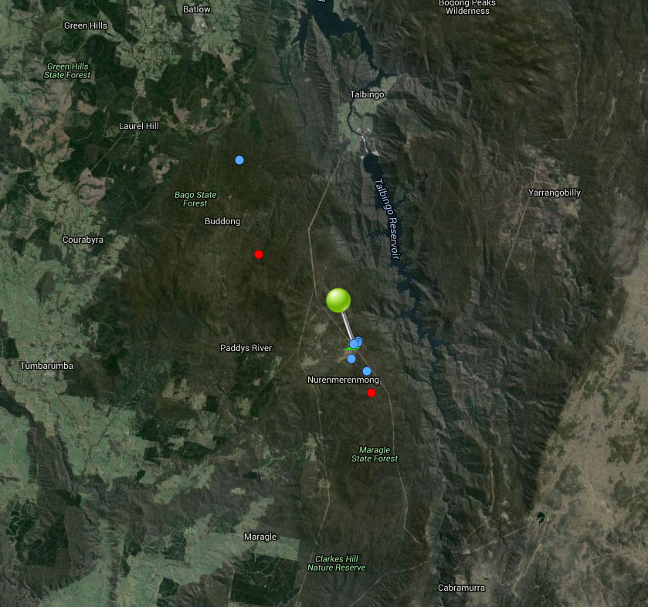

**Figure 35.** Map of species occurrence records in NSW for *Prasophyllum keltonii* (Kelton's Leek Orchid). Records from Australia’s Virtual Herbarium are shown in red and records from the NSW Wildlife Atlas are shown in blue, with management sites marked in green.

***Climate change threat(s) identified in Final Determination***

* Altered hydrology

***Number and name(s) of management sites, with estimated population size at each site:*** One

McPhersons Plain: 400

***Are all extant sites managed?***

* Yes

***Is a translocation site suggested?***

* No

***How is climate change threat addressed in SoS conservation project?***

There is a management action to prevent future damming projects which may restrict water to McPhersons Plain.

* There is a management action to supplement the extant population with *ex-situ* material which will also increase resilience to climate change.

S***uggestions to improve species adaptive capacity and resilience to climate change***

* Monitoring/management of water availability at extant site is essential.
* Consider appropriate strategies to allow for dependence on moisture including: protect and restore moist environments; change land use and vegetation retention and restoration in catchments to reduce runoff and to increase rainfall retention in soils and vegetation; manufactured strategies e.g. the creation of artificial water bodies, use of portable irrigation frames or pumps, misting/ sprinklers; use of water storage devices (Lee *et al.* 2015).
* Identify translocation sites. Not enough occurrence records for species distribution modelling but use knowledge of predicted future climate and species’ requirements, environmental variation data (Figure 36) and <http://www.nswthreatenedspecies.net/>) to select appropriate sites. Some sites at higher elevations may be available (Figure 36c). As well as climate, need to consider habitat (tall wet sphagnum heath, fens, and open heathland adjacent to aquatic sedgelands, at 1,100 m elevation, preference for moderately boggy ground), soil type (moisture retentive brown loam), land tenure and other threats. Species also requires symbiotic fungus to reproduce.
* Collection and storage of seeds/plant material is already factored into the management action to supplement the population at McPhersons Plain. Determine germination/propagation requirements (including mycorrhizal associations) so are ready for supplementation/translocation (Australian PlantBank).
* Determine population genetic diversity and level of inbreeding in preparation for translocation.

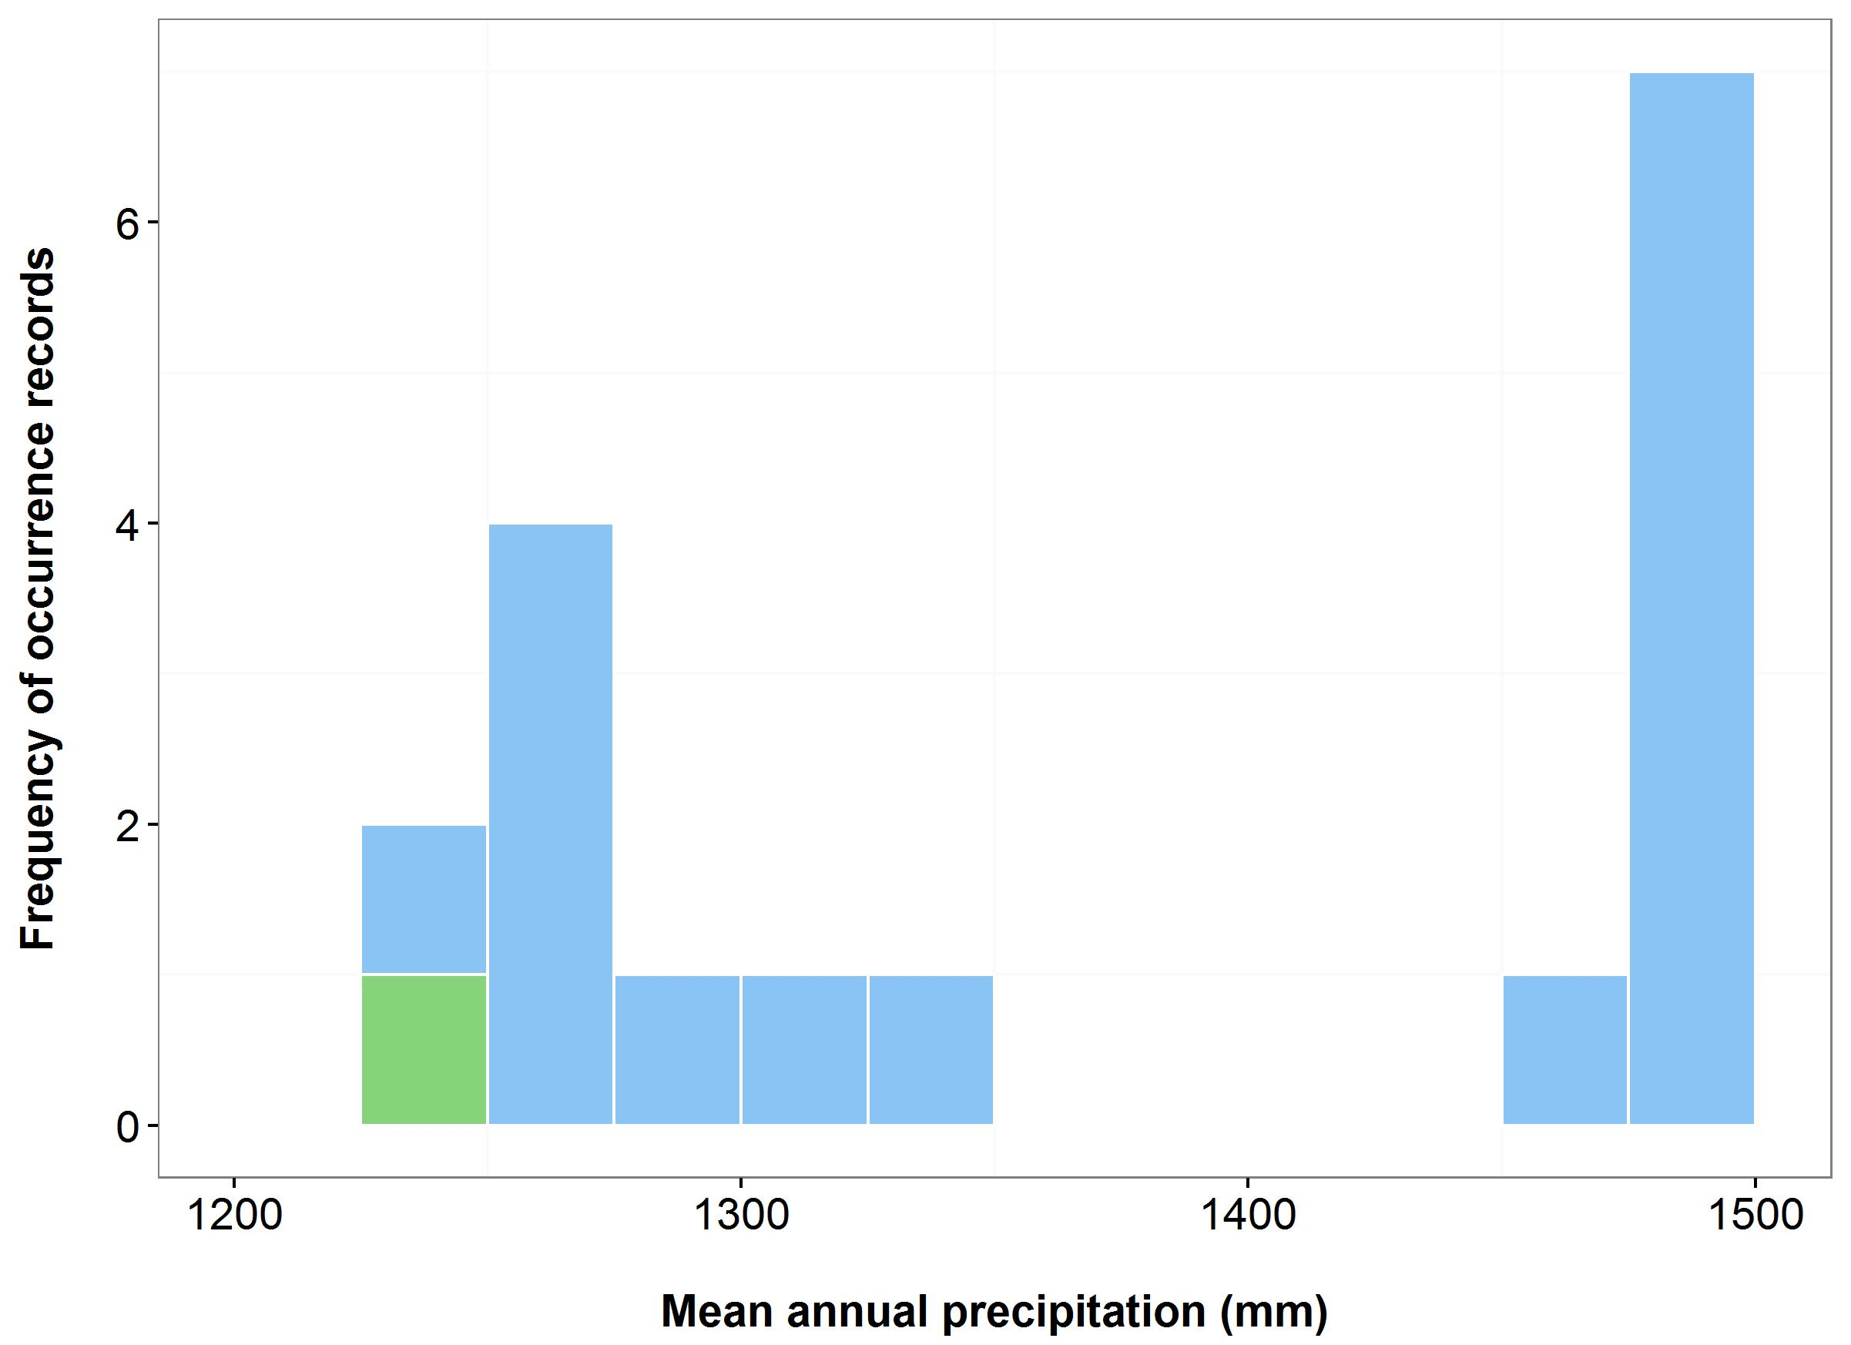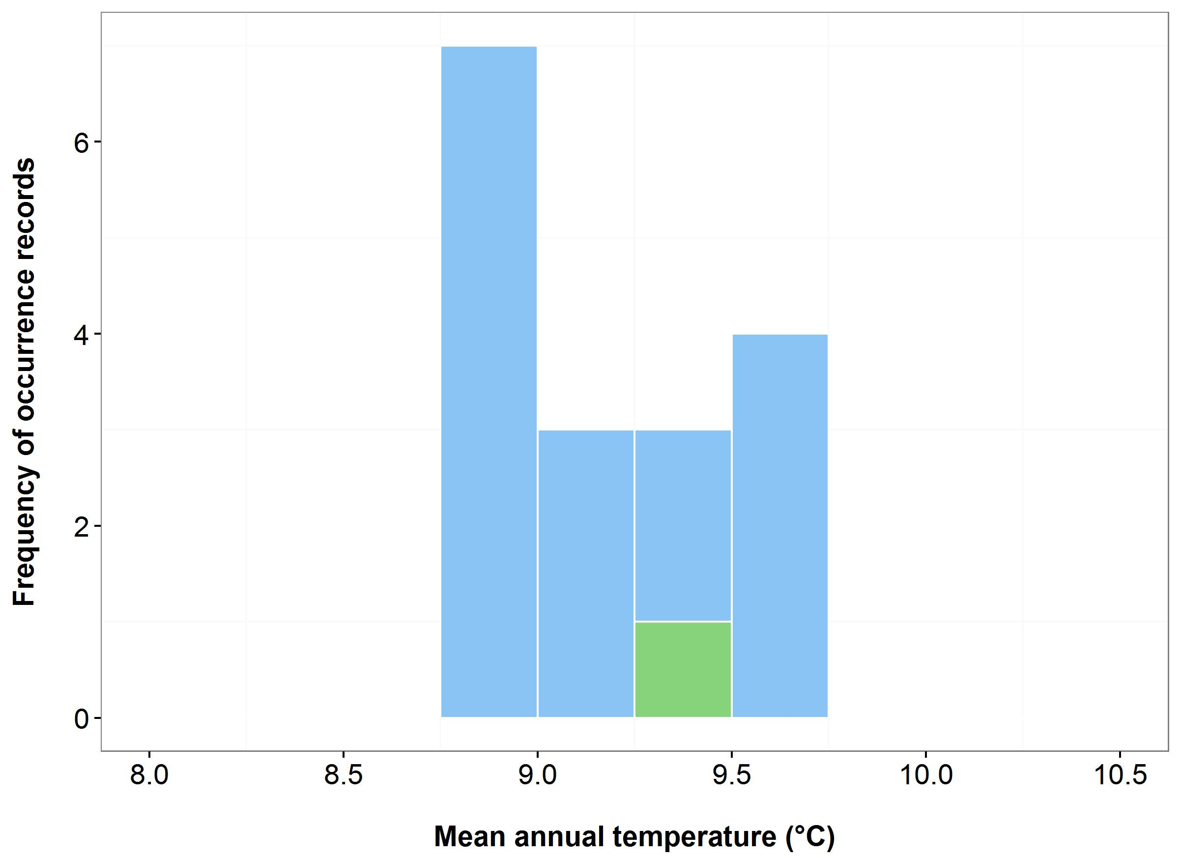

(a)

(b)



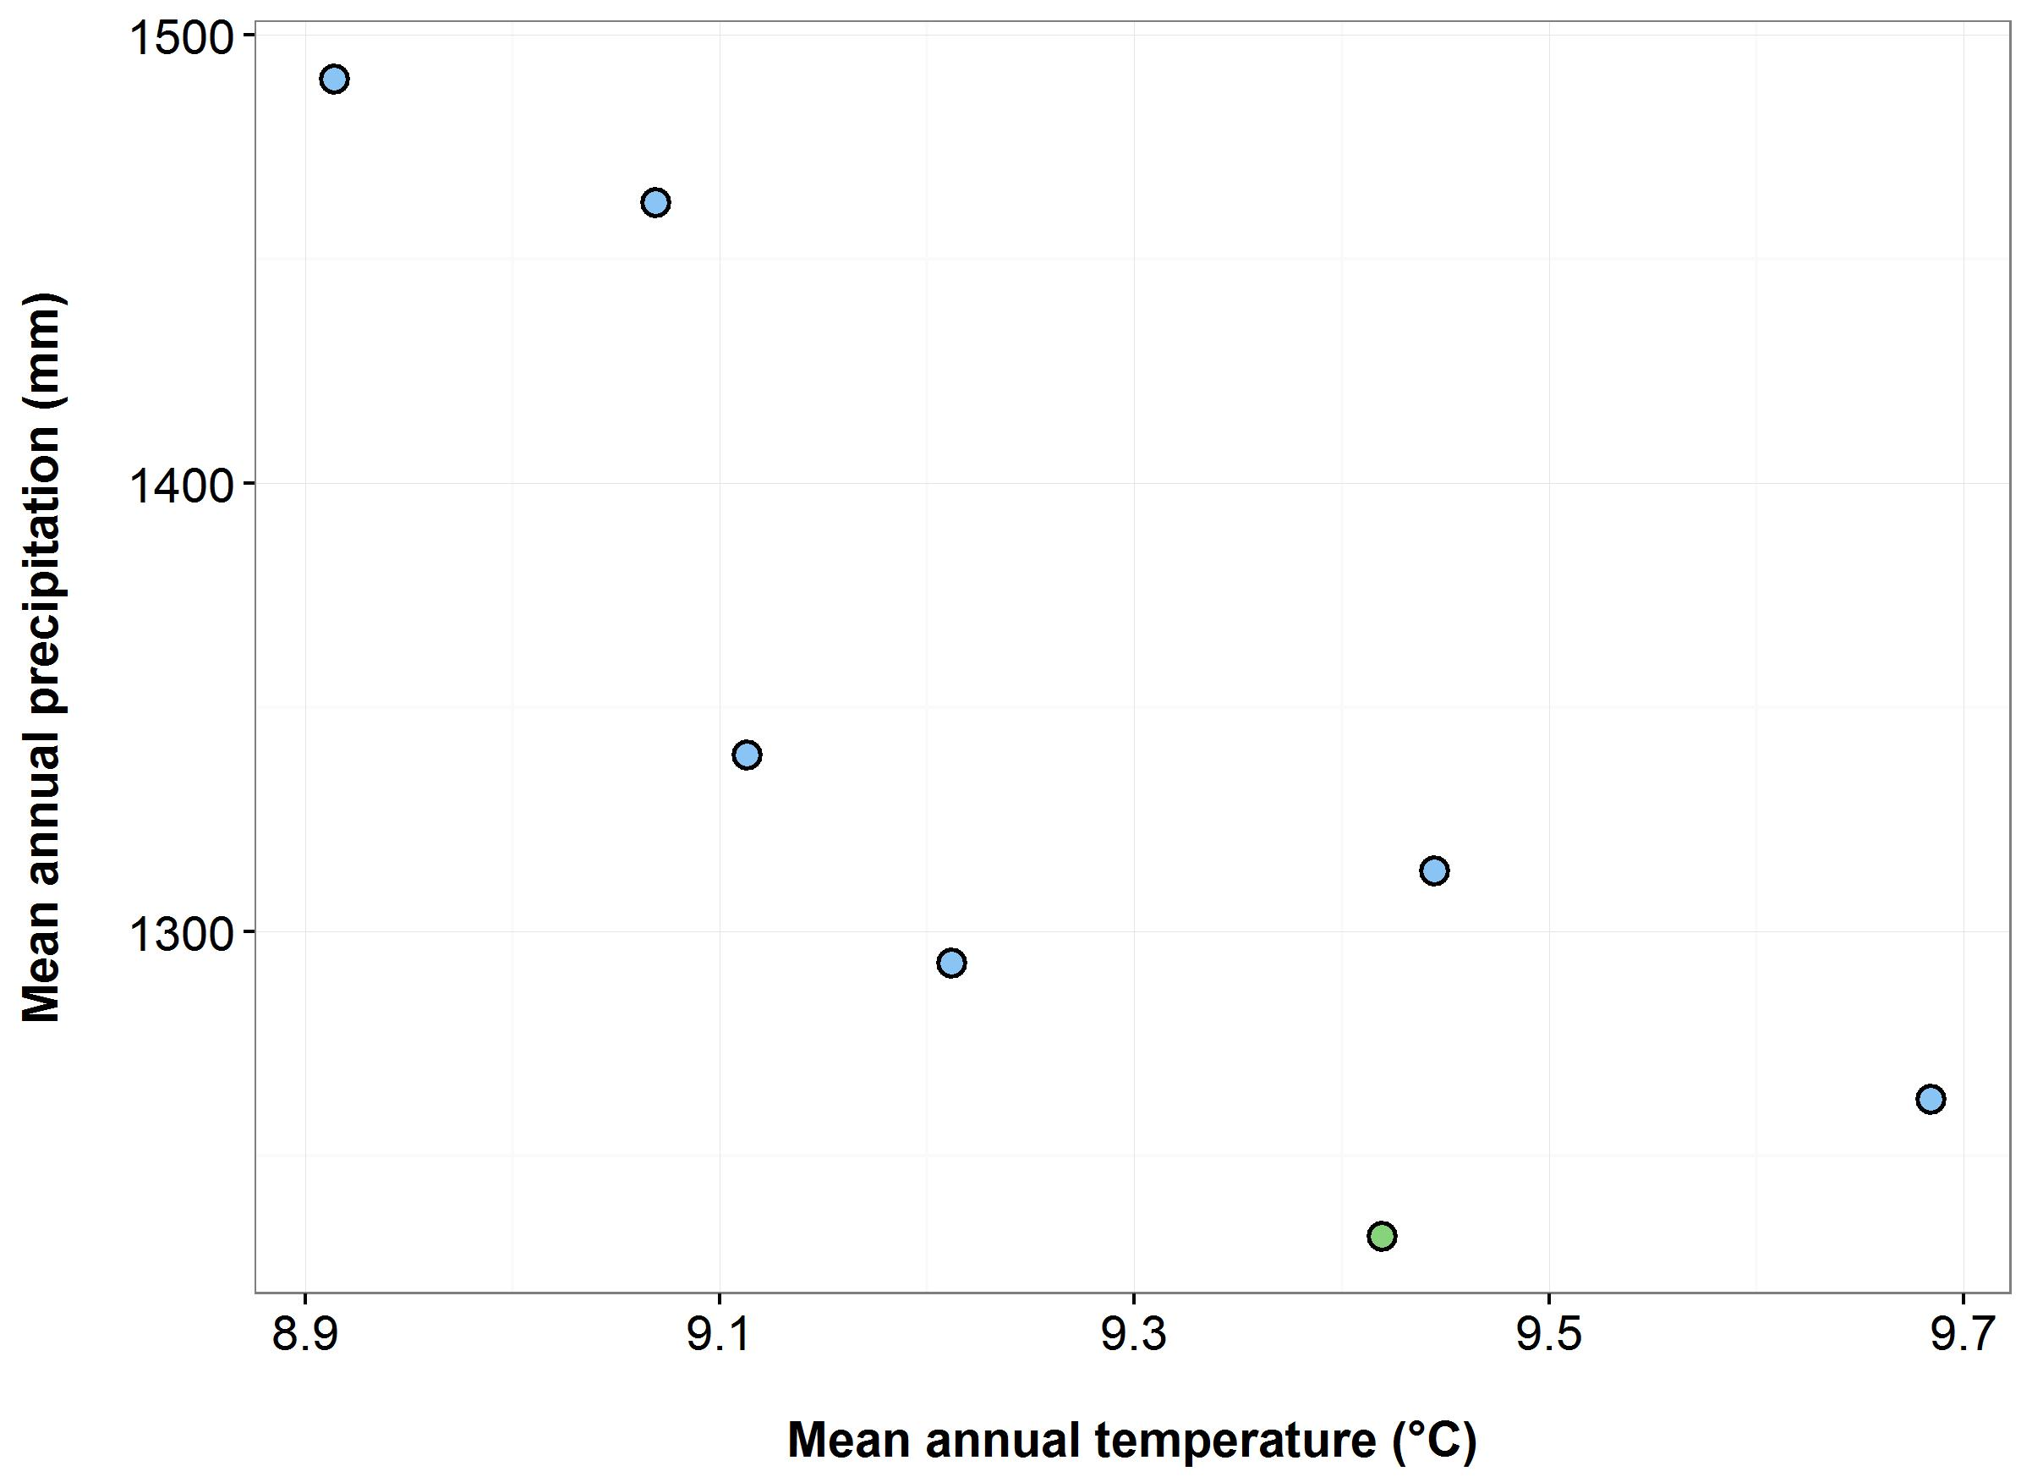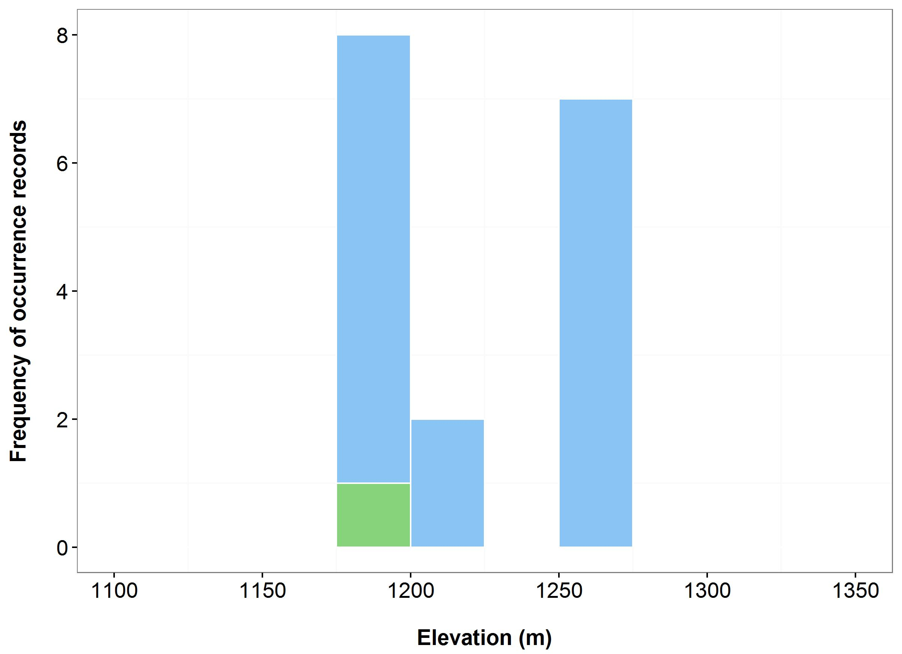

(c)

(d)

**Figure 36.** Environmental variables for the NSW distribution of *Prasophyllum keltonii* that are outside of Saving our Species (SoS) management sites (blue bars/dots) and within management sites (green bars/dots): mean annual temperature (MAT) (a); mean annual precipitation (MAP) (b); elevation (c); and scatterplot of MAT and MAP (d).

***Name:*** *Thelymitra kangaloonica* (Kangaloon Sun Orchid)

***Growth form:*** Herb

***Habitat:*** Swamps in sedgelands over grey silty grey loam soils

***Distribution:*** Sydney Basin Bioregion

***Threat status:*** CriticallyEndangered

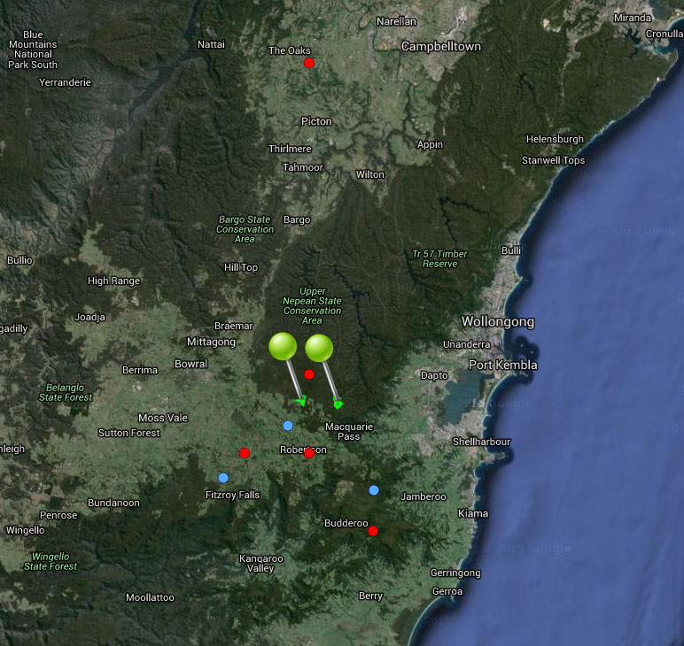

**Figure 37.** Map of species occurrence records in NSW for *Thelymitra kangaloonica* (Kangaloon Sun Orchid). Records from Australia’s Virtual Herbarium are shown in red and records from the NSW Wildlife Atlas are shown in blue, with management sites marked in green.

***Climate change threat(s) identified in Final Determination***

* Altered hydrology (drying of swamp habitat)

***Number and name(s) of management sites, with estimated population size at each site:*** Two

* [Butlers Swamp](javascript:__doPostBack('ctl00$ContentPlaceHolder1$gridSites$ctl00$ctl04$linkSite','')): 50
* [Molly Morgans Swamp](javascript:__doPostBack('ctl00$ContentPlaceHolder1$gridSites$ctl00$ctl06$linkSite','')): n/a

***Are all extant sites managed?***

* Yes (the current existence of two of the four recorded populations are doubtful)

***Is a translocation site suggested?***

* No

***How is climate change threat addressed in SoS conservation project?***

* Climate change threat (future drying out of swamps) is directly addressed at both management sites. There are actions to monitor and manage environmental water levels to meet species’ requirements.

S***uggestions to improve species adaptive capacity and resilience to climate change***

* Supplement both extant populations and consider translocations.
* Not enough occurrence records for species distribution modelling but use knowledge of predicted future climate and species’ requirements to select appropriate translocation sites. As well as climate, need to consider habitat/soil type (swamps in sedgelands over grey silty grey loam soils at 550-700 m altitude), land tenure and other threats.
* Enter all outstanding occurrence records into database to enable environmental variation data (Figure 38 and <http://www.nswthreatenedspecies.net/>) to be analysed to assist with site selection, e.g. select the highest elevation sites and capture the species’ broad range of environmental conditions.
* Collect seed from both extant populations. Determine germination/propagation requirements (including mycorrhizal associations) in preparation for supplementation/translocation (Australian PlantBank).
* In preparation for supplementation/translocation, determine population genetic parameters: between-population genetic differences, within-population genetic diversity and inbreeding.
* Consider appropriate strategies to allow for dependence on moisture including: protect and restore moist environments; change land use and vegetation retention and restoration in catchments to reduce runoff and to increase rainfall retention in soils and vegetation; manufactured strategies (Lee *et al.* 2015).

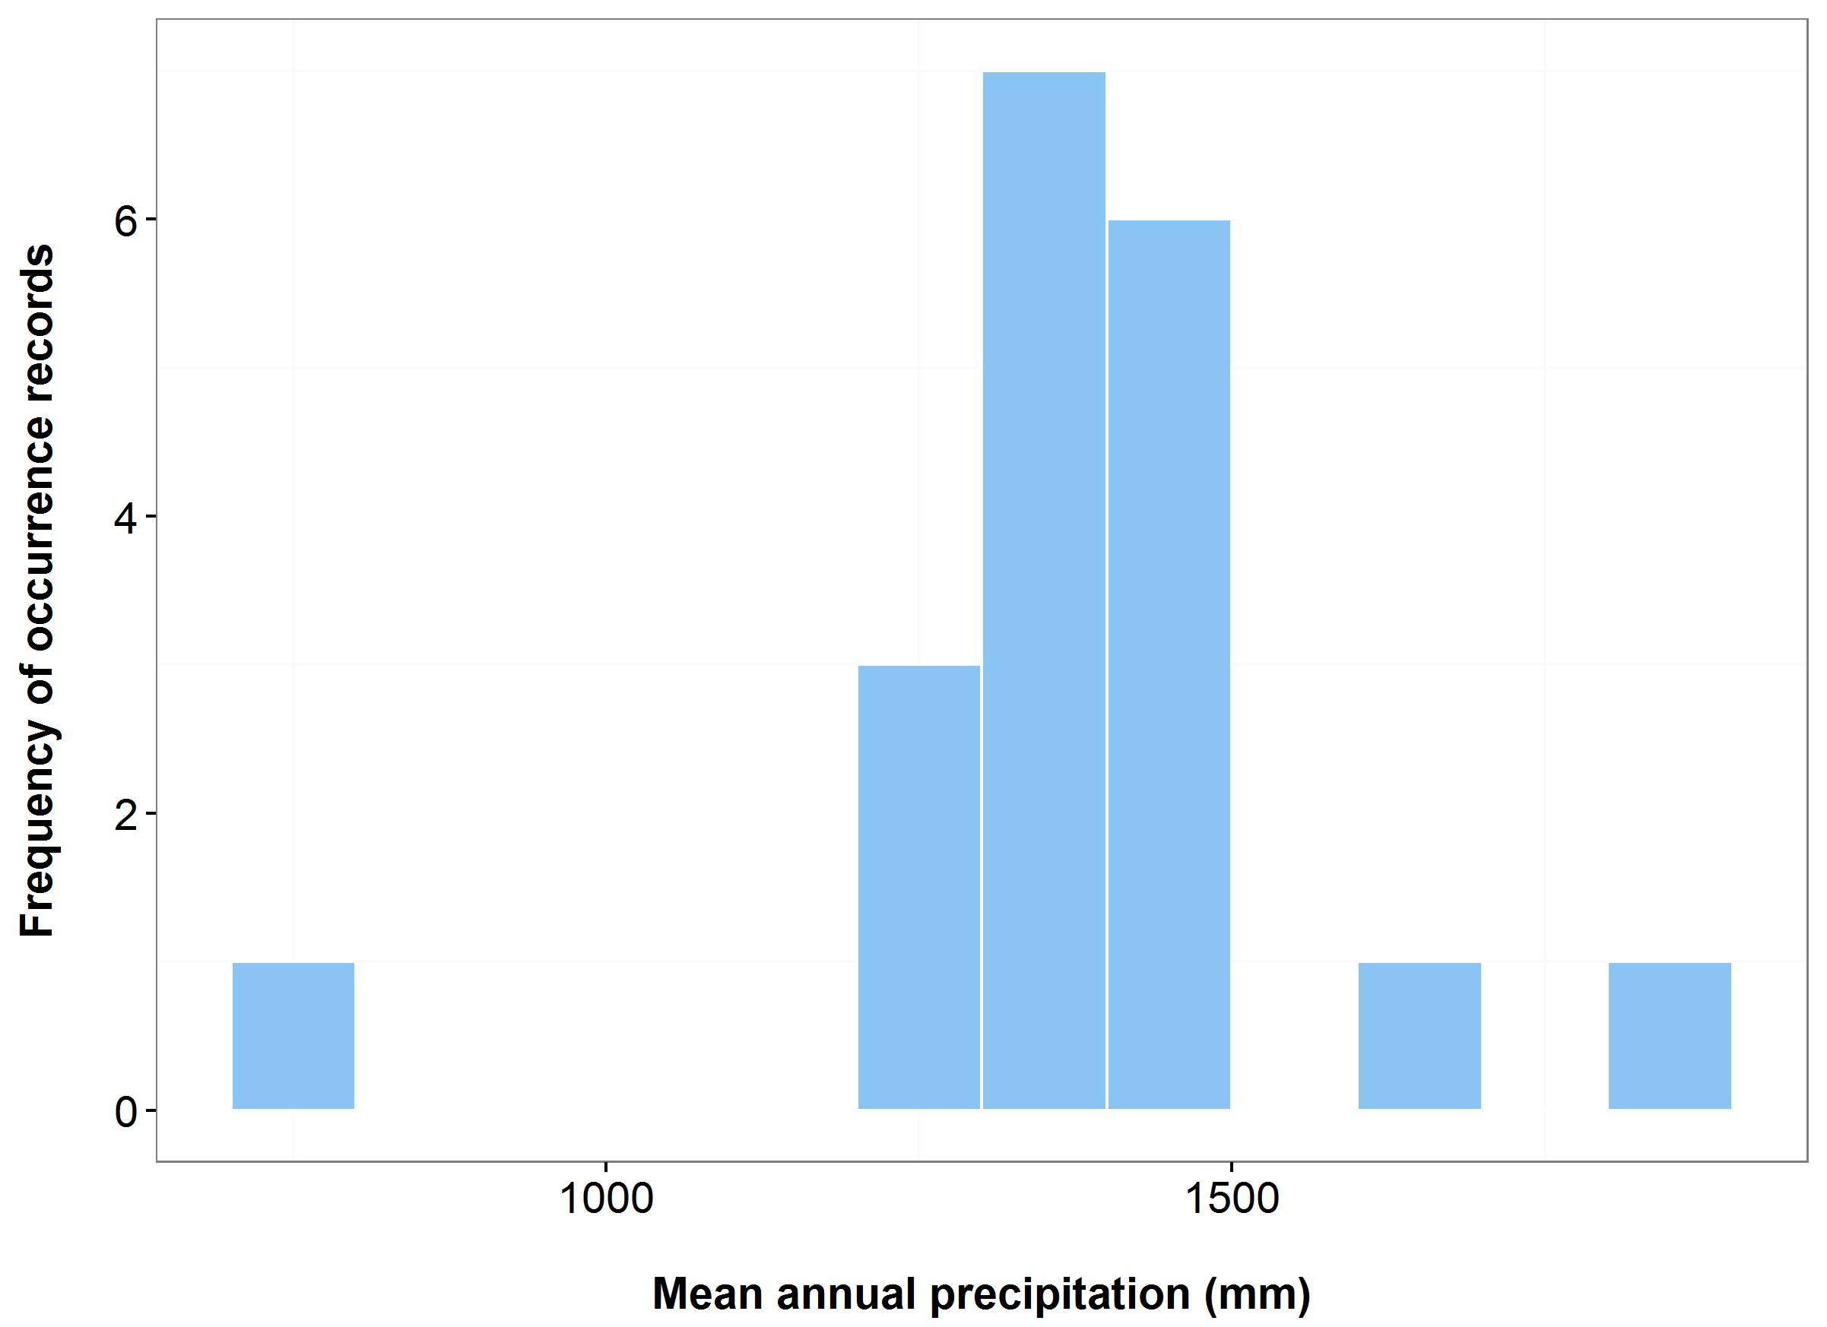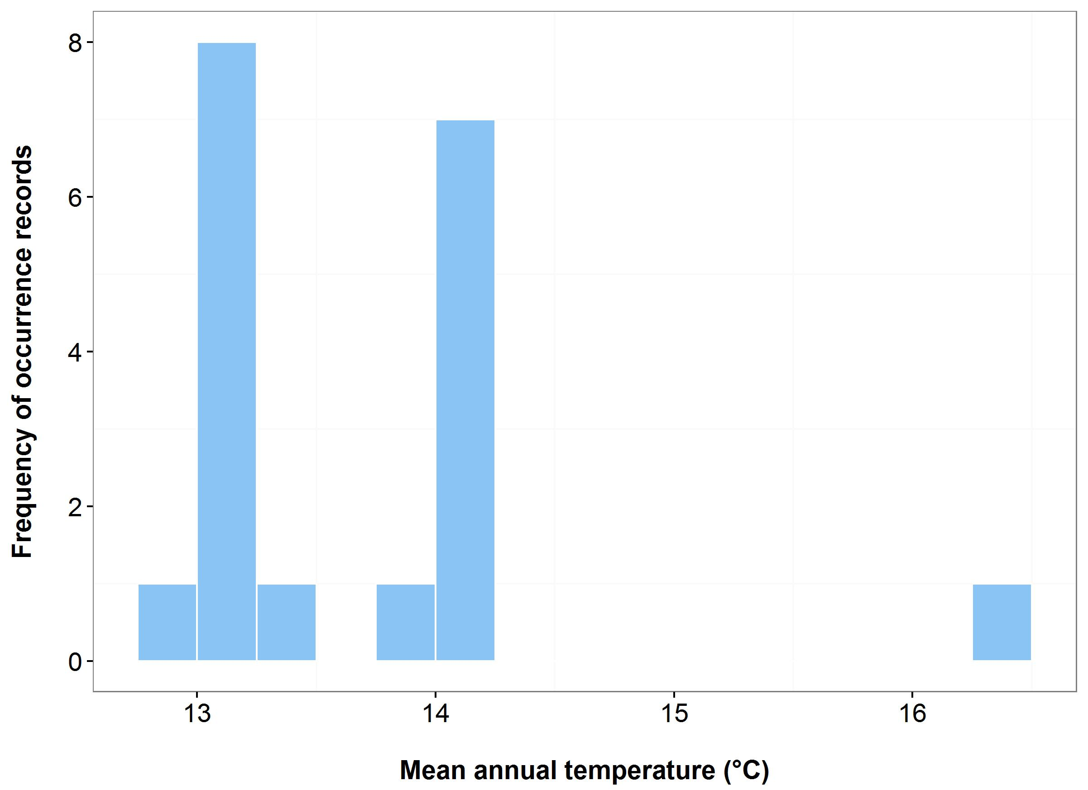

(a)

(b)



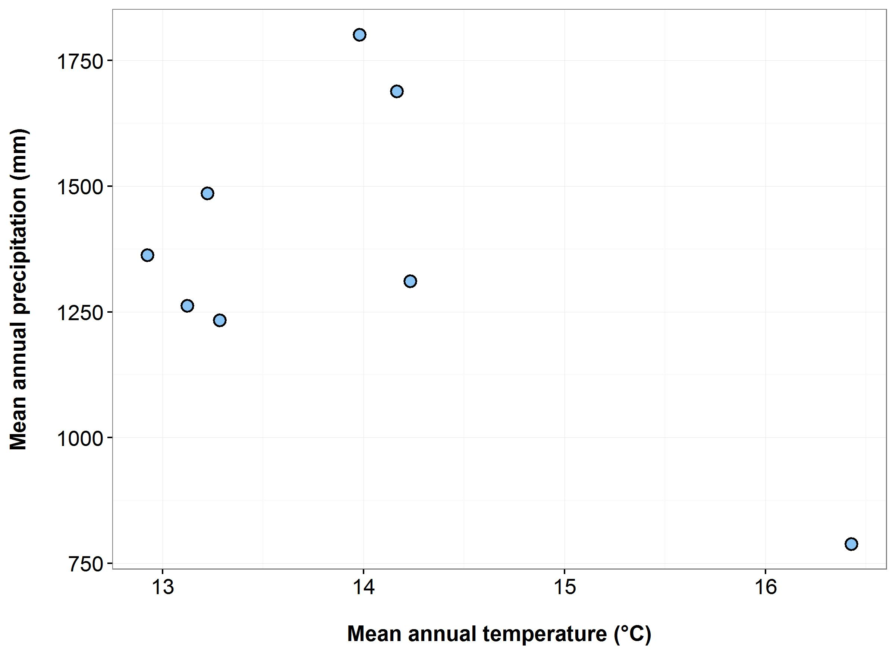

(d)

(c)

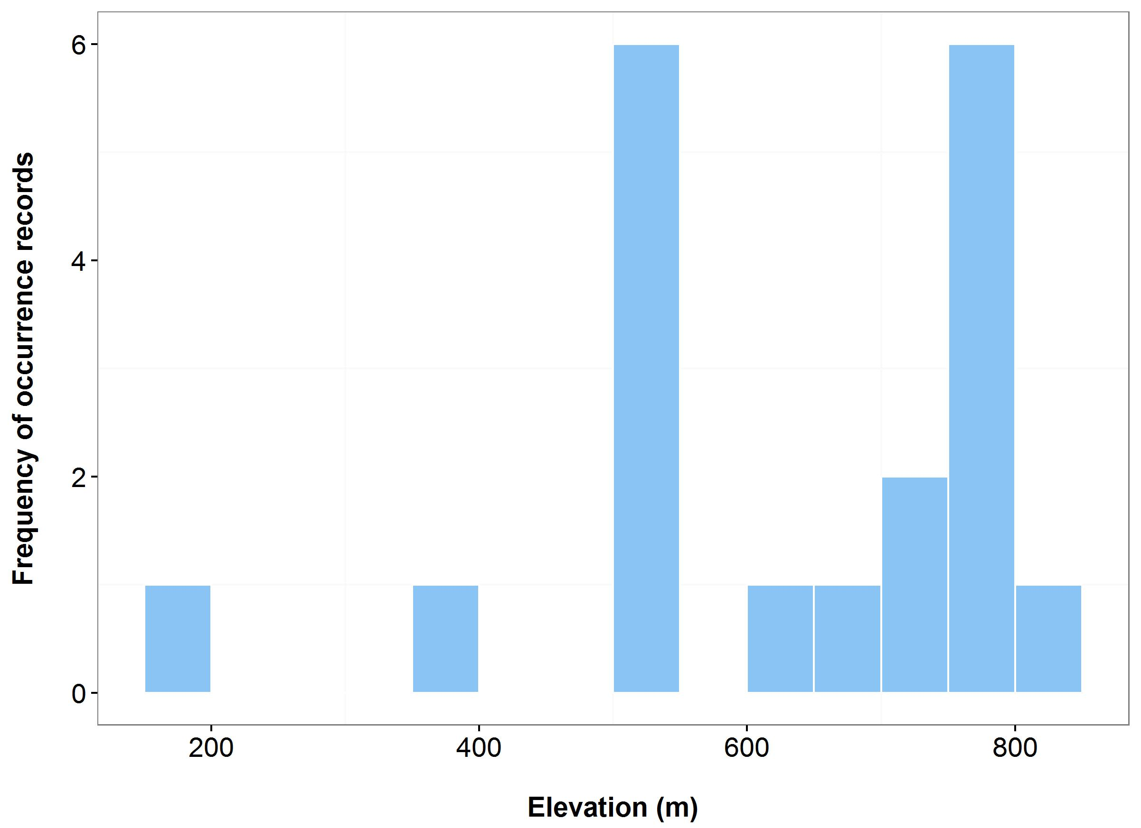**Figure 38**. Environmental variables for the NSW distribution of *Thelymitra kangaloonica* that are outside of Saving our Species (SoS) management sites (blue bars/dots) and within management sites (green bars/dots): mean annual temperature (MAT) (a); mean annual precipitation (MAP) (b); elevation (c); and scatterplot of MAT and MAP (d). N.B. Data points are nearby the management sites but not within, therefore no occurrences are shown within SoS site (green bars); data entry may be incomplete.

***Name:*** *Zieria buxijugum* (Box Range Zieria)

***Growth form:*** Shrub

***Habitat:*** Near the summit of a steep rhyolite rocky outcrop on a slope with an easterly aspect. Shrub plant community dominated by *Melaleuca armillaris* (Bracelet Honey Myrtle)

***Distribution:*** South East Corner Bioregion

***Threat status:*** CriticallyEndangered

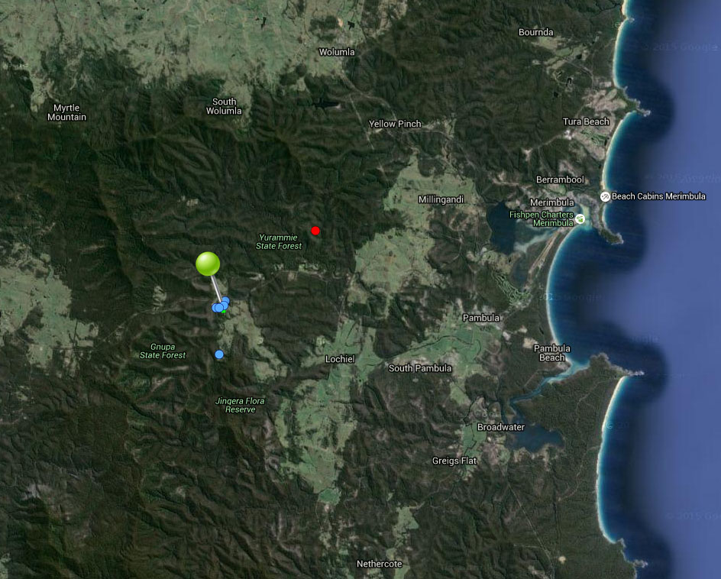

**Figure 39.** Map of species occurrence records in NSW for *Zieria buxijugum* (Box Range Zieria). Records from Australia’s Virtual Herbarium are shown in red and records from the NSW Wildlife Atlas are shown in blue, with management sites marked in green.

***Climate change threat(s) identified in Final Determination***

* Changes to precipitation (increased frequency and intensity of drought)

***Number and name(s) of management sites, with estimated population size at each site:*** One

* [Pambula](javascript:__doPostBack('ctl00$ContentPlaceHolder1$gridSites$ctl00$ctl04$linkSite','')): 130 (all size classes)

***Are all extant sites managed?***

* Yes

***Is a translocation site suggested?***

* No

***How is climate change threat addressed in SoS conservation project?***

* There is a management action to maintain an *ex-situ* population for supplementation of the small extant population (and to provide buffer against extinction from stochastic processes such as drought) which will increase resilience to climate change.

S***uggestions to improve species adaptive capacity and resilience to climate change***

* Identify translocation sites. Not enough occurrence records for species distribution modelling but use knowledge of predicted future climate, environmental data (Figure 40), and <http://www.nswthreatenedspecies.net/>) and species’ requirements to select appropriate sites. Figure 40 suggests that some hotter, drier and higher elevation locations within the species current range may be available. As well as climate, need to consider habitat/soil type (shrubby heath vegetation growing in skeletal brown loam, on an ignimbrite rock outcrop at 290 m altitude), land tenure and other threats.
* Determine germination/propagation requirements in preparation for supplementation/translocation (Australian PlantBank).
* In preparation for supplementation/translocation, determine within-population genetic diversity and level of inbreeding.

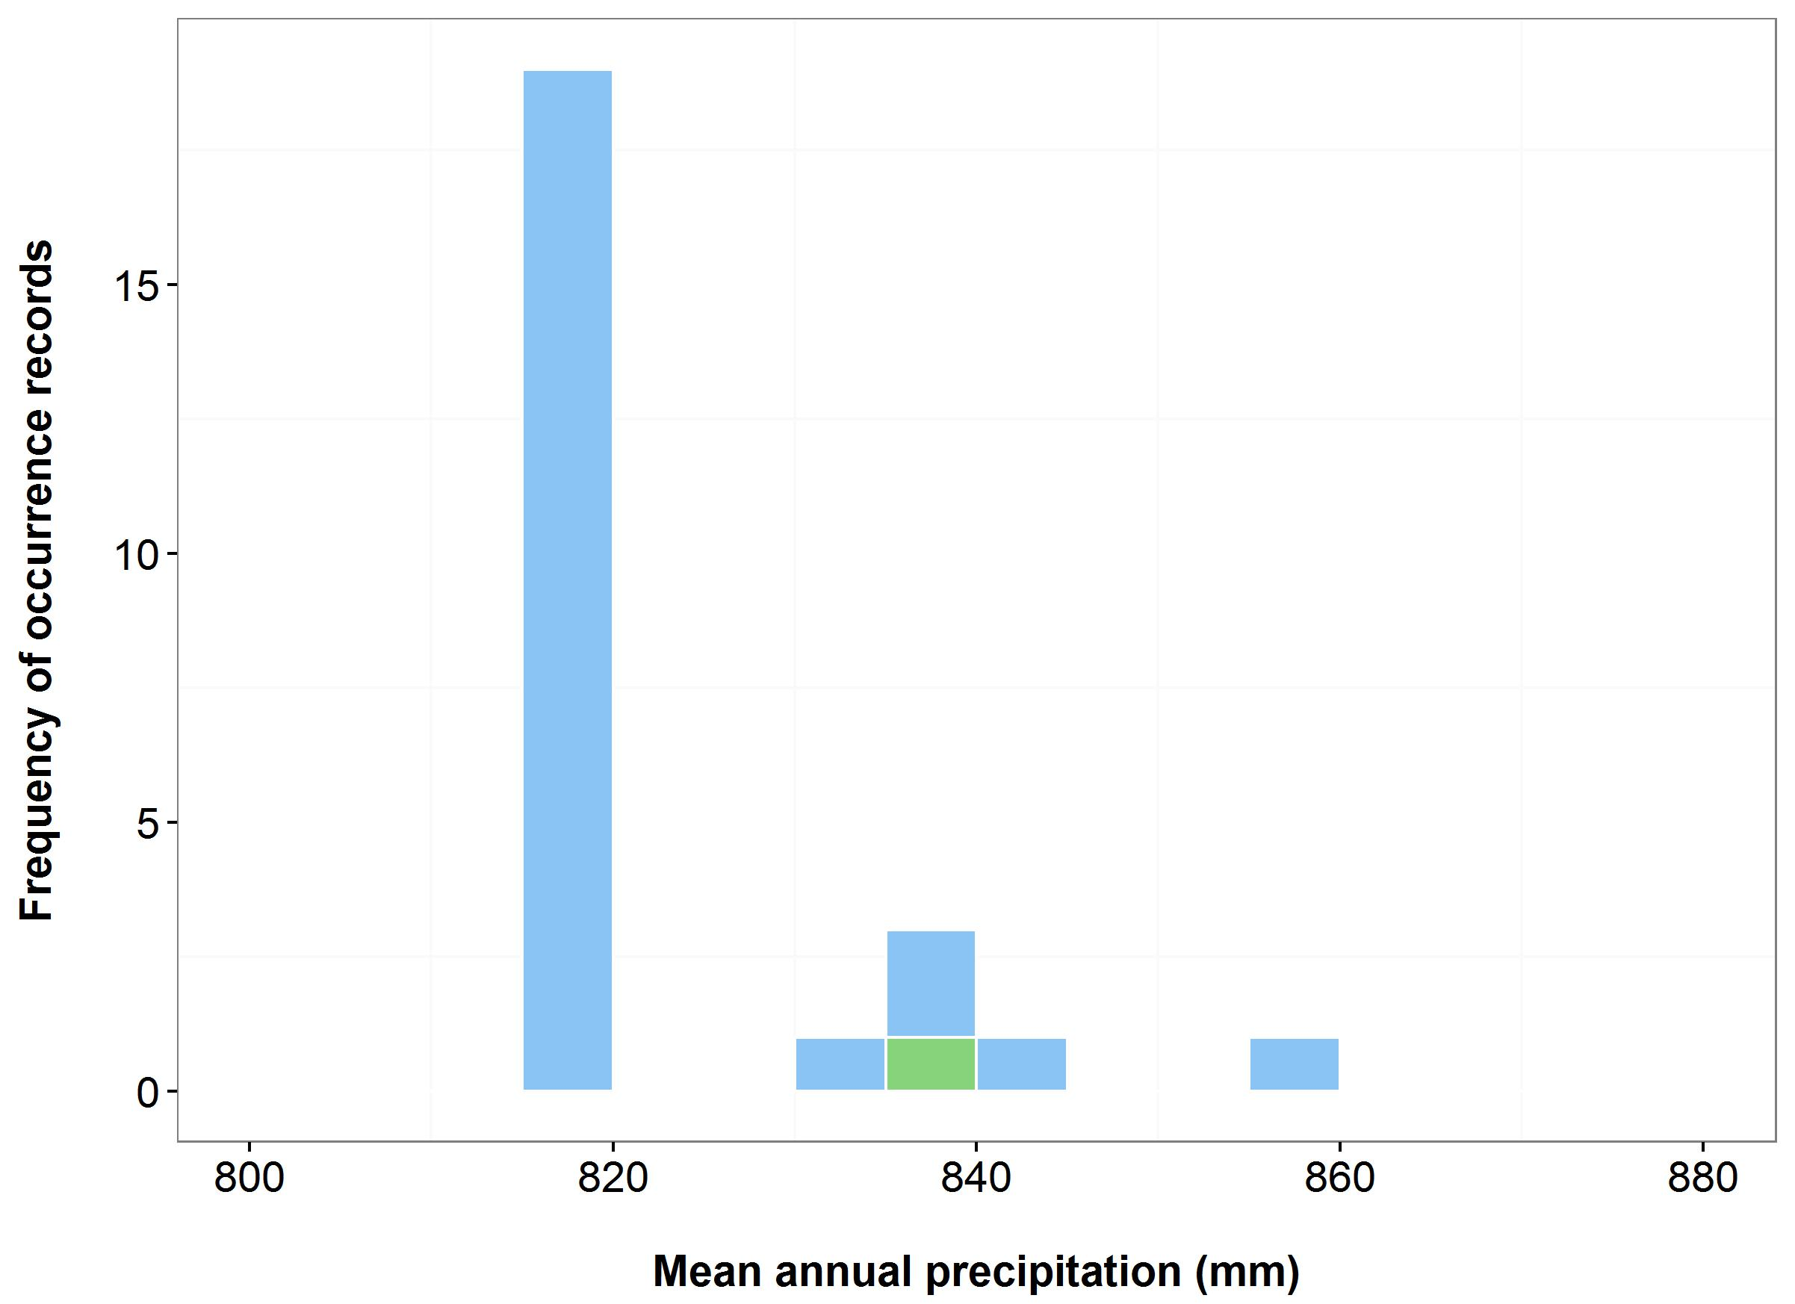

(b)

(a)

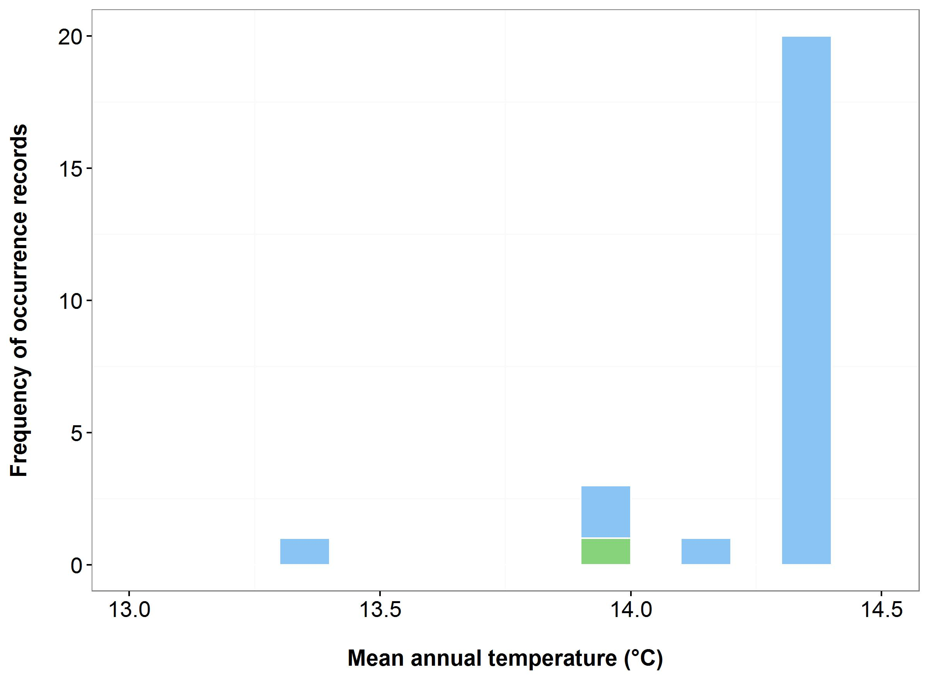

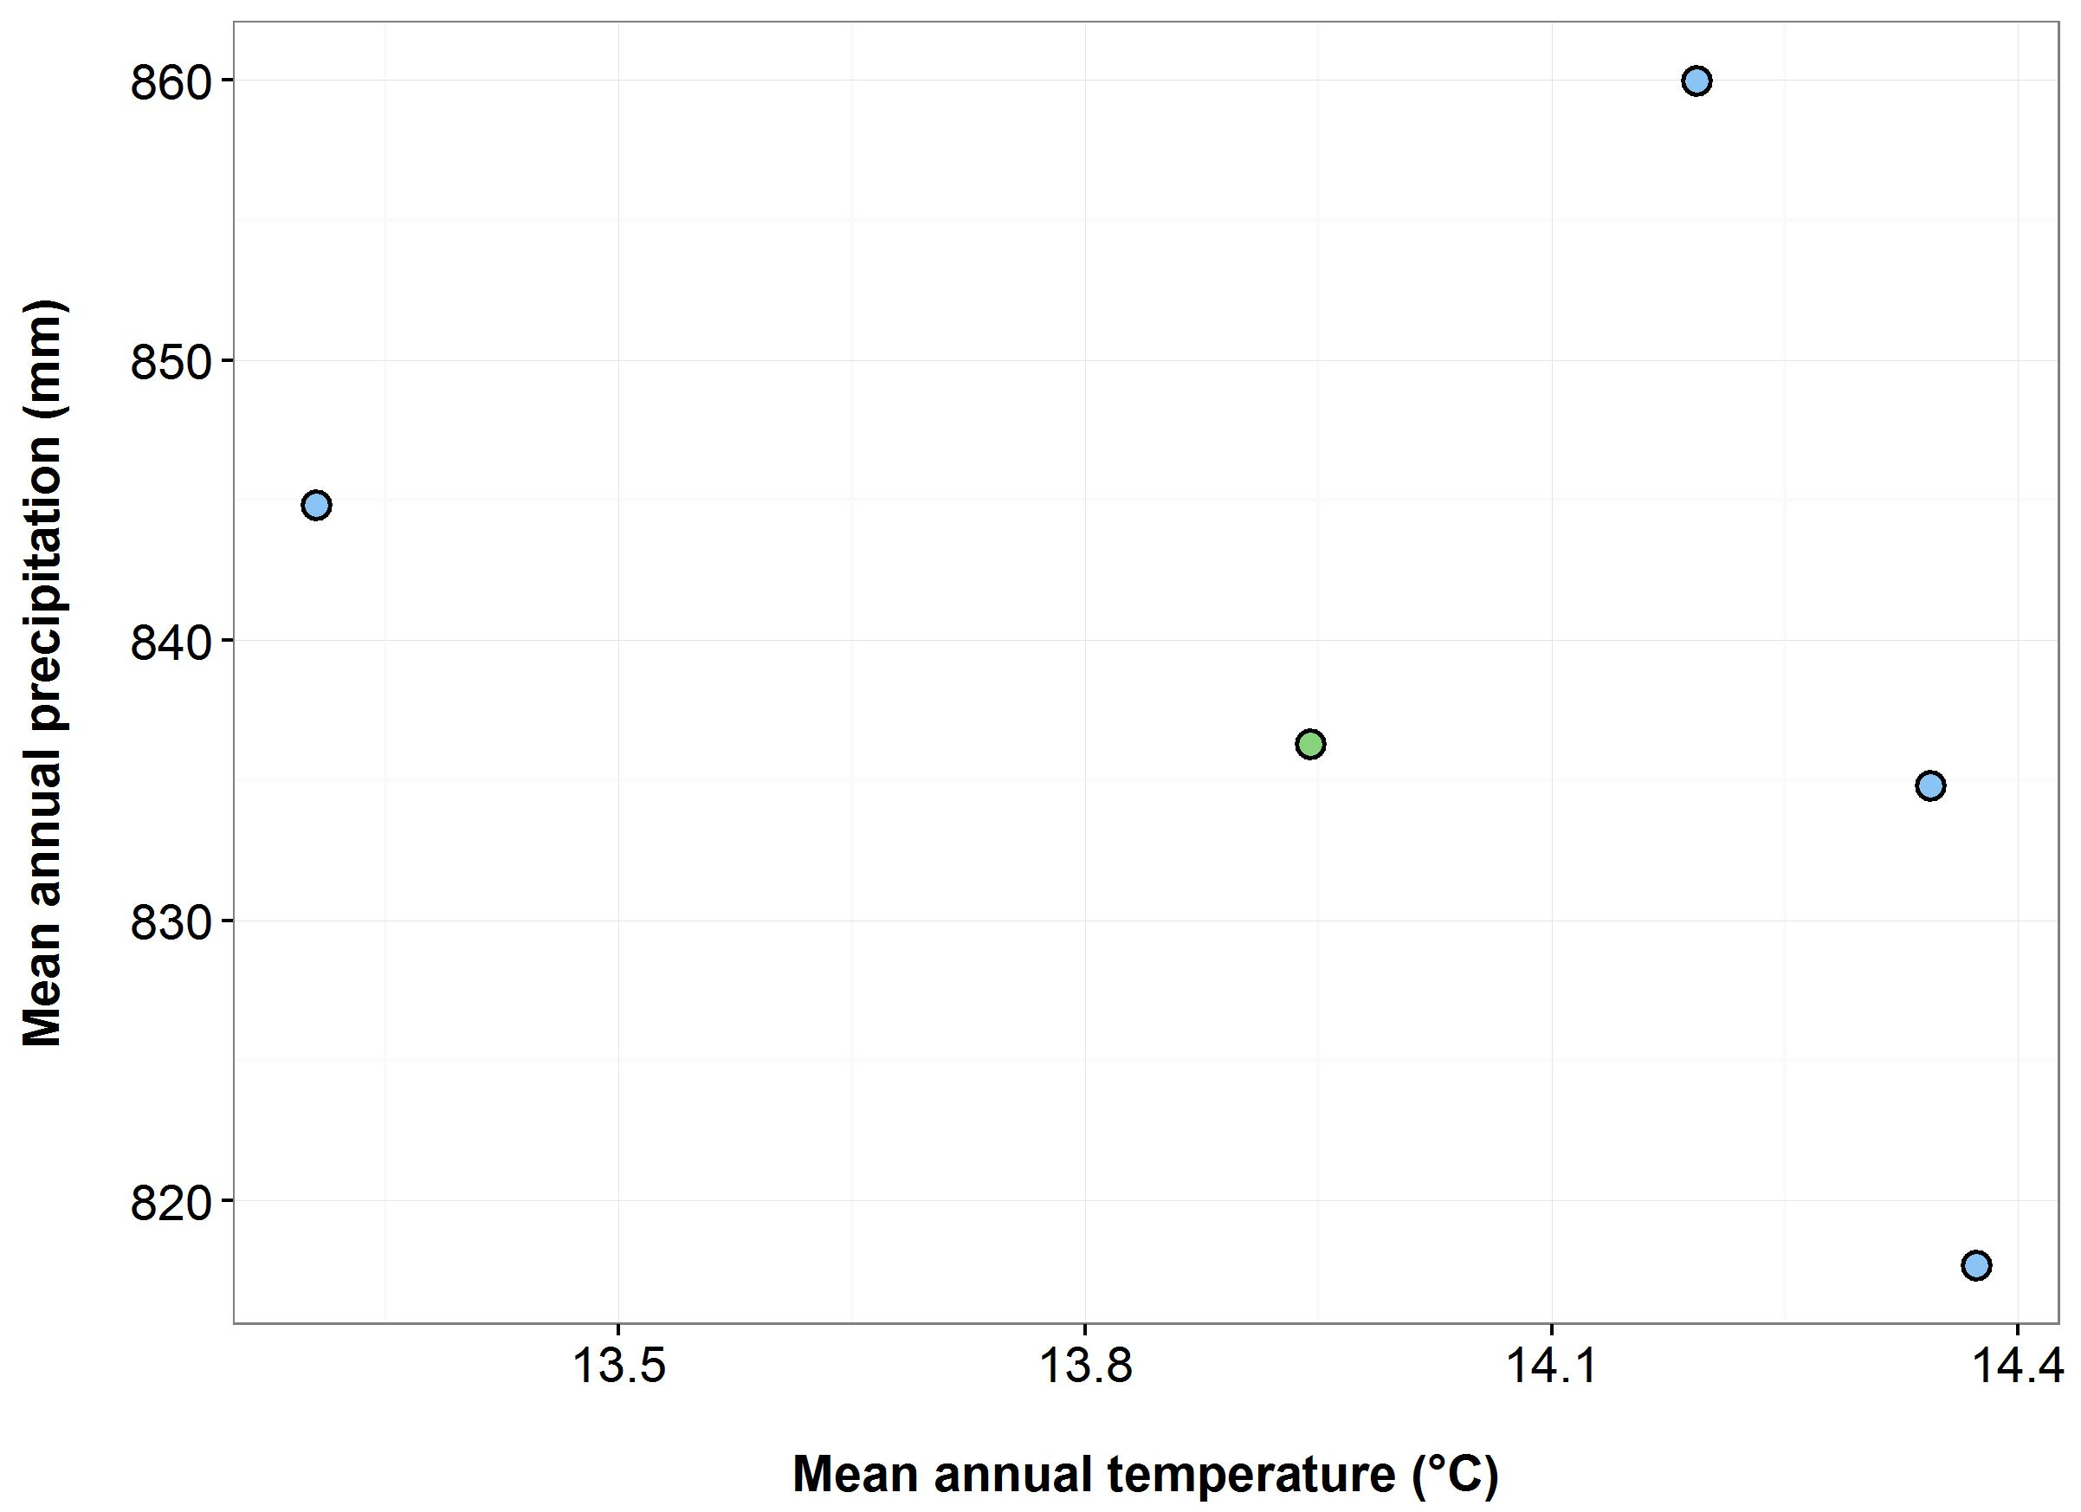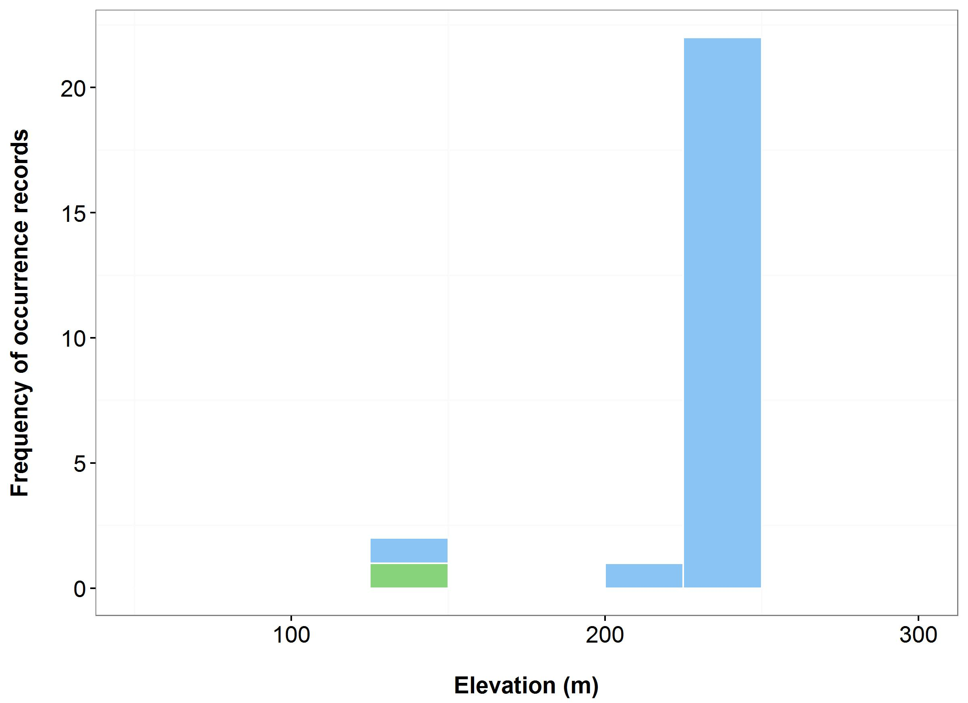

(d)

(c)

**Figure 40**. Environmental variables for the NSW distribution of *Zieria buxijugum* that are outside of management sites (blue bars/dots) and within management sites (green bars/dots): mean annual temperature (MAT) (a); mean annual precipitation (MAP) (b); elevation (c); and scatterplot of MAT and MAP (d).

***Name:*** *Zieria formosa* (Shapely Zieria)

***Growth form:*** Shrub

***Habitat:*** North-east aspect of an upper, moderately steep slope of a 'break-away' area above a small valley. Soil is skeletal, grey sandy loam and there is much exposed surface rock

***Distribution:*** South East Corner Bioregion

***Threat status:*** CriticallyEndangered

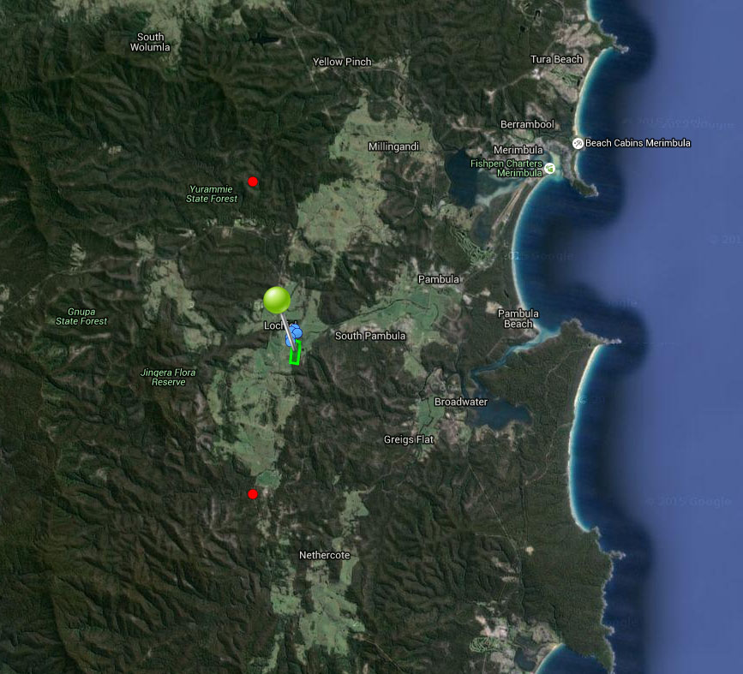

**Figure 41.** Map of species occurrence records in NSW for *Zieria formosa* (Shapely Zieria). Records from Australia’s Virtual Herbarium are shown in red and records from the NSW Wildlife Atlas are shown in blue, with management sites marked in green.

***Climate change threat(s) identified in Final Determination***

* Changes to precipitation (increased frequency and intensity of drought)

***Number and name(s) of management sites, with estimated population size at each site:*** One

* Pambula: 100

***Are all extant sites managed?***

* Yes

***Is a translocation site suggested?***

* No

***How is climate change threat addressed in SoS conservation project?***

* Threat from increased drought addressed. There is a management action to preserve genetic material in perpetuity (through seed banking) which can also be used to supplement/enhance population.

S***uggestions to improve species adaptive capacity and resilience to climate change***

* Identify translocation sites. Not enough occurrence records for species distribution modelling but use knowledge of predicted future climate, environmental data (Figure 42) and <http://www.nswthreatenedspecies.net/>) and species’ requirements to select appropriate sites. As well as climate, need to consider habitat/soil type (shrub-dominated community on skeletal, grey, sandy loam amid broken rocks and boulders at 50 m altitude), land tenure and other threats.
* Enter all outstanding occurrence records into databases to enable environmental data to be analysed to assist with site selection (e.g. select highest elevations (Figure 42). Translocation sites may need to be outside of the species current distribution.
* Determine germination/propagation requirements for supplementation/translocation (Australian PlantBank).
* In preparation for supplementation/translocation, determine within-population genetic diversity and level of inbreeding.

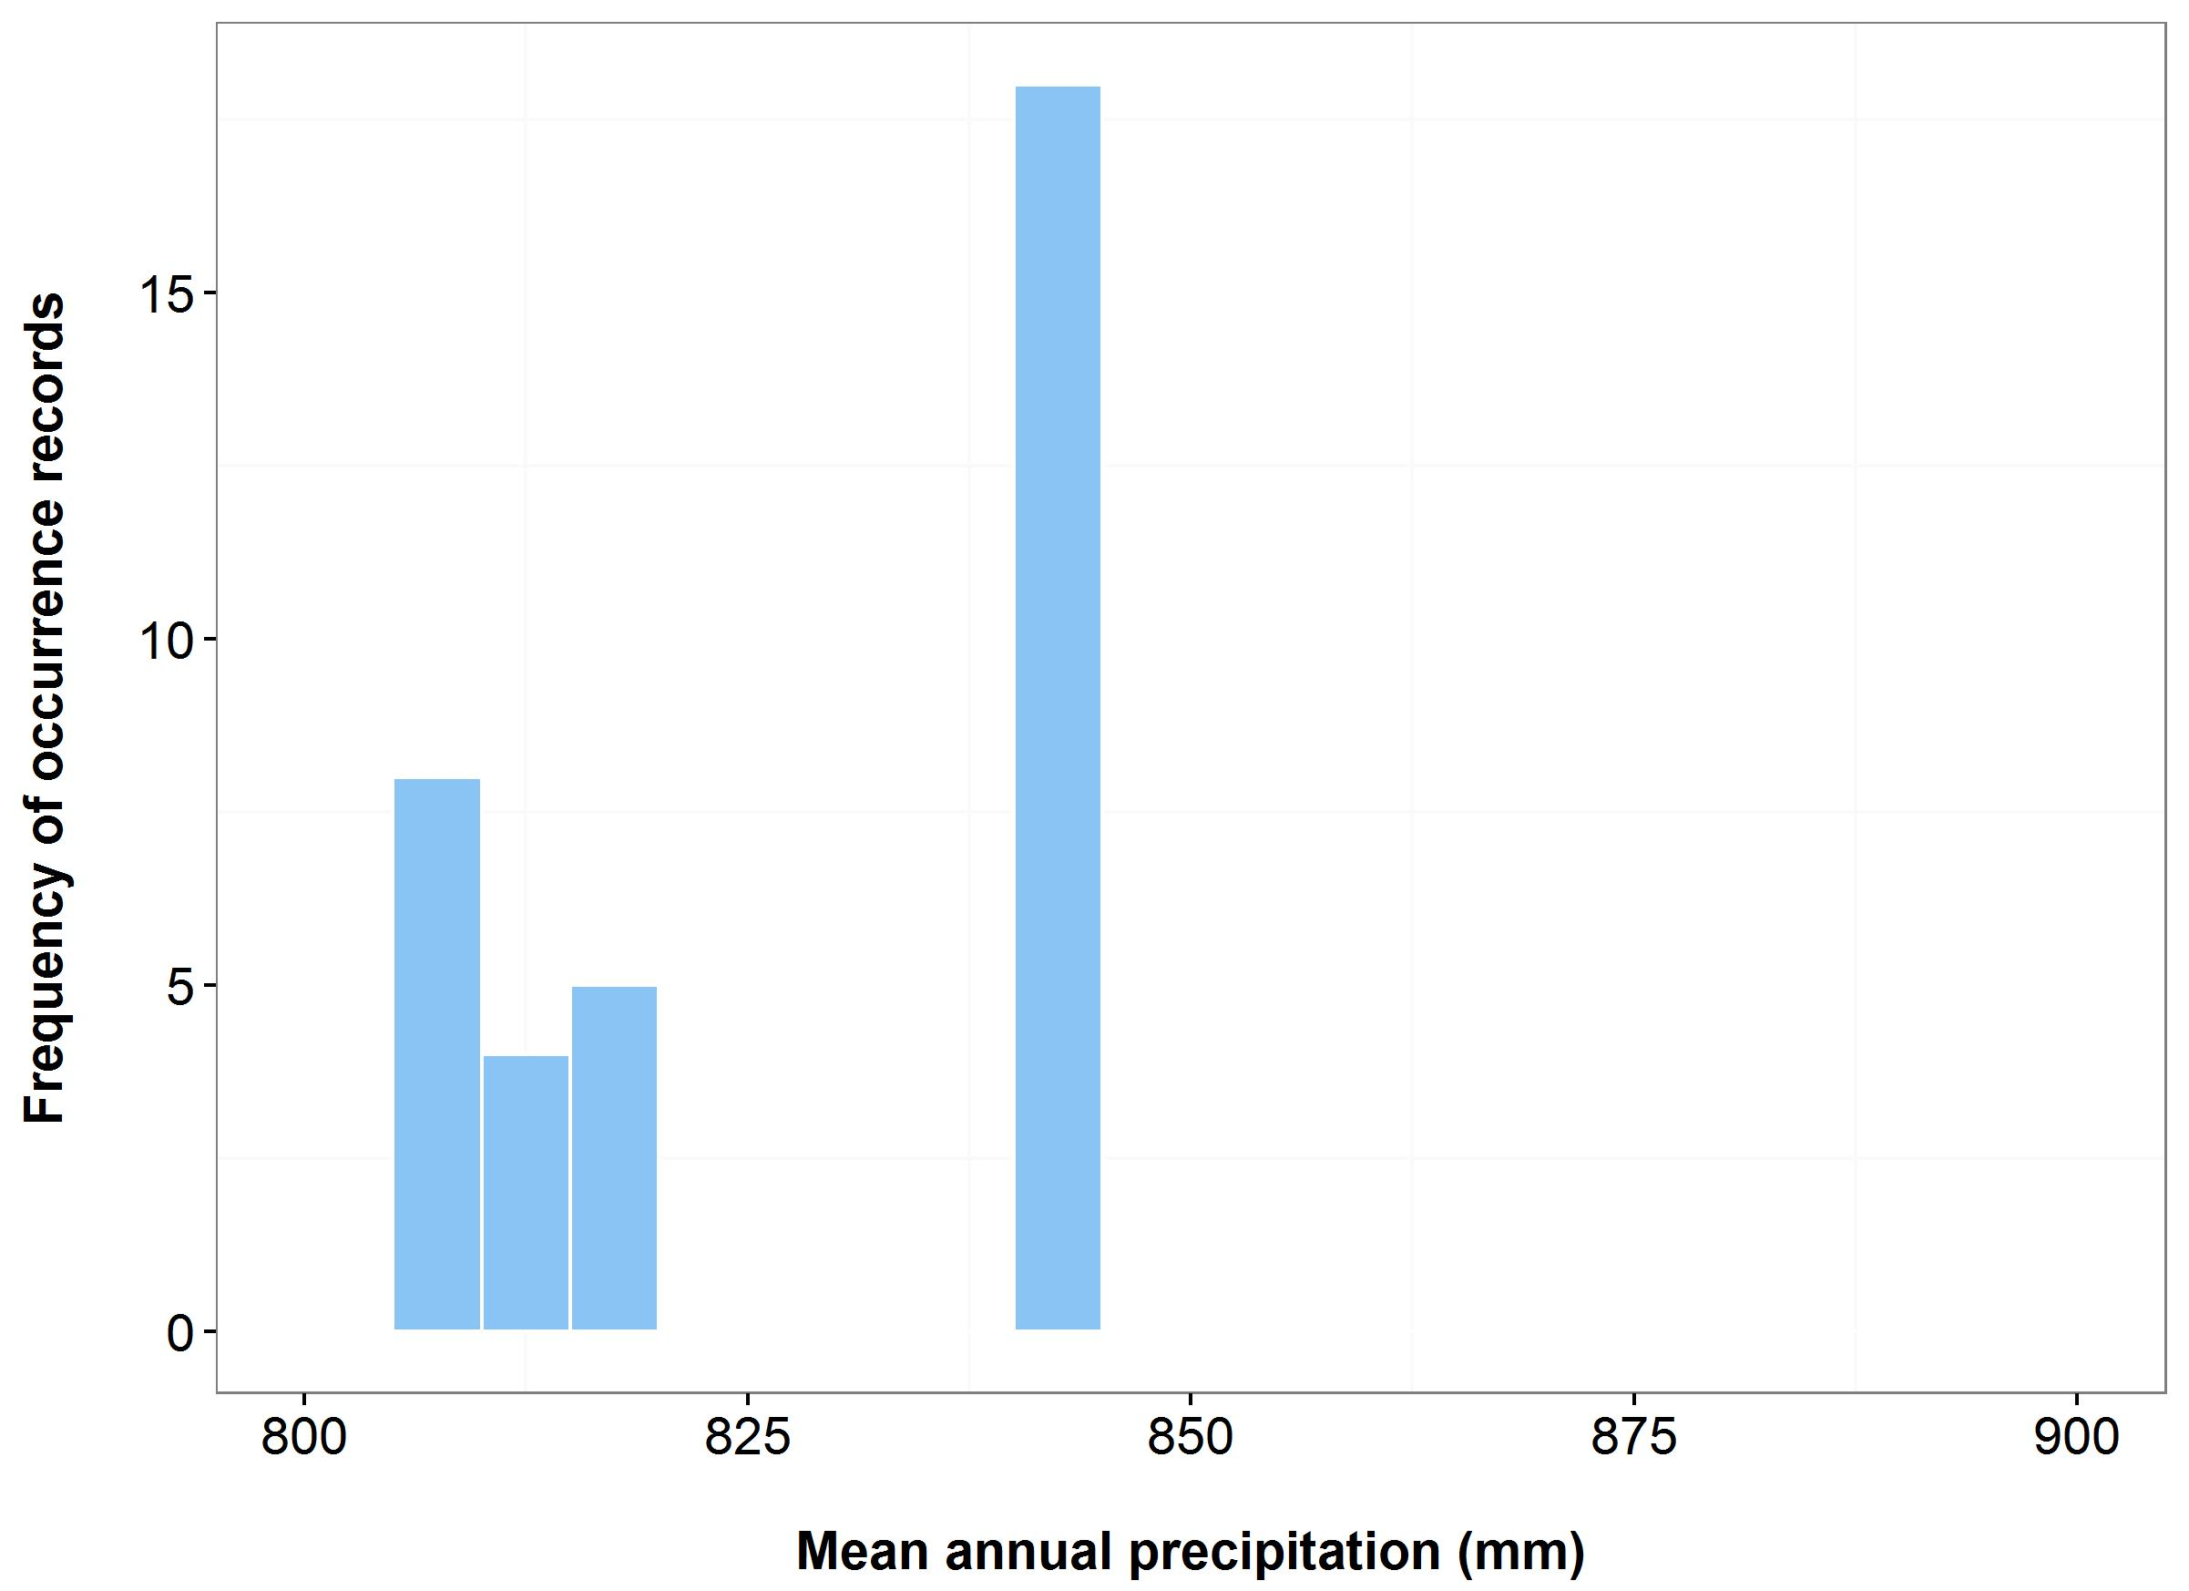

(b)

(a)

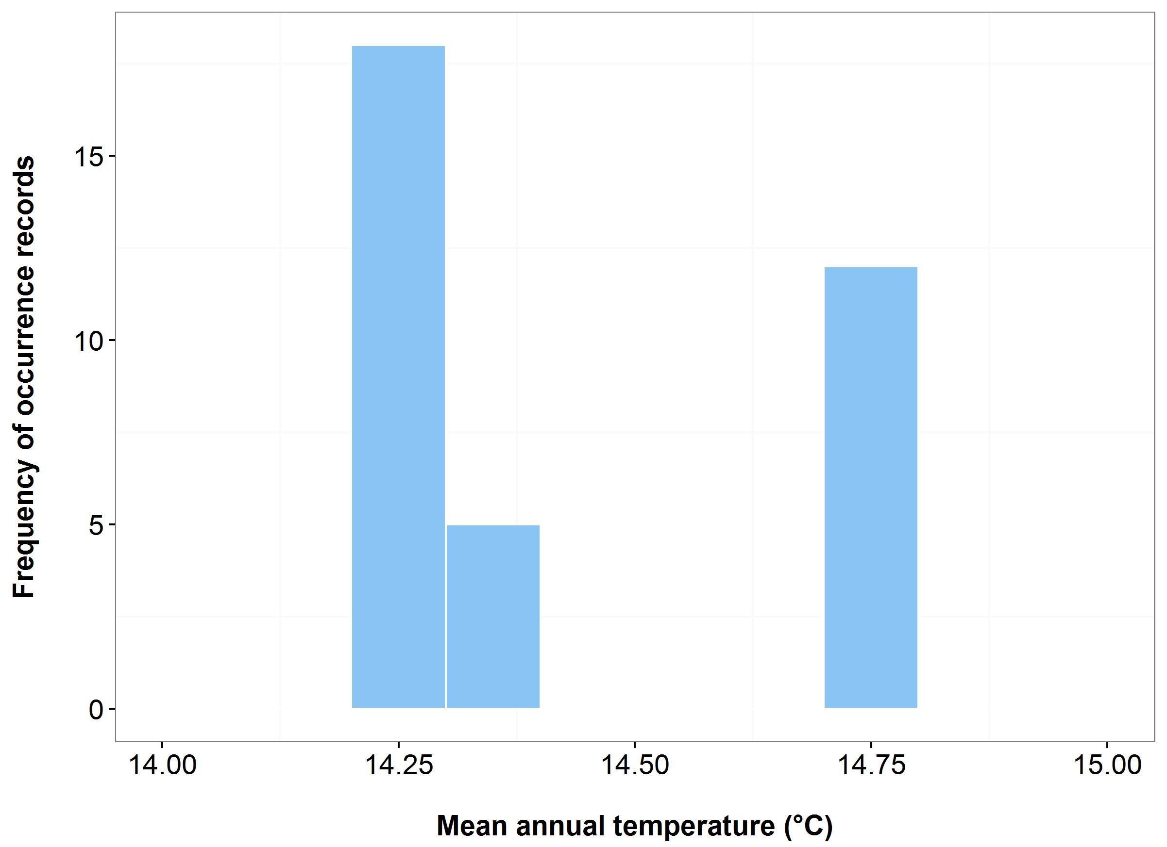



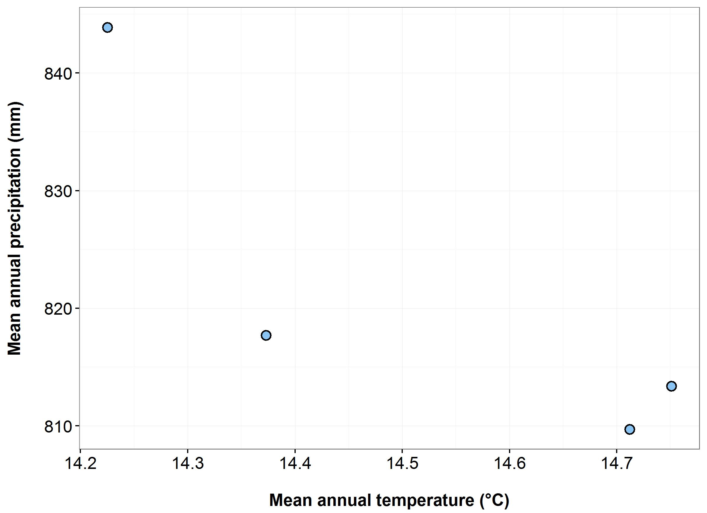

(c)

(d)

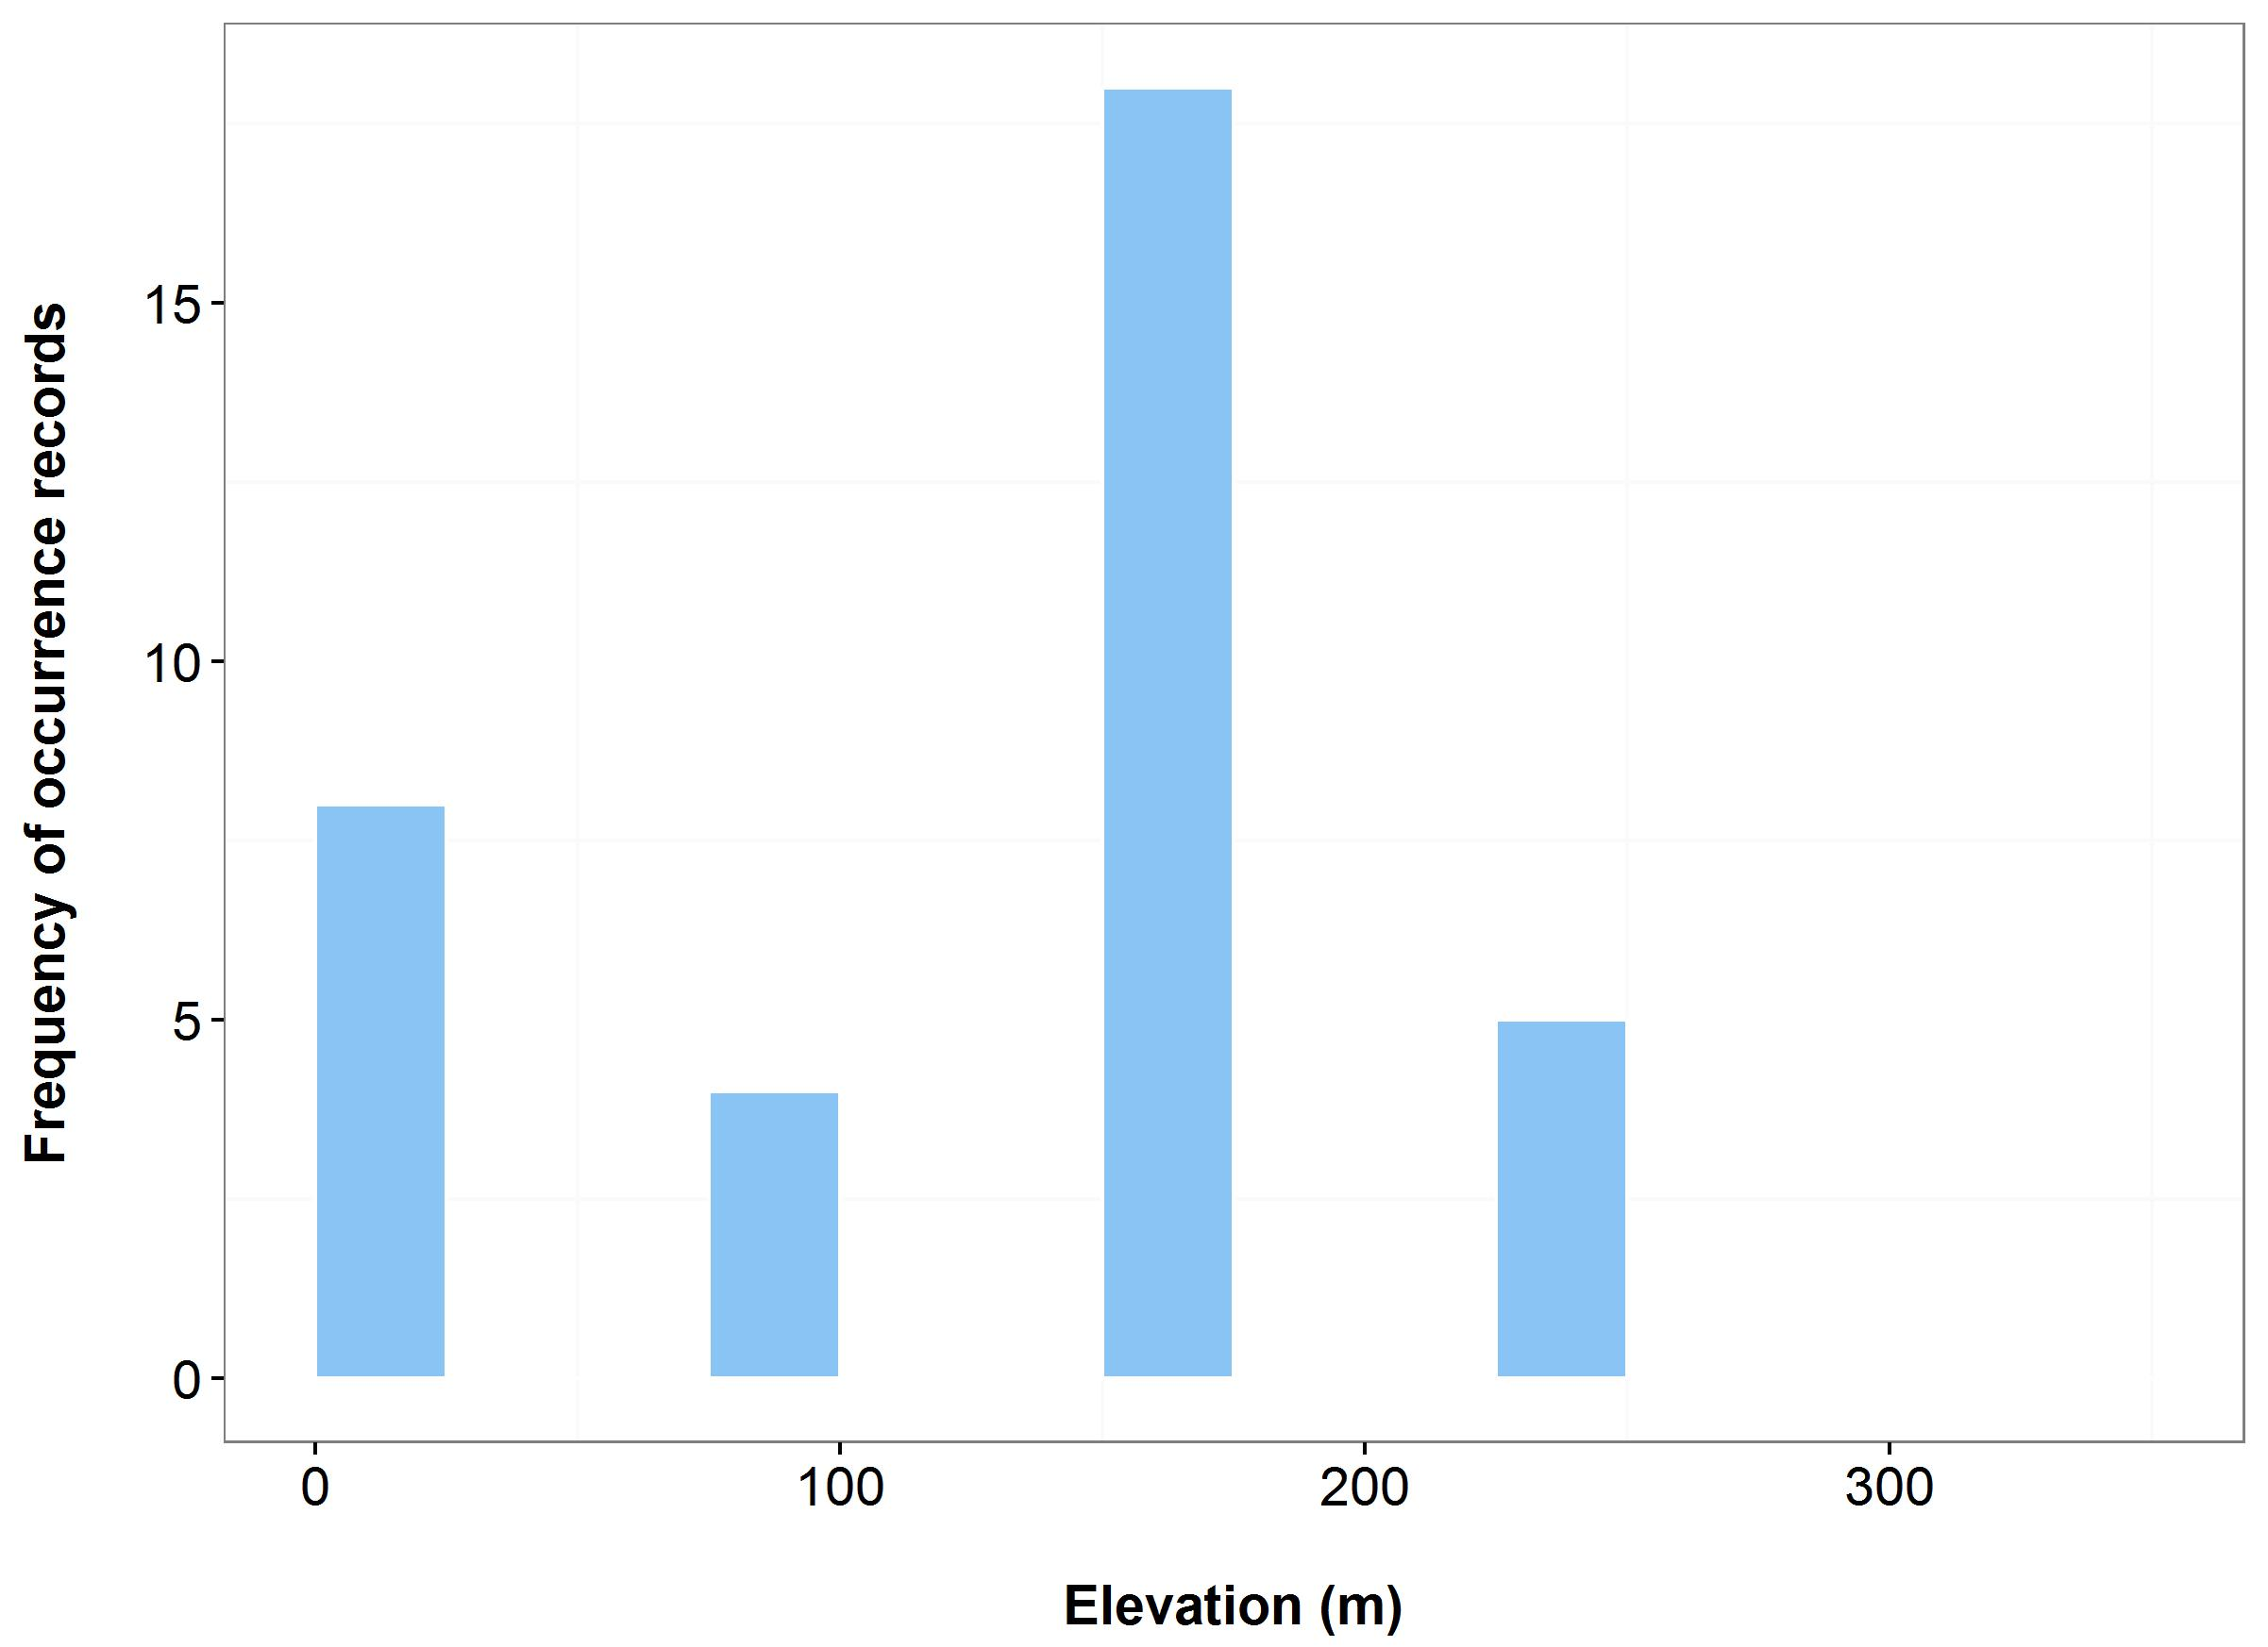

**Figure 42**. Environmental variables for the NSW distribution of *Zieria formosa* that are outside of Saving our Species (SoS) management sites (blue bars/dots) and within management sites (green bars/dots): mean annual temperature (MAT) (a); mean annual precipitation (MAP) (b); elevation (c); and scatterplot of MAT and MAP (d). N.B.Data points for this species occur outside of the management site and therefore no within SoS sites (green bars) are shown – either data entry is incomplete or incorrect co-ordinates.

**Vulnerable animals**

***Name:*** *Pterodroma leucoptera leucoptera* (Gould’s Petrel)

***Taxa:*** Bird

***Habitat:*** Breeds on both Cabbage Tree Island and on nearby Boondelbah Island (offshore from Port Stephens). Principal nesting habitat is located within two gullies which are characterised by steeply, sloping rock scree with a canopy of Cabbage Tree Palms

***Distribution:*** Sydney Basin, North Coast Bioregions (Figure 43)

***Threat status:*** Vulnerable

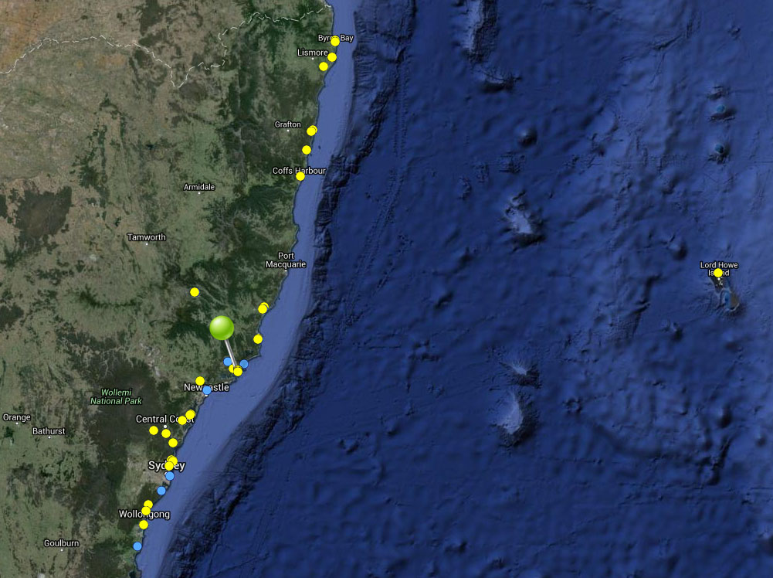

**Figure 43.** Map of species occurrence records in NSW for *Pterodroma leucoptera leucoptera* (Gould’s Petrel). Records from the Atlas of Living Australia are shown in yellow and records from the NSW Wildlife Atlas are shown in blue, with management sites marked in green.

***Climate change threat(s) identified in Final Determination***

* Limited ability to shift range (lack of suitable colonisation sites to the south)

***Number and name(s) of management sites, with estimated population size at each site:*** One (includes four islands)

* Located on 4 islands off Port Stephens: Cabbage Tree, Boodelbah, Broughton, and Little Broughton: 839 nesting pairs.

***Are all extant sites managed?***

* Yes

***Is a translocation site suggested?***

* No

***How is climate change threat addressed in SoS conservation project?***

* NA – But managing existing threats (predatory birds, fire) will increase resilience to climate change.

S***uggestions to improve species adaptive capacity and resilience to climate change***

* Species Distribution Modelling results for site selection (Figure 44). Only a single site at Port Stephens is managed for this species (Figure 45) and given its small size it is difficult to make projections. However, the adjacent mainland regions are projected to retain suitable habitat under the warmer scenarios. Conditions will be less suitable under the hotter scenarios.
* Investigate translocation to additional islands, preferably to the south. Conservation project states there is a new breeding population on Montague Island – explore potential to supplement/manage this breeding population. N. B. potential coastal islands to the south – Montague Island, Five Islands Nature Reserve and Wasp Island may be climatically suitable but have limited appropriate breeding habitat.
* Investigate potential for establishing appropriate breeding habitat at translocation site(s) (man made –e.g. nest boxes and natural e.g. hollow fallen palm trunks), as per the translocation to Boondelbah Island (Priddel *et al.* 2006).
* In preparation for translocation(s), determine population genetic parameters: between-population genetic differences, within-population genetic diversity and inbreeding.

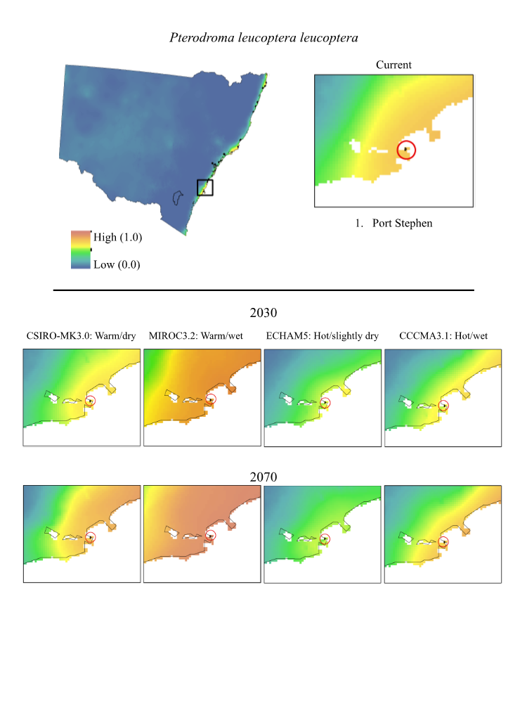

**Figure 44.** Maps of projected current and future (2030, 2070) suitable habitat for *Pterodroma leucoptera leucoptera* (Gould’s Petrel)across its site-managed location, highlighted in red in the top right panel.

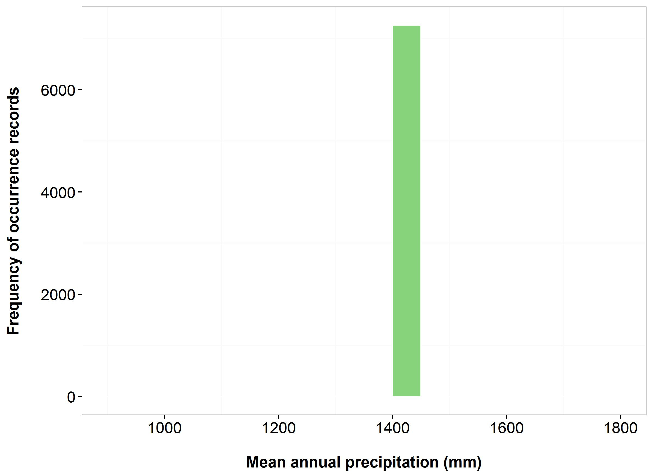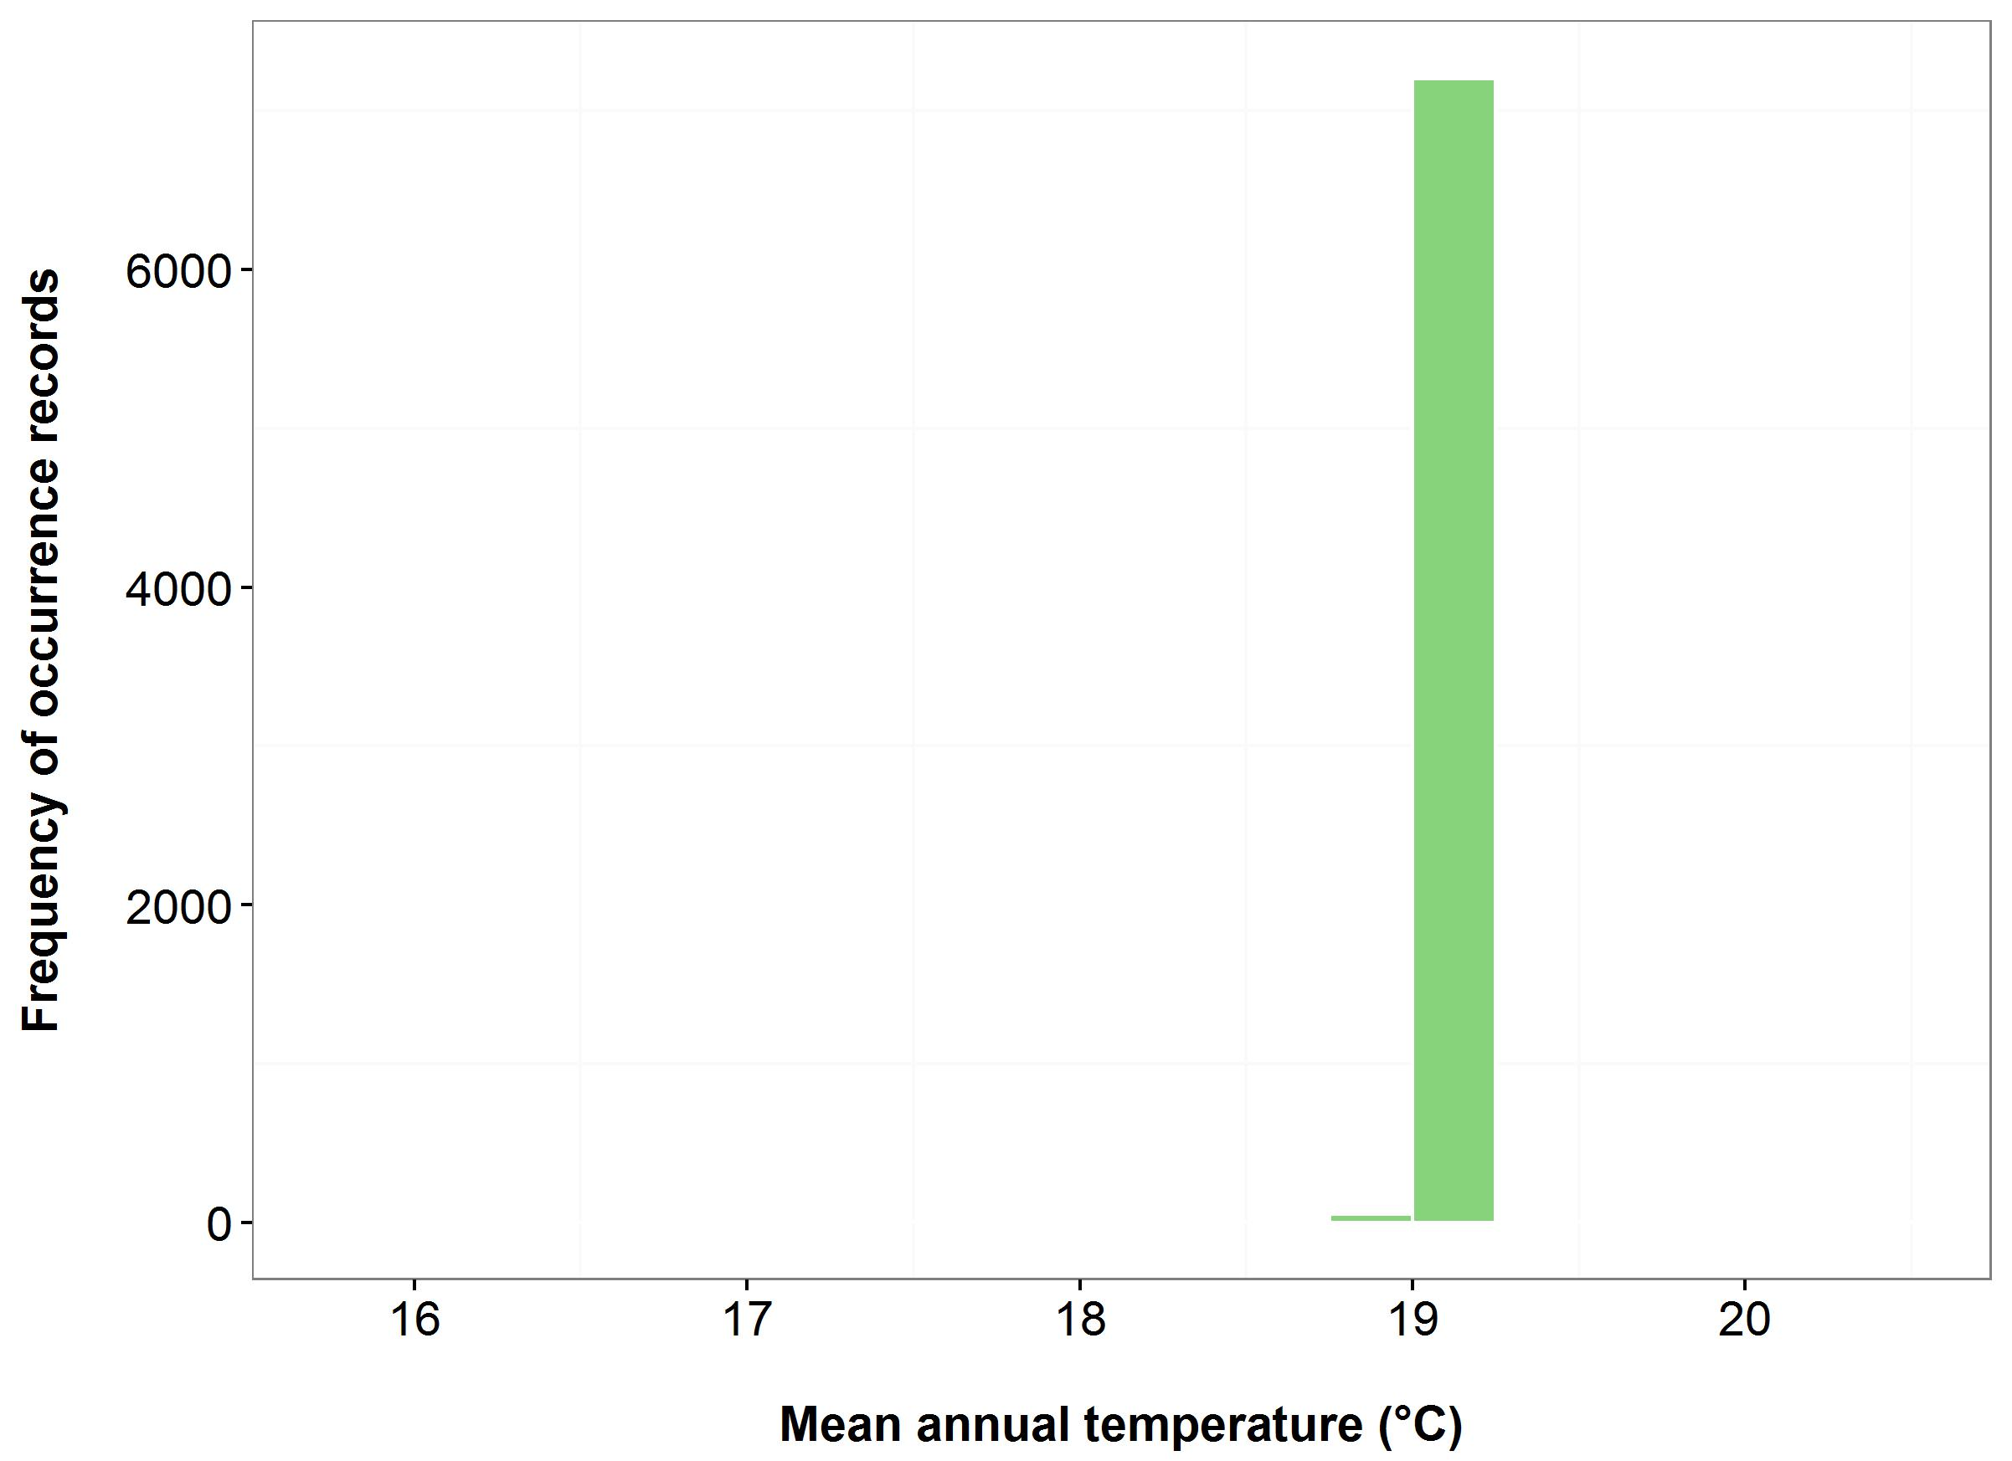

(b)

(a)



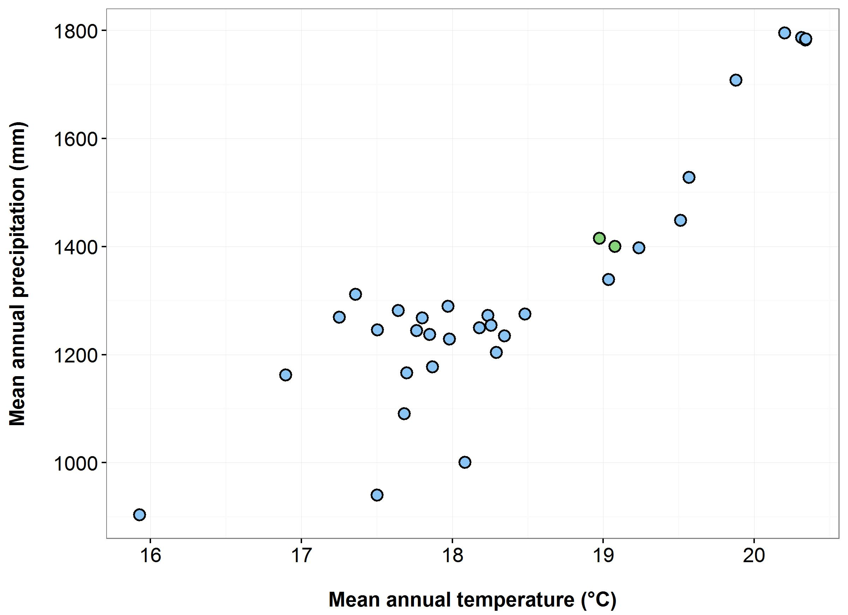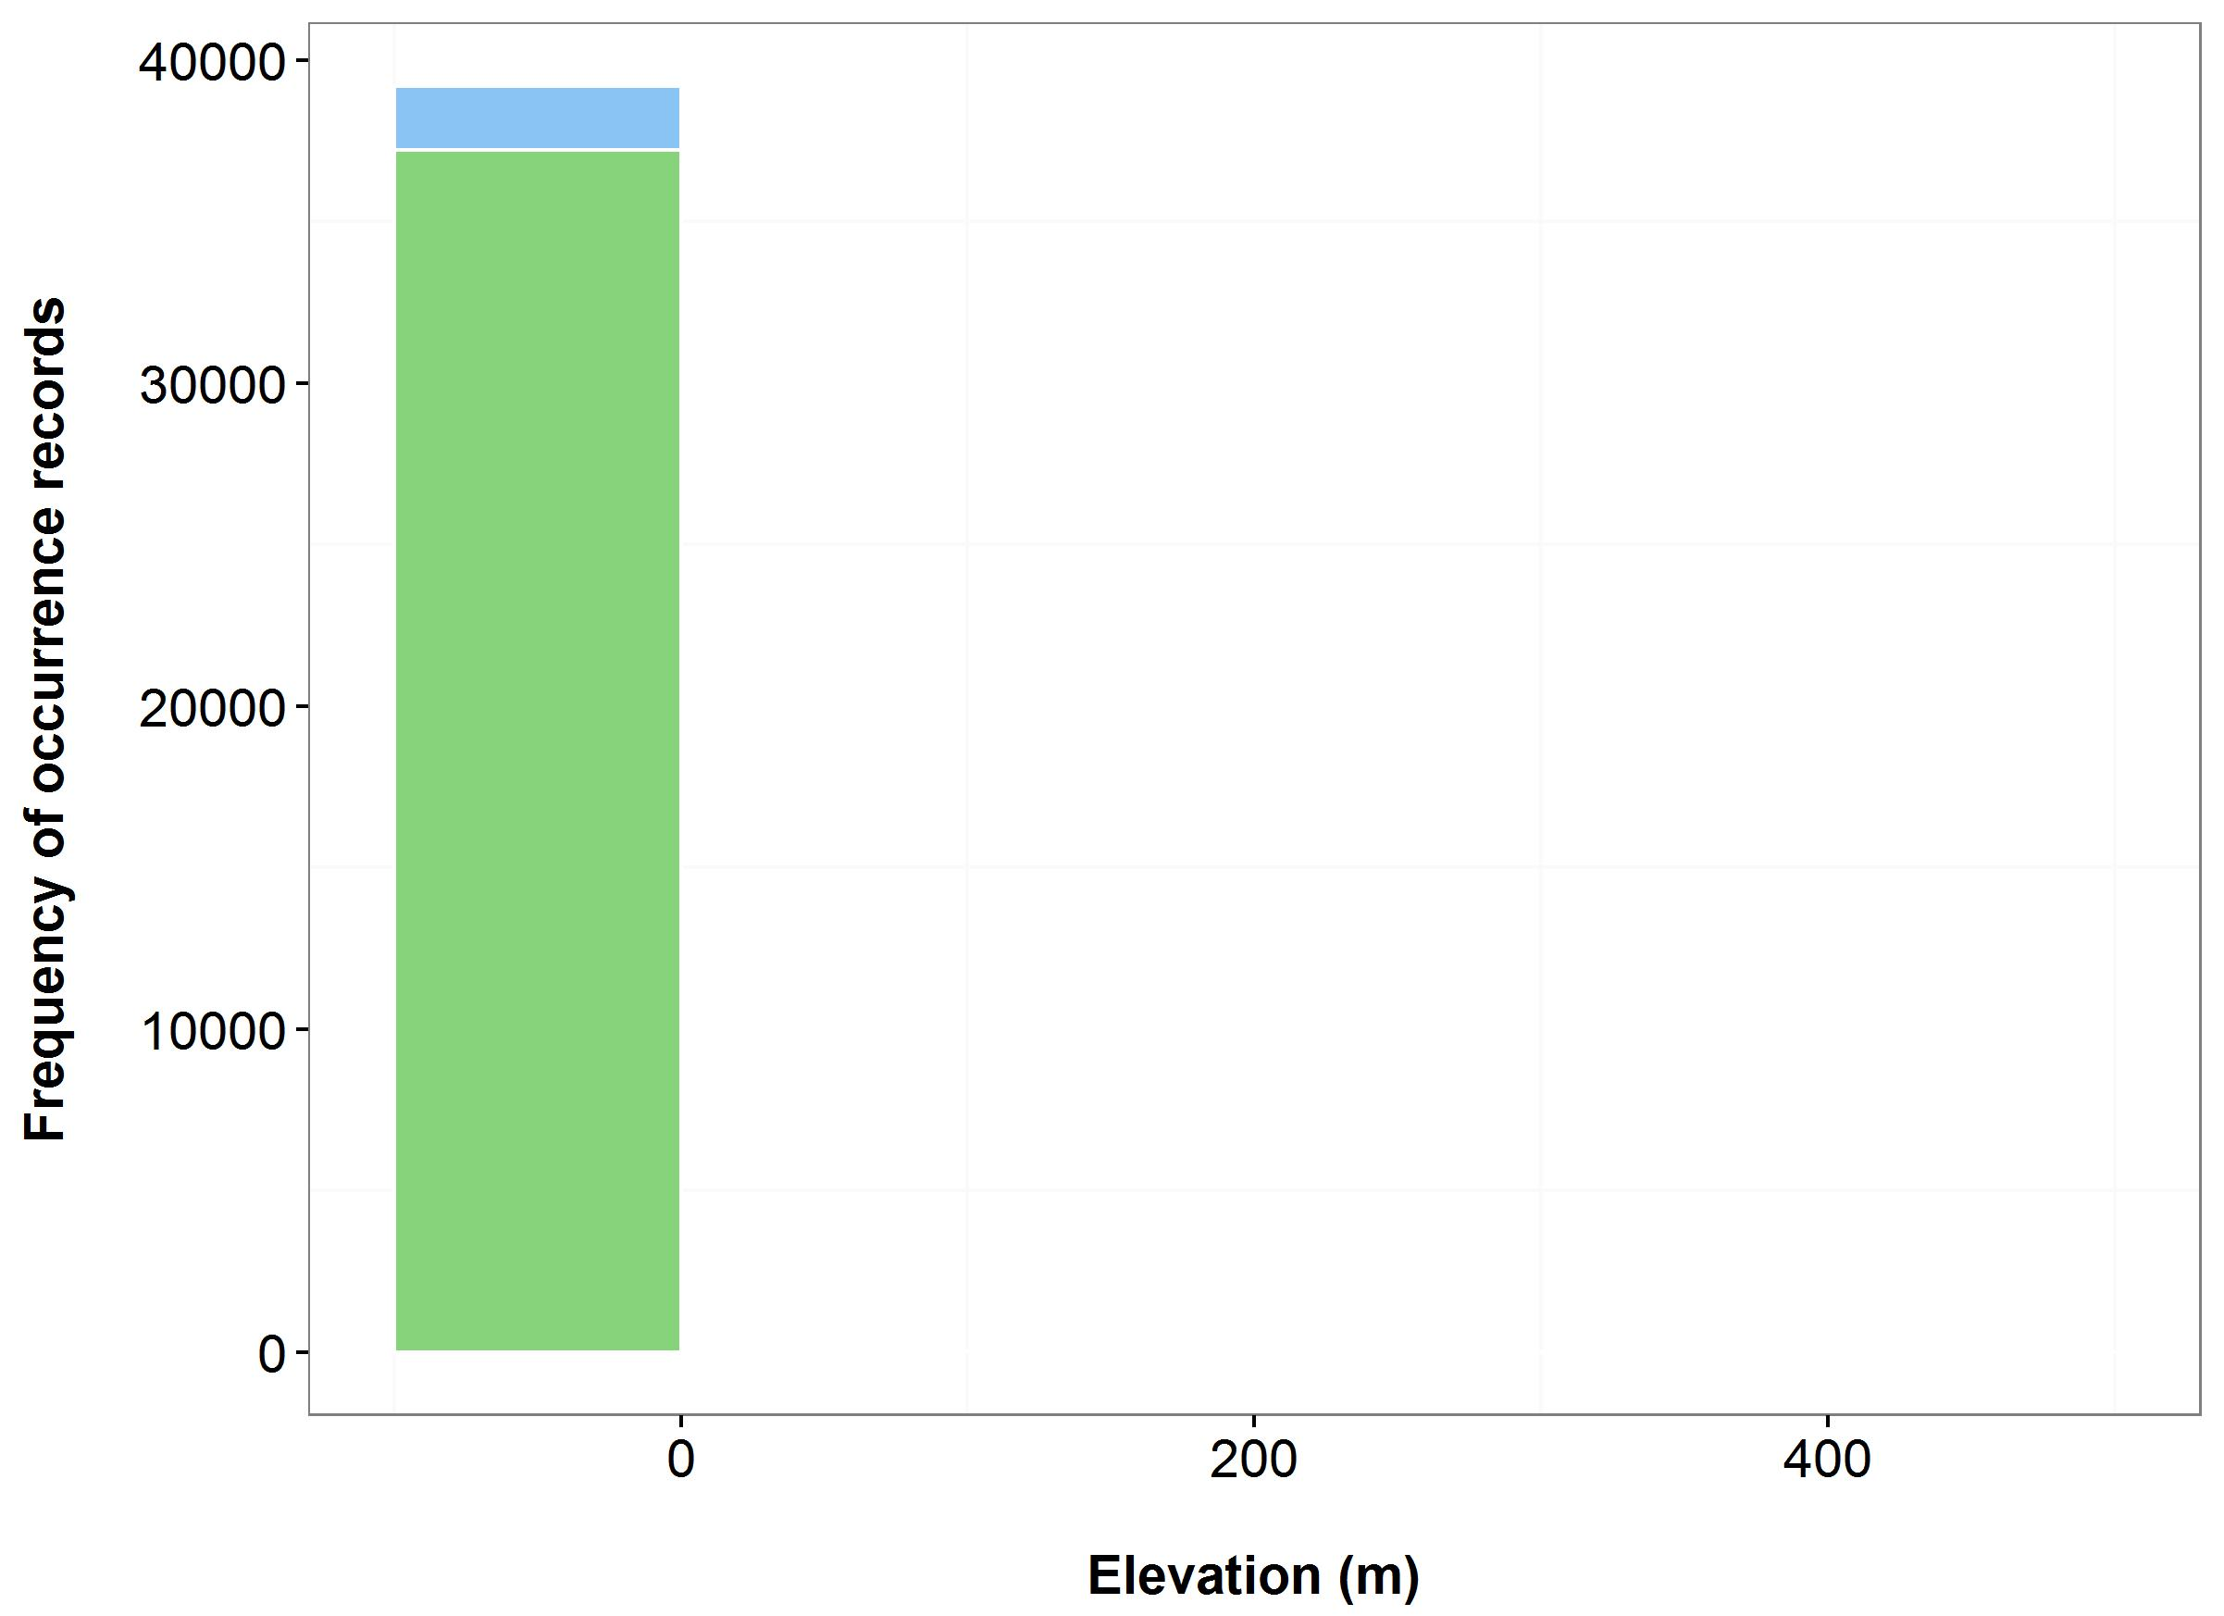

(c)

(d)

**Figure 45**. Environmental variables for the NSW distribution of *Pterodroma leucoptera leucoptera* that are outside of Saving our Species (SoS) management sites (blue bars/dots) and within management sites (green bars/dots): mean annual temperature (MAT) (a); mean annual precipitation (MAP) (b); elevation (c); and scatterplot of MAT and MAP (d).

**Critically Endangered animals**

***Name:*** *Anthochaera phrygia* (Regent Honeyeater)

***Taxa:*** Bird

***Habitat:*** Key breeding regions in the Capertee Valley and the Bundarra-Barraba region. Dry open forest and woodland, particularly Box-Ironbark woodland, and riparian forests of River She-oak

***Distribution:*** New England Tableland, Sydney Basin, Nandewar, North Coast, South Western Slopes, Brigalow Belt South, South Eastern Highlands, South East Corner, Riverina, Cobar Peneplain, Darling Riverine Plains Bioregions (Figure 46)

***Threat status:*** Critically Endangered

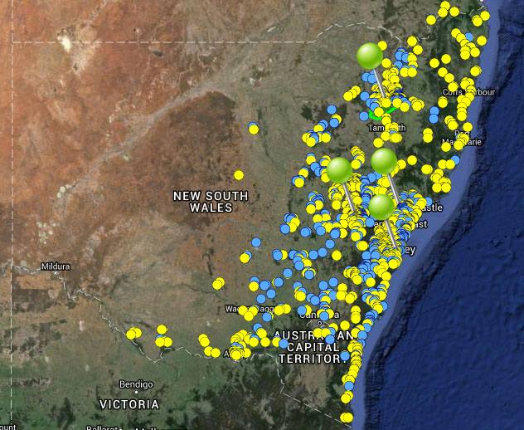

**Figure 46.** Map of species occurrence records in NSW for *Anthochaera phrygia* (Regent Honeyeater). Records from the Atlas of Living Australia are shown in yellow and records from the NSW Wildlife Atlas are shown in blue, with management sites marked in green. N.B.Sydney (Taronga Zoo) is shown as a management site

***Climate change threat(s) identified in Final Determination***

* Changes to precipitation (drought)
* Food availability (reduced due to drought)

***Number and name(s) of management sites, with estimated population size at each site:*** Three (plus captive breeding program at Taronga Zoo)

* [Bundarra - Barraba](javascript:__doPostBack('ctl00$ContentPlaceHolder1$gridSites$ctl00$ctl04$linkSite','')): Approximately 50
* [Lower Hunter Valley](javascript:__doPostBack('ctl00$ContentPlaceHolder1$gridSites$ctl00$ctl06$linkSite','')): 100
* [Capertee Valley](javascript:__doPostBack('ctl00$ContentPlaceHolder1$gridSites$ctl00$ctl08$linkSite','')): 150

***Are all extant sites managed?***

* No. But the two key breeding sites (Capertee Valley and the Bundarra-Barraba region) and one of the most reliable minor breeding sites in recent years (Lower Hunter Valley) are all covered. Other minor breeding sites appear to have either been lost or have suffered a population decline over the last decade.

***Is a translocation site suggested?***

* No. But the captive breeding program at Taronga Zoo will release individuals into the wild at strategic locations such as Chiltern, Victoria.

***How is climate change threat addressed in SoS conservation project?***

* SoS conservation project notes acknowledge climate change is likely to affect flowering patterns of eucalypts and therefore affect breeding activity.
* Through the captive breeding/release program at Taronga Zoo, individuals will be released into wild populations to buffer against extinction due to stochastic processes (although not explicitly mentioned, such stochastic processes would include reduced eucalypt flowering due to increased drought under climate change) and maintain a sustainable number of breeding individuals.

S***uggestions to improve species adaptive capacity and resilience to climate change***

* **Species Distribution Modelling results for site selection**. With the exception of the hot/slightly dry scenario, by 2030, moderate to high quality habitat is projected to remain at Bundarra-Barraba and Capertee Valley. In contrast, poor to no suitable habitat is projected in all scenarios for the Lower Hunter Valley site. By 2070, medium to high suitability habitat should remain under the warm/wet scenario for all sites, although suitability declines substantially in the other climate scenarios (Figure 47). These results suggest that the location and number of current management sites may not be viable in the future and additional sites should be considered.
* May be necessary to also manage sites that are not currently core habitat but are likely to be better buffered against climate change. As an example, the species currently occurs outside of management sites in locations with higher temperatures but these locations tend to coincide with higher rainfall, and therefore may not be suitable under drier future conditions (Figure 48d). The selection of non-core habitat sites may require habitat regeneration to improve foraging and breeding habitat at these sites. May also be necessary to increase connectivity between current and potential future habitats through habitat regeneration to assist dispersal. Refer to Decision Framework for site selection page 128.
* As well as future climate, need to consider habitat (eucalypt open forests and woodlands, predominantly Box-Ironbark types, but also Spotted Gum and Swamp Mahogany on the coast and River She-oak gallery forest with *Amyema cambagei*), land tenure and other threats when considering potential future habitat. Breeding habitat - forks in live eucalypt, including *Angophora*, or she-oak canopy. Food species – nectar from flowering eucalypts, especially Boxes and Ironbarks and *Amyema cambagei*.
* Reduce existing stressors at all management sites, particular habitat fragmentation (restoration of habitat) and reducing the threat of Noisy Miners, working with the Australian Government’s 20 birds by 2020 program: (<https://www.environment.gov.au/system/files/resources/f2f2ed7a-8811-498d-87cf-d112ef20e5cf/files/factsheet-threatened-species-strategy-eight-additional-birds.pdf>).
* Recent genetic studies have shown that that the species can be treated as one (genetic) population, regardless of its captive or wild status (Kvistad *et al.* 2015). Therefore, the genetic diversity of the species may not be substantially improved by the captive release program, but the increase in population size may give the species a competitive edge over more aggressive honeyeaters (Kvistad *et al.* 2015). The relatedness of breeding individuals in captivity should be tightly monitored (Kvistad *et al.* 2015).
* Management should be coordinated across state and other jurisdictional boundaries to maximize genetic diversity and for management site selection.

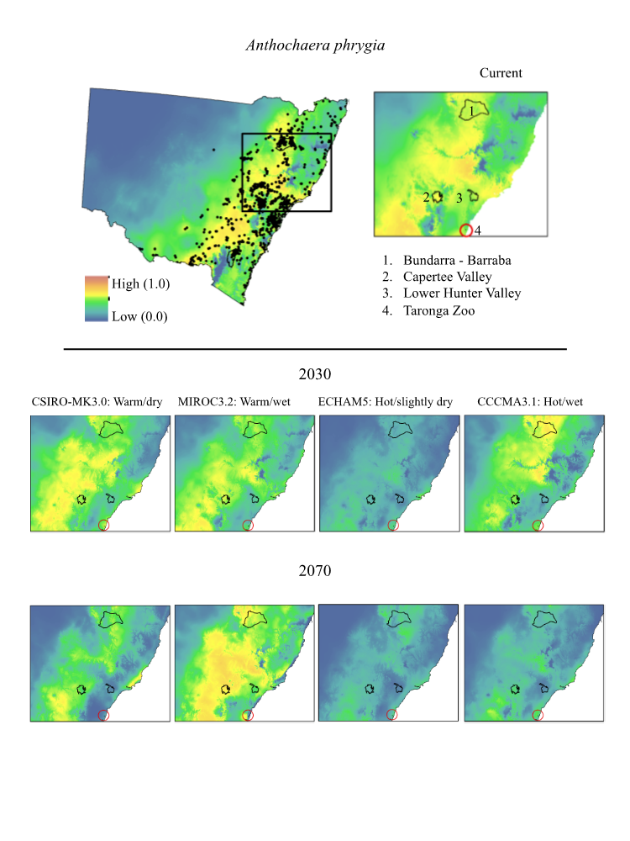

**Figure 47.** Maps of projected current and future (2030, 2070) suitable habitat for *Anthochaera Phrygia* (Regent Honeyeater)across three site-managed locations and Taronga Zoo (circled in red). Sites are numbered in the top right panel.

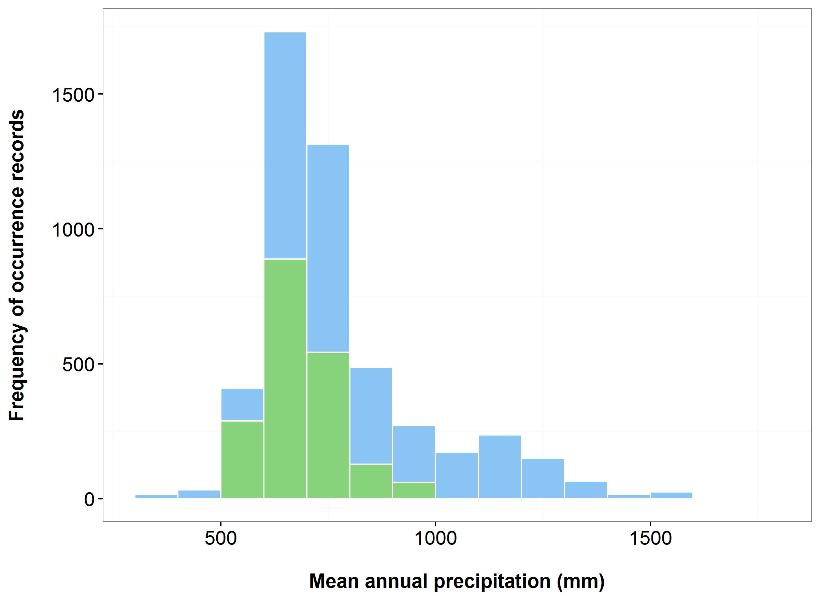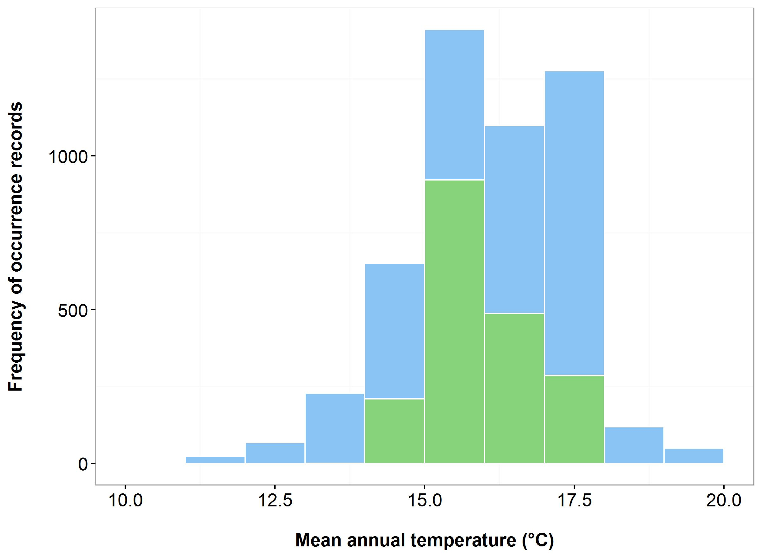

(b)

(a)

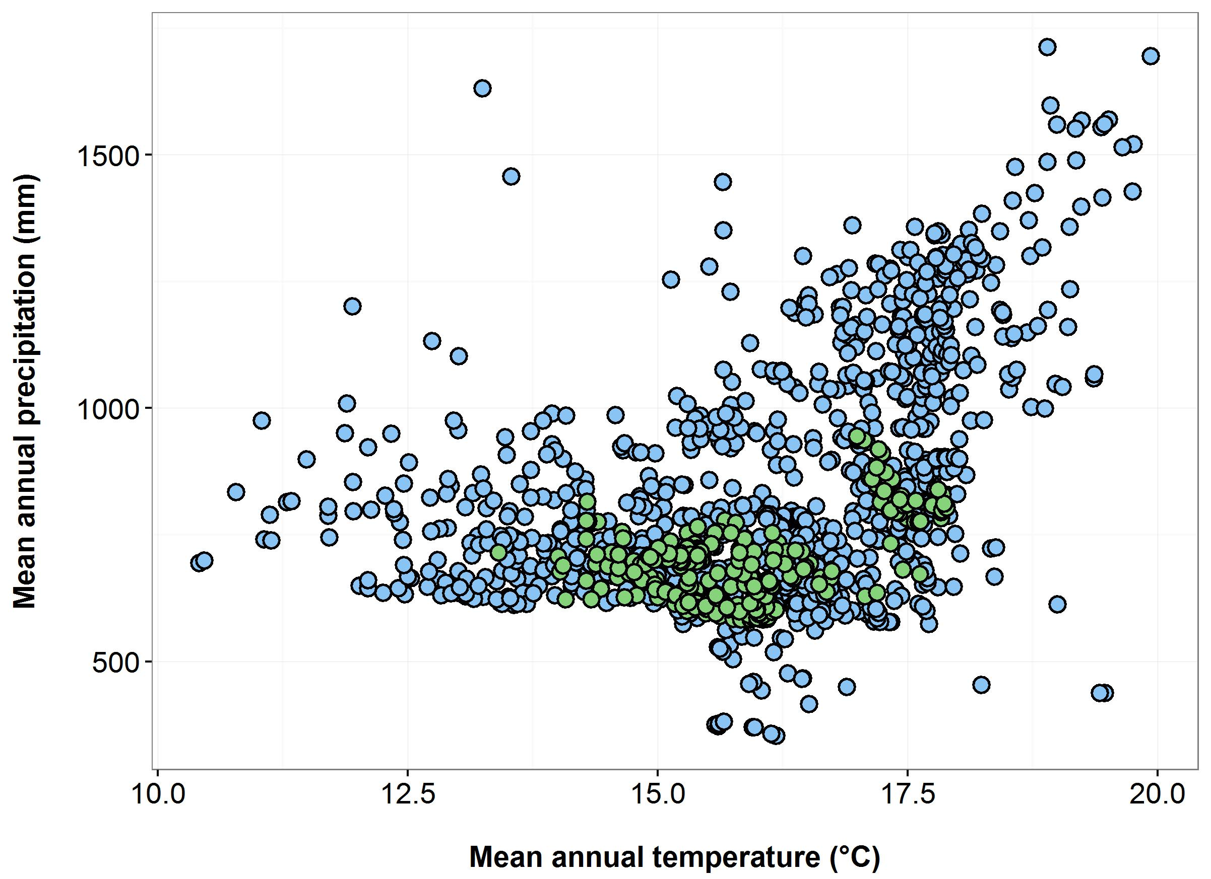

(c)

(d)

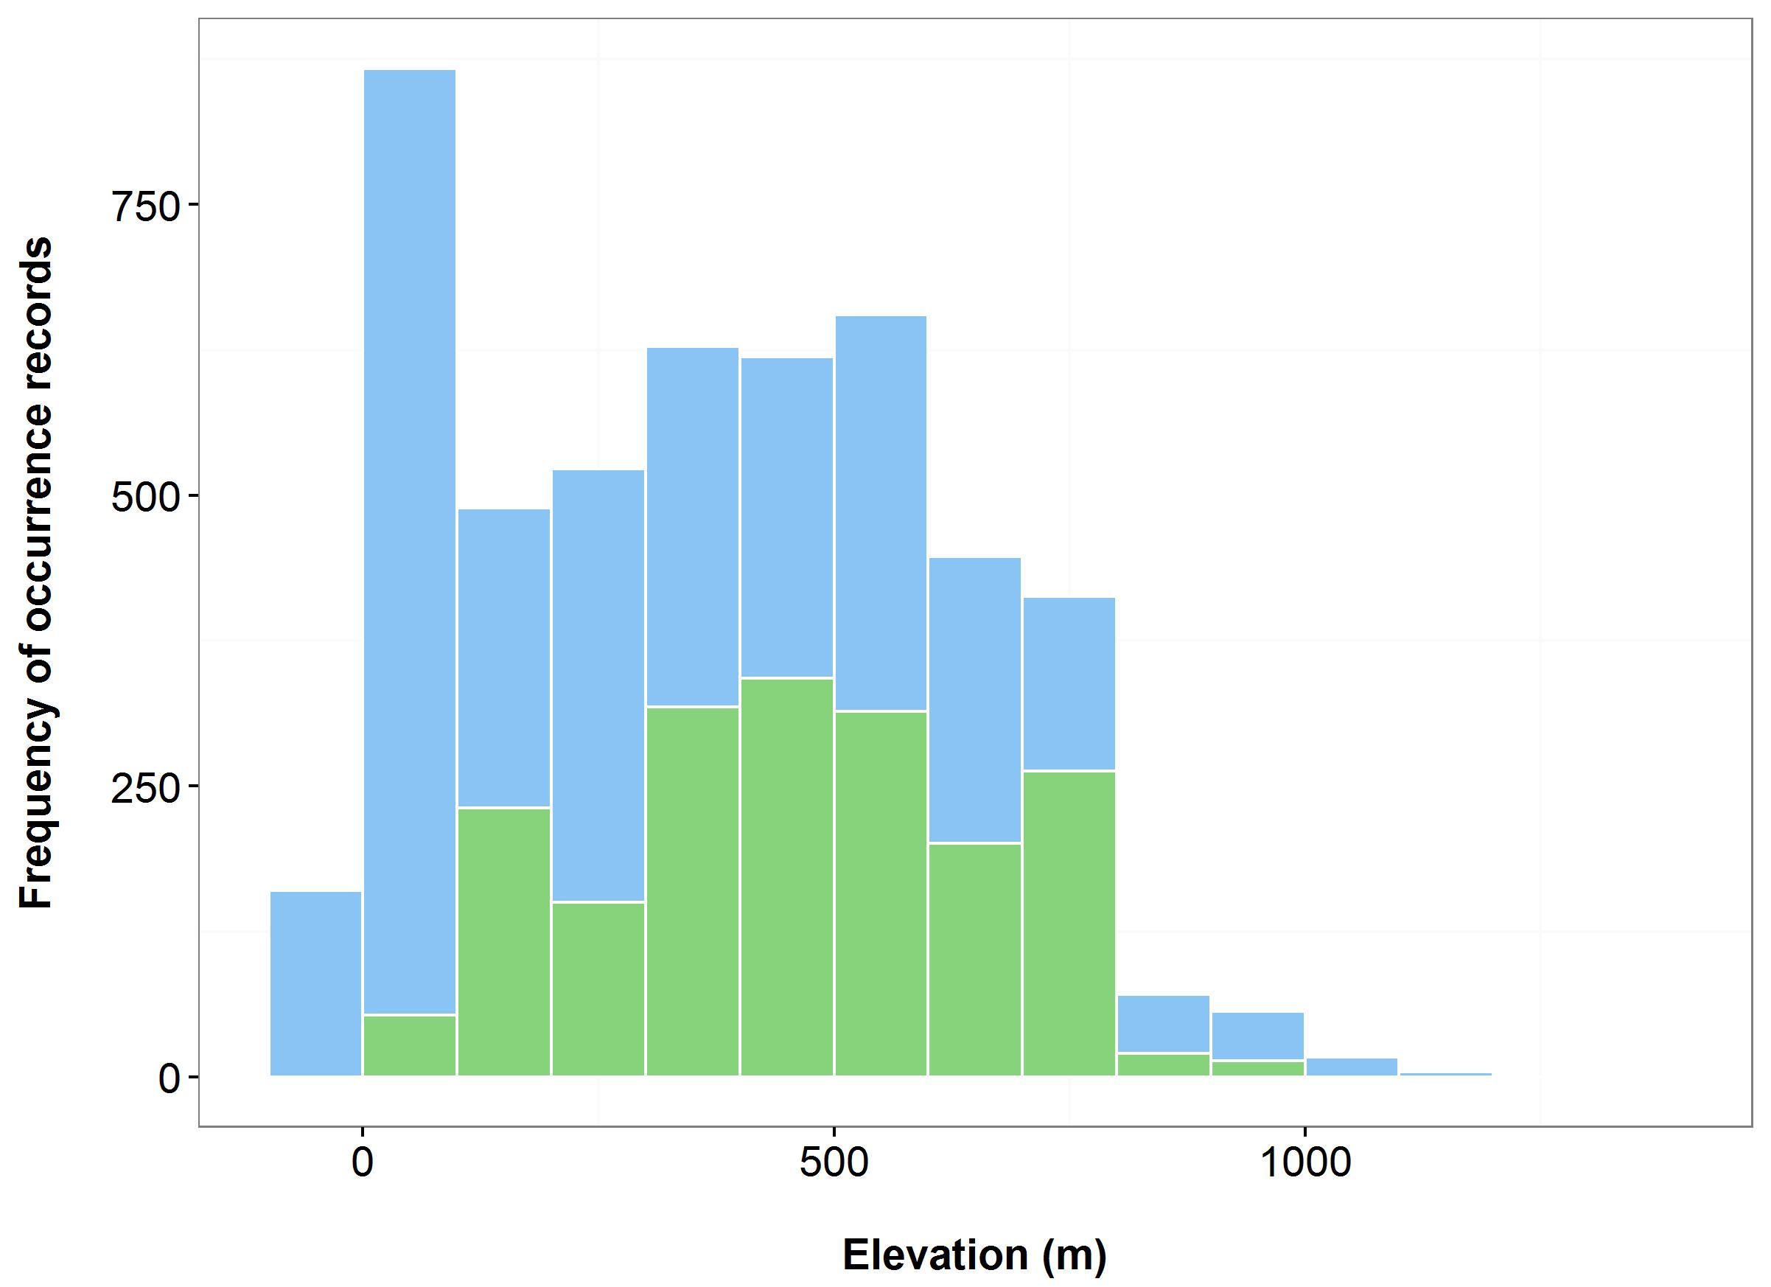

**Figure 48**. Environmental variables for the NSW distribution of *Anthochaera phrygia* that are outside of Saving our Species (SoS) management sites (blue bars/dots) and within management sites (green bars/dots): mean annual temperature (MAT) (a); mean annual precipitation (MAP) (b); elevation (c); and scatterplot of MAT and MAP (d).

**2.4. Overview: how well do the 18 conservation projects address the threat from climate change?**

Here we provide a general overview of our review of the 18 SoS conservation projects, including a summary of their strengths and suggestions for how they might be improved to better manage the species in the face of climate change.

*2.4.1 Species with multiple management sites in Saving our Species conservation projects*

A relatively easy way to increase the resilience and adaptive capacity of threatened species is by managing multiple populations. Managing more than one population of a species increases the number of individuals being managed (and hence the genetic diversity), reduces risk due to adverse events operating at the site-scale and provides an extra buffer against the effects of climate change, especially if the populations chosen for management span a range of environmental conditions. Eleven of the eighteen species (61%) have more than one management site identified in their conservation project. The remaining seven species (39%) only have one known extant population. Six of these species are Critically Endangered plants. Therefore for some species, especially those that are Critically Endangered, it may not be possible to manage multiple populations. However, a criteria that the IUCN use to define a species’ threatened status is its extent of occurrence or area of occupancy: ‘vulnerable’ if ≤ 10 locations: ‘endangered’ if ≤ 5 locations and ‘critically endangered if a single location (IUCN Standards and Petitions Subcommittee 2014). Wherever multiple sites are available, the maximum possible (up to 10) should be selected, based on the IUCN standards (IUCN Standards and Petitions Subcommittee 2014).

When there are multiple populations of a species to choose from, a number of factors should be considered when selecting management sites in order to maximise the adaptive capacity and resilience of the species (see the following section on the development of a decision framework for selecting management sites). Briefly, the environmental conditions at each site, including climate and geology, should also be considered and management sites should aim to capture the full range of environmental variation across the species’ range. Where possible, species distribution models should be used to determine which locations are likely to maintain climatically suitable habitat into the future. Other factors to consider include population size (larger populations are likely to have higher genetic diversity and adaptive potential), land tenure (public land such as National Parks are likely to have great long-term security) and habitat quality (populations with fewer existing threats are likely to be more resilient to climate change).

*2.4.2 Saving our Species conservation projects which directly address the climate change threat identified in the Determination*

As well as using management site selection to maximise species’ resilience and adaptive potential, some climate change threats can be directly managed through specific actions within the management sites. Four of the eighteen SoS conservation projects (22%) directly address the climate change threat identified in the species’ NSW Scientific Committee Determination. For example, the Final Determination for *Eucalyptus aggregata* identified increased densities of competing native species as a threat likely to affect the species under climate change and there is a management action in the SoS conservation project to monitor and manage the numbers of such species within two of the three management sites.

*2.4.3 Control of existing threats and adaptive management*

Management of current (non-climate change) threats is essential for increasing the resilience of all threatened species to climate change. In addition, the combined effects of climate change and existing threats to threatened species (and biodiversity in general) may accelerate the impacts those threats and processes would have alone (Driscoll *et al.* 2012). All conservation projects under the Saving our Species program identify current threats to the survival of the species and determine appropriate management actions.

Another essential part of biodiversity management in the face of climate change is continual monitoring and adaptive management. The uncertainty surrounding climate change means it is important to be able to adapt management actions based on new information and the success or failure of past actions. Adaptive management and the need for continual monitoring are factored into each of the SoS conservation projects. There are actions to monitor the effects of different management actions so that management can be adapted over time.

*2.4.4 Species with translocation site(s) suggested in conservation project*

Highly vulnerable species, such as those with only one or two extant populations and species whose current habitats are unlikely to be climatically suitable in the future might require translocation to new environments to reduce the risk of extinction under climate change. Five of the eighteen SoS conservation projects (28%) suggest conducting species translocations.

Future climate (and species distribution models, where possible) should be considered when selecting translocation sites. In addition to future climate, preferred habitat, land tenure and habitat quality (existing threats) should be considered when selecting potential translocation sites. It is also important to consider the risks associated with translocations, which need to be weighed against the risk of extinction. Risks to consider include uncertainties in models used to predict species distribution changes and suitable translocation sites (McLachlan *et al.* 2007), and the potential for species to become a pest or carry disease to the new site (McLachlan *et al.* 2007; Hoegh-Guldberg *et al.* 2008). See Hoegh-Guldberg *et al.* (2008), Gallagher *et al.* (2015) and Hunter Jr. (2007) for discussions about what to consider when determining whether to conduct species translocations.

*2.4.5 Species with population supplementation suggested in conservation project*

Small populations are highly vulnerable to climate change and many threatened species have very low numbers of individuals (Ottewell *et al.* 2015). Population supplementation is an important way to increase the resilience of threatened species. Ten of the eighteen conservation projects (56%) have a management action to supplement at least one of the management sites with *ex-situ* material. One conservation project (Regent Honeyeater) has a captive breeding and release program that will release individuals into strategic locations to maintain a viable number of breeding individuals. All populations with low numbers of individuals should be supplemented to increase resilience to climate change. In preparation for supplementations/translocations, between-population genetic differences, within-population genetic diversity and the level of inbreeding should be assessed. These results will assist in the determination of appropriate management actions. For example, actions may include maintaining/improving pollinator services, introducing new genotypes from unrelated individuals or increasing natural recruitment, depending on the level of genetic diversity and inbreeding between and within populations (see framework in Ottewell *et al.* 2015). Only two conservation projects, *Anthochaera phrygia* (Regent Honeyeater) and *Syzygium paniculatum*, have determined any genetic parameters.

Population supplementation (and indeed translocation) requires germplasm (seed/cuttings/live plants/living tissue/captive populations) to be collected and stored *ex-situ*. For some plant species it will be difficult to collect and/or germinate seed and so in some cases this might not be possible. Where feasible, germplasm should be collected and stored for all threatened species. Germplasm collected for supplementation and translocation should represent the full range of environmental variation in which the species occurs and capture the full range of genetic variation. Where possible, populations should be supplemented with genetically diverse material, rather than simply local provenance.

**Section 3**

**3.1 A decision framework for selecting management sites for threatened species**

*3.1.1 Introduction*

As part of an extension to this project, a decision framework was developed to underpin optimisation software that can be used to guide the selection of management sites for threatened species (Figures 49 & 50). During the development of this framework, a workshop was held at Macquarie University (July 2015), and we would like to thank James Brazill-Boast, Tony Auld (NSW Office of Environment and Heritage), Rachael Gallagher and Stuart Allen (Macquarie University) for their input on the day.

A set of criteria forms the basis of the framework and this was developed based on a literature review using Google Scholar, covering the factors that increase a species’ vulnerability to climate change and suggested management actions for improving species’ resilience and adaptive capacity under a changing climate. The decision framework can be used to systematically and transparently assess potential management sites against criteria important for maximising threatened species’ resilience to climate change (most of these were identified in the previous section). The criteria includes both species range-level considerations and individual population and site level considerations (Table 9).

Central to this framework is the definition of a population. There are many definitions of ‘population’; there are at least 10 solely with an ecological or evolutionary context (Waples and Gaggiotti 2006). For the purposes of this decision framework, populations are defined as ‘geographically or otherwise distinct groups of individuals within the same species, between which there is little demographic or genetic exchange (typically one successful migrant individual or gamete per year or less’ (NSW Scientific Committee 2014). The determination of what constitutes the optimal number of managed populations and the difference between the terms ‘effective population size’ and ‘population size’ (N) also needs to be defined. There is no general optimal number of populations. However the IUCN consider a species: ‘vulnerable’ if ≤ 10 locations: ‘endangered’ if ≤ 5 locations and ‘critically endangered if a single location (IUCN Standards and Petitions Subcommittee 2014). For the purposes of this decision framework, where populations total less than five, it is recommended that all sites are managed. Effective population size (Ne), in its most simplistic form, is defined as the number of breeding individuals in a population (Primack 2014). Population size (N), or census size, typically refers to the number of individuals in a population and is more commonly used than Ne. A conversion from Ne to N depends on the species, but the mean Ne/N has been estimated at 0.1 – 0.2 (Frankham *et al.* 2014). Recently, the recommended Ne to prevent inbreeding depression and to retain adaptive potential were increased. To prevent inbreeding depression, Frankham *et al.* (2014) suggest that Ne of ≥ 100 is required to limit loss in total fitness to ≤ 10% over five generations in the wild. To retain evolutionary potential for fitness in perpetuity, Ne of ≥ 1000 is recommended (Frankham *et al.* 2014). Frankham et al (2014) also recommend that the IUCN Red List Criterion C thresholds are updated from < 250 to <500 for Critically Endangered; <2,500 to <5,000 for endangered and <10,000 to < 20,000 for vulnerable categories.

**Table 9.** Criteria included in the decision framework for selecting management sites for threatened species.

|  |  |
| --- | --- |
| Step 1: Species range-level considerations | Step 2: Site-level considerations |
| *CRITERIA 1: NUMBER OF POPULATIONS*  How many populations/sites should be managed to maximise likelihood of long-term viability? Should all known locations of the species be managed? | *CRITERIA 1: POPULATION SIZE*  Are some populations large enough to be viable over the long-term? |
| *CRITERIA 2: ENVIRONMENTAL VARIATION*  What are the range of environmental conditions occupied by the species? | *CRITERIA 2: ASSESSMENT OF THREATS*  What are the current and future threats to the populations/sites? |
| *CRITERIA 3: ISOLATION/CONNECTIVITY*  Are any populations well-connected to each other so that dispersal might be possible? | *CRITERIA 3: SECURITY OF TENURE*  Are any populations in the current reserve system? |
| *CRITERIA 4: LONG-TERM CLIMATE SUITABILITY*  Are some populations likely to remain in climatically suitable habitat over the next 50-100 years? |  |

*3.1.2. How to use the Decision Framework*

The first step in the decision framework is to assess all management sites/populations against the species range-level considerations (Figure 49). The second step is to then prioritise / rank potential management sites/populations based on how many/which species range-level criteria they satisfy (Figure 50). Note two additional criteria (‘Co-benefit’ and ‘Special cases’), not included in Table 9, appear in step 2 of the decision framework. These are additional considerations for decision makers, but should not necessarily be used to prioritise management site selection.

Where numerous sites are considered, an optimisation model (to be developed) evaluates the criteria simultaneously. Ultimately, the two-step process prioritizes populations/management sites likely to maximise the species’ resilience to climate change. The framework identifies where uncertainties exist and where more data or expert opinion is required in order to make informed decisions. If and when new information becomes available, the decision framework should be updated accordingly. Examples of how the framework process works is included for two plant species (*Eucalyptus aggregata* and *Syzygium paniculatum*) and one animal species (*Anthochaera phrygia*) and it is anticipated that the decision framework will be applicable across taxa.

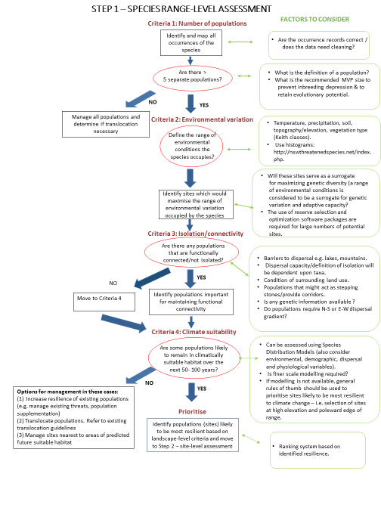

**Figure 49.** Consideration of species range-level criteria. Step 1 of the decision framework for selecting management sites for threatened species.

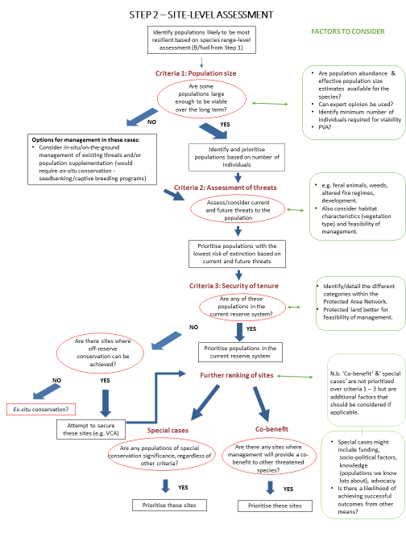

**Figure 50.** Consideration of site-level criteria. Step 2 of the decision framework for selecting management sites for threatened species.

*3.1.3 Application of the Decision Framework to 18 site-managed species*

To demonstrate how this decision framework might be applied to site-managed species under the Saving our Species program and to provide an indication of the type of data which might be required during this process, we have considered each of the criteria within the decision framework for the 18 site-managed species where climate change was identified as a threat in the Determination (see Table 7 and Section 2).

After identifying and mapping all occurrences of the species, the first step is to determine the number of populations (criteria 1). Of the 18 site-managed species we have assessed here, 15 species have fewer than five known populations. Therefore, to maximise their resilience to climate change, the decision framework recommends managing all known populations of these species. These species are: *Calochilus pulchellus*, *Dampiera fusca*, *Eucalyptus parvula*, *Pelargonium* sp. (G. W. Carr 10345), *Rytidosperma vickeryae*, *Gentiana bredboensis*, *Gentiana wingecarribiensis*, *Eucalyptus imlayensis*, *Lepidorrhachis mooreana*, *Pomaderris walshii*, *Prasophyllum keltonii*, *Thelymitra kangaloonica*, *Zieria buxijugum*, *Zieria formosa*, *Pterodroma leucoptera*. There is no need to consider the remaining criteria within the decision framework for these species, although in some cases it will not be possible to manage all five sites due to other factors such as tenure. In addition to managing all known populations, it might be necessary to consider population supplementation and/or translocation for these species.

For the three species with more than five known locations (*Eucalyptus aggregata*, *Syzygium paniculatum* and *Anthochaera phrygia*), the remaining criteria within the decision framework need to be considered. This process is summarised on the following pages. For some of the steps in the framework, data needed to assess the relevant criteria is currently unavailable. The aim of these examples is not to make recommendations but to illustrate the process to use the decision framework and to offer interpretations where sufficient data are available.

See Section 2.1 for details on data sources.

***Example 1: Eucalyptus aggregata (Black Gum)***

**Table 10.** Compilation of information required to apply decision framework to *Eucalyptus aggregata* (Black Gum).

|  |
| --- |
| **Step 1: Species range-level considerations** |
| *Criteria 1: Number of populations*  **Data needed:**  Map and details of species occurrence records.  **Data consulted and interpretation**:  Map of species occurrence records: <http://nswthreatenedspecies.net/species_profile.php?species_id=575>.  Figure 6.  NSW Scientific Committee final determination – compilation of survey data indicates 6300-8100 mature individuals are scattered across 130-150 locations.  The species has been recorded in many locations (>5), but it is not feasible to manage all known locations. Use the decision framework to help determine which locations to manage.  Move to criteria 2. |
| *Criteria 2: Environmental variation*  **Data needed:**  Environmental conditions across the range of occurrence records.  **Data consulted and interpretation**:  Graphs showing environmental variation (average temp., average precipitation, elevation (see Figure 8) min./max. temperature, soil type, geology and vegetation type,) across range of occurrence records, sourced from <http://nswthreatenedspecies.net/species_profile.php?species_id=575>  |environmental variables,  http://nswnichefinder.net/species_profile.php?taxon_level=species&taxon_id=2866 and Auld *et al.* (2016).  The occurrence records span an annual precipitation range of ~ 600-950 mm/year. Therefore, as well as managing locations in the middle of this range (as captured by the current Saving our Species management sites), an attempt should be made to secure locations at either extreme of the precipitation range (see Figure 8). Populations at the drier locations are likely be adapted to drier conditions and this adaptive potential should be conserved. Similarly, those populations at the higher end of the rainfall range should be captured (this occurrence datum should be validated).  The occurrence records span a mean annual temperature range of 9-16 °C. Currently, the management sites all occur in areas with an average annual temperature of 12 - 13°C (Figure 8) and an attempt to manage locations along this range should be made, at the warmer, more northerly locations to ensure the survival of genotypes adapted to warmer conditions and at southern locations because this is likely to be more climatically more suitable in the future (see criteria 4).  To assist with finding suitable locations, go to the scatterplot at <http://nswthreatenedspecies.net/species_profile.php?species_id=575> and hover the mouse over the points on the scatterplot. An indication of their location appears as yellow circles on the accompanying occurrences map. This process should be undertaken for all of the relevant environmental variables for which information is available.  Auld *et al.* (2016) conclude that the geographical or environmental range of the species is not adequately covered within the SoS program and that more management sites should be included to add adaptive capacity.  **Other data needed:** Ideally, optimisation software would be used to identify sites which capture the maximum environmental variation as it is not realistic to examine each environmental variable independently. Consideration of what constitutes an ecologically meaningful bin size for each environmental variable (and potentially the permutations for each species within variable) will be required.  Move to criteria 3. |
| *Criteria 3: Isolation/connectivity*  **Data needed:**  To determine whether any locations should be prioritised based on connectivity and the species’ ability to disperse between locations, will need to consider the species’ dispersal capacity and overlay land use/vegetation cover/agricultural/forestry/CAPAD layers onto a map of species’ occurrence records.  Calculate distance between populations.  **Data consulted and interpretation:**  CAPAD layers over occurrence records: <http://nswthreatenedspecies.net/species_profile.php?species_id=575>.  (map of occurrences|display CAPAD protected areas).  Pollen dispersal estimates: (Field *et al.* 2011).  Expert opinion may be needed to clarify some of the data limitation issues.  **Other data needed:**  Detailed information on seed dispersal distances.  Genetic variability within and between populations.  Move to criteria 4. |
| *Criteria 4: Climate suitability*  **Data needed:**  Use species distribution modelling (SDM) to determine which locations (if any) are likely to remain climatically suitable into the future. Apply ecological and biological trait knowledge to determine if finer scale SDM is required.  **Data consulted and interpretation:**  Results from species distribution modelling -Figure 7.  Saving our Species conservation project.  By 2070, at least one site may not be climatically suitable.Modelling at a finer scale than that provided here is advisable for this species (habitat: cold and poorly-drained flats and hollows).  Move to Step 2: criteria 1 |
| **Step 2: Site-level considerations** |
| *Criteria 1: Population size*  **Data needed:**  Accurate or reliable estimates of population sizes (census and effective) of the species throughout its distribution.  **Data consulted and interpretation:**  Saving our Species conservation project – Coxs River area management sites recorded as having 2,000 individuals.  Field (2007) surveyed 76 locations and determined that 56% of populations had fewer than 40 individuals. Only 9% populations had >200 individuals. The four populations in NPs all have <60 individuals.  NSW Scientific Committee final determination – compilation of survey data indicates 6300-8100 mature individuals are scattered across 130-150 locations.  **Other data needed:**  A more thorough assessment of population sizes for this species to be able to prioritise based on population size.  Move to criteria 2 |
| *Criteria 2: Assessment of threats*  **Data needed:**  To determine which locations should be prioritised based on the number of current and future threats, need a thorough assessment of threats to populations (i.e. invasive species, development, altered disturbance regimes). N.B. *E. aggregata* occurs in many locations and it may not really feasible to assess all populations.  **Data consulted and interpretation:**  Saving our Species conservation project; NSW Scientific Committee Final Determination.  Threats identified: changes to precipitation (reduced); increased temperatures; increase in abundance or distribution of native co-occurring species; land clearing; exotic plant species (weed invasion).  Move to criteria 3 |
| *Criteria 3: Security of tenure*  **Data needed:**  Ownership details of land wherein individuals/populations exist e.g. freehold / crown land.  **Data consulted and interpretation**:  Saving our Species conservation project – Two of the current management sites are on private property (Coxs River area and Bendoura area), whilst the Back Creek Travelling Stock Reserve is not.  Field (2007)– Majority of populations are on land under lease or under private ownership and subject to grazing. There are four small populations within National Parks (Tallaganda NP, Yanununbeyan NP, Morton NP, and Blue Mountains NP).  NSW Scientific Committee Final Determination - Most populations of *E. aggregata* are located on private land or road verges and travelling stock routes.  CAPAD overlaid onto the species’ distribution: <http://nswthreatenedspecies.net/species_profile.php?species_id=575#map-anchor>  Largest populations likely to be on private property or land under lease – populations in National Parks might not be most resilient. |

***Example 2: Syzygium paniculatum* (Magenta Lilly Pilly)**

**Table 11.** Compilation of information required to apply decision framework to *Syzygium paniculatum* (Magenta Lilly Pilly).

|  |
| --- |
| **Step 1: Species range-level considerations** |
| *Criteria 1: Number of populations*  **Data needed:**  Map and details of species occurrence records.  **Data consulted and interpretation**:  Map of species occurrence records: <http://nswthreatenedspecies.net/species_profile.php?species_id=567> and see Figure 21).  National Recovery Plan (2012) – The known total population of *Syzygium paniculatum* is estimated to be approximately 1200 plants that are distributed along a 400 kilometre stretch of coastal NSW. Five broad metapopulations are identified: Jervis Bay, Coalcliff, Botany Bay, Central Coast and Karuah-Manning. These comprise a total of 44 known subpopulations.  As the species has been recorded in many locations, it is not feasible to manage all known locations.  Move to criteria 2. |
| *Criteria 2: Environmental variation*  **Data needed:**  Environmental conditions across the range of occurrence records.  **Data consulted and Interpretation:**  Graphs showing environmental variation (average temp., average precipitation, elevation (see Figure 23) min./max. temperature, soil type, geology and vegetation type,) across range of occurrence records, sourced from  <http://nswthreatenedspecies.net/species_profile.php?species_id=567> |environmental variables,  <http://nswnichefinder.net/species_profile.php?taxon_level=species&taxon_id=6880> and  Auld *et al* (2016).The occurrence records span an annual precipitation range of 600-1600 mm/year (NB, using the cleaned data from Auld *et al* (2016) the range is narrower ~850 - 1350). Therefore, as well as managing locations towards the wetter end of this range (as captured by the current Saving our Species management sites), attempt should be made to secure locations at the drier end of the precipitation range (see Figure 23). Populations at the drier end are likely to be adapted to drier conditions. If drier conditions eventuate, conservation of this adaptive potential would be beneficial.  The occurrence records span an average annual temperature range of 14.5-20°C. Current management sites are at the warmer end of the range. Consideration could be given to the potential for managing populations at the cooler (southern) end of this range (see Figure 23).  To assist with finding suitable locations, go to the scatterplot at <http://nswthreatenedspecies.net/species_profile.php?species_id=567> and hover the mouse over the points on the scatterplot. An indication of their location appears as yellow circles on the accompanying occurrences map. This process should be undertaken for all of the relevant environmental variables for which information is available.  Auld *et al.* (2016)conclude that the geographical or environmental range of the species is not adequately covered within the SoS program and that more management sites should be included, particularly from the southern regions and higher altitudes.  **Other data needed:**  Ideally, optimisation software would be used to identify sites which capture the maximum environmental variation as it is not realistic to examine each environmental variable independently. Consideration of what constitutes an ecologically meaningful bin size for each environmental variable (and potentially the permutations for each species within variable) will be required.  Move to criteria 3. |
| *Criteria 3: Isolation/connectivity*  **Data needed:**  To determine whether any locations should be prioritised based on connectivity and the species’ ability to disperse between locations, will need to consider the species’ dispersal capacity and overlay land use/vegetation cover/agricultural/forestry/CAPAD layers onto a map of species’ occurrence records.  Calculate distance between populations.  **Data consulted and Interpretation:**  National Recovery Plan (2012) – Species’ dispersal capacity approx. 30km based on foraging range of dispersal agents (Grey-headed Flying Fox and White-headed Pigeon). This estimate was used to identify metapopulations.  CAPAD layers over occurrence records:  <http://nswthreatenedspecies.net/species_profile.php?species_id=567>  (map of occurrences|display CAPAD protected areas)  Move to criteria 4 |
| *Criteria 4: Climate suitability*  **Data needed:**  To determine which locations (if any) are likely to remain climatically suitable into the future, use species distribution modelling. Apply ecological and biological trait knowledge to determine if finer scale SDM is required.  Apply ecological and biological trait knowledge to determine if finer scale SDM is required.  **Data consulted and interpretation:**  By 2030, low to high quality habitat is likely to remain in at least one of the three sites managed for this species. For instance, under the warm/wet scenario Wyrrabalong and Wamberal Lagoon are likely to have high suitability, while Seal Rocks is projected to be most suitable under the hot/wet scenario. However, by 2070, Wyrrabalong and Wamberal Lagoon are likely to be unsuitable under the hot/slightly dry and warm/dry scenarios, or have very low suitability under the warm/wet and hot/wet scenarios. The Seal Rocks site may continue to be suitable under the hot/wet scenario for 2070 (Figure 22).  Modelling at a finer scale than that provided here is advisable for this species in addition to sea-level modelling because of its restricted habitats and its vulnerability to sea-level rise.  **Other data needed:**  Finer scale modelling, including projections of sea level rise by 2030 and 2070.  Move to Step 2: criteria 1  **Step 2: Site-level considerations** |
| *Criteria 1: Population size*  **Data needed:**  Accurate or reliable estimates of population sizes (census and effective) of the species throughout its distribution.  **Data consulted and interpretation**:  Saving our Species conservation project – Wyrrabalong management site recorded as having 50 individuals, Wamberal Lagoon management site recorded as having 20 individuals, and Seal Rocks management site recorded as having 5 individuals.  Thurlby *et al.* (2012) -estimates of the number of individuals within some of the other subpopulations are also available but not publically accessible. However, genetic studies have been conducted on this species which implies that population numbers are available for at least 11 sampling sites. Little genetic diversity within and among populations increases the susceptibility of this species to stochastic events. Any supplementation should ensure that maximum genetic diversity is retained and is cognizant of the differentiation between the northern and southern populations.  There may be other subpopulations which might be prioritised based on population size. However, many of these are on council land or private property (Population numbers provided by Sue Chate (NSW Scientific Committee).  **Other data needed:**  Need a more thorough assessment of population sizes for this species to be able to prioritise based on population size. At many locations, the population sizes are unknown and those with population sizes recorded are likely to be estimates.  Move to criteria 2. |
| *Criteria 2: Assessment of threats*  **Data needed:**  To determine which locations should be prioritised based on the number of current and future threats, need a thorough assessment of threats to populations (i.e. invasive species, development, sea-level rise, and altered disturbance regimes). However, the species occurs in many locations and it may not be feasible to assess all populations.  **Data consulted and interpretation:**  Saving our Species conservation project; NSW Scientific Committee Final Determination.  Threats identified: sea-level rise (habitat loss); land clearing; fragmentation; altered hydrology (reduced flow, frequency and magnitude of floods); exotic plant species (weed invasion); exotic animal species (grazing, habitat disturbance); restricted geographic distribution/narrow ecological range; environmental stochasticity; low population size. Very little genetic diversity exists within and among populations, increasing the species’ susceptibility to extreme stochastic events as well as pests and diseases (Thurlby *et al.* 2012).  Move to criteria 3. |
| *Criteria 3: Security of tenure*  **Data needed:**  Ownership details of land wherein individuals/populations exist e.g. freehold / crown land.  **Data consulted and interpretation**:  Saving our Species conservation project – All three of the current management sites are in a National Park or Nature Reserve.  National Recovery Plan (2012) – 15/44 known subpopulations are in a National Park or Nature Reserve, the remainder are on private property, council land or land owned by the Department of Defence etc.  CAPAD overlaid onto the species’ distribution: <http://nswthreatenedspecies.net/species_profile.php?species_id=567>  This criteria should be relatively easy to assess as there is information on land tenure for all 44 of the known subpopulations. According to information obtained from Suzanne Chate (NSW Scientific Committee’s Executive Officer), the three current management sites are some of the largest populations within the reserve system. However the majority of known populations occur outside of the reserve system and it might be necessary to consider the potential for securing some of these populations. |

***Example 3: Anthochaera phrygia* (Regent Honeyeater)**

**Table 12.** Compilation of information required to apply decision framework to *Anthochaera phrygia* (Regent Honeyeater).

|  |
| --- |
| **Step 1: Species range-level considerations** |
| *Criteria 1: Number of populations*  **Data needed:**  Map and details of species occurrence records.  **Data consulted and interpretation**:  Map of species occurrence records (NSW Wildlife Atlas and Atlas of Living Australia).  <http://nswthreatenedspecies.net/species_profile.php?species_id=513> and see Figure 46.  NSW Scientific Committee Final Determination – in NSW, breeding subpopulations are fragmented and occur mainly around the Capertee Valley and the Bundarra-Barraba region. Minor and sporadic breeding occurs in other areas such as Warrumbungle National Park, Pilliga forests, Mudgee-Wollar region, and the Hunter and Clarence Valleys.  This bird species is able to disperse widely across the landscape and has been recorded at many locations in NSW. Compared to plant species, it is less simple to identify discrete populations based on mapped occurrence records for this species. However, expert opinion should be used to confirm details such as core breeding habitat/key breeding populations/key feeding sites/annual movement patterns to provide the basis for identifying management sites for this species. Analysis of the future distribution of the main nectar resource may also be informative.  Move to criteria 2. |
| *Criteria 2: Environmental variation*  **Data needed:**  Environmental conditions across the range of occurrence records.  **Data consulted and interpretation:** Rather than considering environmental variation across all of the species’ recorded range (using all occurrence records), consider environmental variation within core breeding locations and other key sites as identified in Criteria 1. Graphs showing environmental variation (average temp., average precipitation, elevation (see Figure 48 ) min./max. temperature, soil type, geology and vegetation type,) across range of occurrence records, sourced from  <http://nswthreatenedspecies.net/species_profile.php?species_id=513> |environmental variables  To assist with finding suitable locations, go to the scatterplot at <http://nswthreatenedspecies.net/species_profile.php?species_id=513> and hover the mouse over the points on the scatterplot. An indication of their location appears as yellow circles on the accompanying occurrences map. This process should be undertaken for all of the relevant environmental variables for which information is available.  **Other data needed:**  Ideally, optimisation software would be used to identify sites which capture the maximum environmental variation as it is not realistic to examine each environmental variable independently. Consideration of what constitutes an ecologically meaningful bin size for each environmental variable (and potentially the permutations for each species within variable) will be required.  Move to criteria 3. |
| *Criteria 3: Isolation/connectivity*  **Data needed:**  To determine whether any locations should be prioritised based on connectivity and the species’ ability to disperse between locations, will need to consider the species’ dispersal capacity and overlay land use/vegetation cover/agricultural/forestry/CAPAD layers onto a map of species’ occurrence records.  Calculate distance between populations.  Land use/vegetation cover should also be used to identify any key locations that are less fragmented and close to additional foraging or ‘stepping stone’ habitats that may be important for maintaining the species’ annual movement patterns and providing additional food sources when primary food locations fail.  **Data consulted and interpretation:**  NSW Scientific Committee final determination - the species is capable of dispersing more than 530 km; despite severe habitat fragmentation, it can disperse freely between remnants.  CAPAD layers over occurrence records: <http://nswthreatenedspecies.net/species_profile.php?species_id=513> (map of occurrences|display CAPAD protected areas).  (Oliver and Lollback 2010) – modelling suggests that the breeding habitat most favoured is found close to edges of linear, well-connected remnants with relatively low proportions of surrounding woodland vegetation cover within 1 – 2 km radius.  Expert opinion may be needed to clarify some of the data limitation issues.  Move to criteria 4. |
| **Step 2: Site-level considerations** |
| *Criteria 1: Population size*  **Data needed:**  Accurate or reliable estimates of population sizes (census and effective) of the species throughout its distribution.  **Data consulted and interpretation**:  NSW Scientific Committee Final Determination – apparent loss of some minor breeding subpopulations over the last decade (Warrumbungle National Park, Pilliga forests). Also declines at two major breeding sites (Capertee Valley and Bundarra-Barraba). Capertee Valley subpopulation declined from hundreds in the mid 1990s to tens in 2008. In the Bundarra-Barraba area, numbers have apparently declined from around 100 in the 1990s, to 50 birds in subsequent breeding seasons, and about 30 birds in recent years. Since 2000, only very small numbers (fewer than 10 birds) have been reported for each of the minor sites in NSW, apart from the lower Hunter and Central Coast, where tens of birds are still sometimes reported.  Saving our Species conservation project – subpopulation within Capertee Valley breeding site estimated at 150 individuals and 100 within Lower Hunter Valley minor breeding site. (N.B. Confirmation of ‘estimates’ required).  Kvistad *et al* (2015) - because the species is highly mobile and individuals may change breeding locations between years and utilise different locations based on food availability, it may not be too important to prioritise locations based on recorded subpopulation numbers during previous breeding seasons. However, these numbers may provide an indication of habitat quality and so should be considered as part of the overall site selection process. Estimated effective population size is between 87 – 149 for the species. See Kvistad *et al* (2015) for details on effective population size for selected sampled sites.  Move to criteria 2. |
| *Criteria 2: Assessment of threats*  **Data needed:**  To determine which locations should be prioritised based on the number of current and future threats, need a thorough assessment of threats to populations (i.e. invasive species, development, altered disturbance regimes, drought).  **Data consulted and interpretation:**  Saving our Species conservation project; NSW Scientific Committee Final Determination; (Franklin *et al.* 1989).  Threats identified: changes to precipitation (drought); food availability (reduced due to drought); land clearing; competition from more aggressive birds (particularly Honeyeaters).  Move to criteria 3. |
| *Criteria 3: Security of tenure*  **Data needed:**  Ownership details of land wherein individuals/populations exist e.g. freehold / crown land.  **Data consulted and interpretation:**  Saving our Species conservation project – all three current management sites (Bundarra-Barraba, Capertee Valley and Lower Hunter Valley), which includes both major breeding locations are on privately owned land. Whilst these are all currently recognised as important bird areas, longevity of protection is critical e.g. <http://www.edonsw.org.au/court_grants_reprieve_to_a_critically_endangered_bird> (approval to develop land in the Lower Hunter Valley’s breeding area rejected by the EDO).  NSW Scientific Committee final determination - two minor breeding sites (Warrumbungle National Park, Pilliga forests) are within the current reserve system.  Oliver and Lollback (2010) –well-connected travelling stock routes along roadways that have been protected from clearing are important for breeding individuals.  Lower Hunter Valley.  CAPAD overlaid onto the species’ distribution. |

**References**

Allen C. R., Fontaine J. J., Pope K. L. & Garmestani A. S. (2011) Adaptive management for a turbulent future. *Journal of Environmental Management* **92**, 1339-45.

Auld T. D., Davis S. T. & Ooi M. K. J. (2016) Assessing the capacity of the NSW Saving our Species site based program to maximise the adaptive capacity of threatened plant species. Internal OEH report.

Bellard C., Bertelsmeier C., Leadley P., Thuiller W. & Courchamp F. (2012) Impacts of climate change on the future of biodiversity. *Ecology Letters* **15**, 365-77.

Cahill A. E., Aiello-Lammens M. E., Fisher-Reid M. C., Hua X., Karanewsky C. J., Ryu H. Y., Sbeglia G. C., Spagnolo F., Waldron J. B., Warsi O. & Wiens J. J. (2013) How does climate change cause extinction? *Proceedings. Biological sciences / The Royal Society* **280**, 20121890.

Caplat P., Cheptou P. O., Diez J., Guisan A., Larson B. M. H., Macdougall A. S., Peltzer D. A., Richardson D. M., Shea K., van Kleunen M., Zhang R. & Buckley Y. M. (2013) Movement, impacts and management of plant distributions in response to climate change: insights from invasions. *Oikos* **122**, 1265-74.

Dawson T. P., Jackson S. T., House J. I., Prentice I. C. & Mace G. M. (2011) Beyond predictions: Biodiversity conservation in a changing climate. *Science* **332**, 53-8.

Department of Environment and Climate Change NSW (DECC). (2007) Department of Environment and Climate Change NSW Adaptation Strategy for Climate Change Impacts on Biodiversity. Actions to implement the National Biodiversity and Climate Change Action Plan and the NSW Biodiversity and Climate Change and Adaptation Framework. Department of Environment and Climate Change NSW, Sydney.

Department of Environment Climate Change and Water NSW (DECCW). (2010) Priorities for Biodiversity Adaptation to Climate Change: Statement of Intent in response to the listing of Anthropogenic Climate Change as a Key Threatening Process under the NSW Threatened Species Conservation Act 1995. Department of Environment, Climate Change and Water NSW, Sydney.

Driscoll D. A., Felton A., Gibbons P., Felton A. M., Munro N. T. & Lindenmayer D. B. (2012) Priorities in policy and management when existing biodiversity stressors interact with climate-change. *Climatic Change* **111**, 533-57.

Dunlop M., Hilbert D. W., Ferrier S., House A., Liedloff A., Prober S. M., Smyth A., Martin T. G., Harwood T., Williams K. J., Fletcher C. & Murphy H. (2012) The Implications of Climate Change for Biodiversity Conservation and the National Reserve System: Final Synthesis. A report prepared for the Department of Sustainability, Environment, Water, Population and Communities, and the Department of Climate Change and Energy Efficiency. Canberra.

Evans J. P. & Ji F. (2012) Choosing GCMs. NARCliM Technical Note 1, 7 pp., NARCliM Consortium, Sydney, Australia.

Field D. L. (2007) The importance of ecological factors in determining the pattern of interspecific hybridization in fragmented landscapes of *Eucalyptus aggregata*. PhD Thesis, University of Wollongong.

Field D. L., Ayre D. J., Whelan R. J. & Young A. G. (2011) The importance of pre-mating barriers and the local demographic context for contemporary mating patterns in hybrid zones of *Eucalyptus aggregata* and *Eucalyptus rubida*. *Molecular Ecology* **20**, 2367-79.

Foden W. B., Butchart S. H. M., Stuart S. N., Vié J.-C., Akçakaya H. R., Angulo A., DeVantier L. M., Gutsche A., Turak E., Cao L., Donner S. D., Katariya V., Bernard R., Holland R. A., Hughes A. F., O’Hanlon S. E., Garnett S. T., Şekercioğlu Ç. H. & Mace G. M. (2013) Identifying the World's Most Climate Change Vulnerable Species: A Systematic Trait-Based Assessment of all Birds, Amphibians and Corals. *PLoS ONE* **8**, e65427.

Foden W. B., Mace G. M., Vié J.-C., Angulo A., Butchart S. H. M., DeVantier L. M., Dublin H. T., Gutsche A., Stuart S. N. & Turak E. (2009) Species susceptibility to climate change impacts. In: *Wildlife in a Changing World – An Analysis of the 2008 IUCN Red List of Threatened Species* (ed J. C. Vié, Hilton-Taylor, C. and Stuart, S. N.), Gland, Switzerland: IUCN.

Frankham R., Bradshaw C. J. A. & Brook B. W. (2014) Genetics in conservation management: Revised recommendations for the 50/500 rules, Red List criteria and population viability analyses. *Biological Conservation* **170**, 56-63.

Franklin D., Menkhorst P. & Robinson J. (1989) Ecology of the Regent Honeyeater *Xanthomyza phrygia*. *Emu* **89**, 140-54.

Gallagher R. V., Hancock N., Makinson R. O. & Hogbin T. (2014) Assisted colonisation as a climate change adaptation tool. Report to the Biodiversity Hub of the NSW Office of Environment & Heritage.

Gallagher R. V., Makinson R. O., Hogbin P. M. & Hancock N. (2015) Assisted colonization as a climate change adaptation tool. *Austral Ecology* **40**, 12-20.

Gillson L., Dawson T. P., Jack S. & McGeoch M. A. (2013) Accommodating climate change contingencies in conservation strategy. *Trends in Ecology & Evolution* **28**, 135-42.

Green O. O. & Garmestani A. S. (2012) Adaptive management to protect biodiversity: Best available science and the Endangered Species Act. *Diversity* **4**, 164-78.

Groves C., Game E., Anderson M., Cross M., Enquist C., Ferdaña Z., Girvetz E., Gondor A., Hall K., Higgins J., Marshall R., Popper K., Schill S. & Shafer S. (2012) Incorporating climate change into systematic conservation planning. *Biodiversity and Conservation* **21**, 1651-71.

Heller N. E. & Zavaleta E. S. (2009) Biodiversity management in the face of climate change: A review of 22 years of recommendations. *Biological Conservation* **142**, 14-32.

Hoegh-Guldberg O., Hughes L., McIntyre S., Lindenmayer D. B., Parmesan C., Possingham H. P. & Thomas C. D. (2008) Assisted Colonization and Rapid Climate Change. *Science* **321**, 345-6.

Hughes L. (2000) Biological consequences of global warming: is the signal already apparent? *Trends in Ecology & Evolution* **15**, 56-61.

Hunter Jr. M. L. (2007) Climate Change and Moving Species: Furthering the Debate on Assisted Colonization. *Conservation Biology* **21**, 1356-8.

IUCN Standards and Petitions Subcommittee. (2014) Guidelines for Using the IUCN Red List Categories and Criteria. Version 11. Prepared by the Standards and Petitions Subcommittee. Downloadable from <http://www.iucnredlist.org/documents/RedListGuidelines.pdf>

Kvistad L., Ingwersen D., Pavlova A., Bull J. K. & Sunnucks P. (2015) Very Low Population Structure in a Highly Mobile and Wide-Ranging Endangered Bird Species. *PLoS ONE* **10**, e0143746.

Lawler J. J. (2009) Climate Change Adaptation Strategies for Resource Management and Conservation Planning. *Annals of the New York Academy of Sciences* **1162**, 79-98.

Lee J. R., Maggini R., Taylor M. F. J. & Fuller R. A. (2015) Mapping the drivers of climate change vulnerability for Australia's threatened species. *PLoS ONE* **10**.

Mackey B. G., Watson J. E. M., Hope G. & Gilmore S. (2008) Climate change, biodiversity conservation, and the role of protected areas: An Australian perspective. *Biodiversity* **9**, 11-8.

Mawdsley J. R., O’Malley R. & Ojima D. S. (2009) A Review of Climate-Change Adaptation Strategies for Wildlife Management and Biodiversity Conservation. *Conservation Biology* **23**, 1080-9.

McLachlan J. S., Hellmann J. J. & Schwartz M. W. (2007) A framework for debate of assisted migration in an era of climate change. *Conservation Biology* **21**, 297-302.

Midgley G. F., Hannah L., Millar D., Thuiller W. & Booth A. (2003) Developing regional and species-level assessments of climate change impacts on biodiversity in the Cape Floristic Region. *Biological Conservation* **112**, (87-97).

National Fish Wildlife and Plants Climate Adaptation Partnership (NFWP). (2012) National Fish, Wildlife and Plants Climate Adaptation Strategy. Association of Fish and Wildlife Agencies, Council on Environmental Quality, Great Lakes Indian Fish and Wildlife Commission, National Oceanic and Atmospheric Administration, and U.S. Fish and Wildlife Service, Washington, DC.

Natural Resource Management Ministerial Council (NRMMC). (2004) National Biodiversity and Climate Change Action Plan 2004–2007. Australian Government, Department of the Environment and Heritage, Canberra, ACT.

Natural Resource Management Ministerial Council (NRMMC). (2010) Australia’s Biodiversity Conservation Strategy 2010-2030, Australian Government, Department of Sustainability, Environment, Water, Population and Communities. Canberra.

NSW Scientific Committee. (2014) Guidelines for interpreting listing criteria for species, populations and ecological communities under the NSW Threatened Species Conservation Act. Listing guidelines version 1.4. <http://www.environment.nsw.gov.au/resources/threatenedspecies/ListingGuideNov2014.pdf>, accessed 23/03/2016.

Office of Environment and Heritage NSW. (2012) National Recovery Plan. Magenta Lilly Pilly *Syzygium paniculatum*. Office of Environment and Heritage NSW, 59 Goulburn Street, Sydney NSW 2000.

Oliver D. L. & Lollback G. W. (2010) Breeding habitat selection by the endangered Regent Honeyeater Anthochaera phrygia (Meliphagidae) at the local and landscape scale. *Pacific Conservation Biology* **16**, 27-35.

Ottewell K. M., Bickerton D. C., Byrne M. & Lowe A. J. (2015) Bridging the gap: A genetic assessment framework for population-level threatened plant conservation prioritization and decision-making. *Diversity and Distributions*.

Phillips S., Anderson R. & Schapire R. (2006) Maximum entropy modeling of species geographic distributions. *Ecological Modelling* **190**, 231-59.

Priddel D., Carlile N. & Wheeler R. (2006) Establishment of a new breeding colony of Gould’s petrel (*Pterodroma leucoptera leucoptera*) through the creation of artificial nesting habitat and the translocation of nestlings. *Biological Conservation* **128**, 553-63.

Primack R. B. (2014) *Essentials of Conservation Biology*. Sinauer Associates, Inc., Sunderland, Massachusetts, U.S.A.

Thomas C. D., Cameron A., Green R. E., Bakkenes M., Beaumont L. J., Collingham Y. C., Erasmus B. F. N., de Siqueira M. F., Grainger A., Hannah L., Hughes L., Huntley B., van Jaarsveld A. S., Midgley G. F., Miles L., Ortega-Huerta M. A., Townsend Peterson A., Phillips O. L. & Williams S. E. (2004) Extinction risk from climate change. *Nature* **427**, 145-8.

Thurlby K. A. G., Wilson P. G., Sherwin W. B., Connelly C. & Rossetto M. (2012) Reproductive bet-hedging in a rare yet widespread rainforest tree, *Syzygium paniculatum* (Myrtaceae). *Austral Ecology* **37**, 936-44.

Walther G.-R., Post E., Convey P., Menzel A., Parmesan C., Beebee T. J. C., Fromentin J.-M., Hoegh-Guldberg O. & Bairlein F. (2002) Ecological responses to recent climate change. *Nature* **416**, 389-95.

Waples R. S. & Gaggiotti O. (2006) INVITED REVIEW: What is a population? An empirical evaluation of some genetic methods for identifying the number of gene pools and their degree of connectivity. *Molecular Ecology* **15**, 1419-39.

Williams S. E., Shoo L. P., Isaac J. L., Hoffmann A. A. & Langham G. (2008) Towards an Integrated Framework for Assessing the Vulnerability of Species to Climate Change. *PLoS Biol* **6**, e325.